

EDUA PROJECT REPORT
Report 3 – Software Requirement Specification

– Hanoi, Jun 2026 –
Table of Contents
I. Record of Changes 3
II. Software Requirement Specification 4
1. Overall Requirements 4
1.1 Context Diagram 4
1.2 Main Workflows 5
1.3 User Requirements 9
1.4 System Functionalities 19
1.5 Entity Relationship Diagram 23
2. Use Case Specifications 27
2.1 Lesson 27
2.2 Test 30
2.3 Slide 33
2.4 Common 36
3. Functional Requirements 37
3.1 Lesson 37
3.2 Slide 42
3.3 Test 51
3.4 Landing Page 56
4. Non-Functional Requirements 57
4.1 External Interfaces 57
4.2 Quality Attributes 58
5. Requirement Appendix 60
5.1 Business Rules 60
5.2 System Messages 61
5.3 Research References 62

I. Record of Changes
Date | A*  M, D | In charge | Change Description
07/06/2026 | A | Bách | Created document structure and Table of Contents for Report 3 - Software Requirement Specification
08/06/2026 | A | Bách | Added section 1. Overall Requirements (Context Diagram, Main Workflows)
10/06/2026 | A | Bách | Added 1.3 User Requirements and 1.4 System Functionalities
12/06/2026 | A | Bách | Added 1.5 Entity Relationship Diagram
14/06/2026 | A | Bách | Added section 2. Use Case Specifications (Lesson, Test, Slide, Common)
16/06/2026 | A | Bách | Added section 3. Functional Requirements (Lesson, Slide, Test, Landing Page)
18/06/2026 | A | Bách | Added section 4. Non-Functional Requirements (External Interfaces, Quality Attributes)
19/06/2026 | A | Bách | Added section 5. Requirement Appendix (Business Rules, System Messages, Research References)
20/06/2026 | M | Bách | Reviewed and updated content based on feedback comments
01/07/2026 | M | Bách | 1.1 Context Diagram
*A - Added M - Modified D - Deleted

II. Software Requirement Specification

1. Overall Requirements

1.1 Context Diagram
EDUA is a web-based, AI-assisted platform built for the STEM teachers of THPT Lê Quý Đôn Hà Đông, supporting Chemistry, Physics, and Mathematics for grades 10–12 in alignment with the "Kết nối tri thức" (KNTT) textbook series — the set the school will adopt in the coming school year under Vietnam's national general-education curriculum (GDPT 2018). The platform is primarily teacher-facing: teachers author lesson plans, slides, tests, and simulations, and manage classes to organize and share this content with their students. Students hold their own accounts to access enrolled classes, view shared teaching resources, and submit assigned work for teacher review. Developed as a non-commercial academic project, EDUA is scoped as a pilot for a single school.
EDUA addresses three recurring pain points for the school's STEM teachers: the time spent preparing lesson plans and slides, the difficulty of visualizing experiments and reaction mechanisms at the microscopic level, and the effort of producing exams from textbook content. Its core is an AI pipeline that generates a lesson plan and then a slide deck from the KNTT knowledge base, with free-prompt AI editing of lessons, slides, and exams. Its differentiating feature is microscopic 3D simulation of atoms, molecules, and reaction mechanisms — most fully developed for Chemistry, with a phenomena hub for Physics and pre-built static visuals for Mathematics — supported by a virtual lab and a teacher resource-sharing hub.
Release 1.0 covers nine functional features — Authentication, Lesson, Slide, Simulation, Test, Class, Personal Library, Community Hub, and Blog — together with a Schedule & Approval workflow for moderators to assign and review lesson-plan tasks, a reporting capability for the principal, and a Management capability for moderators and administrators (account management, content moderation, and system administration). It deliberately excludes parent accounts, online grading, native mobile apps, school-management functions, and any payment or marketplace capability.
The context diagram below illustrates the external entities (system actors and connected services) that interface with EDUA and the data flows between them.
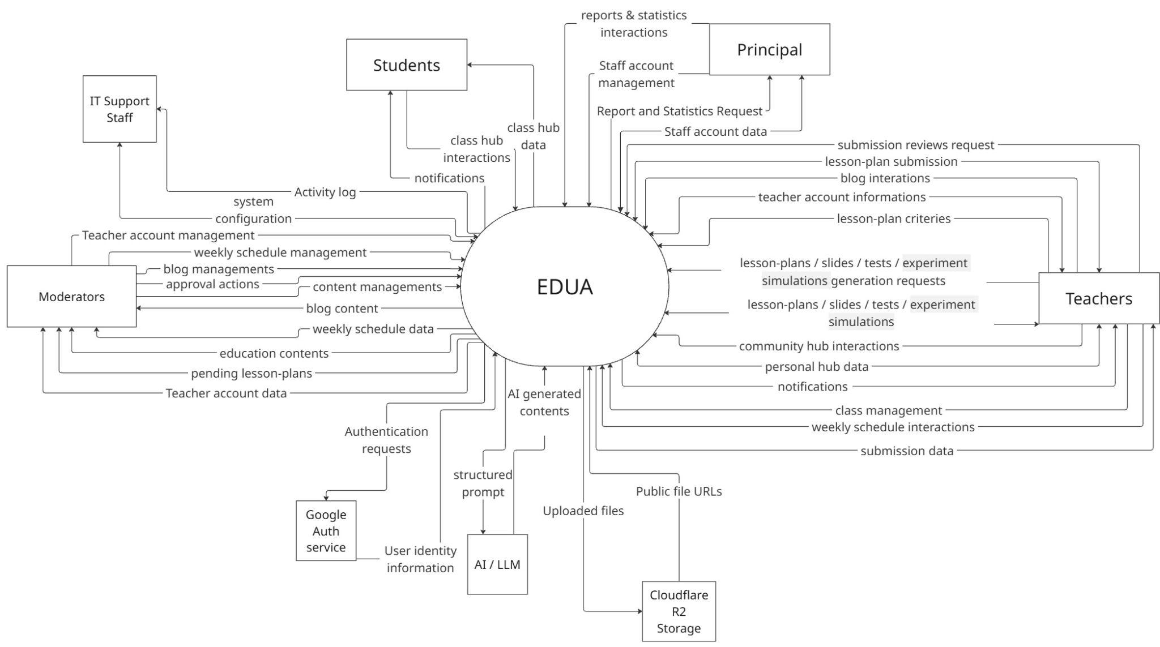

1.2 Main Workflows

1.2.1 Create lesson plan process
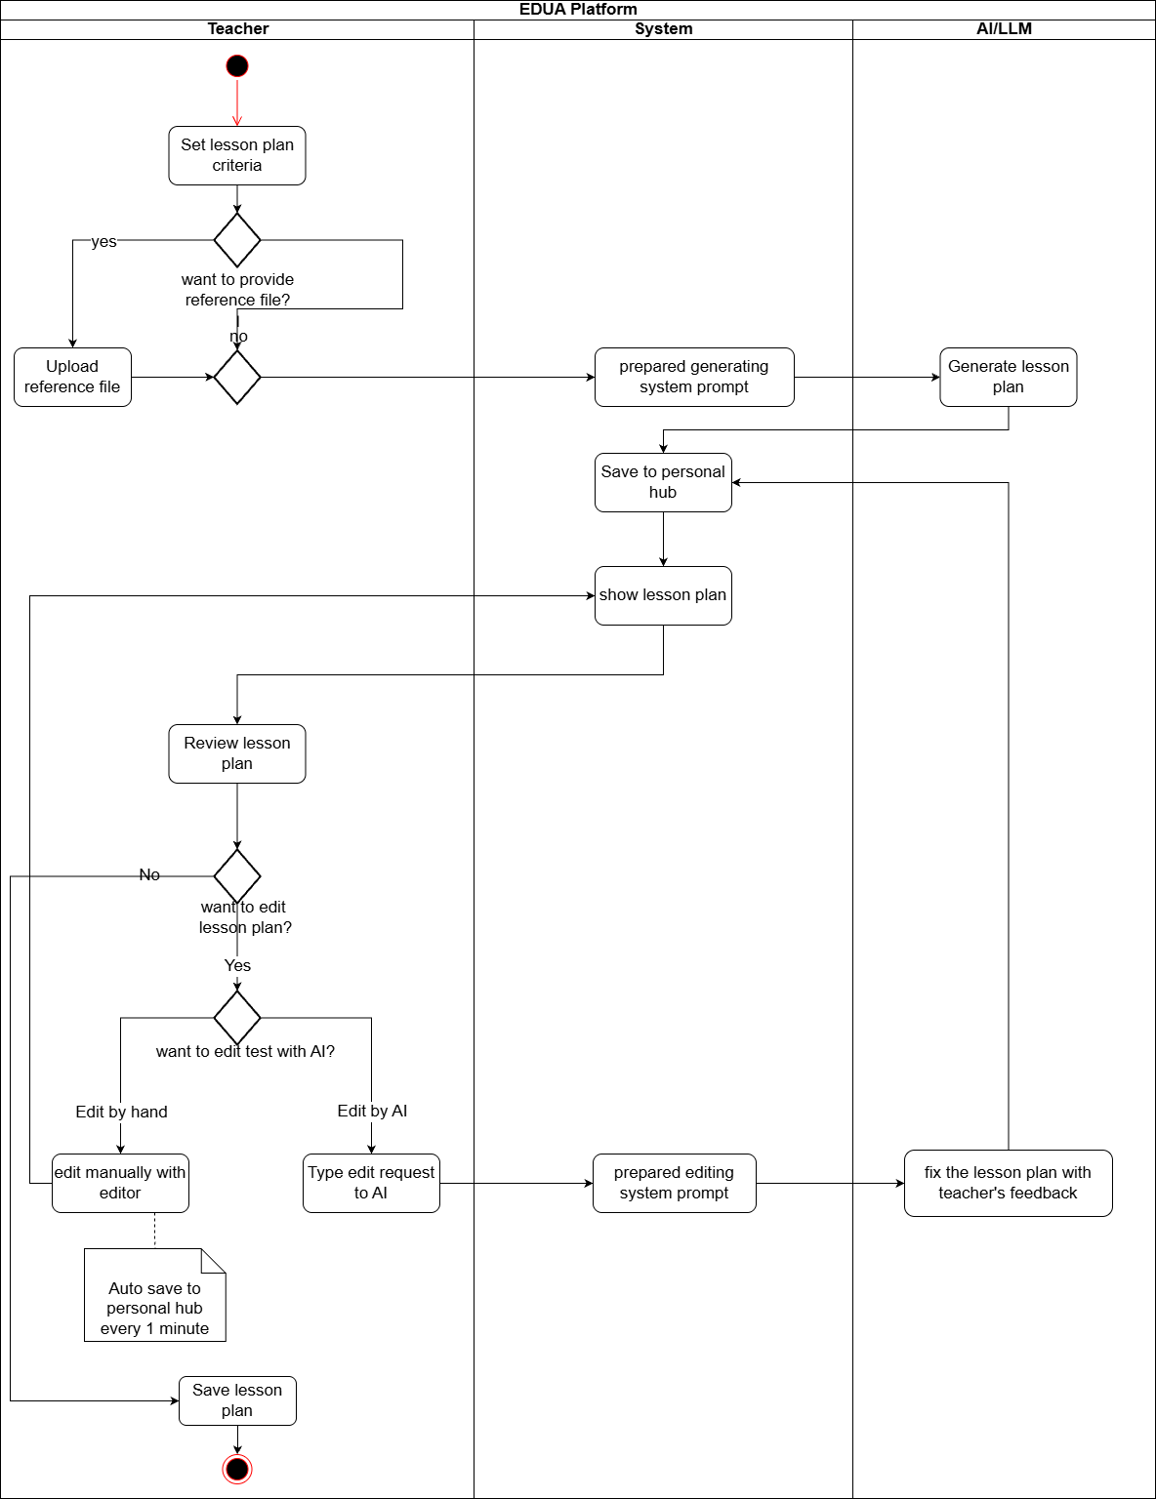

1.2.2 Create slide process
ProjectCode – Report 3 (SRS Document) | Page /18
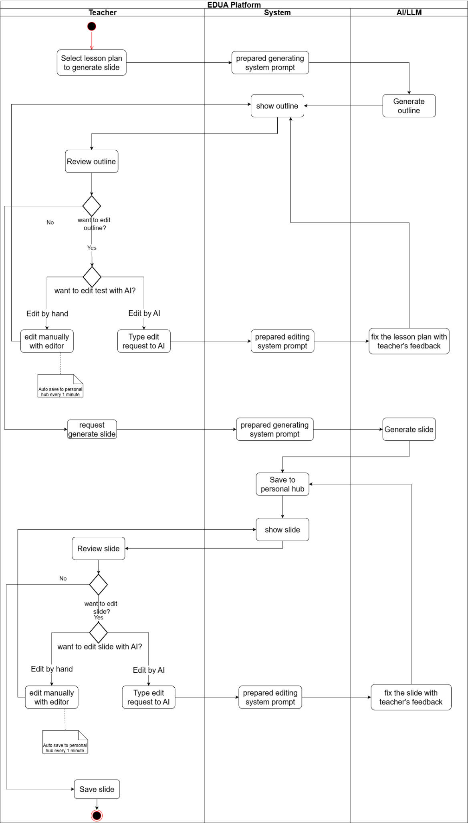

1.2.3 Create test process
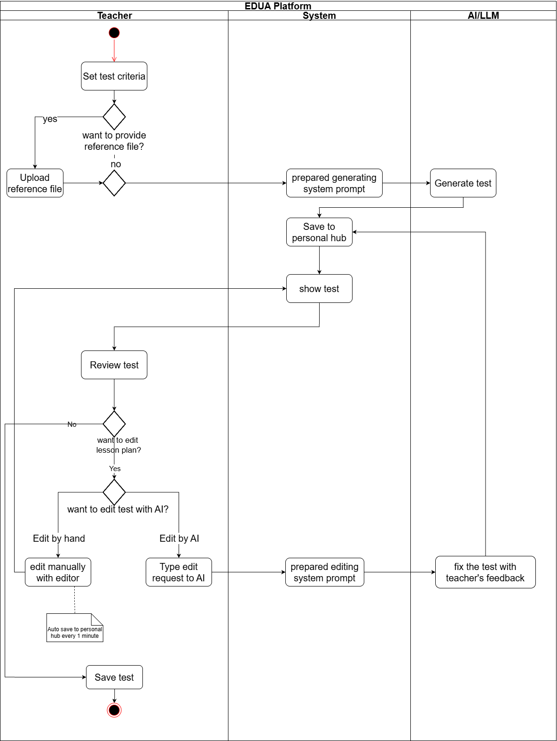

1.2.4 Presentation mode
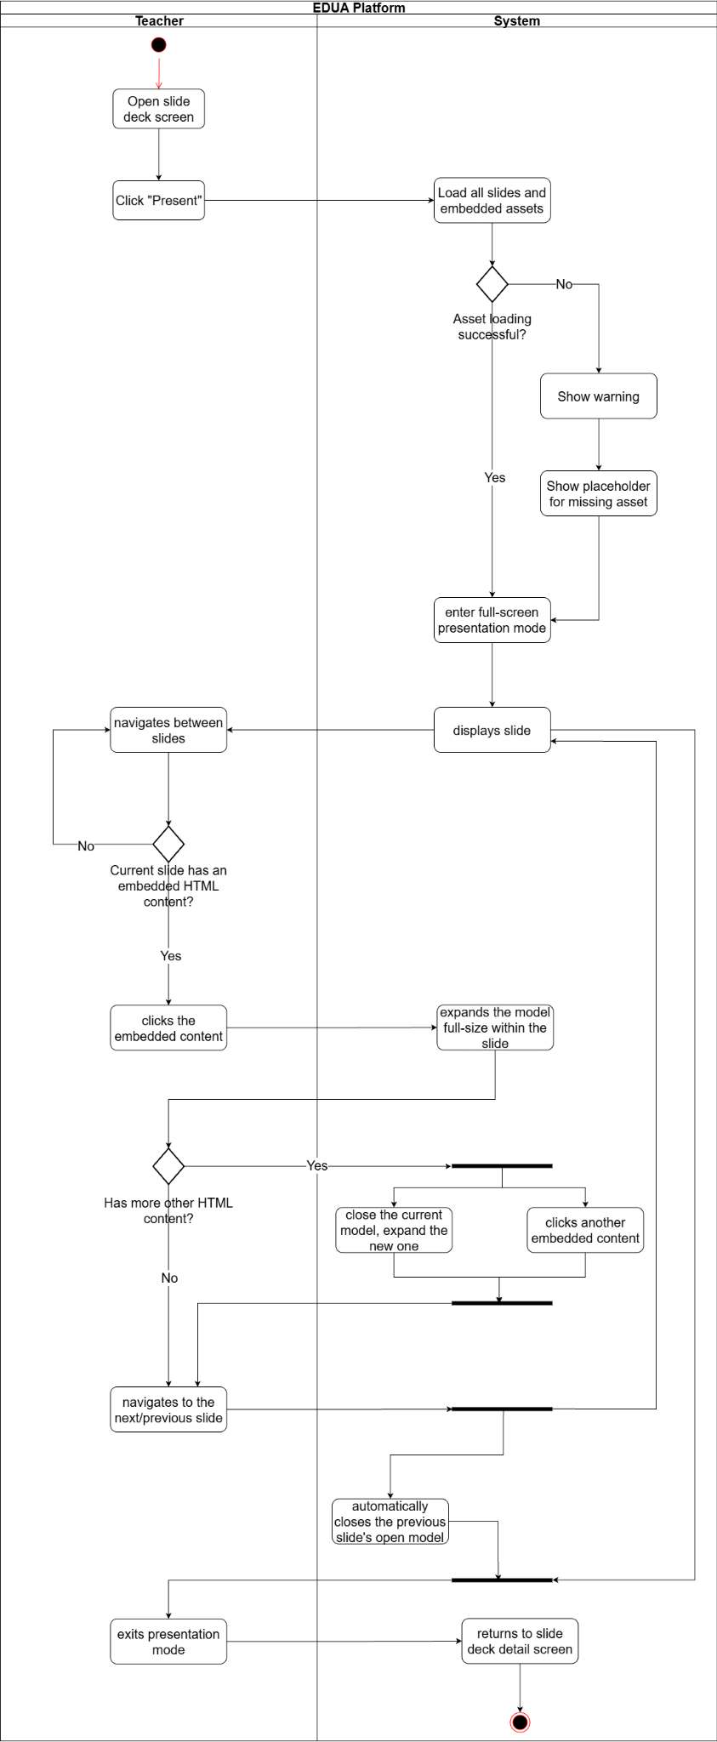

1.2.5 Simulation physical
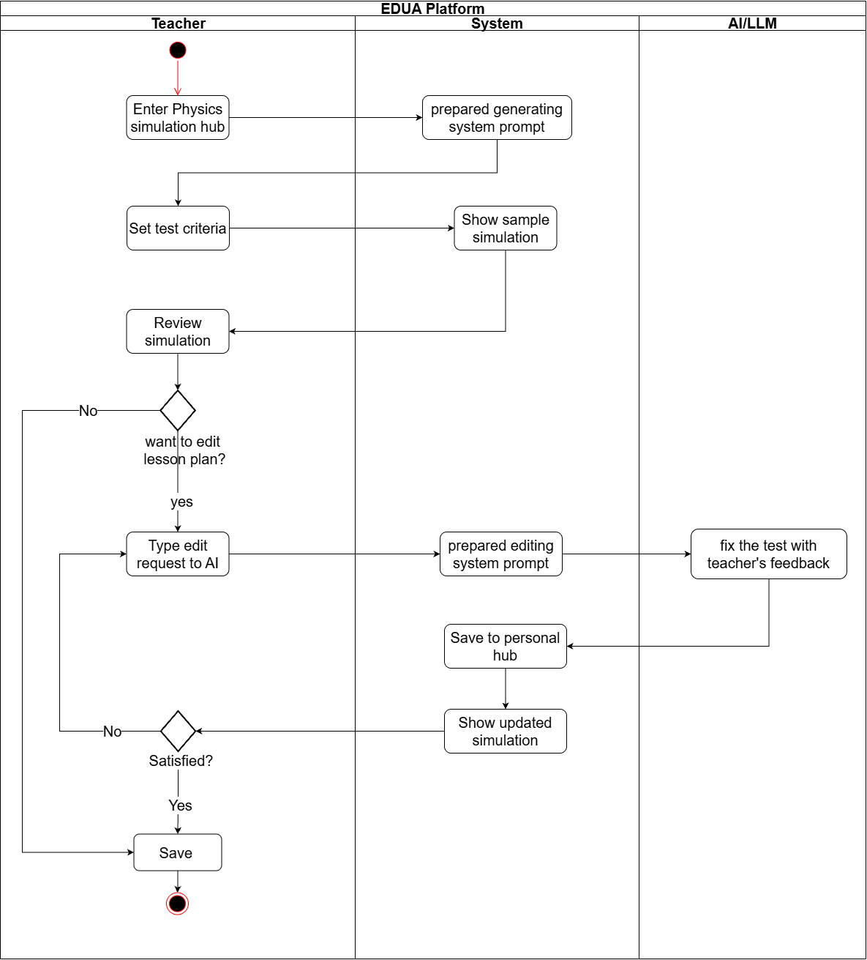

1.2.6 Download Slide
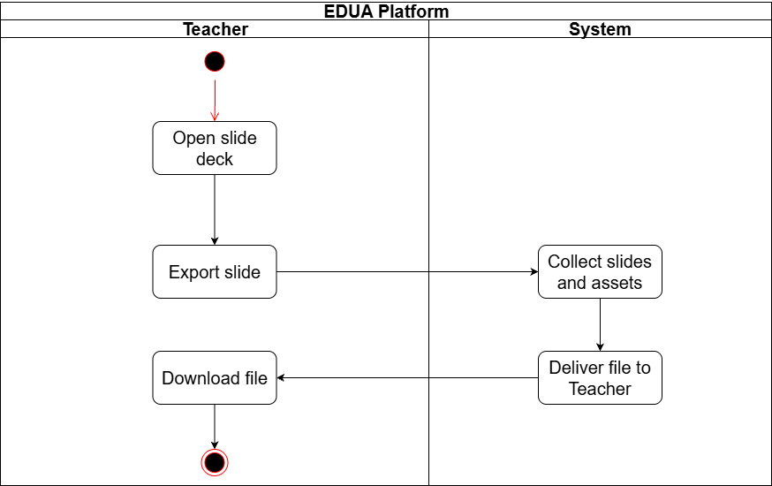

1.2.7 Weekly Schedule & Lesson Plan Approval
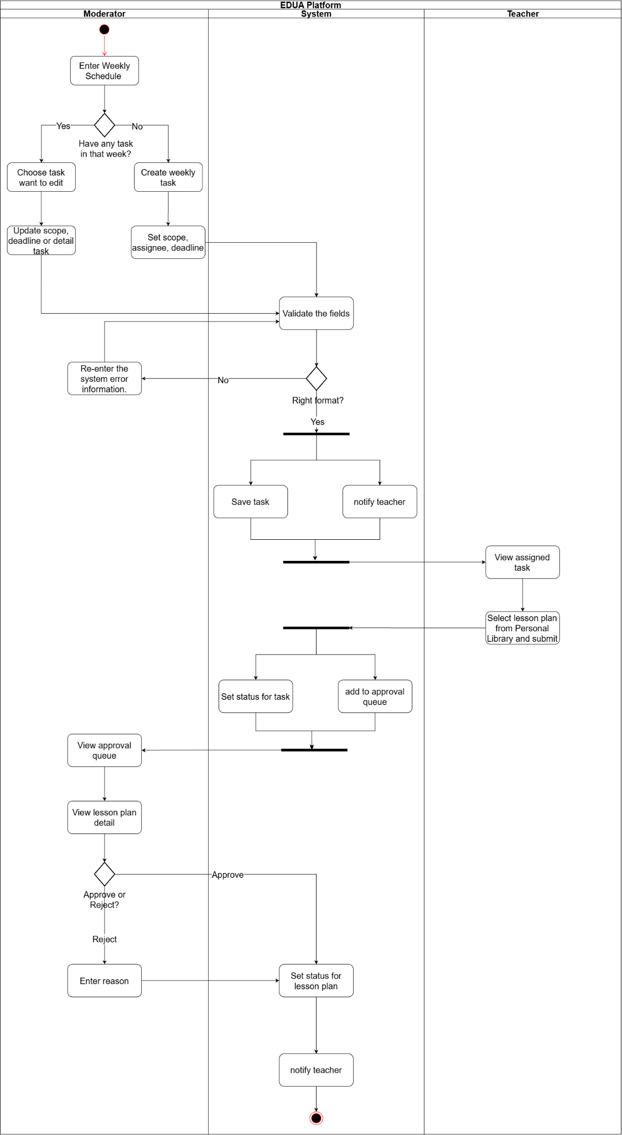

1.2.8 Publish Content
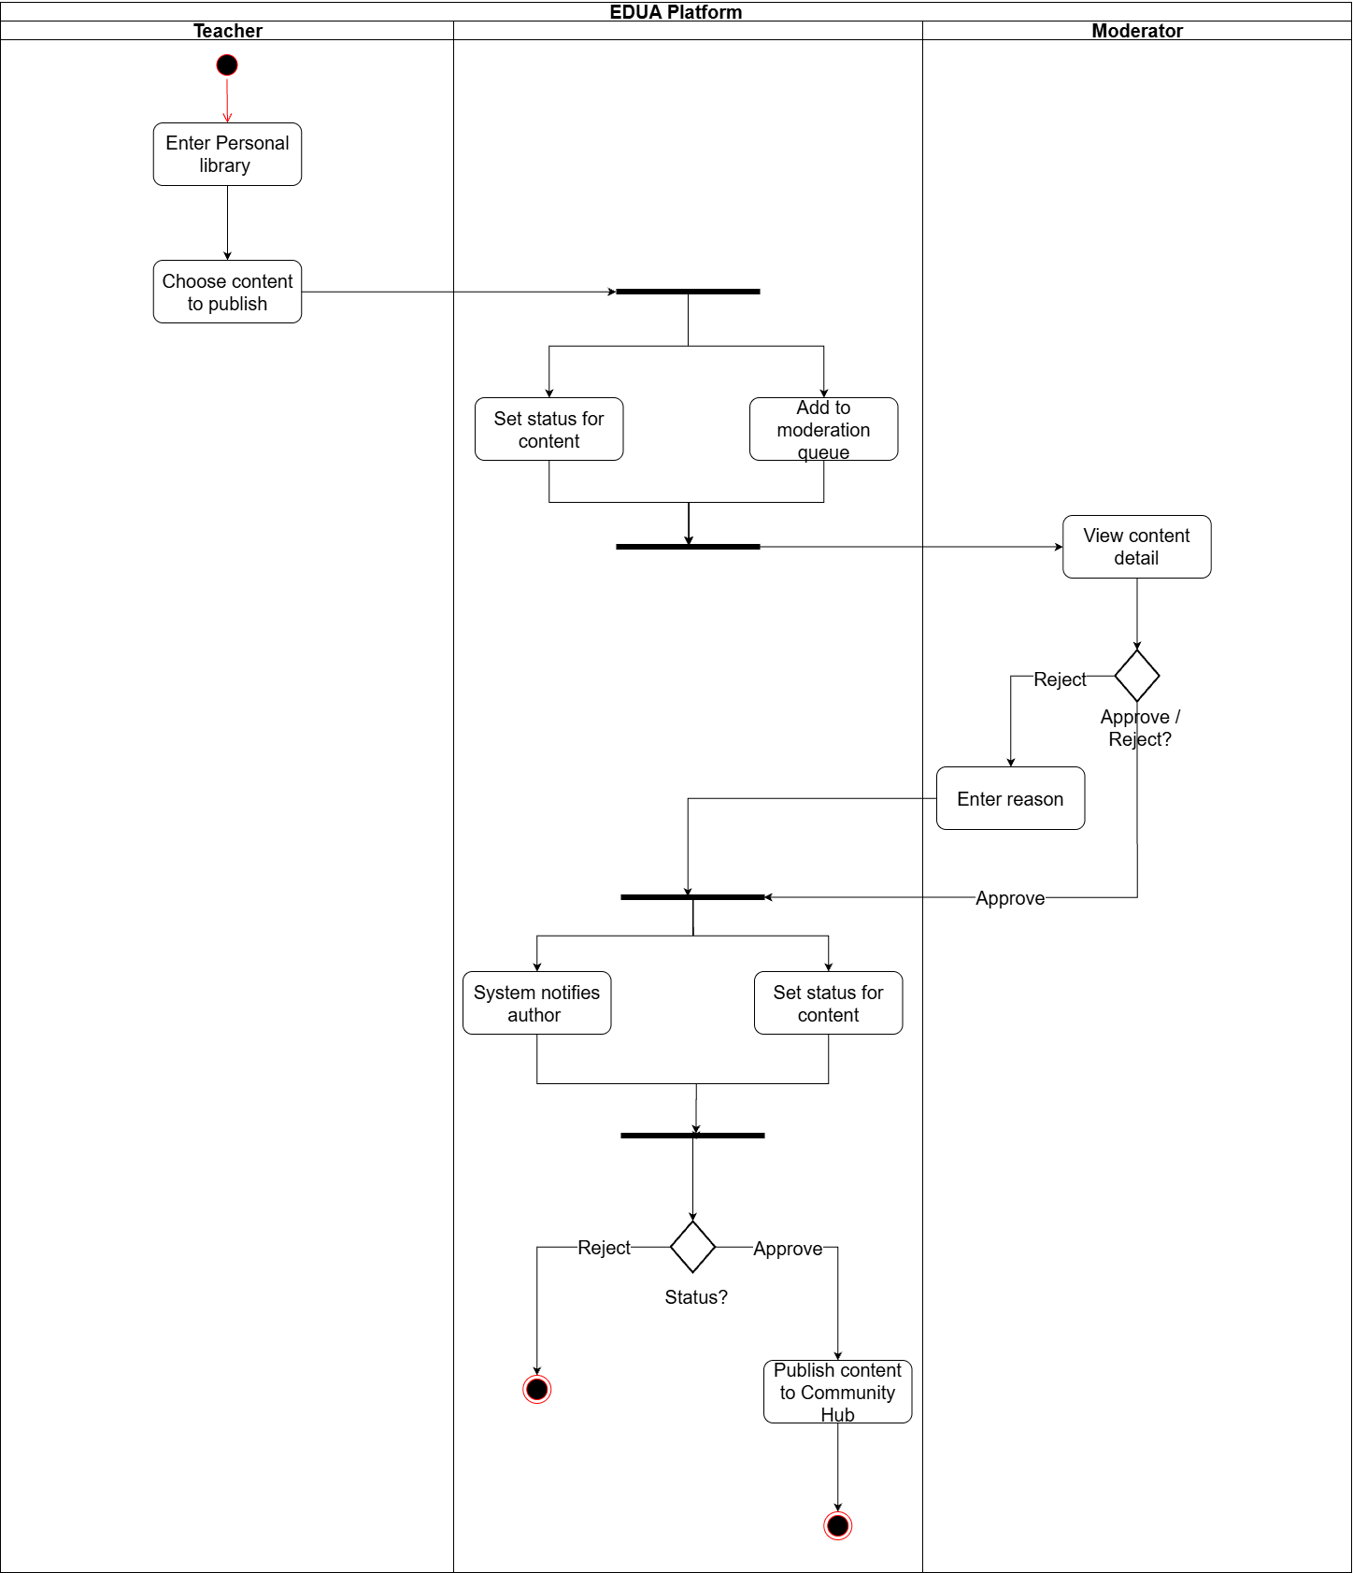

1.2.9 Workflow for using lesson plan to work
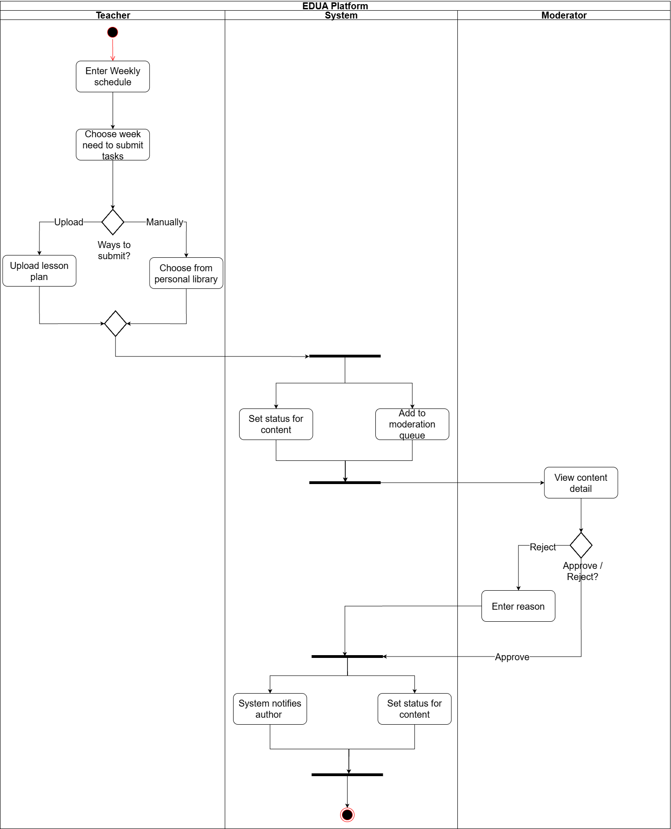

1.2.10 Class management
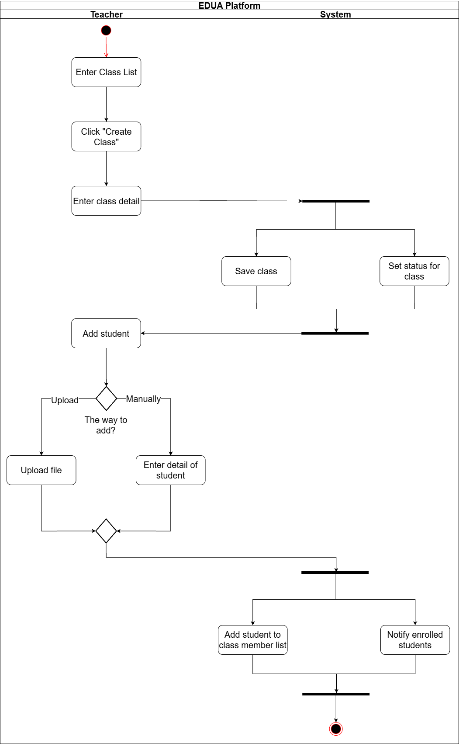

1.2.11 Customize content on community hub
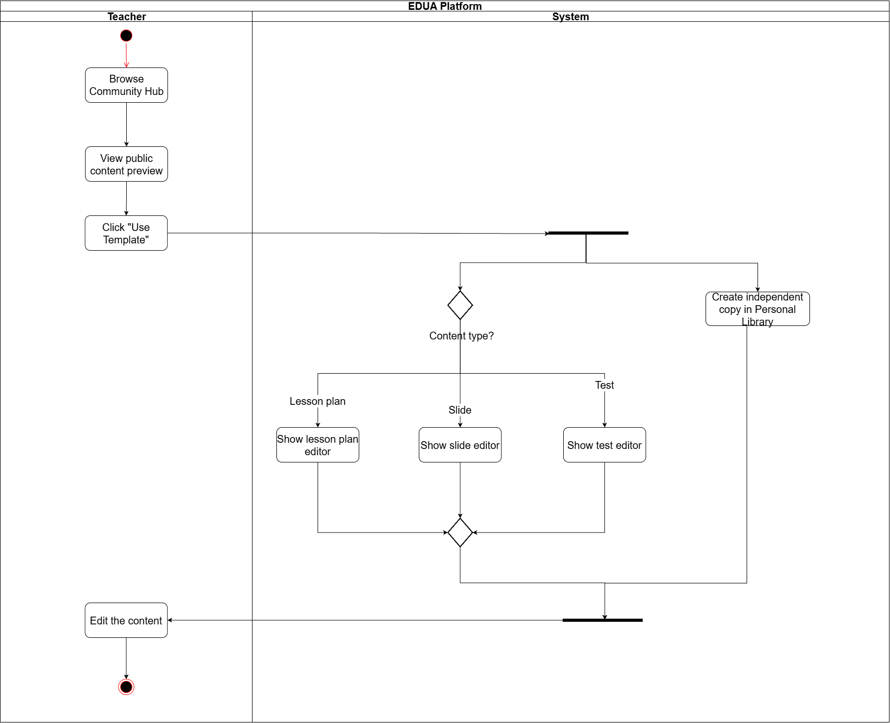

1.2.12 Student submit assignment
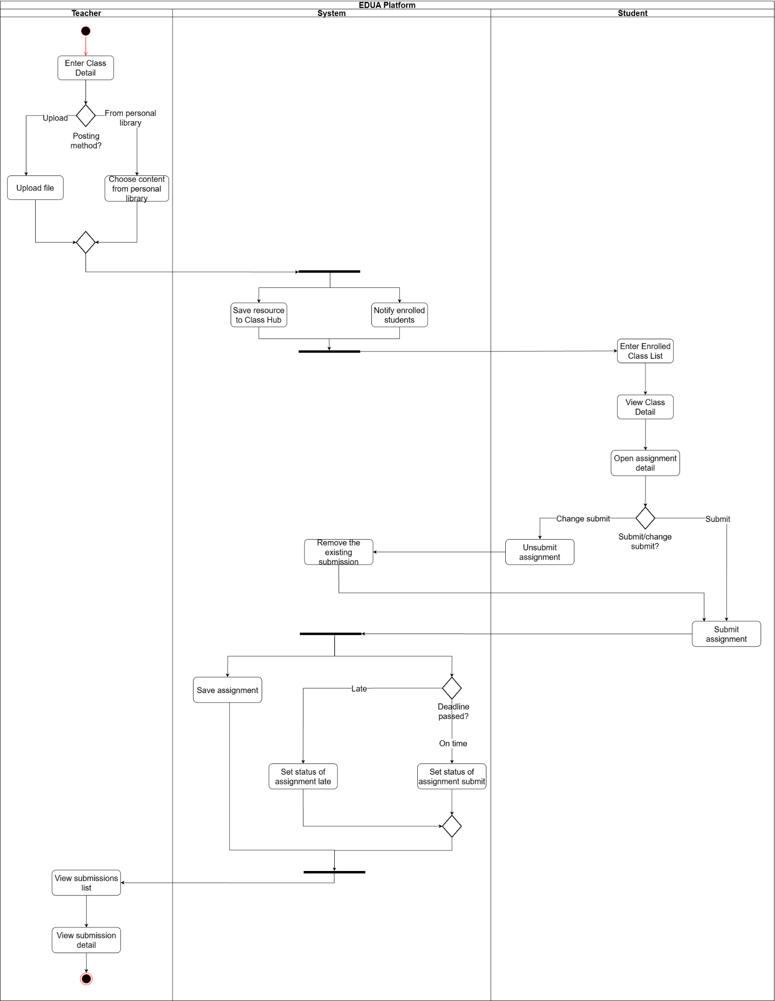

1.2.13 View & Comment on Blog Post
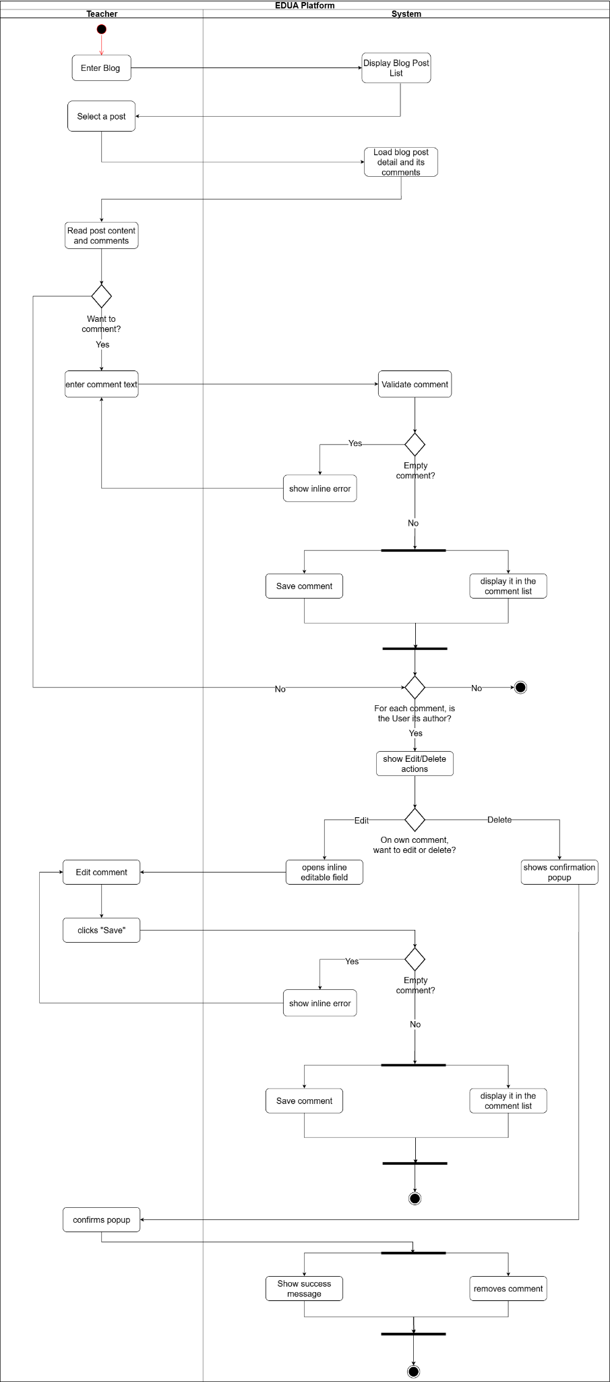

1.2.14 Manage Own Blog Post
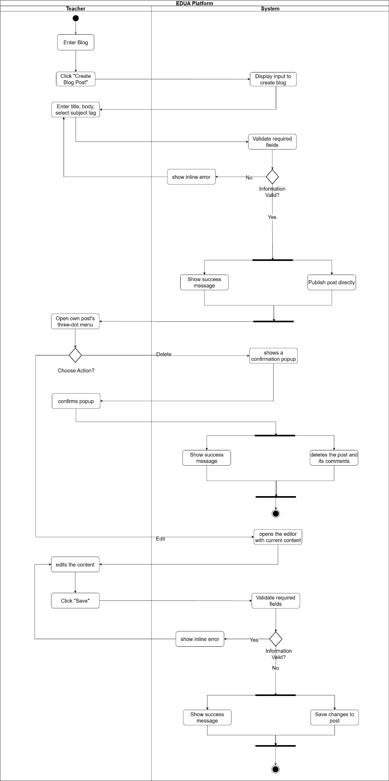

1.2.15 Delete Comment on Own Blog Post
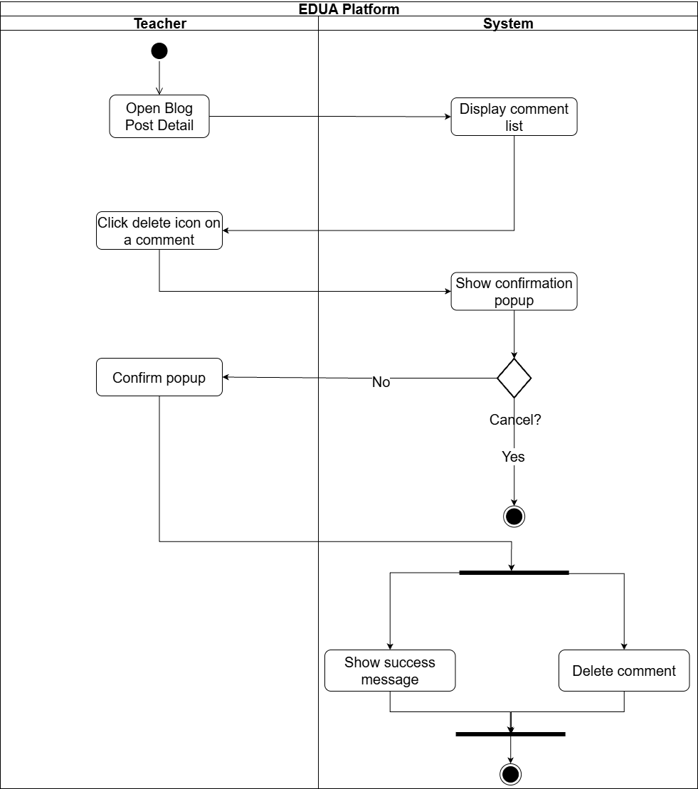

1.2.16 Set Class Inactive → Read-Only Access

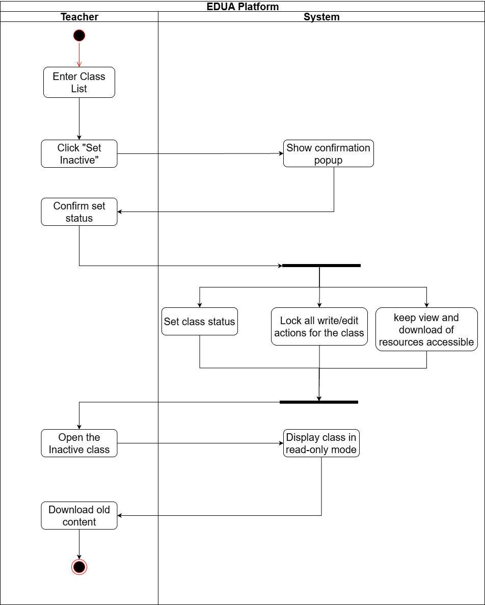

1.3 User Requirements

1.3.1 Actors
# | Actor | Description
1 | Teacher | A STEM teacher (Chemistry, Physics, or Mathematics, grades 10–12) at THPT Lê Quý Đôn Hà Đông — the primary end user and the generalized teacher actor. Represents the capabilities common to all three subjects; subject-level specialization into Math Teacher, Physics Teacher, and Chemistry Teacher is shown in the use case diagrams in section 1.3.3.4. Manages their own account, generates and edits lesson plans, slides, and tests, presents content in class, maintains a personal library, shares and interacts with content in the Community Hub, and writes and discusses posts on the Blog.
2 | Math Teacher | A Mathematics teacher (grades 10–12) at THPT Lê Quý Đôn Hà Đông. Inherits all capabilities of Teacher with no additional subject-specific simulation features (Mathematics has no virtual lab or phenomena hub).
3 | Physics Teacher | A Physics teacher (grades 10–12) at THPT Lê Quý Đôn Hà Đông. Inherits all capabilities of Teacher and additionally accesses the Physics Hub: browses the library of interactive physics phenomena, views phenomenon details, and customizes or generates new simulation variants with AI assistance for their lessons.
4 | Chemistry Teacher | A Chemistry teacher (grades 10–12) at THPT Lê Quý Đôn Hà Đông. Inherits all capabilities of Teacher and additionally accesses the Chemistry Lab: runs virtual experiments, views the interactive periodic table and 3D atomic models, and generates 3D organic molecule models with AI assistance for their lessons.
5 | Moderator | A head of subject department (e.g., Chemistry, Physics, or Mathematics) who manages their department within EDUA: grant and revoke permissions for teacher accounts of their subject, reviews content submitted to the Community Hub of that subject and approves or rejects it, and removes violating blog posts of that subject.
6 | IT Support Staff | The school's IT staff (in practice, the ICT/Informatics teacher) who manages moderator accounts (grant and revoke access), manages the AI system prompts and master data, views and filters the system activity log, and views user activity records to oversee overall platform operation.
7 | AI / LLM Service | An external AI service (OpenAI/DeepSeek) that receives structured prompts from EDUA and returns AI-generated content for lesson plans, slides, tests, and simulation descriptions.
8 | Authentication Service | An external identity service (Google OAuth2 service) that handles authentication requests and returns user identity information for sign-in and role-based authorization.
9 | File Storage Service | An external object-storage service (Cloudflare R2) that stores uploaded and generated files and returns public file URLs for retrieval.
10 | User | The generalized authenticated actor — any signed-in user of the platform (Teacher, Moderator, or Administrator). Used to group common authenticated capabilities such as login, logout, view and update profile, and view notifications.
11 | Student | A student at THPT Lê Quý Đôn Hà Đông who is enrolled in one or more classes by their teachers. Views the teaching resources shared to a class hub and submits assignments (entering text and/or uploading files) before their deadlines.
12 | Principal | The head of the school (Hiệu trưởng). Views statistics and reports on platform usage — such as the number of lesson plans and slides generated with AI by teachers — to oversee teaching activity and support school reporting.

1.3.2 Use Cases (UC)

ID | Use Case | Feature | Use Case Description
UC-01 | View Landing Page | User Identity | The system displays the public EDUA homepage, introducing the platform, supported roles, and major teaching tools. Visitors can review this information before deciding to sign in.
UC-02 | Login | User Identity | The user selects Google sign-in and authenticates with a permitted account. The system verifies that the account exists, is Active, and has an assigned role before opening the corresponding workspace.
UC-03 | Logout | User Identity | The signed-in user requests to leave the platform. The system terminates the current session, clears the authentication context, and returns the user to the public entry screen.
UC-04 | Update Profile Information | User Identity | The user opens the profile screen and updates permitted fields such as display name, avatar, school, or subject information. The system validates the input and stores the latest profile data without changing the user role.
UC-05 | Create Lesson Plan | Lesson Plan - AI Auto-generation | The teacher selects subject, grade, lesson, and knowledge units and may upload a reference document. The system sends the configured input to AI, generates a MOET-5512 lesson plan, stores it as a Draft in the Personal Library, and opens it for review.
UC-06 | Edit Lesson Plan | Lesson Plan - Manual Customization | The teacher opens an editable lesson plan and changes its content manually or through an AI instruction. The system saves the updated version and applies the applicable Publish Status transition; Pending Publish content remains locked until withdrawn.
UC-07 | Export Lesson Plan | Lesson & Slide Storage | The teacher chooses an available file format such as PDF or Word. The system converts the current lesson-plan version into a downloadable file without changing the stored content or its Publish Status.
UC-08 | View Personal Library | Lesson & Slide Storage | The system lists the teacher's saved lesson plans, slide decks, tests, and other supported resources with their applicable Publish Status and Weekly Task Review Status. Search, filter, and item-opening actions are available separately.
UC-09 | Update Content | Lesson & Slide Storage | The teacher opens an owned item that is currently editable and saves changes to its working version. The system preserves ownership and applies the applicable transition according to the relevant State Diagram.
UC-10 | Delete Content | Lesson & Slide Storage | The teacher selects an owned item and confirms deletion. The system removes it from the Personal Library while preventing deletion when the current status or dependency rules do not permit the action.
UC-11 | Create Slide Outline | Presentation - Outline Creation | The teacher selects an owned lesson plan as the main source or uploads a supported external document as an alternative source. The system sends the selected source to AI, generates a structured slide outline preview, and presents it for review before slide-deck generation. The outline is not stored as a Personal Library item.
UC-12 | Edit Slide Outline | Presentation - Outline Creation | The teacher changes slide titles, order, key points, or supporting notes in the outline preview. The system updates the current preview and uses its latest valid structure when a slide deck is generated, without creating a Personal Library item for the outline.
UC-13 | Create Slide Deck | Presentation - Slide Creation | The teacher confirms a slide outline and requests deck generation. The system uses AI to create the full slide deck, stores it in the Personal Library, and opens the generated slides for editing.
UC-14 | Edit Slide Deck | Presentation - Manual Customization | The teacher modifies slide text, layout, media, or presentation elements manually or through an AI request. The system saves the latest deck version while keeping the source outline and lesson plan unchanged.
UC-15 | Present Slide | Presentation - Online Presentation | The teacher launches presentation mode for a selected deck. The system displays the slides full-screen and provides navigation controls for classroom presentation without modifying the deck.
UC-16 | Export Slide | Presentation - Offline Presentation | The teacher requests an offline version of the selected deck. The system packages the current presentation as an HTML file and provides it for download so it can be presented without the platform.
UC-17 | Create Test | Exam Generation - AI Generation | The teacher enters the test information and assessment constraints, then requests generation. The system uses AI to produce a complete test and answer key, saves them in the Personal Library, and opens the test for review.
UC-18 | Edit Test | Exam Generation - Manual Customization | The teacher edits questions, answers, scoring information, or instructions manually or through AI. The system saves the revised test and retains the latest valid answer key.
UC-19 | Export Test | Test Storage | The teacher chooses an export format and whether to include the answer key. The system generates a printable file from the current test version and makes it available for download.
UC-20 | View Blog List | Blog Sharing | The system displays published blog posts available to the teacher or moderator, with basic metadata and subject tags. Users can browse or open a post to read its full content.
UC-21 | View Blog Post Detail | Blog Sharing | The system loads the selected blog post, author information, subject tag, and current discussion. Comment, owner, and moderation actions are shown only when the user has the required permission.
UC-22 | Create Blog Post | Blog Sharing | The teacher or moderator enters the post title, body, and one subject tag. After validation, the system publishes the post immediately and records the current user as its author.
UC-23 | Edit Own Blog Post | Blog Sharing | The author opens a published blog post, changes its permitted content, and saves the revision. The system updates the post while preserving authorship and existing discussion.
UC-24 | Delete Own Blog Post | Blog Sharing | The author confirms deletion of a blog post they created. The system removes the post from public view together with its associated discussion according to the platform retention rules.
UC-25 | Comment on Blog Post | Blog Feedback | The user writes a comment on a blog post and submits it. The system stores the comment under the post with the author and timestamp, then refreshes the discussion.
UC-26 | Edit Own Blog Comment | Blog Feedback | The user selects a comment they previously posted and updates its text. The system verifies ownership and saves the revised comment while retaining its original author.
UC-27 | Delete Own Blog Comment | Blog Feedback | The user confirms deletion of a comment they previously posted. The system verifies ownership and removes the comment from the blog discussion.
UC-28 | Delete Comment on Own Blog Post | Blog Feedback | The blog-post author selects another user's comment on their own post, enters a removal reason, and confirms the action. The system removes the comment and records the moderation reason.
UC-29 | View Class List | Class Management | The system displays classes owned by the teacher with key information such as name, subject, member count, and Active or Inactive status. Search and filtering are available as separate actions.
UC-30 | Create Class | Class Management | The teacher enters the required class information and confirms creation. The system creates the class, assigns the teacher as owner, and prepares its member and resource areas.
UC-31 | Edit Class Information | Class Management | The class owner updates permitted class information such as name, description, or subject. The system validates and saves the changes without altering existing members or resources.
UC-32 | Set Class Status | Class Management | The class owner selects a target Active or Inactive status. The system applies the selected status and the corresponding permissions for normal teaching activity.
UC-33 | View Class Detail | Class Management | The system verifies that the user owns or is enrolled in the selected class and opens the Class Hub. It displays the class information, members, shared resources, assignments, and related submissions permitted for that role.
UC-34 | View Class Members | Class Management | The system displays the teacher and enrolled students of the selected class. The available management actions depend on whether the current user is the class owner or a student and on the class status.
UC-35 | View Enrolled Classes List | Class Management | The system lists all classes in which the student is currently enrolled, including their current status. The student can open an available class to access shared learning content.
UC-36 | Add Student | Enroll Student | The class owner enters student accounts manually or imports them from a supported file. The system validates each account, prevents duplicate enrollment, adds eligible students to the class, and notifies each successfully added student.
UC-37 | Remove Student | Enroll Student | The class owner selects an enrolled student and confirms removal. The system revokes that student's access to the class while preserving existing submission records as required.
UC-38 | Post Class Resource | Share Resource | The teacher creates a class post by selecting an owned Personal Library item or uploading a supported file and may enable submission with a deadline. The system publishes an independent resource to enrolled students, records its assignment settings, and notifies the enrolled students.
UC-39 | Update Class Resource | Share Resource | The teacher edits an owned class resource, including its description, attachments, submission setting, or deadline where permitted. The system saves the changes and updates the information shown to students.
UC-40 | Delete Class Resource | Share Resource | The teacher confirms deletion of an owned class resource. The system permanently removes the resource and all submissions associated with it from the class.
UC-41 | View Class Resources | Share Resource | The system displays the resources and assignments shared in an enrolled class, including deadlines and the student's latest submission status where applicable.
UC-42 | View Class Resource Detail | Share Resource | The system opens the selected resource and displays its full instructions, attachments, deadline, submission state, and the actions permitted by the resource and class status.
UC-43 | Download Assigned Material | Share Resource | The student selects an attachment from a class resource. The system retrieves the file and provides it for local download without changing the student's submission status.
UC-44 | View Submissions List | Create & Assign | The class owner opens a resource that requires submission. The system lists enrolled students and their current submission state, submission time, and On Time or Late tag.
UC-45 | View Submission Detail | Create & Assign | The teacher selects a student entry from the submission list. The system displays the submitted files, latest submission time, and status so the teacher can review the work.
UC-46 | Download Submission File | Create & Assign | The teacher selects a file attached to a student submission. The system retrieves the stored image or Word document and provides it for local review.
UC-47 | Submit Assignment | Student File Upload | The student uploads one or more supported files and confirms submission. The system stores the latest submission, records its time, and assigns an On Time or Late tag based on the deadline.
UC-48 | Unsubmit Assignment | Student File Upload | The student withdraws the current submission so it can be revised and submitted again. A replacement submitted after the deadline receives a Late tag even when an earlier submission was On Time.
UC-49 | View Physics Simulation Library | Basic Simulation Hub | The system displays the available physics simulation collection with searchable metadata. The Physics teacher can browse and open a simulation suitable for a lesson.
UC-50 | View Physics Simulation Detail | Basic Simulation Hub | The system loads the selected HTML simulation and its supported parameters. The teacher can run the simulation and adjust values to observe the resulting behavior.
UC-51 | View Physics Simulation Analysis | Basic Simulation Hub | The system presents analysis generated from the current simulation run, such as motion, acceleration, or time-based data. The displayed analysis updates when the simulation inputs change.
UC-52 | Customize Physics Simulation | AI Chat Customization | The Physics teacher describes a desired change to the selected simulation. The system sends the current simulation and request to AI, applies the returned customization, and presents the revised simulation for review.
UC-53 | View Periodic Table | Periodic Table | The system displays the interactive periodic table and supports searching or filtering elements. The Chemistry teacher can select an element to inspect its detailed information.
UC-54 | View Electron Model | Periodic Table | The Chemistry teacher selects an element from the periodic table. The system displays the element's electron model for interactive inspection without changing the scientific reference data.
UC-55 | View Element Detail | Periodic Table | The system displays the selected element's scientific properties and reference information. The Chemistry teacher can inspect the details without modifying the underlying data.
UC-56 | View Molecule Structure | 3D Molecule Model | The Chemistry teacher selects an available molecule structure. The system renders it as an interactive three-dimensional ball-and-stick model that can be rotated and zoomed.
UC-57 | Generate Molecule Structure | 3D Molecule Model | The Chemistry teacher enters a supported substance name or chemical formula. The system validates the input, generates the molecular structure, and displays the resulting three-dimensional ball-and-stick model.
UC-58 | View Community Hub | Content Sharing | The system displays public teaching resources shared through the Community Hub. The teacher can search, filter, and open content relevant to a lesson.
UC-59 | View Public Content Detail | Content Sharing | The system loads the selected public resource, its author, metadata, and available discussion. The teacher can review it before deciding to comment or create a customized copy.
UC-60 | Customize Public Content | Content Sharing | The teacher selects another user's public content and creates a personal copy. The system stores the copy as an independent Draft in the Personal Library so later changes do not affect the original public item.
UC-61 | Publish Hub Content | Content Sharing | The teacher submits an eligible owned content item for Community Hub publication. The system changes its Publish Status to Pending Publish and places it in the moderator's Hub Content List without changing any Weekly Task Review Status.
UC-62 | Unpublish Hub Content | Content Sharing | The teacher withdraws an owned content item while its Publish Status is Pending Publish. The system removes it from the Hub moderation queue and returns it to Draft so the teacher can edit it.
UC-63 | View Own Content Detail | Content Sharing | The system displays the Published version of a Community Hub item authored by the current teacher, its comments, and available owner actions. Any Draft revision in the Personal Library remains separate from the Published version.
UC-64 | Edit Own Public Content | Content Sharing | The author edits a Draft revision of owned Published content. The system saves the revision in the Personal Library while keeping the current Published version unchanged until the revision is approved.
UC-65 | Delete Own Public Content | Content Sharing | The author confirms deletion of their Published Community Hub item. The system removes the public version while leaving any separate Personal Library item unchanged.
UC-66 | View Content Comments | Content Feedback | The system displays the discussion attached to a public content item, including comment authors and timestamps.
UC-67 | Create Content Comment | Content Feedback | The teacher writes and submits a comment on a public content item. The system stores it in the discussion and associates it with the current user.
UC-68 | Update Content Comment | Content Feedback | The teacher edits a comment they previously posted on public content. The system verifies ownership and saves the updated text.
UC-69 | Delete Content Comment | Content Feedback | The teacher confirms removal of a comment they previously posted. The system verifies ownership and deletes it from the discussion.
UC-70 | Delete Comment on Own Content | Content Feedback | The content owner selects another user's comment on their public item and confirms deletion. The system verifies ownership of the content before removing the comment.
UC-71 | View Content List | Hub Content Moderation | The moderator opens the Community Hub moderation queue for the assigned subject. The system lists only content submitted for Hub publication together with its author, source, submission time, and Publish Status.
UC-72 | View Content Detail | Hub Content Moderation | The moderator opens a content item submitted for Community Hub publication. The system displays its complete content, author, subject, metadata, and available Hub moderation actions.
UC-73 | Approve Content | Hub Content Moderation | The moderator approves eligible content submitted for Community Hub publication within the assigned subject. The system records the decision and changes the item's Publish Status to Published.
UC-74 | Reject Content | Hub Content Moderation | The moderator rejects eligible content submitted for Community Hub publication and enters a reason. The system records the decision, changes the Publish Status to Rejected, and returns the reason to the teacher.
UC-75 | View Teacher List | Teacher Account Management | The moderator views teachers assigned to the moderator's subject with their account status and basic information. Search and filtering help locate a teacher for management.
UC-76 | View Teacher Detail | Teacher Account Management | The system displays the selected teacher's account information, assigned subject, and Active or Inactive status. It also shows the account actions available to the moderator.
UC-77 | Add Teacher | Teacher Account Management | The moderator enters an eligible Gmail account and required teacher information. The system validates the account, creates or activates the teacher account, and assigns it to the moderator's subject.
UC-78 | Update Teacher Account | Teacher Account Management | The moderator edits permitted information for a teacher in the assigned subject. The system validates and saves the changes without granting management rights outside that subject.
UC-79 | Ban Teacher | Teacher Account Management | The moderator confirms removal of platform access for a teacher in the assigned subject. The system sets the account to Inactive while preserving the teacher's existing content and records.
UC-80 | View Weekly Schedule | Weekly Calendar | The system displays Weekly Tasks for the moderator or teacher according to role and assigned subject. Each task shows its scope, assignee, deadline, and Weekly Task Review Status.
UC-81 | Create Weekly Task | Weekly Calendar | The moderator defines the lesson-plan requirement, selects an eligible teacher in the assigned subject, and sets a deadline. The system creates the task and makes it visible to the assigned teacher.
UC-82 | Edit Weekly Task | Weekly Calendar | The moderator changes an existing Weekly Task before its deadline. The system validates the new scope, assignee, or deadline and permanently locks task editing after the deadline passes.
UC-83 | View Assigned Task | Weekly Calendar | The teacher opens a Weekly Task assigned to them. The system displays the required lesson-plan scope, deadline, current Weekly Task Review Status, and the actions available before the deadline.
UC-84 | Submit Lesson Plan for Weekly Task | Lesson Plan Submission | The teacher selects an eligible owned lesson plan or uploads a supported external lesson-plan document and submits it to the assigned Weekly Task before or at the deadline. The system records the source and submission time, changes the Weekly Task Review Status to Submitted, and places the submission in the moderator Lesson Plan Approval List.
UC-85 | Unsubmit Lesson Plan for Weekly Task | Lesson Plan Submission | The teacher withdraws a Weekly Task lesson-plan submission before or at the deadline. The system removes it from the Lesson Plan Approval List, restores the pre-submission Weekly Task Review Status, and leaves Publish Status unchanged.
UC-86 | View Lesson Plan Approval List | Lesson Plan Moderation | The moderator views lesson plans submitted through Weekly Tasks by teachers in the assigned subject. The system displays the teacher, related Weekly Task, submission time, deadline, and Weekly Task Review Status.
UC-87 | View Lesson Plan Detail | Lesson Plan Moderation | The moderator opens a lesson plan submitted through a Weekly Task. The system displays the complete plan, teacher, related task requirement, submission time, and available Weekly Task review actions.
UC-88 | Approve Lesson Plan | Lesson Plan Moderation | The moderator approves an eligible lesson plan submitted through a Weekly Task in the assigned subject. The system records the decision and changes only its Weekly Task Review Status to Approved.
UC-89 | Reject Lesson Plan | Lesson Plan Moderation | The moderator rejects an eligible lesson plan submitted through a Weekly Task and enters a reason. The system records the decision, changes only its Weekly Task Review Status to Rejected, and returns the feedback to the teacher.
UC-90 | Create Notifications | Send Subject Notification | The moderator writes a subject-level announcement and confirms delivery. The system sends the notification to teachers in the moderator's assigned subject and records the dispatch.
UC-91 | View Notifications | Receive Notification | The system displays notifications addressed to the current user, including content decisions, task events, and subject announcements. The user can open an item to read its full content.
UC-92 | Remove Blog Post | Blog Moderation | The moderator opens a blog post tagged with the assigned subject and enters a removal reason. The system removes the post from public view and records the moderation action.
UC-93 | View & Filter Activity Log | View Activity Log | The IT Supporter opens the activity-log screen and filters records by supported criteria such as actor, action, feature, or time. The system displays matching audit entries without permitting modification of the records.
UC-94 | View System Prompts | System Prompt Management | The IT Supporter views the configured AI system prompts used by platform generation features. The system displays each prompt with its related feature and current content.
UC-95 | Update System Prompts | System Prompt Management | The IT Supporter selects a system prompt, edits its permitted content, and confirms the update. The system validates and stores the new prompt for subsequent AI requests while preserving the change record.
UC-96 | View Staff List | Staff Management | The Principal opens the combined Staff Management screen. The system displays the Moderator positions and the IT Supporter position with assigned subject where applicable and current account status.
UC-97 | View Staff Detail | Staff Management | The Principal selects a Moderator or IT Supporter. The system displays full account details, role, assignment, status, and the management actions valid for that staff type.
UC-98 | Add Moderator Account | Staff Management | The Principal enters an eligible account and selects a subject that does not already have another Active Moderator. The system assigns the Moderator role and subject while maintaining exactly one Active Moderator per subject.
UC-99 | Update Moderator Account | Staff Management | The Principal edits permitted Moderator information. The system saves the changes while enforcing that a Moderator remains assigned to only one subject and each subject has exactly one Active Moderator.
UC-100 | Replace Moderator Account | Staff Management | The Principal provides an eligible replacement for the current Moderator. The system transfers the role and subject, changes the former Moderator to an Active Teacher, and maintains exactly one Active Moderator for the subject.
UC-101 | Ban Moderator Account | Staff Management | The Principal provides an eligible replacement and confirms that the current Moderator should be banned. The system transfers the role and subject, changes the former Moderator to an Inactive Teacher, and preserves existing records.
UC-102 | Add IT Support Account | Staff Management | The Principal enters an eligible account for the IT Supporter role. The system assigns the role only when no Active IT Supporter exists, ensuring exactly one Active IT Supporter after the operation.
UC-103 | Update IT Support Account | Staff Management | The Principal edits permitted information for the current IT Supporter. The system validates and saves the changes without creating another IT Supporter account.
UC-104 | Replace IT Support Account | Staff Management | The Principal provides an eligible replacement for the current IT Supporter. The system transfers the role, changes the former IT Supporter to Inactive, and maintains exactly one Active IT Supporter.
UC-105 | Ban IT Support Account | Staff Management | The Principal provides an eligible replacement and confirms that the current IT Supporter should be banned. The system transfers the role, changes the former IT Supporter to Inactive, and preserves existing system records.
UC-106 | View Reports Dashboard | AI Statistics | The Principal opens the reporting dashboard. The system aggregates and displays supported statistics for users, AI generation, Community Hub moderation, Weekly Task review, classes, and other tracked platform activities.
UC-107 | Export Statistics | AI Statistics | The Principal selects the currently displayed report scope and requests export. The system generates a downloadable report file containing the selected statistics without changing the underlying data.

1.3.3 Use Case Diagrams

1.3.3.1 UCs for User
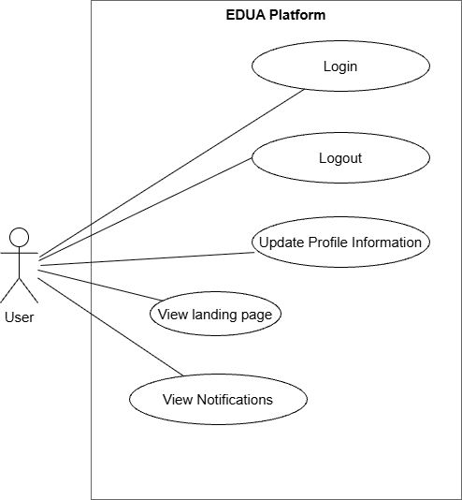

1.3.3.2 UCs for IT Support Staff
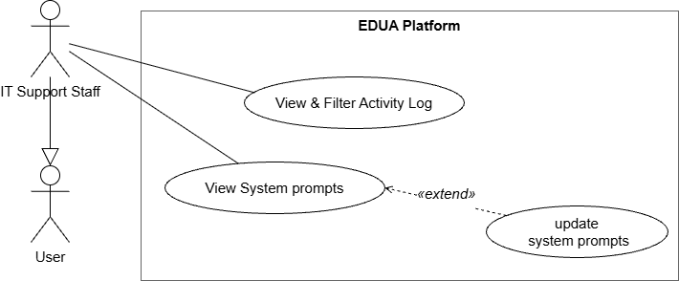

1.3.3.3 UCs for Moderator
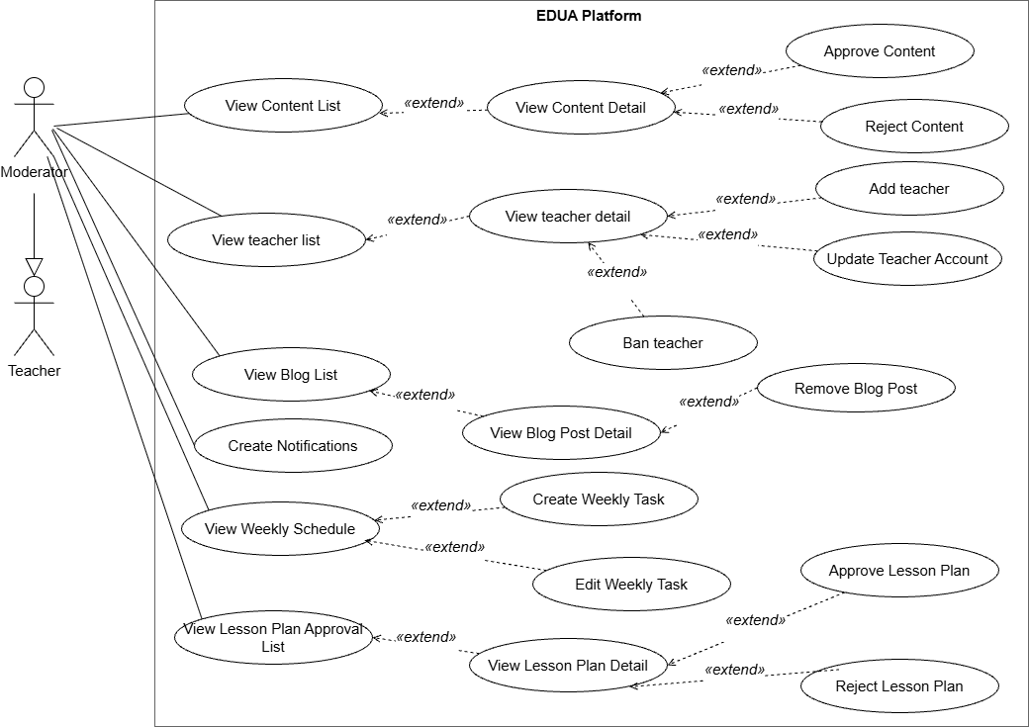

1.3.3.4 UCs for Teacher

1.3.3.4.1 UCs for Math Teacher

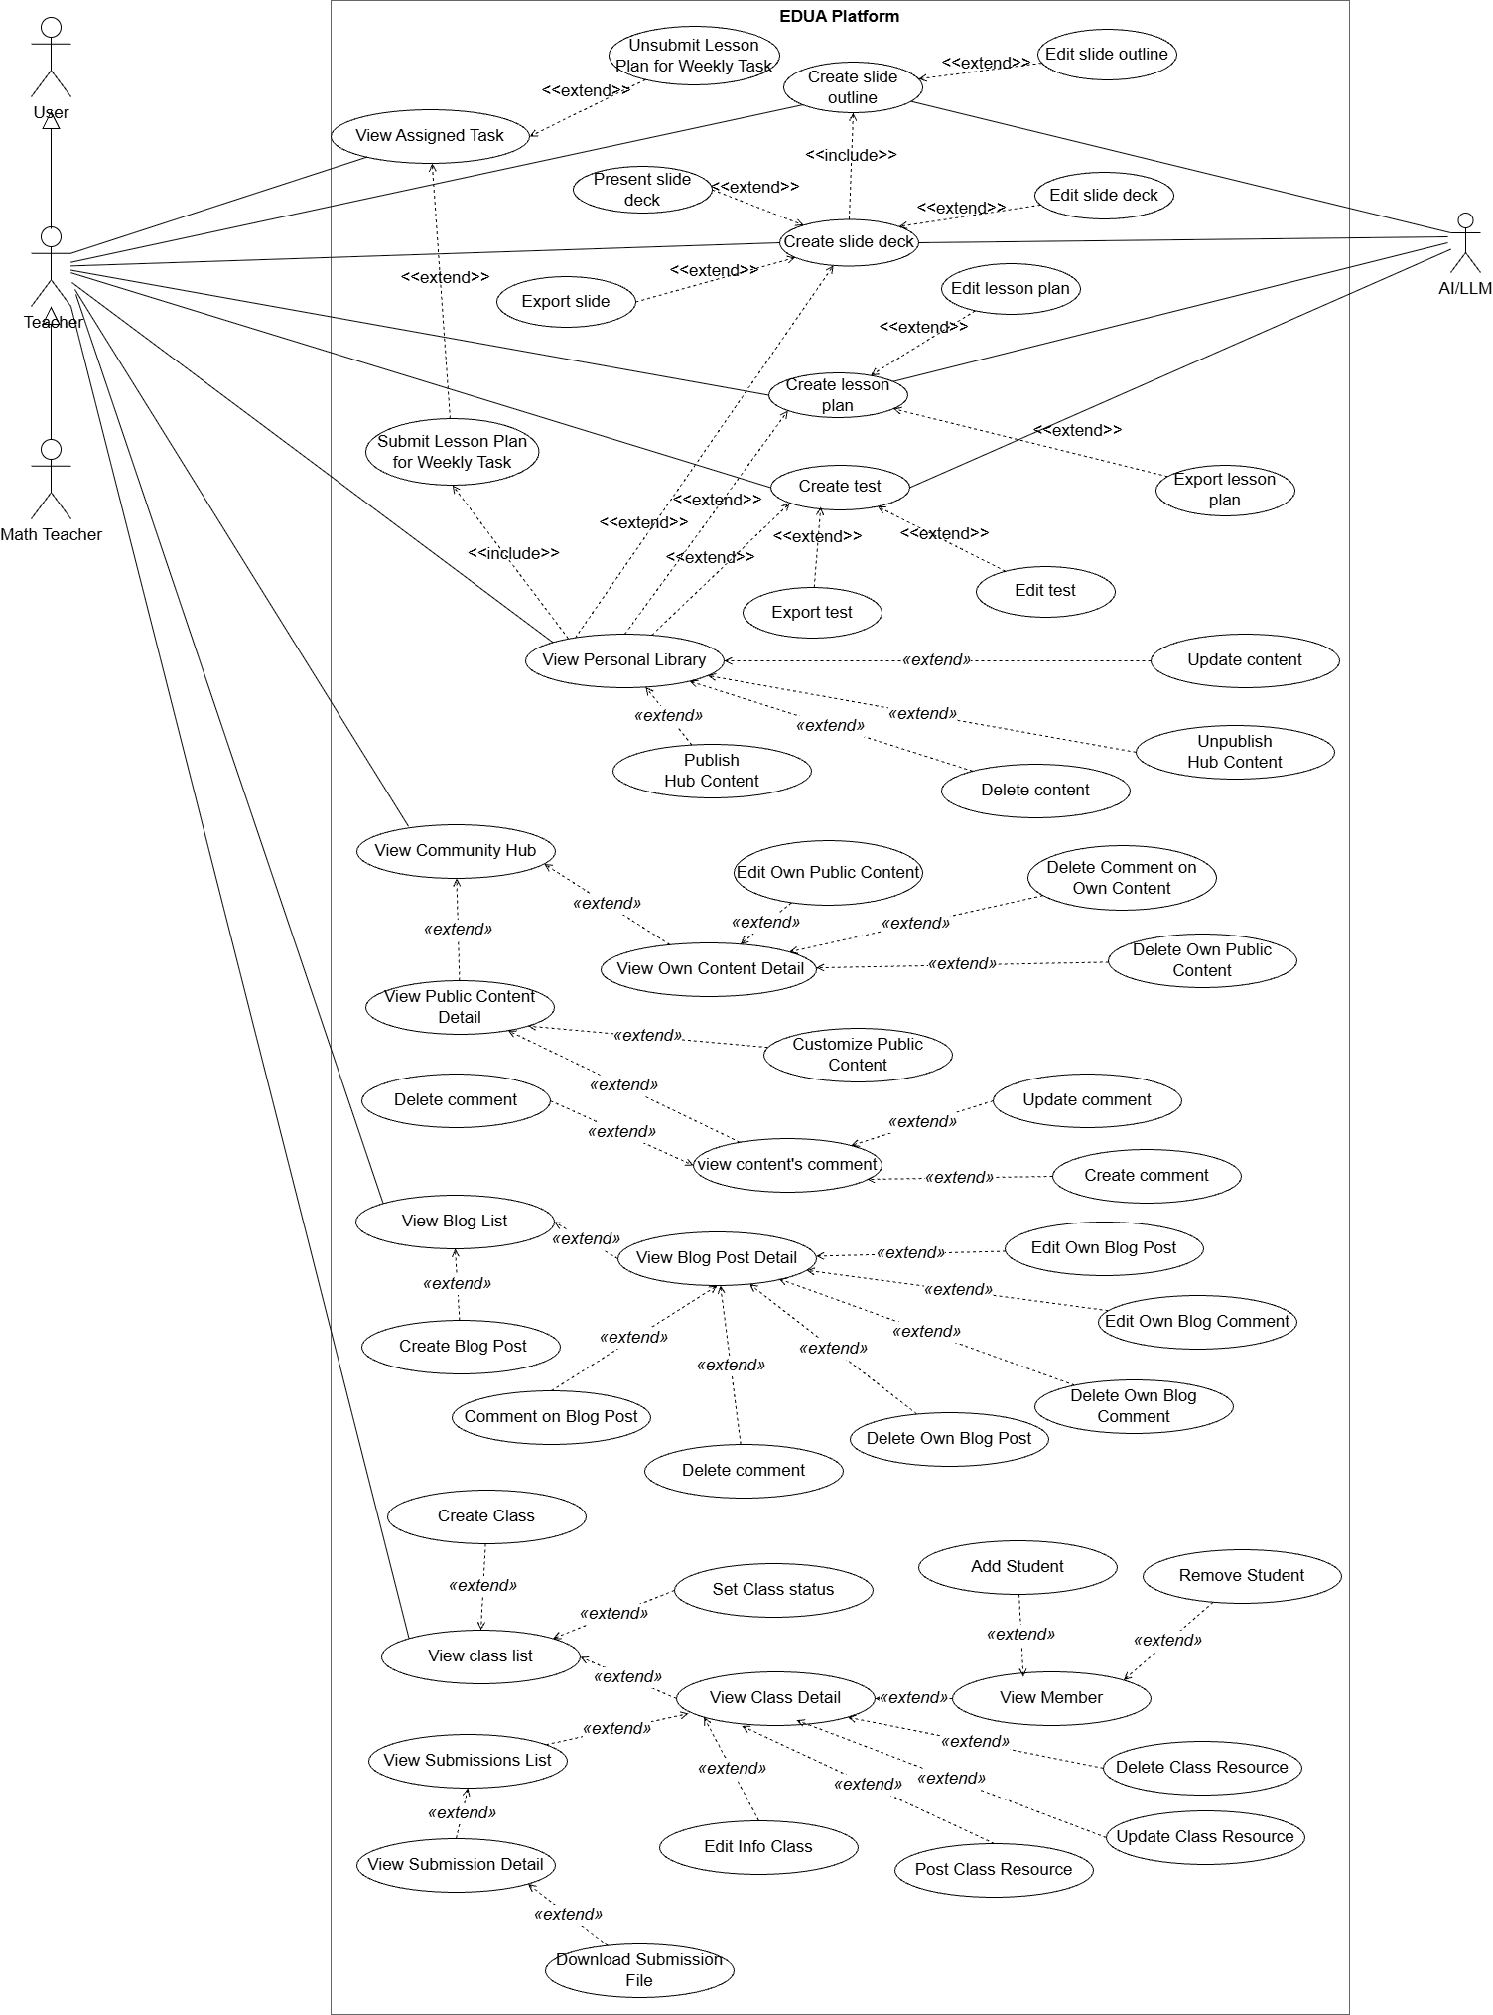

1.3.3.4.2 UCs for Physics Teacher
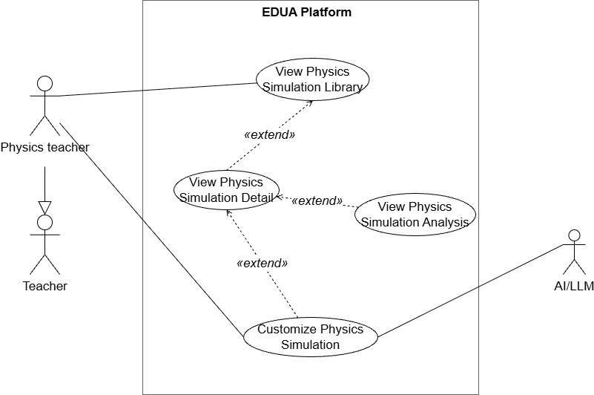

1.3.3.4.3 UCs for Chemistry Teacher
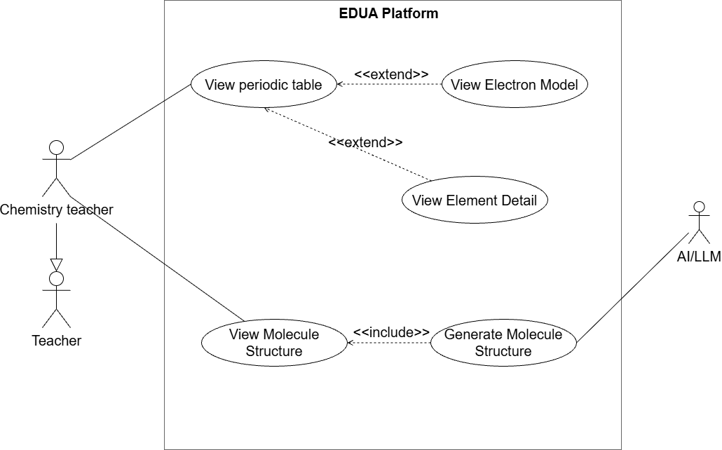

1.3.3.5 UCs for Student
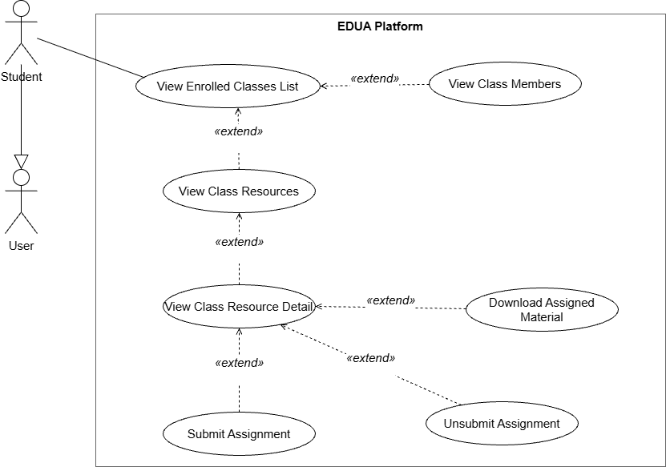

1.3.3.6 UCs for Principle
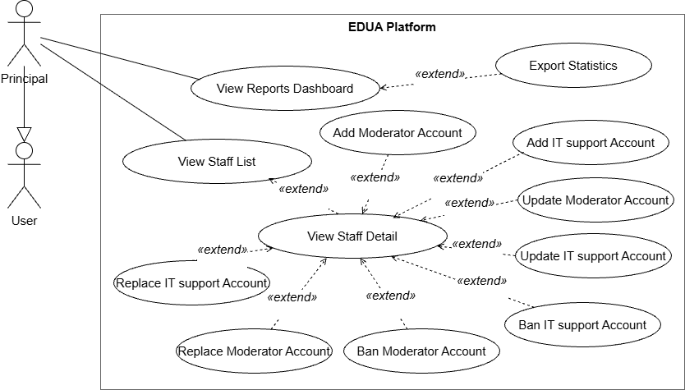

1.4 System Functionalities

1.4.1 Screens Flow

1.4.1.1 Screens Flow for Teacher
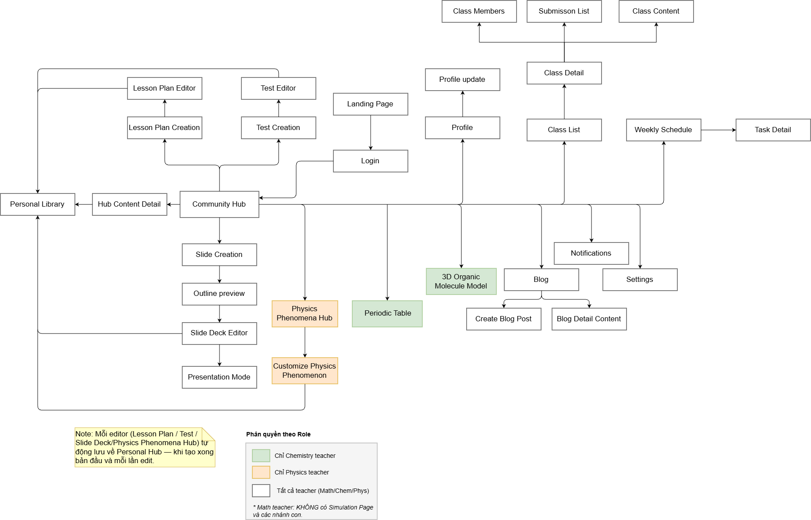

1.4.1.2 Screens Flow for Moderator
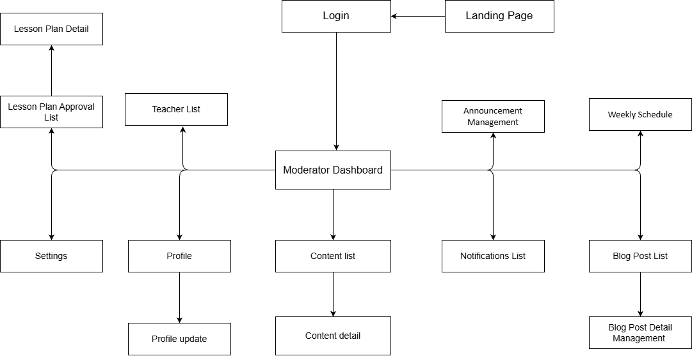

1.4.1.3 Screens Flow for IT Support Staff

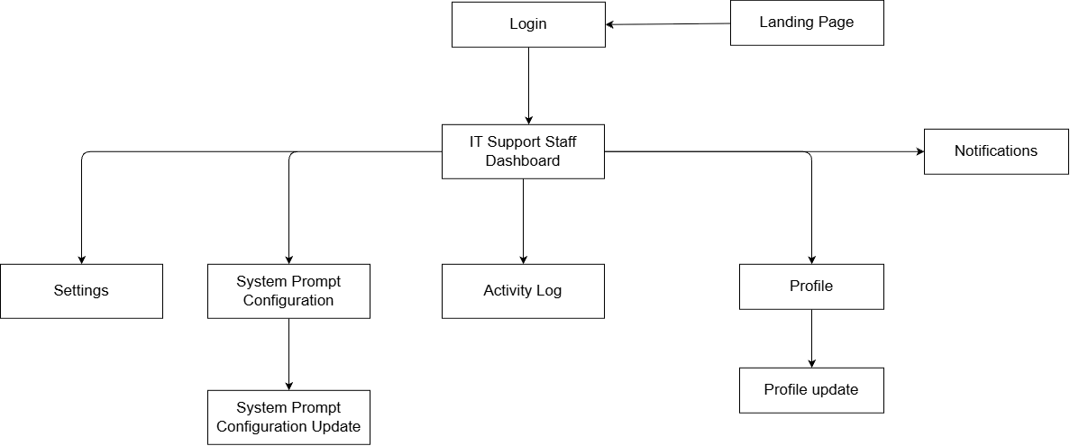

1.4.1.4 Screens Flow for Principle
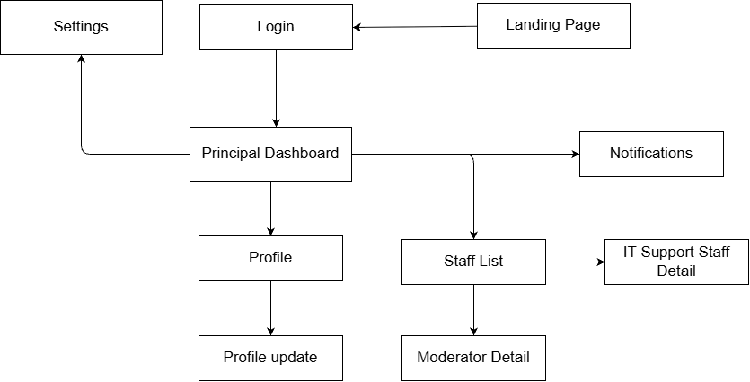

1.4.1.5 Screens Flow for Student
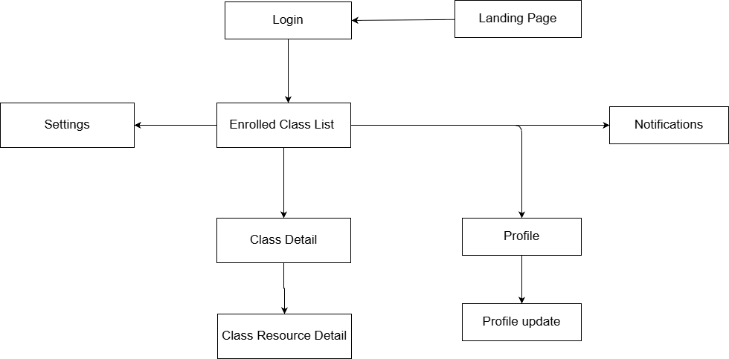

1.4.2 Screen Authorization

Screen | Math Teacher | Chemistry Teacher | Physics Teacher | Moderator | Principal | IT Support Staff | Student
Landing Page | X | X | X | X | X | X | X
Login | X | X | X | X | X | X | X
Settings | X | X | X | X | X | X | X
Profile | X | X | X | X | X | X | X
Profile Update | X | X | X | X | X | X | X
Notifications | X | X | X | X | X | X | X
Community Hub | X | X | X
Hub Content Detail | X | X | X
Personal Library | X | X | X
My Published Content | X | X | X
Lesson Plan Creation | X | X | X
Lesson Plan Editor | X | X | X
Test Creation | X | X | X
Test Editor | X | X | X
Slide Creation | X | X | X
Outline Preview | X | X | X
Slide Deck Editor | X | X | X
Presentation Mode | X | X | X
Periodic Table |  | X
3D Organic Molecule Model |  | X
Physics Phenomena Hub |  |  | X
Customize Physics Phenomenon |  |  | X
Blog | X | X | X
Blog Detail Content | X | X | X
Create Blog Post | X | X | X
Class List | X | X | X
Class Detail | X | X | X |  |  |  | X
Class Members | X | X | X
Submission List | X | X | X
Class Content | X | X | X
Weekly Schedule | X | X | X | X
Enrolled Class List |  |  |  |  |  |  | X
Class Resource Detail |  |  |  |  |  |  | X
Moderator Dashboard |  |  |  | X
Teacher List |  |  |  | X
Content List |  |  |  | X
Content Detail |  |  |  | X
Lesson Plan Approval List |  |  |  | X
Lesson Plan Detail |  |  |  | X
Blog Post List |  |  |  | X
Blog Post Detail Management |  |  |  | X
Announcement Management |  |  |  | X
Principal Dashboard |  |  |  |  | X
Moderator List |  |  |  |  | X
Moderator Detail |  |  |  |  | X
IT Support Staff Detail |  |  |  |  | X
IT Support Staff Dashboard |  |  |  |  |  | X
System Prompt Configuration |  |  |  |  |  | X
Activity Log |  |  |  |  |  | X
System Prompt Configuration Update |  |  |  |  |  | X
Activity Log |  |  |  |  |  | X

1.4.3 Non-UI Functions

# | Feature | System Function | Description
1 | Authentication | Identity Provider Integration | Handles user login via Google OAuth2 and session/token validation, and stores the identity in user_profiles.
2 | Authentication | Role-based Authorization | Resolves the signed-in user's roles from user_roles and enforces screen/feature permissions on every request.
3 | Lesson | AI Lesson Plan Generation | Calls the AI/LLM service (OpenAI/DeepSeek) to generate a draft lesson plan from the selected textbook / chapter / lesson and returns structured content to the Lesson Plan Editor.
4 | Slide | AI Slide Deck Generation | Calls the AI/LLM service to generate a slide deck from a selected lesson plan and returns the slide content to the Slide Deck Editor.
5 | Test | AI Test Generation | Calls the AI/LLM service to generate test questions from a lesson plan or an uploaded lesson file.
6 | Simulation | AI Simulation Refinement | Sends the teacher's prompt to the AI/LLM service to adjust a physics/chemistry simulation and returns the updated simulation parameters.
7 | Personal Library | File Storage Service (Cloudflare R2) | Uploads, stores and serves generated artifacts (lesson plans, slide decks, media) and returns access URLs to the application.
8 | Community Hub | Content Moderation Workflow | Routes content submitted for publishing into the moderation queue (Hub Content Review List) for moderator approval or rejection.
9 | Notifications | Notification Dispatch | Generates and delivers in-app notifications (e.g. content approved/rejected, account status changes) to the relevant users.
10 | Administration | Activity / Audit Logging | Records user and system actions (logins, content changes, moderation decisions, account changes) to the activity log for administrator review.
11 | Lesson / Slide / Test | Asynchronous AI Generation Processing | Queues long-running AI generation requests and processes them asynchronously so the UI can poll for results without blocking the user.
12 | Personal Library | Scheduled Storage Cleanup | Periodic background job that removes temporary and unreferenced files from the storage service (Cloudflare R2) to reclaim space.

1.5 Entity Relationship Diagram
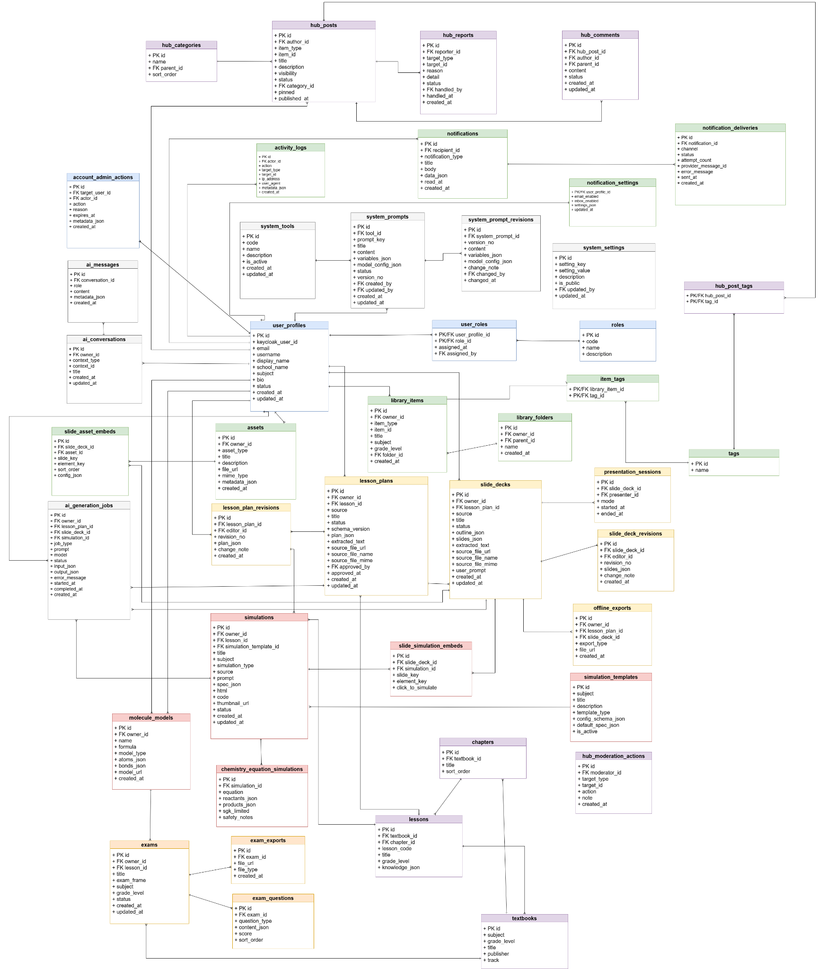


Entities Description

# | Entity | Description
1 | user_profiles | Teacher account profiles (email, username, display name, school, subject, status).
2 | roles | Catalog of system roles defining permission levels (e.g. admin, teacher).
3 | user_roles | Junction table assigning roles to users, with who granted them and when.
4 | textbooks | Textbook catalog organized by subject and grade level.
5 | chapters | Chapters belonging to a textbook, with title and display order.
6 | lessons | Lessons within a textbook/chapter, including lesson code, grade level and knowledge data.
7 | lesson_plans | Teacher-authored lesson plans built from lessons.
8 | lesson_plan_revisions | Version history of lesson plans, tracking each saved change.
9 | slide_decks | Presentation slide decks (title, status, outline/slides data, source file, owner).
10 | slide_deck_revisions | Version history of slide decks, recording each editor's revision and change note.
11 | presentation_sessions | Live presentation/teaching sessions running a slide deck (presenter, mode, start/end time).
12 | offline_exports | Offline export files (e.g. PDF/HTML) generated from lesson plans and slide decks.
13 | assets | Uploaded media assets (images, files) owned by users.
14 | slide_asset_embeds | Junction linking assets embedded into specific slides.
15 | library_folders | Folders that organize a user's content library.
16 | library_items | Items stored in a user's content library.
17 | tags | Catalog of reusable tags/labels.
18 | item_tags | Junction linking library items to tags.
19 | simulations | Interactive simulations created for lessons.
20 | simulation_templates | Reusable templates used to create simulations.
21 | chemistry_equation_simulations | Chemistry equation simulations (balancing/reaction visualisations).
22 | molecule_models | 3D molecule models used in chemistry content.
23 | slide_simulation_embeds | Junction linking simulations embedded into slides.
24 | exams | Exams / tests authored by teachers.
25 | exam_questions | Questions belonging to an exam.
26 | exam_exports | Exported exam files generated for printing/sharing.
27 | hub_categories | Categories used to organize community hub posts.
28 | hub_posts | Community hub posts shared by users.
29 | hub_comments | Comments left on hub posts.
30 | hub_reports | Reports/flags raised against hub content for moderation.
31 | hub_moderation | Moderation records/decisions on community hub content (review actions, status).
32 | hub_post_tags | Junction linking hub posts to tags.
33 | notifications | Notifications generated for users.
34 | notification_settings | Per-user notification preferences.
35 | notification_deliveries | Delivery records of notifications across channels (in-app, email, etc.).
36 | activity_logs | Audit log of user activity across the system.
37 | account_admin_actions | Administrative actions performed on user accounts.
38 | system_tools | Registered system/AI tools available to the platform.
39 | system_prompts | System prompt templates used by AI features.
40 | system_prompt_revisions | Version history of system prompts.
41 | system_settings | Global system configuration settings.
42 | ai_generation_jobs | Records/queue of AI content-generation jobs and their status.
43 | ai_conversations | AI chat conversations between users and the assistant.
44 | ai_messages | Individual messages within an AI conversation.

2. Use Case Specifications

2.1 User Identity

2.1.1 UC-01 - View Landing Page
Primary Actors | User | Secondary Actors | None
Description | As a user, I want to view the public homepage to learn about the platform, its features, and available teaching tools, so that I can decide whether to sign in or explore further.
Preconditions | - The platform is available.  - The user is not required to be signed in to access the landing page (BR-04).
Postconditions | The landing page is displayed with an overview of EDUA's features and a call-to-action to sign in.
Normal Flow | View Landing Page  - The user opens the platform URL.  - The system loads and displays the landing page, including the hero section, feature highlights, demonstration previews, and the Sign in call-to-action.
Alternative Flow | Step 2_Active session exists  - The system detects that the user already has an active session.  - The system does not display the public Landing Page.  - No session data is changed.  - The system redirects the user to the appropriate role-based home screen.  - The use case ends.  Step 2_Content fails to load  - The system cannot load one or more Landing Page assets.  - The system displays the available page content and shows a failure message (MSG25).  - No user or platform data is changed.  - The user may retry loading the Landing Page.  Step 2_User chooses to sign in  - The user selects the Sign in call-to-action.  - The system displays the Login screen.  - No platform session is created at this point.  - The use case ends.

2.1.2 UC-02 - Login
Primary Actors | User | Secondary Actors | Google Identity Service (SSO)
Description | As a user, I want to sign in with my Google account so that I can access the platform according to my assigned role and account status.
Preconditions | The user is not signed in.
Postconditions | - The user is authenticated successfully.  - A user session is established.  - The user is redirected to the appropriate role-based home screen.
Normal Flow | Login  - The system displays the Google sign-in option.  - The user selects Sign in with Google.  - The system redirects the user to Google Identity Service.  - The user completes Google authentication.  - Google Identity Service returns the authentication result to the system.  - The system validates the authentication result.  - The system validates that the account is permitted, Active, and assigned a platform role.  - The system establishes the user session.  - The system shows a successful login message (MSG05).  - The system redirects the user to the workspace corresponding to the assigned role.
Alternative Flow | Step 4_Google authentication is not completed successfully  - Google authentication is cancelled, fails, or returns an invalid authentication result.  - The system does not establish a user session.  - The system returns the user to the Login screen.  - The system shows an authentication-failure message (MSG04).  - The user may retry from Step 2 of the Normal Flow.  Step 4_User cancels Google authentication  - The user cancels or closes the Google authentication process.  - Google Identity Service does not authenticate the user.  - The system returns the user to the Login screen.  - No user session is established.  Step 4_Google authentication fails  - Google Identity Service cannot authenticate the user.  - The system does not establish a user session.  - The system returns the user to the Login screen.  - The system shows an authentication-failure message (MSG04).  - The user may retry from Step 2 of the Normal Flow.  Step 6_Authentication result is invalid  - The system cannot validate the authentication result returned by Google Identity Service (BR-05).  - The system blocks the login attempt.  - No user session is established.  - The system shows an authentication-failure message (MSG04).  - The user may retry from Step 2 of the Normal Flow.  Step 6_Invalid authentication token  - The authentication token is invalid, expired, or cannot be verified (BR-05).  - The system blocks the login attempt.  - No user session is established.  - The system shows an authentication-failure message (MSG04).  - The user may retry from Step 2 of the Normal Flow.  Step 7_Account is not permitted  - The system determines that the authenticated Google account has not been granted platform access (BR-06).  - The system blocks the login attempt.  - No user session is established.  - The system shows an access-denied message (MSG04).  Step 7_Account is Inactive  - The system determines that the account has Inactive status (BR-06).  - The system blocks the login attempt.  - No user session is established.  - The system shows an access-denied message (MSG04).  Step 7_Account has no assigned role  - The system determines that the account does not have an assigned platform role (BR-03).  - The system blocks the login attempt.  - No user session is established.  - The system informs the user that the account has not been assigned a platform role.

2.1.3 UC-03 - Logout
Primary Actors | User | Secondary Actors
Description | As a permission-granted user, I want to log out of the system so that my session is securely terminated and my account access is cleared on the device.
Preconditions | The user is signed in (BR-04) and has an active session.
Postconditions | - The current user session is terminated.  - The public landing page is displayed.
Normal Flow | Logout  - The user opens the account menu.  - The system displays the available account actions.  - The user selects Log out.  - The system terminates the current user session.  - The system shows a successful logout message (MSG19).  - The system redirects the user to the public landing page.
Alternative Flow | Step 4_Session already expired  - The system determines that the current session is no longer active.  - The system does not attempt to terminate the session again.  - The system redirects the user to the public landing page.  Step 4_Logout request fails  - The system cannot complete the logout operation.  - The current session remains active.  - The system shows a failure message (MSG25).  - The user may retry from Step 3 of the Normal Flow.

2.1.4 UC-04 - Update Profile Information
Primary Actors | User | Secondary Actors | File Storage Service
Description | As a user, I want to view and update my personal profile information (such as display name, avatar, school, and subject) so that my account stays accurate.
Preconditions | - The user is signed in.  - The user is on the Profile screen.
Postconditions | - The updated profile information is saved successfully.  - The assigned platform role remains unchanged.
Normal Flow | Update Profile Information  - The system displays the user’s current profile information.  - The user edits one or more permitted profile fields.  - The user selects Save.  - The system validates the entered profile information (BR-24).  - The system saves the valid profile changes.  - The system shows a success message (MSG08).  - The system refreshes the Profile screen with the updated information.
Alternative Flow | Step 2_User changes avatar  - The user selects the option to change the current avatar.  - The system displays the avatar file-selection function.  - The user selects an avatar image.  - The system validates the selected file type and size.  - The File Storage Service uploads the valid avatar.  - The system adds the uploaded avatar to the current profile changes.  - No profile information is saved at this step.  - The flow returns to Step 2 of the Normal Flow.  Step 5_Required field is missing  - The system detects that a required field is empty.  - The system blocks the save operation.  - The system highlights the invalid field.  - The system shows a validation message (MSG02).  - The user may correct the field and retry from Step 4 of the Normal Flow.  Step 2_Invalid avatar file  - The avatar file does not meet the permitted file-type or file-size requirements.  - The system rejects the file.  - The system shows a file-validation message.  - The user may select another file and retry from Step 6 of the Normal Flow.  Step 2_Avatar upload fails  - The File Storage Service cannot upload the avatar.  - The system keeps the user's other profile changes in the form.  - The system shows a failure message (MSG25).  - The user may retry the upload.  Step 2_Avatar file is invalid  - The selected avatar does not satisfy the supported file-type or file-size rules.  - The system rejects the selected file.  - The current avatar remains unchanged.  - The system shows a file-validation message.  - The user may select another file and retry from Step 2 of this Alternative Flow.  Step 5_Save fails  - The system cannot save the updated profile information.  - The system keeps the user's edits in the form.  - The system shows a failure message (MSG25).  - The user may retry from Step 4 of the Normal Flow.

2.2 Lesson Plan

2.2.1 UC-05 - Create Lesson Plan
Primary Actors | Teacher | Secondary Actors | AI/LLM Service; File Storage Service
Description | As a teacher, I want to generate a lesson plan from selected textbook content so that I can prepare a MOET-5512 lesson efficiently.
Preconditions | - The teacher is signed in (BR-04).  - The teacher can select a valid Subject, Grade, Lesson, and knowledge target (BR-07).
Postconditions | - A MOET-5512 lesson plan is generated (BR-08).  - The generated plan is saved to the teacher's Personal Library as Draft (BR-15, BR-19).
Normal Flow | Create Lesson Plan  - The teacher opens the lesson-plan creation screen.  - The teacher selects the Subject, Grade, Lesson, and knowledge units.  - The teacher requests lesson-plan generation.  - The system validates the selected content target (BR-07).  - The system sends the valid generation request to the AI/LLM Service.  - The system displays MSG06.  - The AI/LLM Service returns a MOET-5512 lesson plan (BR-08).  - The system validates the generated content.  - The system saves the lesson plan to the teacher's Personal Library as Draft (BR-15, BR-19).  - The system shows MSG14.  - The system opens the generated plan for review.
Alternative Flow | Step 3_Add a reference document  - The teacher selects a supported reference document.  - The system validates the file type and size (BR-09, BR-10).  - The File Storage Service stores the valid file.  - The system includes the document as additional generation context.  - The flow continues at Step 3 of the Normal Flow.  Step 3_Add an AI instruction  - The teacher enters an additional generation instruction.  - The system includes the instruction in the generation request.  - The flow continues at Step 3 of the Normal Flow.  Step 4_Required content target is missing  - The system highlights the missing selection.  - No AI request is sent and no lesson plan is created.  - The system shows MSG02.  - The teacher may complete the target and retry from Step 3 of the Normal Flow.  Step 4_Selected content target is invalid  - No AI request is sent and no lesson plan is created.  - The system informs the teacher that the selected target is invalid.  - The teacher may correct the target and retry from Step 3 of the Normal Flow.  Step 5_AI generation fails  - The AI/LLM Service returns an error or times out.  - No lesson plan is created or saved.  - The system shows MSG07.  - The teacher may retry from Step 3 of the Normal Flow.  Step 8_Generated content is invalid  - The system cannot process the generated content.  - No lesson plan is saved.  - The system shows MSG07.  - The teacher may retry from Step 3 of the Normal Flow.  Step 9_Save fails  - No new lesson plan is stored.  - The system keeps the generated content available for retry.  - The system shows MSG25.  - The teacher may retry saving.

2.2.2 UC-06 - Edit Lesson Plan
Primary Actors | Teacher | Secondary Actors | AI/LLM Service
Description | As a teacher, I want to edit a generated lesson plan manually or through an AI prompt so that I can refine its content before using it.
Preconditions | The teacher is signed in and a lesson plan owned by the teacher is open in the Lesson Plan Editor.
Postconditions | - The updated lesson plan is saved successfully.  - The applicable lifecycle transition is performed according to BR-23.  - The last valid saved version remains available if an update operation fails.
Normal Flow | Edit Lesson Plan  - The system displays the current lesson plan in the Lesson Plan Editor.  - The teacher edits one or more lesson-plan sections, activities, objectives, or other content.  - The system validates the updated lesson-plan content.  - The system auto-saves the valid changes to the teacher's Personal Library (BR-19).  - The system applies the applicable lifecycle transition according to BR-23.  - The system shows a success message (MSG08).
Alternative Flow | Step 2_Edit by using an AI prompt  - The teacher enters an AI prompt describing the requested changes.  - The system validates the prompt.  - The system sends the current lesson-plan content and prompt to the AI/LLM Service.  - The system shows a generation-in-progress message (MSG06).  - The AI/LLM Service returns the revised content.  - The system applies the revisions to the lesson plan.  - The flow resumes at Step 3 of the Normal Flow.  Step 2_AI revision fails  - The AI/LLM Service returns an error, times out, or returns an unusable response.  - The system keeps the last valid version of the lesson plan.  - The system shows a failure message (MSG07).  - The teacher may retry the AI revision.  Step 3_Updated content is invalid  - The system detects invalid or missing lesson-plan content.  - The system highlights the affected fields or sections.  - The system does not save the invalid changes.  - The teacher may correct the content and retry.  Step 4_Auto-save fails  - The system cannot save the updated lesson plan.  - The system keeps the current edits in the editor.  - The system shows a failure message (MSG25).  - The teacher may retry saving.

2.2.3 UC-07 - Export Lesson Plan
Primary Actors | Teacher | Secondary Actors | File Storage Service
Description | As a teacher, I want to export a lesson plan to a downloadable file (PDF/Word) so that I can use it outside the system.
Preconditions | The teacher is signed in and has access to a lesson plan available for export.
Postconditions | The lesson plan is downloaded to the teacher's device in the chosen format; the stored lesson plan is unchanged.
Normal Flow | Export Lesson Plan  - The teacher selects the Export action for a lesson plan.  - The system displays the available export formats.  - The teacher selects PDF or Word.  - The system generates the lesson-plan file in the selected format.  - The system makes the generated file available for download.  - The teacher downloads the file to their device.  - The system shows a successful export message (MSG18).
Alternative Flow | Step 4_File generation fails  - The system cannot generate the requested export file.  - The system shows a failure message (MSG25).  - The teacher may retry from Step 1 of the Normal Flow.  Step 6_Download fails  - The generated file cannot be downloaded to the teacher's device.  - The system keeps the generated file available.  - The system shows a failure message (MSG25).  - The teacher may retry the download.

2.3 Personal Library

2.3.1 UC-08 - View Personal Library
Primary Actors | Teacher | Secondary Actors
Description | As a teacher, I want to open my Personal Library to view and manage all the teaching content I have created (lesson plans, slide outlines, slide decks, tests, and supported customized physics simulations), so that I can find and reuse my own materials.
Preconditions | The teacher is signed in (BR-04).
Postconditions | The teacher's Personal Library is displayed with their owned content items, supporting search, filter, and selection.
Normal Flow | View Personal Library  - The teacher opens the Personal Library from the main navigation.  - The system retrieves all content items owned by the teacher.  - The system displays the content items grouped by content type, together with each item's applicable status.
Alternative Flow | Step 2_Personal Library is empty  - The system finds no content items owned by the teacher.  - The system displays an empty-state message (MSG01).  - The system displays an option to create new content.  - The use case ends.  Step 3_Teacher searches or filters content  - The teacher enters a search keyword or applies one or more filters.  - The system retrieves the matching content items.  - The system refreshes the Personal Library list.  - The flow returns to Step 4 of the Normal Flow.  Step 3_Search returns no results  - No content items match the selected search or filter criteria.  - The system displays an empty-state message (MSG01).  - The teacher may change or remove the search and filter criteria.  Step 3_Teacher selects a content item  - The teacher selects a content item from the Personal Library.  - The system retrieves the selected item.  - The system opens the corresponding content-detail screen.  - No content data is modified.

2.3.2 UC-09 - Update Content
Primary Actors | Teacher | Secondary Actors
Description | As a teacher, I want to update the content of a resource I own to keep it current, so that my Personal Library always reflects the latest version.
Preconditions | - The teacher is signed in (BR-04).  - The selected content item exists, is owned by the teacher, and has an editable Publish Status (BR-16, BR-23).
Postconditions | - The valid content changes are saved successfully.  - The applicable Publish Status transition is handled according to BR-23 and the Publish Status State Diagram.  - If the update operation fails, the last valid saved version remains available.
Normal Flow | Update Content  - The teacher selects the Edit action for a content item.  - The system verifies that the content item exists, belongs to the teacher, and has an editable Publish Status (BR-16, BR-23).  - The system opens the appropriate content editor with the current content loaded.  - The teacher modifies the content.  - The system periodically auto-saves valid changes (BR-19).  - The teacher selects Save or Done to complete the editing session.  - The system validates the current content.  - The system saves the valid changes and applies the applicable Publish Status rule (BR-23).  - The system shows a success message (MSG08).
Alternative Flow | Step 1_Edit from content detail  - The teacher opens the content detail screen and selects Edit.  - The flow continues at Step 2 of the Normal Flow.  Step 2_Content is unavailable or not owned  - The system blocks editing.  - No stored content is changed.  - The system informs the teacher that the content is unavailable or access is not permitted.  - The use case ends.  Step 2_Content is Pending Publish  - The system blocks editing according to BR-23.  - The content and Hub moderation request remain unchanged.  - The system informs the teacher that the content must be unpublished before editing.  - The use case ends.  Step 7_Content is invalid  - The system blocks final saving and highlights the invalid fields or sections.  - The previously stored version remains unchanged.  - The teacher may correct the content and retry from Step 6 of the Normal Flow.  Step 8_Save fails  - The system cannot save the changes.  - The previously stored version remains unchanged and the current edits remain in the editor.  - The system shows MSG25.  - The teacher may retry from Step 6 of the Normal Flow.

2.3.3 UC-10 - Delete Content
Primary Actors | Teacher | Secondary Actors
Description | As a teacher, I want to delete one of my own content items, so that I can remove it from my Personal Library.
Preconditions | The teacher is signed in (BR-04), owns the content item (BR-16), and is on the Personal Library or content detail screen.
Postconditions | - The selected content item is removed from the teacher's Personal Library.  - The item is no longer accessible from the Personal Library.  - Any existing published Community Hub version remains unchanged (BR-32).
Normal Flow | Delete Content  - The teacher selects Delete for a content item in the Personal Library.  - The system verifies that the item exists, belongs to the teacher, and is eligible for deletion under its current lifecycle and dependency rules (BR-16, BR-23).  - The system displays a confirmation popup (MSG09).  - The teacher confirms the deletion.  - The system removes the item from the Personal Library while leaving any separate Published Community Hub version unchanged (BR-32).  - The system shows MSG10 and refreshes the Personal Library.
Alternative Flow | Step 1_Delete from content detail  - The teacher opens the owned content detail screen and selects Delete.  - The flow continues at Step 2 of the Normal Flow.  Step 2_Content is unavailable or not owned  - The system blocks deletion.  - No stored content is changed.  - The system informs the teacher that the content is unavailable or access is not permitted.  - The use case ends.  Step 2_Content is Pending Publish  - The system blocks deletion according to BR-23.  - The content and moderation request remain unchanged.  - The system informs the teacher that the content must be unpublished before deletion.  - The use case ends.  Step 2_Deletion is blocked by a dependency  - The system blocks deletion and leaves the content unchanged.  - The system informs the teacher why the item cannot be deleted.  - The use case ends.  Step 3_Content has a Published Community Hub version  - The system adds a warning to the confirmation popup stating that deleting the Personal Library item will not remove the Published Hub version (BR-32).  - The flow continues at Step 4 of the Normal Flow.  Step 4_Teacher cancels deletion  - The system closes the confirmation popup.  - No stored content is changed.  - The use case ends.  Step 5_Delete operation fails  - The Personal Library item and any Published Hub version remain unchanged.  - The system shows MSG25.  - The teacher may retry from Step 1 of the Normal Flow.

2.4 Presentation

2.4.1 UC-11 - Create Slide Outline
Primary Actors | Teacher | Secondary Actors | AI/LLM Service; File Storage Service
Description | As a teacher, I want to generate a slide outline so that I can organize the presentation before creating the full slide deck.
Preconditions | - The teacher is signed in (BR-04).  - The slide-outline generation feature is available.
Postconditions | - A structured slide outline preview is generated.  - The latest valid preview is available for review and subsequent slide-deck generation.  - No Slide Outline item is created in the Personal Library.
Normal Flow | Create Slide Outline  - The teacher opens an owned lesson plan and selects Create Slide Outline.  - The system verifies that the lesson plan exists and belongs to the teacher (BR-16).  - The teacher confirms the outline generation request.  - The system sends the lesson-plan content to the AI/LLM Service (BR-13).  - The AI/LLM Service returns a structured slide outline.  - The system validates the generated outline.  - The system presents the generated outline as the current Slide Outline Preview.  - The system shows MSG17.
Alternative Flow | Step 1_Use an external document as the source  - The teacher opens the slide-outline generation screen and uploads a supported external document.  - The system validates the document type and size (BR-09, BR-10).  - The File Storage Service makes the valid document available for processing.  - The system uses the uploaded document as the outline source.  - The flow continues at Step 3 of the Normal Flow.  Step 1_External document is invalid  - The system blocks the upload.  - No AI request is sent and no slide outline is created.  - The system shows MSG13.  - The teacher may select another document and retry from Step 1 of the Normal Flow.  Step 1_Document upload fails  - The File Storage Service cannot make the document available.  - No AI request is sent and no slide outline is created.  - The system shows MSG25.  - The teacher may retry the upload.  Step 2_Selected lesson plan is unavailable  - The system cannot find the selected lesson plan or the teacher no longer owns it.  - The system stops the operation.  - No slide outline is created.  - The system informs the teacher that the selected lesson plan is unavailable.  - The use case ends.  Step 3_Teacher cancels generation  - The system closes the confirmation popup.  - No AI request is sent and no slide outline is created.  - The use case ends.  Step 5_AI generation fails  - The AI/LLM Service returns an error or times out.  - The system stops the generation process.  - No slide outline is created or saved.  - The system shows a failure message (MSG07).  - The teacher may retry from Step 3 of the Normal Flow.  Step 6_Generated outline is invalid  - The system cannot process the generated outline.  - No slide outline is saved.  - The system shows a failure message (MSG07).  - The teacher may retry from Step 3 of the Normal Flow.

2.4.2 UC-12 - Edit Slide Outline
Primary Actors | Teacher | Secondary Actors | AI/LLM Service
Description | As a teacher, I want to edit the generated slide outline so that I can adjust the structure before generating the slide deck.
Preconditions | The teacher is signed in (BR-04) and has a slide outline open in the Slide Outline Preview.
Postconditions | The latest valid slide outline becomes the current preview used for subsequent slide-deck generation (BR-13).  No Slide Outline item is created in the Personal Library.
Normal Flow | Edit Slide Outline  - The system displays the current slide outline in the Slide Outline Preview.  - The teacher edits the outline manually by adding, removing, renaming, or reordering outline items.  - The system validates the updated outline.  - The system updates the current Slide Outline Preview.  - The system shows MSG08.
Alternative Flow | Step 2_Edit by using an AI prompt  - The teacher enters an AI prompt describing the requested outline changes.  - The system sends the current outline and prompt to the AI/LLM Service.  - The system shows MSG06.  - The AI/LLM Service returns the revised outline.  - The system applies the returned changes.  - The flow continues at Step 3 of the Normal Flow.  Step 2_AI revision fails  - The AI/LLM Service returns an error, times out, or returns an unusable response.  - The current outline preview remains unchanged.  - The system shows MSG07.  - The teacher may retry the AI revision.  Step 3_Outline is invalid  - The system does not update the preview and highlights the affected items.  - The current valid preview remains unchanged.  - The teacher may correct the outline and retry from Step 2 of the Normal Flow.  Step 4_Preview update fails  - The system cannot apply the validated changes to the preview.  - The previous preview remains unchanged and the current edits remain available.  - The system shows MSG25.  - The teacher may retry from Step 2 of the Normal Flow.

2.4.3 UC-13 - Create Slide Deck
Primary Actors | Teacher | Secondary Actors | AI/LLM Service; File Storage Service
Description | As a teacher, I want to generate a slide deck from a slide outline with AI assistance so that I can prepare presentation slides quickly.
Preconditions | The teacher is signed in and a valid slide outline is available in the Slide Outline Preview.
Postconditions | - A slide deck is generated successfully.  - The slide deck is displayed in the Slide Deck Editor.  - The slide deck is auto-saved to the teacher's Personal Library with status Draft (BR-15, BR-19).
Normal Flow | Create Slide Deck  - The teacher confirms the current slide outline.  - The teacher submits the slide-deck generation request.  - The system validates the confirmed slide outline (BR-13).  - The system sends the outline and related lesson content to the AI/LLM Service.  - The system shows a generation-in-progress message (MSG06).  - The AI/LLM Service returns the generated slide content.  - The system validates and renders the slide deck in the Slide Deck Editor.  - The system auto-saves the slide deck to the teacher's Personal Library with status Draft (BR-15, BR-19).  - The system shows a successful generation message (MSG16).
Alternative Flow | Step 3_Slide outline is invalid  - The system determines that the slide outline is incomplete or invalid.  - The system blocks slide-deck generation.  - The system directs the teacher to correct the outline.  - The teacher may retry from Step 1 of the Normal Flow.  Step 6_AI generation fails  - The AI/LLM Service returns an error, times out, or returns an unusable response.  - The system shows a failure message (MSG07).  - The teacher may retry from Step 2 of the Normal Flow.  Step 8_Auto-save fails  - The system cannot save the generated slide deck.  - The system keeps the generated deck open in the editor.  - The system shows a failure message (MSG25).  - The teacher may retry saving.

2.4.4 UC-14 - Edit Slide Deck
Primary Actors | Teacher | Secondary Actors | AI/LLM Service
Description | As a teacher, I want to edit a generated slide deck manually or via an AI prompt so that I can refine the slides before presenting.
Preconditions | The teacher is signed in and a slide deck owned by the teacher is open in the Slide Deck Editor.
Postconditions | - The updated slide deck is saved successfully.  - The applicable lifecycle transition is performed according to BR-23.  - The last valid saved version remains available if an update operation fails.
Normal Flow | Edit Slide Deck  - The system displays the current slide deck in the Slide Deck Editor.  - The teacher edits slide text, images, layout, or slide order.  - The system validates the updated slide content.  - The system auto-saves the valid changes (BR-19).  - The system applies the applicable lifecycle transition according to BR-23.  - The system shows a success message (MSG08).
Alternative Flow | Step 2_Edit by using an AI prompt  - The teacher enters an AI prompt describing the requested slide changes.  - The system sends the selected slide content and prompt to the AI/LLM Service.  - The system shows a generation-in-progress message (MSG06).  - The AI/LLM Service returns the revised slide content.  - The system applies the returned changes to the slide deck.  - The flow resumes at Step 3 of the Normal Flow.  Step 2_AI revision fails  - The AI/LLM Service returns an error, times out, or returns an unusable response.  - The system keeps the last valid slide-deck version.  - The system shows a failure message (MSG07).  - The teacher may retry the AI revision.  Step 3_Updated slide content is invalid  - The system detects invalid or incomplete slide content.  - The system highlights the affected slides or components.  - The system does not save the invalid changes.  - The teacher may correct the slide content and retry.  Step 4_Auto-save fails  - The system cannot save the updated slide deck.  - The system keeps the current edits in the editor.  - The system shows a failure message (MSG25).  - The teacher may retry saving.

2.4.5 UC-15 - Present Slide
Primary Actors | Teacher | Secondary Actors
Description | As a teacher, I want to launch an online presentation mode to display my slide deck full-screen with navigation, so that I can teach the lesson in the classroom directly from the platform.
Preconditions | The teacher is signed in and has access to a slide deck available for presentation.
Postconditions | - The presentation session is completed.  - The teacher returns to the slide-deck detail screen or Slide Deck Editor.  - The stored slide deck remains unchanged.
Normal Flow | Present Slide  - The teacher selects the Present action for a slide deck.  - The system loads the slides and embedded assets.  - The system enters full-screen presentation mode.  - The system displays the first slide.  - The teacher navigates through the slide deck using the available controls or keyboard shortcuts.  - The teacher exits presentation mode.  - The system returns the teacher to the slide-deck detail screen or Slide Deck Editor.
Alternative Flow | Step 2_One or more assets fail to load  - The system fails to load one or more embedded assets.  - The system displays placeholders for the unavailable assets.  - The system shows a warning message.  - The presentation continues with the available content.  Step 3_Full-screen mode is unavailable  - The browser denies or does not support full-screen mode.  - The system opens the presentation in a maximized presentation view.  - The flow resumes at Step 4 of the Normal Flow.  Step 5_Teacher interacts with an embedded simulation  - The teacher selects an embedded simulation on the current slide.  - The system activates the simulation within presentation mode.  - The teacher interacts with the simulation.  - The teacher closes or stops the simulation.  - The system returns to the current slide.  - The flow resumes at Step 5 of the Normal Flow.  Step 2_Slide deck cannot be loaded  - The system cannot load the slide deck.  - The system stops the presentation process.  - The system shows a failure message (MSG25).  - The teacher may retry from Step 1 of the Normal Flow.

2.4.6 UC-16 - Export Slide
Primary Actors | Teacher | Secondary Actors | File Storage Service
Description | As a teacher, I want to export a slide deck as an HTML file for offline use, so that I can present or use the slide deck outside the platform.
Preconditions | The teacher is signed in and has access to a slide deck available for export.
Postconditions | - The slide deck is exported successfully in HTML format.  - The exported file is downloaded to the teacher's device.  - The stored slide deck remains unchanged.
Normal Flow | Export Slide  - The teacher selects the Export action for a slide deck.  - The system displays the available export format.  - The teacher selects HTML.  - The system validates that the slide deck is available and can be exported.  - The system generates the HTML export package through the File Storage Service.  - The system makes the generated file available for download.  - The teacher downloads the exported file to their device.  - The system shows a successful export message (MSG18).
Alternative Flow | Step 4_Slide deck is unavailable  - The system determines that the slide deck has been deleted or is no longer accessible.  - The system blocks the export operation.  - The system shows an unavailable-content message.  Step 5_File generation fails  - The system cannot generate the HTML export package.  - The system shows a failure message (MSG25).  - The teacher may retry from Step 1 of the Normal Flow.  Step 7_Download fails  - The generated export file cannot be downloaded to the teacher's device.  - The system keeps the generated file available for download.  - The system shows a failure message (MSG25).  - The teacher may retry the download.

2.5 Test

2.5.1 UC-17 - Create Test
Primary Actors | Teacher | Secondary Actors | AI/LLM Service
Description | As a teacher, I want to generate a test from selected lesson content and assessment constraints so that I can prepare an assessment efficiently.
Preconditions | - The teacher is signed in (BR-04).  - The teacher has selected a valid Subject, Grade, Lesson, and knowledge target (BR-07).
Postconditions | - A test and its answer key are generated.  - The generated test is saved to the teacher's Personal Library as Draft.
Normal Flow | Create Test  - The teacher opens the test creation screen.  - The teacher selects the Subject, Grade, Lesson, and knowledge units.  - The teacher enters the test frame, number of questions, difficulty level, and question types (BR-12, BR-31).  - The teacher requess test generation.  - The system validates the content target and test configuration.  - The system sends the validated configuration to the AI/LLM Service.  - The AI/LLM Service returns a test and answer key.  - The system validates the generated test.  - The system saves the test and answer key to the teacher's Personal Library as Draft (BR-15).  - The system shows a successful generation message (MSG15).  - The system opens the test for review.
Alternative Flow | Step 2_Add a reference document  - The teacher uploads a supported reference document.  - The system validates the file type and size (BR-09, BR-10).  - The system includes the valid document as additional generation context.  - The flow continues at Step 3 of the Normal Flow.  Step 5_Required information is missing  - The system detects that required configuration is incomplete.  - The system highlights the affected fields.  - No AI request is sent and no test is created.  - The system shows MSG02.  - The teacher may complete the information and retry from Step 4 of the Normal Flow.  Step 5_Selected content target is invalid  - The system determines that the selected Subject, Grade, Lesson, or knowledge unit is invalid (BR-07).  - No AI request is sent and no test is created.  - The system informs the teacher that the selected content target is invalid.  - The teacher may correct the configuration and retry from Step 4 of the Normal Flow.  Step 6_AI generation fails  - The AI/LLM Service returns an error or times out.  - No test is created or saved.  - The system shows MSG07.  - The teacher may retry from Step 4 of the Normal Flow.  Step 8_Generated test is partially invalid  - The system preserves the valid questions and identifies the invalid or missing questions (BR-40).  - The system asks whether the teacher wants to regenerate only the affected questions (MSG26).  - The teacher may request regeneration of the affected questions.  Step 9_Save fails  - The system cannot save the generated test.  - No new test is stored in the Personal Library.  - The system shows MSG25.  - The teacher may retry saving.

2.5.2 UC-18 - Edit Test
Primary Actors | Teacher | Secondary Actors | AI/LLM Service
Description | As a teacher, I want to edit an owned test so that its questions, answers, scoring, and instructions meet my assessment needs.
Preconditions | - The teacher is signed in (BR-04).  - The selected test exists, is owned by the teacher, and is editable (BR-16, BR-23).
Postconditions | - The valid changes are saved to the test's editable working version.  - The latest valid answer key remains consistent with the saved test.  - The applicable Publish Status transition is handled according to BR-23 and the Publish Status State Diagram.
Normal Flow | Edit Test  - The teacher opens an editable owned test.  - The system verifies the test's existence, ownership, and editable Publish Status (BR-16, BR-23).  - The system displays the test in the editor.  - The teacher edits the questions, answers, scoring information, or instructions.  - The teacher selects Save.  - The system validates the changes and answer-key consistency.  - The system applies the applicable Publish Status transition according to BR-23 and the Publish Status State Diagram.  - The system saves the valid changes.  - The system shows MSG08.  - The system displays the updated test.
Alternative Flow | Step 2_Test is unavailable, not owned, or not editable  - The system blocks editing.  - The stored test remains unchanged.  - The system informs the teacher that the action is unavailable.  - The use case ends.  Step 4_Edit with an AI instruction  - The teacher enters an AI instruction.  - The system sends the current editable content and instruction to the AI/LLM Service.  - The AI/LLM Service returns revised content.  - The system displays the revision in the editor without saving it.  - The flow continues at Step 5 of the Normal Flow.  Step 4_AI revision fails  - The AI/LLM Service returns an error or times out.  - The system keeps the current editor content and stored test unchanged.  - The system shows MSG07.  - The teacher may retry the AI instruction or continue editing manually.  Step 5_Teacher cancels editing  - The system closes the editor after confirming that unsaved changes will be discarded.  - The stored test remains unchanged.  - The use case ends.  Step 6_Changes are invalid  - The system highlights the affected content.  - The stored test remains unchanged.  - The teacher may correct the changes and retry from Step 5 of the Normal Flow.  Step 8_Save fails  - The previously stored test remains unchanged.  - The system keeps the current edits in the editor.  - The system shows MSG25.  - The teacher may retry saving.

2.5.3 UC-19 - Export Test
Primary Actors | Teacher | Secondary Actors | File Storage Service
Description | As a teacher, I want to export a test and its answer key to a printable file so that I can print and distribute it to students.
Preconditions | The teacher is signed in and has access to a test available for export.
Postconditions | - The test is exported successfully in the selected format.  - The exported file is downloaded to the teacher's device.  - The stored test remains unchanged.
Normal Flow | Export Test  - The teacher selects the Export action for a test.  - The system displays the available export formats.  - The teacher selects the output format (PDF or Word).  - The teacher chooses whether to include the answer key.  - The system generates the printable file through the File Storage Service.  - The system makes the generated file available for download.  - The teacher downloads the exported file.  - The system shows a successful export message (MSG18).
Alternative Flow | Step 1_Open from Personal Library  - The teacher selects a saved test from the Personal Library.  - The flow resumes at Step 2 of the Normal Flow.  Step 5_File generation fails  - The system cannot generate the export file.  - The system shows a failure message (MSG25).  - The teacher may retry from Step 1 of the Normal Flow.  Step 7_Download fails  - The generated file cannot be downloaded.  - The system keeps the generated file available.  - The system shows a failure message (MSG25).  - The teacher may retry the download.

2.6 Blog

2.6.1 UC-20 - View Blog List
Primary Actors | Teacher or Moderator | Secondary Actors
Description | As a teacher or moderator, I want to browse published blog posts so that I can find and read shared discussions.
Preconditions | - The user is signed in (BR-04).
Postconditions | - Published blog posts are displayed with their basic metadata.  - No stored data is changed.
Normal Flow | View Blog List  - The user opens the Blog screen.  - The system retrieves the published blog posts.  - The system displays each post with its title, author, subject tag, and publication date.
Alternative Flow | Step 2_Retrieval fails  - The system cannot retrieve the published blog posts.  - No stored data is changed.  - The system shows MSG25.  - The user may retry loading the Blog screen.  Step 3_No blog posts are available  - The system displays MSG01.  - The use case ends.  Step 3_User selects a blog post  - The system opens the selected Blog Post Detail.  - No stored data is changed.  - The use case ends.

2.6.2 UC-21 - View Blog Post Detail
Primary Actors | Teacher or Moderator | Secondary Actors
Description | As a teacher or moderator, I want to read a published blog post and its discussion so that I can participate according to my permissions.
Preconditions | - The user is signed in (BR-04).  - The user has selected a published blog post.
Postconditions | - The selected blog post and its discussion are displayed.  - Only actions permitted for the current user are available.
Normal Flow | View Blog Post Detail  - The user selects a published blog post.  - The system verifies that the selected blog post exists and remains published.  - The system retrieves the post title, body, author, subject tag, publication date, and comments.  - The system determines the comment, owner, and moderation actions available to the current user (BR-21, BR-30, BR-33).  - The system displays the Blog Post Detail screen and the permitted actions.
Alternative Flow | Step 2_Blog post is unavailable  - The system determines that the selected post no longer exists or is no longer published.  - No stored data is changed.  - The system informs the user that the post is unavailable.  - The system returns to the Blog screen and the use case ends.  Step 3_Content retrieval fails  - The system cannot retrieve the complete blog post or discussion.  - No stored data is changed.  - The system shows MSG25.  - The user may retry from Step 1 of the Normal Flow.

2.6.3 UC-22 - Create Blog Post
Primary Actors | Teacher, Moderator | Secondary Actors
Description | As a teacher or moderator, I want to create and publish a blog post, so that I can share teaching experience, subject knowledge, or classroom ideas with the community.
Preconditions | - The user is signed in (BR-04).  - The user has permission to create blog posts (BR-33).
Postconditions | - A new blog post is created.  - The blog post is published immediately without prior moderation approval (BR-20).  - The published post is visible to users on the platform.
Normal Flow | Create Blog Post  - The user opens the Blog screen.  - The user selects Create Blog Post.  - The system displays the Blog Creation screen.  - The user enters the blog post title and body.  - The user selects one subject tag (BR-20).  - The user selects Publish.  - The system validates the title, body, and subject tag.  - The system creates and publishes the blog post directly (BR-20).  - The system shows a successful operation message (MSG08).  - The system displays the published blog post.
Alternative Flow | Step 7_Required information is missing  - The system detects that the title, body, or subject tag is missing.  - The system blocks publication.  - The system highlights the missing fields.  - The system shows a validation message (MSG02).  - The user may complete the required fields and retry from Step 6 of the Normal Flow.  Step 8_Publish fails  - The system cannot create or publish the blog post.  - The system keeps the entered content in the Blog Creation screen.  - The system shows a failure message (MSG25).  - The user may retry from Step 6 of the Normal Flow.

2.6.4 UC-23 - Edit Own Blog Post
Primary Actors | Teacher, Moderator | Secondary Actors
Description | As a teacher or moderator, I want to edit a blog post that I authored, so that I can correct or update its published content.
Preconditions | - The user is signed in (BR-04).  - The user is the author of the selected blog post.  - The selected blog post exists.
Postconditions | - The updated blog post is saved successfully.  - The changes are immediately visible to readers (BR-20).
Normal Flow | Edit Own Blog Post  - The user opens the three-dot menu for one of their own blog posts (BR-33).  - The user selects Edit.  - The system verifies that the user is the author of the selected post.  - The system opens the Blog Editor with the current title, body, and subject tag.  - The user edits the blog post.  - The user selects Save.  - The system validates the required fields.  - The system saves and publishes the updated blog post.  - The system shows MSG08.  - The system displays the updated blog post.
Alternative Flow | Step 1_Edit from blog post detail  - The user opens the detail screen of their own blog post and selects Edit.  - The flow continues at Step 3 of the Normal Flow.  Step 3_User is not the author  - The system blocks editing and leaves the blog post unchanged.  - The system informs the user that the action is not permitted.  - The use case ends.  Step 6_User cancels editing  - The system closes the Blog Editor.  - The published blog post remains unchanged.  - The use case ends.  Step 7_Required information is missing  - The system blocks saving and highlights the missing fields.  - The published blog post remains unchanged.  - The system shows MSG02.  - The user may correct the fields and retry from Step 6 of the Normal Flow.  Step 8_Save fails  - The previously published blog post remains unchanged and the current edits remain in the Blog Editor.  - The system shows MSG25.  - The user may retry from Step 6 of the Normal Flow.

2.6.5 UC-24 - Delete Own Blog Post
Primary Actors | Teacher, Moderator | Secondary Actors
Description | As a teacher or moderator, I want to delete a blog post that I authored, so that I can remove it and its associated discussion from the platform.
Preconditions | - The user is signed in (BR-04).  - The user is the author of the selected blog post.  - The selected blog post exists.
Postconditions | - The selected blog post is deleted.  - All comments associated with the blog post are deleted.  - The blog post is no longer accessible.
Normal Flow | Delete Own Blog Post  - The user opens the three-dot menu for one of their own blog posts (BR-33).  - The user selects Delete.  - The system verifies that the user is the author of the blog post.  - The system displays a confirmation popup (MSG09).  - The user confirms the deletion.  - The system deletes the blog post and all associated comments.  - The system removes the blog post from the displayed Blog list.  - The system shows a successful deletion message (MSG10).
Alternative Flow | Step 1_Delete from blog post detail  - The user opens the detail screen of their own blog post.  - The user selects Delete.  - The flow resumes at Step 3 of the Normal Flow.  Step 3_User is not the author  - The system determines that the user is not the author of the selected blog post.  - The system blocks the delete operation.  - The system shows an access-denied message.  - The use case ends.  Step 5_User cancels deletion  - The user cancels the confirmation popup.  - The system closes the popup.  - The blog post remains unchanged.  - The use case ends.  Step 6_Delete fails  - The system cannot delete the blog post.  - The blog post and its comments remain unchanged.  - The system shows a failure message (MSG25).  - The user may retry from Step 1 of the Normal Flow.

2.6.6 UC-25 - Comment on Blog Post
Primary Actors | Teacher, Moderator | Secondary Actors
Description | As a teacher or moderator, I want to comment on a blog post, so that I can discuss or respond to its content.
Preconditions | - The user is signed in (BR-04).  - The selected blog post exists.  - The user is viewing the Blog Post Detail screen.
Postconditions | - A new comment is added to the blog post.  - The comment is immediately visible in the comment list (BR-22).
Normal Flow | Comment on Blog Post  - The user enters text in the comment field on the Blog Post Detail screen (BR-33).  - The user selects Post.  - The system validates that the comment is not empty.  - The system saves the comment.  - The system displays the new comment with the author's name and timestamp.  - The system shows a successful operation message (MSG08).
Alternative Flow | Step 3_Comment is empty  - The system detects that the comment contains no valid text.  - The system blocks the comment from being posted.  - The system highlights the comment field.  - The system shows a validation message (MSG02).  - The user may enter valid content and retry from Step 2 of the Normal Flow.  Step 4_Blog post no longer exists  - The system determines that the blog post has been deleted.  - The system blocks the comment from being saved.  - The system displays an unavailable-content message.  - The use case ends.  Step 4_Save fails  - The system cannot save the comment.  - The system keeps the entered comment text.  - The system shows a failure message (MSG25).  - The user may retry from Step 2 of the Normal Flow.

2.6.7 UC-26 - Edit Own Blog Comment
Primary Actors | Teacher, Moderator | Secondary Actors
Description | As a teacher or moderator, I want to edit a blog comment that I previously posted, so that I can correct or update its content.
Preconditions | - The user is signed in (BR-04).  - The user is the author of the selected comment (BR-30).  - The user is viewing the Blog Post Detail screen.
Postconditions | - The selected comment is updated successfully.  - The updated comment is immediately visible.
Normal Flow | Edit Own Blog Comment  - The user selects Edit on one of their own comments (BR-33).  - The system verifies that the user is the author of the selected comment (BR-30).  - The system opens the comment in edit mode.  - The user modifies the comment text.  - The user selects Save.  - The system validates that the updated comment is not empty.  - The system saves the updated comment.  - The system displays the updated comment.  - The system shows a successful operation message (MSG08).
Alternative Flow | Step 2_User is not the author  - The system determines that the user is not the author of the selected comment.  - The system blocks the edit operation.  - The system shows an access-denied message.  - The use case ends.  Step 6_Updated comment is empty  - The system detects that the updated comment contains no valid text.  - The system blocks the save operation.  - The system highlights the comment field.  - The system shows a validation message (MSG02).  - The user may correct the comment and retry from Step 5 of the Normal Flow.  Step 7_Save fails  - The system cannot save the updated comment.  - The system keeps the user's edited comment text.  - The system shows a failure message (MSG25).  - The user may retry from Step 5 of the Normal Flow.

2.6.8 UC-27 - Delete Own Blog Comment
Primary Actors | Teacher, Moderator | Secondary Actors
Description | As a teacher or moderator, I want to delete a comment that I previously posted on a blog post, so that I can remove it from the discussion.
Preconditions | - The user is signed in (BR-04).  - The user is the author of the selected comment (BR-30).  - The user is viewing the Blog Post Detail screen.
Postconditions | - The selected comment is deleted.  - The deleted comment is no longer visible in the blog discussion.  - Other comments remain unchanged.
Normal Flow | Delete Own Blog Comment  - The user selects Delete on one of their own comments (BR-33).  - The system verifies that the user is the author of the selected comment (BR-30).  - The system displays a confirmation popup (MSG09).  - The user confirms the deletion.  - The system deletes the selected comment.  - The system removes the comment from the displayed comment list.  - The system shows a successful deletion message (MSG10).
Alternative Flow | Step 2_User is not the author  - The system determines that the user is not the author of the selected comment.  - The system blocks the delete operation.  - The system shows an access-denied message.  - The use case ends.  Step 4_User cancels deletion  - The user cancels the confirmation popup.  - The system closes the popup.  - The selected comment remains unchanged.  - The use case ends.  Step 5_Delete fails  - The system cannot delete the selected comment.  - The comment remains visible.  - The system shows a failure message (MSG25).  - The user may retry from Step 1 of the Normal Flow.

2.6.9 UC-28 - Delete Comment on Own Blog Post
Primary Actors | Teacher or Moderator | Secondary Actors | None
Description | As a blog-post author, I want to remove an inappropriate comment from my own post so that I can moderate the discussion attached to my content.
Preconditions | - The user is signed in (BR-04).  - The selected blog post and comment exist.  - The current user authored the selected blog post.
Postconditions | - The selected comment is removed from the blog discussion.  - The removal reason is recorded.
Normal Flow | Delete Comment on Own Blog Post  - The blog-post author selects a comment on their own post and chooses Delete.  - The system verifies that the post and comment exist and that the current user authored the post (BR-30).  - The system displays a confirmation popup and requires a removal reason.  - The blog-post author enters the reason and confirms deletion.  - The system validates the removal reason.  - The system removes the comment and records the reason.  - The system shows a successful deletion message (MSG10).  - The system refreshes the discussion.
Alternative Flow | Step 2_Post or comment is unavailable  - The system cannot find the selected post or comment.  - No discussion data is changed.  - The system informs the user that the selected item is unavailable.  - The use case ends.  Step 2_User does not own the blog post  - The system determines that the current user is not the author of the selected post.  - The system blocks the deletion.  - The comment remains unchanged.  - The system informs the user that the action is not permitted.  - The use case ends.  Step 4_User cancels deletion  - The system closes the confirmation popup.  - The comment remains unchanged and no removal reason is recorded.  - The use case ends.  Step 5_Removal reason is missing  - The system highlights the reason field.  - The comment remains unchanged.  - The system shows MSG02.  - The user may enter a reason and retry from Step 4 of the Normal Flow.  Step 6_Delete fails  - The system cannot remove the comment.  - The comment remains visible and no removal record is created.  - The system shows MSG25.  - The user may retry from Step 4 of the Normal Flow.

2.7 Class

2.7.1 UC-29 - View Class List
Primary Actors | Teacher | Secondary Actors | None
Description | As a teacher, I want to view owned classes so that I can review and manage my classes.
Preconditions | The teacher is signed in (BR-04).
Postconditions | - The system displays owned classes within the current user's permitted scope.  - No stored data is changed.
Normal Flow | View Class List  - The teacher opens the Class List.  - The system retrieves classes owned by the teacher (BR-34).  - The system displays the owned classes with their summary information.
Alternative Flow | Step 1_Apply search or filters  - The user enters supported search or filter criteria.  - The system validates the criteria.  - The system retrieves and displays matching items within the same permission scope.  - No stored data is changed.  - The use case ends.  Step 2_Data retrieval fails  - The system cannot retrieve the list.  - No stored data is changed.  - The system shows MSG25.  - The user may retry from Step 1 of the Normal Flow.  Step 3_No items are available  - The system displays MSG01.  - No stored data is changed.  - The use case ends.  Step 3_Teacher selects a class  - The system opens the selected Class Hub.  - No stored data is changed.  - The use case ends.

2.7.2 UC-30 - Create Class
Primary Actors | Teacher | Secondary Actors | None
Description | As a teacher, I want to create a class so that I can manage its students and learning resources.
Preconditions | The teacher is signed in (BR-04).
Postconditions | - A new Active class is created.  - The teacher is assigned as the class owner.  - The class member and resource areas are available.
Normal Flow | Create Class  - The teacher selects Create Class.  - The system displays the class-creation form.  - The teacher enters the required class name, subject, and grade.  - The teacher submits the form.  - The system validates the entered information.  - The system creates an Active class and assigns the teacher as its owner.  - The system shows MSG08.  - The system opens the new Class Hub.
Alternative Flow | Step 3_Add a class description  - The teacher enters an optional class description.  - The system includes the description in the submitted class information.  - The flow continues at Step 4 of the Normal Flow.  Step 4_Teacher cancels creation  - The system closes the form.  - No class is created.  - The use case ends.  Step 5_Required information is missing  - The system highlights the required field.  - No class is created.  - The system shows MSG02.  - The teacher may complete the form and retry from Step 4 of the Normal Flow.  Step 5_Entered information is invalid  - The system highlights the affected field.  - No class is created.  - The system informs the teacher that the entered information is invalid.  - The teacher may correct the form and retry from Step 4 of the Normal Flow.  Step 6_Save fails  - No class is created.  - The system keeps the entered information in the form.  - The system shows MSG25.  - The teacher may retry from Step 4 of the Normal Flow.

2.7.3 UC-31 - Edit Class Information
Primary Actors | Teacher | Secondary Actors
Description | As a teacher, I want to update the details of a class that I own, so that its information remains accurate.
Preconditions | - The teacher is signed in (BR-04).  - The selected class exists.  - The teacher owns the selected class (BR-34).  - The selected class is Active (BR-37).
Postconditions | - The class details are updated.  - The updated information is displayed in the Class List and Class Hub.
Normal Flow | Edit Class Information  - The teacher selects Edit from the class's three-dot menu or Class Hub.  - The system verifies that the selected class exists.  - The system verifies that the teacher owns the class (BR-34).  - The system verifies that the class is Active (BR-37).  - The system displays the current class details in an editable form.  - The teacher modifies the class name, subject, grade, or description.  - The teacher selects Save.  - The system validates the required fields.  - The system saves the updated class details.  - The system shows a successful operation message (MSG08).
Alternative Flow | Step 2_Class does not exist  - The system determines that the selected class no longer exists.  - The system displays an unavailable-content message.  - The system returns the teacher to the Class List.  - The use case ends.  Step 3_Teacher is not the owner  - The system determines that the teacher does not own the selected class.  - The system blocks the edit operation.  - The system shows an access-denied message.  - The use case ends.  Step 4_Class is inactive  - The system determines that the class is Inactive.  - The system blocks the edit operation.  - The system displays the class information in read-only mode.  - The system shows a read-only message (MSG23).  - The use case ends.  Step 7_Teacher cancels editing  - The teacher cancels the edit operation.  - The system discards the unsaved changes.  - The class details remain unchanged.  - The use case ends.  Step 8_Required information is missing  - The system detects that one or more required fields are empty.  - The system blocks the save operation.  - The system highlights the missing fields.  - The system shows a validation message (MSG02).  - The teacher may correct the information and retry from Step 7 of the Normal Flow.  Step 9_Save fails  - The system cannot save the updated details.  - The previously stored class information remains unchanged.  - The system keeps the edited information in the form.  - The system shows a failure message (MSG25).  - The teacher may retry from Step 7 of the Normal Flow.

2.7.4 UC-32 - Set Class Status
Primary Actors | Teacher | Secondary Actors | None
Description | As a class owner, I want to change my class status so that I can control whether normal teaching activity is available.
Preconditions | - The teacher is signed in (BR-04).  - The selected class exists and is owned by the teacher (BR-34).
Postconditions | - The class has the selected Active or Inactive status.  - The permissions associated with the resulting status are applied (BR-37, BR-39).
Normal Flow | Set Class Status  - The teacher selects Set Class Status for an owned class.  - The system verifies the class's existence, ownership, and current status (BR-34).  - The system displays the available target status and its effect.  - The teacher selects the target status.  - The system displays a confirmation popup.  - The teacher confirms the change.  - The system updates the class status and applies the corresponding permissions (BR-37, BR-39).  - The system shows MSG08.  - The system displays the updated class status.
Alternative Flow | Step 2_Class is unavailable or not owned  - The system blocks the operation.  - The class status remains unchanged.  - The system informs the teacher that the action is unavailable.  - The use case ends.  Step 4_Teacher keeps the current status  - The system does not enable confirmation.  - The class status remains unchanged.  - The use case ends.  Step 6_Teacher cancels the change  - The system closes the confirmation popup.  - The class status remains unchanged.  - The use case ends.  Step 7_Save fails  - The class status and permissions remain unchanged.  - The system shows MSG25.  - The teacher may retry from Step 6 of the Normal Flow.

2.7.5 UC-33 - View Class Detail
Primary Actors | Teacher or Student | Secondary Actors | None
Description | As a class participant, I want to view a class hub so that I can access the class information and activities permitted for my role.
Preconditions | - The user is signed in (BR-04).  - The selected class exists.  - The user is the class owner or an enrolled student (BR-34).
Postconditions | - The Class Hub is displayed with role- and status-appropriate information and actions.  - No stored data is changed.
Normal Flow | View Class Detail  - The user selects an accessible class.  - The system verifies the class's existence and the user's ownership or enrollment (BR-34).  - The system retrieves the class information, members, resources, assignments, and permitted submission summaries.  - The system determines the actions available from the user's role and the class status (BR-37, BR-39).  - The system displays the Class Hub with the applicable information and actions.
Alternative Flow | Step 2_Class is unavailable or inaccessible  - The system does not display the Class Hub.  - No stored data is changed.  - The system informs the user that the class is unavailable or access is not permitted.  - The use case ends.  Step 3_Data retrieval fails  - The system cannot load the Class Hub.  - No stored data is changed.  - The system shows MSG25.  - The user may retry from Step 1 of the Normal Flow.

2.7.6 UC-34 - View Class Members
Primary Actors | Teacher or Student | Secondary Actors | None
Description | As a class participant, I want to view the class members so that I can identify the teacher and enrolled students.
Preconditions | - The user is signed in (BR-04).  - The selected class exists.  - The user is the class owner or an enrolled student (BR-34).
Postconditions | - The class owner and enrolled students are displayed.  - Management actions are displayed only when permitted by the user's role and class status.
Normal Flow | View Class Members  - The user opens the Class Members area.  - The system verifies the class's existence and the user's access (BR-34).  - The system retrieves the class owner and enrolled students.  - The system determines the actions permitted by the user's role and the class status (BR-37).  - The system displays the member list and applicable actions.
Alternative Flow | Step 2_Class is unavailable or inaccessible  - The system does not display the member list.  - No membership data is changed.  - The system informs the user that the class is unavailable or access is not permitted.  - The use case ends.  Step 3_Member retrieval fails  - The system cannot retrieve the member list.  - No membership data is changed.  - The system shows MSG25.  - The user may retry from Step 1 of the Normal Flow.

2.7.7 UC-35 - View Enrolled Classes List
Primary Actors | Student | Secondary Actors | None
Description | As a student, I want to view classes in which the student is enrolled so that I can access my enrolled classes.
Preconditions | The student is signed in (BR-04).
Postconditions | - The system displays classes in which the student is enrolled within the current user's permitted scope.  - No stored data is changed.
Normal Flow | View Enrolled Classes List  - The student opens the Enrolled Classes List.  - The system retrieves the classes in which the student is enrolled (BR-34).  - The system displays the enrolled classes with their summary information and current status.
Alternative Flow | Step 1_Apply search or filters  - The user enters supported search or filter criteria.  - The system validates the criteria.  - The system retrieves and displays matching items within the same permission scope.  - No stored data is changed.  - The use case ends.  Step 2_Data retrieval fails  - The system cannot retrieve the list.  - No stored data is changed.  - The system shows MSG25.  - The user may retry from Step 1 of the Normal Flow.  Step 3_No items are available  - The system displays MSG01.  - No stored data is changed.  - The use case ends.  Step 3_Student selects a class  - The system verifies that the class remains accessible and opens its Class Hub.  - No stored data is changed.  - The use case ends.

2.7.8 UC-36 - Add Student
Primary Actors | Teacher | Secondary Actors | Google Identity Service; Notification Service
Description | As a teacher, I want to add students to a class manually or through a file import, so that they can access the class's resources and assignments.
Preconditions | - The teacher is signed in (BR-04).  - The teacher owns the class (BR-34).  - The class is Active (BR-37).  - The teacher is on the Class Members screen.
Postconditions | - Valid student accounts are added to the class.  - Added students can access the class resources and assignments.  - Each added student receives a class-enrollment notification (BR-46).  - Duplicate or invalid student accounts are not added.
Normal Flow | Add Student  - The teacher selects Add Student.  - The system displays the Add Student form.  - The teacher enters the student Gmail address.  - The teacher submits the form.  - The system verifies that the class remains Active (BR-37).  - The system validates that the email address is provided and has a valid format.  - The system verifies that the student is not already enrolled in the class.  - The system adds the student to the Class Members list.  - The system grants the student access to the class (BR-06).  - The Notification Service sends a class-enrollment notification to the added student (BR-46).  - The system shows MSG08.
Alternative Flow | Step 1_Teacher imports students  - The teacher selects Import Students.  - The system displays an import dialog with a file-upload control and a downloadable template.  - The teacher selects and submits a CSV or Excel file.  - The system verifies that the class remains Active (BR-37).  - The system validates the file type, format, size, required email column, and data rows.  - The system validates each row and identifies valid, invalid, and duplicate email addresses.  - The system adds all valid and non-duplicate students while skipping invalid or duplicate rows (BR-38).  - The Notification Service sends a class-enrollment notification to each successfully added student (BR-46).  - The system displays an import summary showing added and skipped records with reasons.  - The use case ends.  Step 1_Imported file is invalid  - The system rejects the file.  - No students are added and no notifications are sent.  - The system shows MSG24.  - The teacher may select another file and retry the import.  Step 1_Imported file contains no valid student rows  - No students are added and no notifications are sent.  - The system displays an import summary showing zero successful records and the reason for each skipped row.  - The use case ends.  Step 1_Bulk addition fails  - The system rolls back the failed bulk addition.  - No partial enrollment remains and no notifications are sent.  - The system shows MSG25.  - The teacher may retry the import.  Step 5_Class is Inactive  - The system blocks the add operation.  - No student is added and no notification is sent.  - The system shows MSG23.  - The use case ends.  Step 6_Email address is missing  - The system blocks the operation and highlights the email field.  - No student is added and no notification is sent.  - The system shows MSG02.  - The teacher may enter an email address and retry from Step 4 of the Normal Flow.  Step 6_Email format is invalid  - The system blocks the operation and highlights the email field.  - No student is added and no notification is sent.  - The system shows MSG03.  - The teacher may correct the email and retry from Step 4 of the Normal Flow.  Step 7_Student is already enrolled  - The system blocks duplicate enrollment.  - The Class Members list remains unchanged and no notification is sent.  - The system informs the teacher that the student is already enrolled.  - The use case ends.  Step 8_Add operation fails  - The Class Members list remains unchanged and no notification is sent.  - The system shows MSG25.  - The teacher may retry from Step 4 of the Normal Flow.

2.7.9 UC-37 - Remove Student
Primary Actors | Teacher | Secondary Actors
Description | As a teacher, I want to remove a student from a class that I own, so that the student can no longer access its resources and assignments.
Preconditions | - The teacher is signed in (BR-04).  - The teacher owns the class (BR-34).  - The class is Active (BR-37).  - The selected student is enrolled in the class.  - The teacher is on the Class Members screen.
Postconditions | - The student is removed from the class and can no longer access its resources or assignments.  - The student platform account remains unchanged.  - The student's existing submission records remain preserved (BR-45).
Normal Flow | Remove Student  - The teacher opens the three-dot menu for a student in the Class Members list.  - The teacher selects Remove.  - The system verifies that the class remains Active (BR-37).  - The system verifies that the selected student remains enrolled in the class.  - The system displays a confirmation popup.  - The teacher confirms the operation.  - The system removes the student from the class and revokes class access.  - The system preserves the student's existing submission records (BR-45).  - The system shows a successful removal message.  - The system refreshes the Class Members list.
Alternative Flow | Step 3_Class is inactive  - The system determines that the class is Inactive.  - The system blocks the removal.  - The system shows a read-only message (MSG23).  - The use case ends.  Step 4_Student is no longer enrolled  - The system determines that the student is no longer a member of the class.  - The system informs the teacher that no action is required.  - The system refreshes the Class Members list.  - The use case ends.  Step 6_Teacher cancels removal  - The teacher cancels the confirmation popup.  - The system closes the popup.  - The student's enrollment remains unchanged.  - The use case ends.  Step 7_Removal fails  - The system cannot remove the student from the class.  - The student's enrollment and access remain unchanged.  - The system shows a failure message (MSG25).  - The teacher may retry from Step 1 of the Normal Flow.

2.7.10 UC-38 - Post Class Resource
Primary Actors | Teacher | Secondary Actors | File Storage Service; Notification Service
Description | As a class owner, I want to post a learning resource to my class so that enrolled students can access the material or assignment.
Preconditions | - The teacher is signed in (BR-04).  - The selected class exists, is Active, and is owned by the teacher (BR-34, BR-37).
Postconditions | - An independent resource is posted to the Class Hub (BR-35).  - Enrolled students can access the posted resource.  - All currently enrolled students receive a resource notification (BR-46).
Normal Flow | Post Class Resource  - The teacher selects Post Class Resource in an owned Active class.  - The system displays the resource-posting form.  - The teacher selects an owned item from the Personal Library.  - The teacher submits the resource.  - The system validates the class, ownership, and selected item.  - The system creates an independent snapshot of the selected item (BR-35).  - The system posts the snapshot to the Class Hub.  - The Notification Service notifies all currently enrolled students (BR-46).  - The system shows MSG08.  - The system displays the posted resource.
Alternative Flow | Step 3_Upload a file directly  - The teacher selects a supported file from the device.  - The system validates the file type and size.  - The File Storage Service stores the valid file independently (BR-35).  - The flow continues at Step 4 of the Normal Flow.  Step 3_Add a description  - The teacher enters an optional description.  - The system includes the description in the submitted resource information.  - The flow continues at Step 4 of the Normal Flow.  Step 3_Enable student submissions  - The teacher enables submissions and enters the applicable deadline.  - The system includes the assignment settings in the submitted resource information.  - The flow continues at Step 4 of the Normal Flow.  Step 4_Teacher cancels posting  - The system closes the form.  - No class resource is created.  - The use case ends.  Step 5_Class or source item is unavailable  - The system blocks posting.  - No class resource is created.  - The system informs the teacher that the class or source item is unavailable.  - The use case ends.  Step 6_Save fails  - No class resource is created.  - The source Personal Library item remains unchanged.  - The system shows MSG25.  - The teacher may retry from Step 4 of the Normal Flow.

2.7.11 UC-39 - Update Class Resource
Primary Actors | Teacher | Secondary Actors | File Storage Service
Description | As a class owner, I want to update a class resource so that its instructions and assignment settings remain accurate.
Preconditions | - The teacher is signed in (BR-04).  - The selected class is Active and owned by the teacher (BR-34, BR-37).  - The selected class resource exists.
Postconditions | - The valid changes are saved to the class resource.  - Any source Personal Library item remains unchanged (BR-35).
Normal Flow | Update Class Resource  - The teacher selects Edit for a resource in an owned Active class.  - The system verifies the class, ownership, status, and resource existence.  - The system displays the editable resource information.  - The teacher updates the permitted resource information.  - The teacher selects Save.  - The system validates the changes.  - The system saves the changes to the independent class resource (BR-35).  - The system shows MSG08.  - The system displays the updated resource.
Alternative Flow | Step 2_Class or resource is unavailable  - The system blocks editing.  - The class resource remains unchanged.  - The system informs the teacher that the action is unavailable.  - The use case ends.  Step 4_Update submission settings or deadline  - The teacher changes the submission setting or deadline.  - The system validates the assignment change.  - After a successful save, the system notifies enrolled students of the assignment change.  - The flow continues at Step 5 of the Normal Flow.  Step 5_Teacher cancels editing  - The system closes the form.  - The class resource remains unchanged.  - The use case ends.  Step 6_Changes are invalid  - The system highlights the affected field.  - The class resource remains unchanged.  - The teacher may correct the changes and retry from Step 5 of the Normal Flow.  Step 7_Save fails  - The previously stored resource remains unchanged.  - The system keeps the current edits in the form.  - The system shows MSG25.  - The teacher may retry saving.

2.7.12 UC-40 - Delete Class Resource
Primary Actors | Teacher | Secondary Actors
Description | As a teacher, I want to delete a resource or assignment from a class that I own, so that it is no longer available to enrolled students.
Preconditions | - The teacher is signed in (BR-04).  - The teacher owns the class (BR-34).  - The class is Active (BR-37).  - The selected resource exists.  - The teacher is on the Class Hub screen.
Postconditions | - The resource is removed from the Class Hub.  - All submissions associated with the resource are permanently deleted (BR-45).  - Enrolled students can no longer access the resource.
Normal Flow | Delete Class Resource  - The teacher opens the three-dot menu for a resource in the Class Hub.  - The teacher selects Delete.  - The system verifies that the class remains Active (BR-37).  - The system verifies that the selected resource exists and belongs to the class.  - The system displays a confirmation popup stating that associated student submissions will also be removed (MSG09).  - The teacher confirms the deletion.  - The system permanently deletes the resource and all associated submissions (BR-45).  - The system removes the resource from the Class Hub.  - The system shows a successful deletion message (MSG10).
Alternative Flow | Step 3_Class is inactive  - The system determines that the class is Inactive.  - The system blocks the deletion.  - The system shows a read-only message (MSG23).  - The use case ends.  Step 4_Resource does not exist  - The system determines that the resource has already been deleted.  - The system displays an unavailable-content message.  - The system refreshes the Class Hub.  - The use case ends.  Step 6_Teacher cancels deletion  - The teacher cancels the confirmation popup.  - The system closes the popup.  - The resource and its submissions remain unchanged.  - The use case ends.  Step 7_Delete fails  - The system cannot delete the resource or its associated submissions.  - The system rolls back any changes made during the deletion operation.  - The resource and submissions remain available.  - The system shows a failure message (MSG25).  - The teacher may retry from Step 1 of the Normal Flow.

2.7.13 UC-41 - View Class Resources
Primary Actors | Student | Secondary Actors | None
Description | As a student, I want to view the resources shared in an enrolled class so that I can access materials and assignments.
Preconditions | - The student is signed in (BR-04).  - The student is enrolled in the selected class (BR-34).
Postconditions | - The class resources and applicable submission summaries are displayed.  - The displayed actions reflect the class status (BR-37, BR-39).
Normal Flow | View Class Resources  - The student opens the Resources area of an enrolled class.  - The system verifies the class's existence and the student's enrollment (BR-34).  - The system retrieves the resources and the student's applicable submission summaries.  - The system determines the actions permitted by the class status (BR-37, BR-39).  - The system displays the resources, deadlines, submission states, and applicable actions.
Alternative Flow | Step 2_Class is unavailable or inaccessible  - The system does not display the resources.  - No stored data is changed.  - The system informs the student that the class is unavailable.  - The use case ends.  Step 3_Resource retrieval fails  - The system cannot retrieve the resources.  - No stored data is changed.  - The system shows MSG25.  - The student may retry from Step 1 of the Normal Flow.  Step 5_No resources are available  - The system displays MSG01.  - No stored data is changed.  - The use case ends.

2.7.14 UC-42 - View Class Resource Detail
Primary Actors | Student | Secondary Actors | None
Description | As a student, I want to view a class resource in detail so that I can read its instructions, access attachments, and understand my submission state.
Preconditions | - The student is signed in (BR-04).  - The student is enrolled in the selected class (BR-34).  - The selected resource exists.
Postconditions | - The resource details, attachments, deadline, and applicable submission state are displayed.  - No stored data is changed.
Normal Flow | View Class Resource Detail  - The student selects a resource from an enrolled class.  - The system verifies the class enrollment and resource existence.  - The system retrieves the resource content, attachments, assignment settings, and the student's applicable submission state.  - The system determines the actions permitted by the resource and class status (BR-37, BR-39).  - The system displays the complete resource detail and applicable actions.
Alternative Flow | Step 2_Resource is unavailable or inaccessible  - The system does not display the resource.  - No stored data is changed.  - The system informs the student that the resource is unavailable.  - The use case ends.  Step 3_Data retrieval fails  - The system cannot retrieve the resource details.  - No stored data is changed.  - The system shows MSG25.  - The student may retry from Step 1 of the Normal Flow.

2.7.15 UC-43 - Download Assigned Material
Primary Actors | Student | Secondary Actors | File Storage Service
Description | As a student, I want to download an attachment from a class resource, so that I can view or work with it offline.
Preconditions | - The student is signed in (BR-04).  - The selected class exists.  - The student is enrolled in the class (BR-34).  - The selected class resource exists.  - The resource contains a downloadable attachment.  - The student is on the Class Resource Detail screen.
Postconditions | - The attached file is downloaded to the student's device.  - The class resource and attachment remain unchanged.
Normal Flow | Download Assigned Material  - The student selects Download for an attachment on the Class Resource Detail screen.  - The system verifies that the student remains enrolled in the class.  - The system verifies that the resource and attachment still exist.  - The system requests the file from the File Storage Service.  - The File Storage Service returns the file.  - The system initiates the file download.  - The file is saved to the student's selected download location or default device download folder.
Alternative Flow | Step 1_Resource has no attachment  - The system determines that the resource has no downloadable attachment.  - The system does not display a Download action.  Step 2_Student is no longer enrolled  - The system determines that the student is no longer enrolled in the class.  - The system blocks the download.  - The system shows an access-denied message  Step 3_Resource or attachment does not exist  - The system determines that the resource or attachment has been deleted.  - The system shows an unavailable-content message.  - The system refreshes the Class Resource Detail screen.  Step 4_File retrieval fails  - The File Storage Service cannot retrieve the attachment.  - No file is downloaded.  - The system shows a failure message (MSG25).  - The student may retry from Step 1 of the Normal Flow.  Step 6_Class is inactive  - The system determines that the class is Inactive.  - The system keeps the class resource in read-only mode.  - The system permits the attachment download according to BR-39.  - The flow continues at Step 6 of the Normal Flow.  Step 7_Download is cancelled  - The student or device cancels the download.  - The system does not modify the resource or attachment.

2.7.16 UC-44 - View Submissions List
Primary Actors | Teacher | Secondary Actors
Description | As a teacher, I want to view the submission status of enrolled students for a class assignment, so that I can track completion and review submitted work.
Preconditions | - The teacher is signed in (BR-04).  - The teacher owns the class (BR-34).  - The selected resource exists.  - Student submissions are enabled for the selected resource.
Postconditions | - All enrolled students are displayed with their submission status.  - The teacher can select a submitted item to view its details.
Normal Flow | View Submissions List  - The teacher selects a class resource with student submissions enabled.  - The system verifies that the teacher owns the class (BR-34).  - The system verifies that the selected resource exists and accepts submissions.  - The system retrieves the currently enrolled students.  - The system retrieves each student submission status, submission timestamp, and On Time or Late tag.  - The system displays all enrolled students sorted by name.  - For each student, the system displays Submitted or Not Submitted.  - For submitted work, the system displays the submission timestamp and On Time or Late tag.
Alternative Flow | Step 2_Teacher is not the class owner  - The system determines that the teacher does not own the class.  - The system blocks access to the submission information.  - The system shows an access-denied message.  - The use case ends.  Step 3_Resource does not exist  - The system determines that the selected resource has been deleted.  - The system displays an unavailable-content message.  - The system returns the teacher to the Class Hub.  - The use case ends.  Step 3_Submissions are not enabled  - The system determines that the resource does not accept student submissions.  - The system informs the teacher that no submission list is available.  - The use case ends.  Step 4_No students are enrolled  - The system finds no enrolled students.  - The system displays an empty-state message (MSG01).  - The use case ends.  Step 5_Submission data fails to load  - The system cannot retrieve the submission information.  - The system shows a failure message (MSG25).  - The teacher may retry loading the submission list.  Step 5_No students have submitted  - The system finds no submitted work.  - The system still displays all enrolled students.  - Each student is displayed with the status Not Submitted.  - The system displays an empty-submission message (MSG01).  Step 8_Teacher selects a submitted item  - The system opens the selected Submission Detail.  - No submission data is changed.  - The use case ends.

2.7.17 UC-45 - View Submission Detail
Primary Actors | Teacher | Secondary Actors | File Storage Service
Description | As a class owner, I want to view a student submission so that I can review the submitted work and its delivery status.
Preconditions | - The teacher is signed in (BR-04).  - The selected class is owned by the teacher (BR-34).  - The selected submission exists.
Postconditions | - The latest submission files, submission time, and On Time or Late status are displayed.  - No submission data is changed.
Normal Flow | View Submission Detail  - The teacher selects a student entry from the Submissions List.  - The system verifies class ownership and submission existence.  - The system retrieves the latest submission metadata and stored file information.  - The File Storage Service provides the file information required for display.  - The system displays the submission files, latest submission time, and On Time or Late status.
Alternative Flow | Step 2_Submission is unavailable  - The system does not display the submission.  - No submission data is changed.  - The system informs the teacher that the submission is unavailable.  - The use case ends.  Step 3_Data retrieval fails  - The system cannot retrieve the submission metadata.  - No submission data is changed.  - The system shows MSG25.  - The teacher may retry from Step 1 of the Normal Flow.  Step 4_File preview is supported  - The File Storage Service provides a preview.  - The system displays the preview without changing the submission.  - The use case ends.  Step 4_File retrieval fails  - The system displays the available submission metadata without the file.  - No submission data is changed.  - The system shows MSG25.  - The teacher may retry retrieving the file.

2.7.18 UC-46 - Download Submission File
Primary Actors | Teacher | Secondary Actors | File Storage Service
Description | As a teacher, I want to download a file submitted by a student, so that I can review it in detail or retain an offline copy.
Preconditions | - The teacher is signed in (BR-04).  - The selected class exists.  - The teacher owns the class (BR-34).  - The selected submission exists.  - The teacher is on the Submission Detail screen.
Postconditions | - The submitted file is downloaded to the teacher's device.  - The submission remains unchanged.
Normal Flow | Download Submission File  - The teacher selects Download on the Submission Detail screen.  - The system verifies that the teacher owns the class (BR-34).  - The system verifies that the submission and submitted file still exist.  - The system requests the file from the File Storage Service.  - The File Storage Service returns the submitted file.  - The system initiates the download.  - The file is saved to the teacher's selected download location or default device download folder.
Alternative Flow | Step 2_Teacher is not the class owner  - The system determines that the teacher does not own the class.  - The system blocks the download.  - The system shows an access-denied message.  Step 3_Submission has been withdrawn  - The system determines that the student has withdrawn the submission.  - The system displays an empty-state message (MSG01).  - The system returns the teacher to the Submissions List.  Step 3_Submitted file does not exist  - The system determines that the submitted file is unavailable or has been removed.  - The system displays the available submission metadata without the Download action.  - The system shows an unavailable-content message.  Step 4_File retrieval fails  - The File Storage Service cannot retrieve the submitted file.  - No file is downloaded.  - The system shows a failure message (MSG25).  - The teacher may retry from Step 1 of the Normal Flow.  Step 6_Class is inactive  - The system determines that the class is Inactive.  - The system keeps the submission in read-only mode.  - The system permits the file download according to BR-39.  - The flow continues at Step 6 of the Normal Flow.  Step 7_Download is cancelled  - The teacher or device cancels the download.  - The submission and submitted file remain unchanged.

2.7.19 UC-47 - Submit Assignment
Primary Actors | Student | Secondary Actors | File Storage Service
Description | As a student, I want to submit my assignment files so that my teacher can review my work.
Preconditions | - The student is signed in (BR-04).  - The student is enrolled in the selected Active class.  - The selected class resource exists and accepts submissions.
Postconditions | - The student has one active submission for the resource (BR-36).  - The latest files and submission time are stored.  - The submission is tagged On Time or Late according to the deadline.
Normal Flow | Submit Assignment  - The student opens a class resource that accepts submissions.  - The system verifies the student's class membership and the resource availability.  - The student selects one or more supported files.  - The student confirms submission.  - The system validates the selected files.  - The File Storage Service stores the valid files.  - The system creates or replaces the student's active submission (BR-36).  - The system records the submission time and assigns the applicable On Time or Late tag.  - The system shows a successful save message (MSG08).  - The system displays the latest submission state.
Alternative Flow | Step 2_Class is Inactive  - The system determines that the class is Inactive (BR-37).  - The system blocks submission.  - No file or submission data is changed.  - The system shows MSG23.  - The use case ends.  Step 3_File is invalid  - The system detects an unsupported file type or a file exceeding the allowed size.  - No file is stored and the active submission remains unchanged.  - The system shows MSG13.  - The student may select another file and retry from Step 3 of the Normal Flow.  Step 4_Student cancels submission  - The system closes the confirmation popup.  - No file is stored and the active submission remains unchanged.  - The use case ends.  Step 6_File upload fails  - The File Storage Service cannot store one or more files.  - The active submission remains unchanged.  - The system shows MSG25.  - The student may retry from Step 3 of the Normal Flow.  Step 7_Submission save fails  - The system cannot create or replace the active submission.  - The previously active submission remains unchanged.  - The system shows MSG25.  - The student may retry from Step 4 of the Normal Flow.

2.7.20 UC-48 - Unsubmit Assignment
Primary Actors | Student | Secondary Actors | None
Description | As a student, I want to withdraw my current assignment submission so that I can revise and submit it again.
Preconditions | - The student is signed in (BR-04).  - The student is enrolled in the selected Active class.  - The student has an active submission for the selected resource (BR-36).
Postconditions | - The active submission is withdrawn.  - The student may submit a replacement while the class and resource remain available.
Normal Flow | Unsubmit Assignment  - The student opens the current submission and selects Unsubmit.  - The system verifies the class, resource, membership, and active submission.  - The system displays a confirmation popup.  - The student confirms the withdrawal.  - The system withdraws the active submission.  - The system shows a successful save message (MSG08).  - The system refreshes the resource detail without an active submission.
Alternative Flow | Step 2_Class is Inactive  - The system determines that the class is Inactive (BR-37).  - The system blocks the withdrawal.  - The active submission remains unchanged.  - The system shows MSG23.  - The use case ends.  Step 2_Active submission is unavailable  - The system cannot find an active submission for the student.  - No submission data is changed.  - The system informs the student that the submission is unavailable.  - The use case ends.  Step 4_Student cancels withdrawal  - The system closes the confirmation popup.  - The active submission remains unchanged.  - The use case ends.  Step 5_Withdrawal fails  - The system cannot withdraw the active submission.  - The active submission remains unchanged.  - The system shows MSG25.  - The student may retry from Step 4 of the Normal Flow.

2.8 Physics Hub

2.8.1 UC-49 - View Physics Simulation Library
Primary Actors | Physics Teacher | Secondary Actors | None
Description | As a physics teacher, I want to view available physics simulations so that I can find a simulation for a lesson.
Preconditions | The physics teacher is signed in (BR-04).
Postconditions | - The system displays available physics simulations within the current user's permitted scope.  - No stored data is changed.
Normal Flow | View Physics Simulation Library  - The physics teacher opens the Physics Simulation Library.  - The system retrieves the available physics simulations within the teacher's permitted scope (BR-03).  - The system displays the simulations with their searchable metadata.
Alternative Flow | Step 1_Apply search or filters  - The user enters supported search or filter criteria.  - The system validates the criteria.  - The system retrieves and displays matching items within the same permission scope.  - No stored data is changed.  - The use case ends.  Step 2_Data retrieval fails  - The system cannot retrieve the list.  - No stored data is changed.  - The system shows MSG25.  - The user may retry from Step 1 of the Normal Flow.  Step 3_No items are available  - The system displays MSG01.  - No stored data is changed.  - The use case ends.  Step 3_Physics teacher selects a simulation  - The system opens the selected Physics Simulation Detail.  - No stored data is changed.  - The use case ends.

2.8.2 UC-50 - View Physics Simulation Detail
Primary Actors | Physics Teacher | Secondary Actors | None
Description | As a physics teacher, I want to view and run a physics simulation so that I can demonstrate the selected phenomenon.
Preconditions | - The teacher is signed in (BR-04).  - Physics is assigned to the teacher (BR-03).  - The selected simulation exists.
Postconditions | - The selected simulation and its supported parameters are displayed.  - No stored simulation is changed.
Normal Flow | View Physics Simulation Detail  - The teacher selects a simulation from the Physics Hub.  - The system verifies that the simulation exists and is accessible.  - The system retrieves the simulation, explanation, and supported parameters.  - The system renders the interactive simulation and its explanation.
Alternative Flow | Step 2_Simulation is unavailable  - The system does not render the simulation.  - No stored data is changed.  - The system informs the teacher that the simulation is unavailable.  - The use case ends.  Step 3_Simulation retrieval fails  - The system cannot retrieve the simulation.  - No stored data is changed.  - The system shows MSG25.  - The teacher may retry from Step 1 of the Normal Flow.  Step 4_Adjust a simulation parameter  - The teacher changes a supported parameter.  - The system validates the value.  - The system updates the current simulation run and displays the result.  - No stored simulation is changed.  - The use case ends.

2.8.3 UC-51 - View Physics Simulation Analysis
Primary Actors | Physics Teacher | Secondary Actors | None
Description | As a physics teacher, I want to view simulation analysis so that I can review the calculated motion and time-based results.
Preconditions | - The physics teacher is signed in (BR-04).  - A valid physics simulation and its current run are open.
Postconditions | - The analysis for the current simulation run is displayed.  - The displayed analysis is recalculated when simulation inputs change.  - No stored simulation data is changed.
Normal Flow | View Physics Simulation Analysis  - The physics teacher opens the Analysis view for the current simulation run.  - The system verifies that the simulation and current run are available.  - The system calculates the supported motion, acceleration, time-based, or related analysis data.  - The system displays the analysis for the current run.
Alternative Flow | Step 2_Simulation run is unavailable  - The system cannot find the selected simulation or its current run.  - No stored data is changed.  - The system informs the teacher that the analysis is unavailable.  - The use case ends.  Step 3_Analysis cannot be calculated  - The system cannot calculate or retrieve the required analysis data.  - No stored data is changed.  - The system shows MSG25.  - The teacher may retry from Step 1 of the Normal Flow.  Step 4_Simulation inputs change  - The system runs the simulation with the updated inputs.  - The system recalculates and refreshes the displayed analysis.  - No stored simulation data is changed.  - The flow returns to Step 4 of the Normal Flow.

2.8.4 UC-52 - Customize Physics Simulation
Primary Actors | Physics Teacher | Secondary Actors | AI/LLM Service
Description | As a Physics teacher, I want to customize an existing physics phenomenon with AI assistance, so that the simulation matches my lesson context and teaching objectives.
Preconditions | - The teacher is signed in (BR-04).  - Physics is assigned as one of the teacher's subjects (BR-03).  - A physics phenomenon is open on the Physics Detail screen.
Postconditions | - A customized phenomenon variant is generated.  - The customized variant is displayed to the teacher.  - After confirmation, the customized variant is saved to the teacher's Personal Library with status Draft (BR-15, BR-19).
Normal Flow | Customize Physics Simulation  - The teacher opens the AI customization panel on the Physics Detail screen.  - The teacher enters a natural-language customization request.  - The teacher submits the customization request.  - The system validates that the customization request is not empty.  - The system sends the current simulation data and customization request to the AI/LLM Service.  - The system displays a generation-in-progress message (MSG06).  - The AI/LLM Service returns the customized simulation parameters and content (BR-11).  - The system validates the returned customization data.  - The system renders the customized simulation variant.  - The teacher reviews the generated variant.  - The teacher selects Save.  - The system saves the customized variant to the teacher's Personal Library with status Draft (BR-15, BR-19).  - The system shows a successful operation message (MSG08).
Alternative Flow | Step 4_Customization request is empty  - The system detects that the customization request contains no valid text.  - The system blocks generation.  - The system highlights the customization field.  - The system shows a validation message (MSG02).  - The teacher may enter a valid request and retry from Step 3 of the Normal Flow.  Step 7_AI customization fails  - The AI/LLM Service returns an error, times out, or returns an unusable response.  - The system keeps the original simulation unchanged.  - The system shows an AI-generation failure message (MSG07).  - The teacher may retry from Step 3 of the Normal Flow.  Step 8_Customized simulation data is invalid  - The system determines that the returned data cannot be used to render a valid simulation.  - The system rejects the returned variant.  - The system keeps the original simulation unchanged.  - The system shows an AI-generation failure message (MSG07).  - The teacher may revise the request and retry from Step 3 of the Normal Flow.  Step 11_Teacher discards the generated variant  - The teacher selects Discard instead of Save.  - The system removes the unsaved generated variant.  - The original phenomenon remains unchanged.  - The system returns the teacher to the Physics Detail screen.  - The use case ends.  Step 12_Save fails  - The system cannot save the customized variant.  - The system keeps the customized variant open.  - The system shows a failure message (MSG25).  - The teacher may retry from Step 11 of the Normal Flow.

2.9 Chemistry Lab

2.9.1 UC-53 - View Periodic Table
Primary Actors | Chemistry Teacher | Secondary Actors | None
Description | As a chemistry teacher, I want to view an interactive periodic table so that I can find chemical elements for lesson preparation or teaching.
Preconditions | - The chemistry teacher is signed in (BR-04).  - Chemistry is assigned as one of the teacher's subjects (BR-03).
Postconditions | - The periodic table containing 118 elements is displayed.  - No scientific reference data is changed (BR-25).
Normal Flow | View Periodic Table  - The chemistry teacher opens the Periodic Table from the Chemistry Lab.  - The system verifies the teacher's assigned subject and access permission (BR-03).  - The system retrieves the static periodic-table reference data (BR-25).  - The system displays all 118 elements with their searchable metadata.
Alternative Flow | Step 2_Teacher is not assigned to Chemistry  - The system blocks access to the Periodic Table.  - No scientific reference data is changed.  - The system informs the teacher that access is not permitted.  - The use case ends.  Step 3_Periodic-table data retrieval fails  - The system cannot retrieve the periodic-table reference data.  - No scientific reference data is changed.  - The system shows a failure message (MSG25).  - The teacher may retry from Step 1 of the Normal Flow.  Step 4_Teacher searches or filters elements  - The teacher enters search or filter criteria.  - The system displays the matching elements.  - No scientific reference data is changed.  - The teacher may modify or clear the criteria.  Step 4_Search or filter returns no result  - The system finds no element matching the entered criteria.  - The system displays an empty-state message (MSG01).  - No scientific reference data is changed.  - The teacher may modify or clear the criteria.  Step 4_Teacher opens element details  - The teacher selects an element and chooses View Element Detail.  - The system verifies that the selected element exists.  - The system opens the selected element's scientific properties and reference information.  - No scientific reference data is changed.  - The use case ends.  Step 4_Teacher opens the electron model  - The teacher selects an element and chooses View Electron Model.  - The system verifies that the selected element exists.  - The system opens the selected element's electron model.  - No scientific reference data is changed.  - The use case ends.

2.9.2 UC-54 - View Electron Model
Primary Actors | Chemistry Teacher | Secondary Actors | None
Description | As a chemistry teacher, I want to view an element's electron model so that I can inspect its atomic electron arrangement.
Preconditions | - The chemistry teacher is signed in (BR-04).  - The selected element exists in the system-provided periodic-table data (BR-25).
Postconditions | - The selected element's electron model is displayed.  - No scientific reference data is changed.
Normal Flow | View Electron Model  - The chemistry teacher selects an element and chooses View Electron Model.  - The system verifies that the selected element exists (BR-25).  - The system retrieves the element's electron configuration and model data.  - The system renders the electron model.  - The system displays the model for interactive inspection.
Alternative Flow | Step 2_Selected element is unavailable  - The system cannot find the selected element.  - No scientific reference data is changed.  - The system informs the teacher that the element is unavailable.  - The use case ends.  Step 3_Electron-model data retrieval fails  - The system cannot retrieve the model data.  - No scientific reference data is changed.  - The system shows MSG25.  - The teacher may retry from Step 1 of the Normal Flow.  Step 4_Electron model cannot be rendered  - The system stops rendering the model.  - No scientific reference data is changed.  - The system shows MSG25.  - The teacher may retry from Step 1 of the Normal Flow.

2.9.3 UC-55 - View Element Detail
Primary Actors | Chemistry Teacher | Secondary Actors | None
Description | As a chemistry teacher, I want to view an element's details so that I can inspect its scientific properties and reference information.
Preconditions | - The chemistry teacher is signed in (BR-04).  - The selected element exists in the system-provided periodic-table data (BR-25).
Postconditions | - The selected element's scientific properties and reference information are displayed (BR-25).  - No scientific reference data is changed.
Normal Flow | View Element Detail  - The chemistry teacher selects an element and chooses View Element Detail.  - The system verifies that the selected element exists (BR-25).  - The system retrieves the element's scientific properties and reference information.  - The system displays the element details.
Alternative Flow | Step 2_Selected element is unavailable  - The system cannot find the selected element.  - No scientific reference data is changed.  - The system informs the teacher that the element is unavailable.  - The use case ends.  Step 3_Element data retrieval fails  - The system cannot retrieve the selected element's information.  - No scientific reference data is changed.  - The system shows MSG25.  - The teacher may retry from Step 1 of the Normal Flow.

2.9.4 UC-56 - View Molecule Structure
Primary Actors | Chemistry Teacher | Secondary Actors | None
Description | As a chemistry teacher, I want to view a molecule structure so that I can inspect its three-dimensional arrangement during lesson preparation or teaching.
Preconditions | - The chemistry teacher is signed in (BR-04).  - The selected molecule structure exists and is available for viewing.
Postconditions | - The selected molecule is displayed as an interactive three-dimensional ball-and-stick model (BR-26).  - No molecule data is changed.
Normal Flow | View Molecule Structure  - The chemistry teacher selects an available molecule structure.  - The system verifies that the selected structure exists.  - The system retrieves the molecule structure data.  - The system renders the molecule as a three-dimensional ball-and-stick model (BR-26).  - The system displays the interactive model.
Alternative Flow | Step 1_Search for a molecule structure  - The chemistry teacher enters a substance name or chemical formula.  - The system displays the matching available structures.  - No molecule data is changed.  - The teacher may select a result and continue from Step 1 of the Normal Flow.  Step 1_Search returns no result  - The system finds no available structure matching the entered criteria.  - The system displays MSG01.  - No molecule data is changed.  - The teacher may modify or clear the criteria.  Step 2_Selected structure is unavailable  - The system cannot find the selected structure.  - No molecule data is changed.  - The system informs the teacher that the structure is unavailable.  - The use case ends.  Step 3_Structure data retrieval fails  - The system cannot retrieve the molecule structure data.  - No molecule data is changed.  - The system shows MSG25.  - The teacher may retry from Step 1 of the Normal Flow.  Step 4_Model rendering fails  - The system cannot render the three-dimensional ball-and-stick model.  - No molecule data is changed.  - The system shows MSG25.  - The teacher may retry from Step 1 of the Normal Flow.  Step 5_Teacher rotates or zooms the model  - The system updates the displayed viewing angle or scale.  - No molecule data is changed.  - The use case ends.

2.9.5 UC-57 - Generate Molecule Structure
Primary Actors | Chemistry Teacher | Secondary Actors | AI/LLM Service
Description | As a chemistry teacher, I want to generate an interactive three-dimensional ball-and-stick molecule structure from a substance name or chemical formula so that I can prepare a molecular model for teaching.
Preconditions | - The chemistry teacher is signed in (BR-04).  - The generation feature is available.
Postconditions | - The system generates and displays an interactive three-dimensional ball-and-stick molecule structure.  - No item is saved until the user explicitly chooses to save it.
Normal Flow | Generate Molecule Structure  - The chemistry teacher opens the generation screen.  - The chemistry teacher enters a substance name or chemical formula.  - The chemistry teacher requests generation.  - The system validates the entered input (BR-26).  - The system sends the valid input to the AI/LLM Service.  - The AI/LLM Service returns an interactive three-dimensional ball-and-stick molecule structure.  - The system validates the generated result.  - The system displays an interactive three-dimensional ball-and-stick molecule structure for review.
Alternative Flow | Step 4_Required input is missing  - The system highlights the required field.  - No AI request is sent and no result is generated.  - The system shows MSG02.  - The chemistry teacher may complete the input and retry from Step 3 of the Normal Flow.  Step 4_Input is invalid  - The system blocks generation.  - No AI request is sent and no result is generated.  - The system informs the user that the entered input is unsupported.  - The chemistry teacher may correct the input and retry from Step 3 of the Normal Flow.  Step 6_AI generation fails  - The AI/LLM Service returns an error or times out.  - No result is created or saved.  - The system shows MSG07.  - The chemistry teacher may retry from Step 3 of the Normal Flow.

2.10 Community Hub

2.10.1 UC-58 - View Community Hub
Primary Actors | Teacher | Secondary Actors
Description | As a teacher, I want to browse the Community Hub to discover teaching resources publicly shared by other teachers, so that I can find material relevant to my lessons.
Preconditions | The teacher is signed in.
Postconditions | The Community Hub is displayed with published content that supports browsing, searching and filtering.
Normal Flow | View Community Hub  - The teacher opens the Community Hub.  - The system retrieves all Published content (BR-17).  - The system displays the Published content grouped by content type, subject, and grade.
Alternative Flow | Step 2_No Published content is available  - The system displays MSG01.  - No stored data is changed.  - The use case ends.  Step 3_Teacher searches or filters content  - The system applies the selected criteria and displays matching Published content.  - No stored data is changed.  - The teacher may modify or clear the criteria.  Step 3_Search or filter returns no result  - The system displays MSG01.  - No stored data is changed.  - The teacher may modify or clear the criteria.  Step 3_Teacher selects a content item  - The system verifies that the item remains Published and opens its Public Content Detail.  - No stored data is changed.  - The use case ends.

2.10.2 UC-59 - View Public Content Detail
Primary Actors | Teacher | Secondary Actors
Description | As a teacher, I want to open a publicly shared content item to view its full detail, so that I can decide whether to reuse or customize it.
Preconditions | The teacher is signed in and is viewing the Community Hub.
Postconditions | The selected published content is displayed together with the available actions.
Normal Flow | View Public Content Detail  - The teacher selects a published content item.  - The system verifies that the content is still Published (BR-17).  - The system retrieves the complete content, metadata and author information.  - The system displays the content detail together with the available actions (Customize, View Comments).
Alternative Flow | Step 2_Content is no longer published  - The system detects that the content has been unpublished or deleted.  - The system displays an unavailable-content message.  - The system returns the teacher to the Community Hub.  - The use case ends.

2.10.3 UC-60 - Customize Public Content
Primary Actors | Teacher | Secondary Actors
Description | As a teacher, I want to create a personal copy of a public content item and customize it, so that I can adapt it for my own teaching needs.
Preconditions | The teacher is signed in and is viewing a published content item.
Postconditions | - A new independent Draft copy is created in the teacher's Personal Library (BR-15, BR-28).  - The copied content is opened in the appropriate editor.
Normal Flow | Customize Public Content  - The teacher selects “Use Templates”.  - The system creates an independent copy of the selected content according to BR-28.  - The system assigns the copied content status Draft (BR-15).  - The system opens the copied content in the appropriate editor.  - The teacher edits the copied content.  - The system auto-saves the changes (BR-19).  - The system shows a successful operation message (MSG08).
Alternative Flow | Step 2_Copy creation fails:  - The system cannot create the copied content.  - The system does not create any new content item.  - The system shows a failure message (MSG25).  - The teacher may retry from Step 1 of the Normal Flow.

2.10.4 UC-61 - Publish Hub Content
Primary Actors | Teacher | Secondary Actors | None
Description | As a teacher, I want to publish an owned content item to the Hub review queue so that it can be considered for Community Hub publication.
Preconditions | - The teacher is signed in (BR-04).  - The selected content exists, is owned by the teacher, and is eligible for Hub submission (BR-16, BR-23).
Postconditions | - The content has Publish Status Pending Publish.  - The content appears in the moderator's Hub Content List.  - The separate Weekly Task Review Status remains unchanged.
Normal Flow | Publish Hub Content  - The teacher selects Publish Hub Content for an eligible owned item.  - The system verifies the item's existence, ownership, and Publish Status (BR-16, BR-23).  - The system displays a confirmation popup.  - The teacher confirms the publication request.  - The system changes the Publish Status to Pending Publish and adds the item to the Hub moderation queue.  - The system shows MSG11.  - The system displays the updated Publish Status.
Alternative Flow | Step 2_Item is unavailable or not owned  - The system blocks the submission.  - No content or moderation-queue data is changed.  - The system informs the teacher that the item is unavailable or the action is not permitted.  - The use case ends.  Step 2_Publish Status is not eligible  - The system blocks the submission.  - The item and Hub moderation queue remain unchanged.  - The system informs the teacher that the item cannot be submitted in its current Publish Status.  - The use case ends.  Step 4_Teacher cancels publishing  - The system closes the confirmation popup.  - No publication request is created and the item remains unchanged.  - The use case ends.  Step 5_Submission fails  - The system cannot update the Publish Status or Hub moderation queue.  - The item and queue remain unchanged.  - The system shows MSG25.  - The teacher may retry from Step 4 of the Normal Flow.

2.10.5 UC-62 - Unpublish Hub Content
Primary Actors | Teacher | Secondary Actors | None
Description | As a teacher, I want to unpublish a pending Hub submission so that I can withdraw it from review and edit it.
Preconditions | - The teacher is signed in (BR-04).  - The selected content exists, is owned by the teacher, and has Publish Status Pending Publish (BR-16, BR-23).
Postconditions | - The content is removed from the Hub moderation queue.  - The content has Publish Status Draft and is available for editing (BR-23).  - The separate Weekly Task Review Status remains unchanged.
Normal Flow | Unpublish Hub Content  - The teacher selects Unpublish Hub Content for an owned item with Publish Status Pending Publish.  - The system verifies the item's existence, ownership, and Publish Status (BR-16, BR-23).  - The system displays a confirmation popup.  - The teacher confirms the withdrawal.  - The system removes the item from the Hub moderation queue and changes its Publish Status to Draft (BR-23).  - The system shows MSG21.  - The system displays the updated Publish Status.
Alternative Flow | Step 2_Item is unavailable or not owned  - The system blocks the withdrawal.  - The item and Hub moderation queue remain unchanged.  - The system informs the teacher that the item is unavailable or the action is not permitted.  - The use case ends.  Step 2_Item is no longer Pending Publish  - The system blocks the withdrawal.  - The item and Hub moderation queue remain unchanged.  - The system informs the teacher that only a pending publication request can be withdrawn.  - The use case ends.  Step 4_Teacher cancels unpublishing  - The system closes the confirmation popup.  - The item remains Pending Publish and stays in the Hub moderation queue.  - The use case ends.  Step 5_Withdrawal fails  - The system cannot update the Publish Status or Hub moderation queue.  - The item remains Pending Publish and the queue remains unchanged.  - The system shows MSG25.  - The teacher may retry from Step 4 of the Normal Flow.

2.10.6 UC-63 - View Own Content Detail
Primary Actors | Teacher | Secondary Actors | None
Description | As a teacher, I want to view owned public content details and discussion so that I can review the public version and the actions available to its author.
Preconditions | - The teacher is signed in (BR-04).  - The selected Community Hub item is Published and authored by the teacher (BR-16, BR-23).
Postconditions | - The owned Published version, its discussion, and available owner actions are displayed.  - Any separate Draft revision in the Personal Library remains unchanged.
Normal Flow | View Own Content Detail  - The teacher selects one of their own Published Community Hub items.  - The system verifies that the item exists, remains Published, and is authored by the teacher (BR-16, BR-23).  - The system retrieves the Published content, metadata, comments, and available owner actions.  - The system displays the owned Published version and its discussion while keeping any Personal Library Draft revision separate.
Alternative Flow | Step 2_Item is unavailable or no longer Published  - The system cannot display the requested Published item.  - No stored data is changed.  - The system informs the teacher that the item is unavailable.  - The use case ends.  Step 2_Teacher is not the author  - The system blocks the owner-only detail view and actions.  - No stored data is changed.  - The system informs the teacher that the action is not permitted.  - The use case ends.  Step 3_Data retrieval fails  - The system cannot retrieve the Published content or discussion.  - No stored data is changed.  - The system shows MSG25.  - The teacher may retry from Step 1 of the Normal Flow.

2.10.7 UC-64 - Edit Own Public Content
Primary Actors | Teacher | Secondary Actors | None
Description | As a teacher, I want to revise my published content so that I can improve it without changing the version currently visible on the Community Hub.
Preconditions | - The teacher is signed in (BR-04).  - The selected Community Hub item exists, is Published, and is owned by the teacher (BR-16).
Postconditions | - A Draft revision containing the saved changes exists in the teacher's Personal Library.  - The currently Published version remains unchanged until the revision is approved (BR-23).
Normal Flow | Edit Own Public Content  - The teacher opens an owned Published item and selects Edit.  - The system verifies the item's existence, ownership, and Publish Status (BR-16, BR-23).  - The system creates or opens the associated Draft revision according to BR-23 and the Publish Status State Diagram.  - The system displays the Draft revision in the editor.  - The teacher updates the content.  - The teacher selects Save.  - The system validates the changes.  - The system saves the changes to the Draft revision.  - The system shows MSG08.  - The system keeps the Published version unchanged.
Alternative Flow | Step 2_Item is unavailable or not owned  - The system blocks editing.  - No Draft revision is created and the Published version remains unchanged.  - The system informs the teacher that the action is unavailable.  - The use case ends.  Step 5_Edit with an AI instruction  - The teacher enters an AI instruction for the Draft revision.  - The system sends the revision content and instruction to the AI/LLM Service.  - The AI/LLM Service returns revised content.  - The system displays the result in the editor without changing the Published version.  - The flow continues at Step 6 of the Normal Flow.  Step 6_Teacher cancels editing  - The system closes the editor after confirming that unsaved changes will be discarded.  - The previously stored Draft revision and Published version remain unchanged.  - The use case ends.  Step 7_Changes are invalid  - The system highlights the affected content.  - The stored Draft revision and Published version remain unchanged.  - The teacher may correct the changes and retry from Step 6 of the Normal Flow.  Step 8_Save fails  - The previously stored Draft revision and Published version remain unchanged.  - The system keeps the current edits in the editor.  - The system shows MSG25.  - The teacher may retry from Step 6 of the Normal Flow.

2.10.8 UC-65 - Delete Own Public Content
Primary Actors | Teacher | Secondary Actors | None
Description | As a teacher, I want to remove my own published content from the Community Hub so that it is no longer publicly available.
Preconditions | - The teacher is signed in (BR-04).  - The selected Community Hub item exists, is Published, and is owned by the teacher (BR-16).
Postconditions | - The selected item is no longer visible on the Community Hub.  - Any separate Personal Library item remains unchanged (BR-32).
Normal Flow | Delete Own Public Content  - The teacher selects Delete on an owned Published item.  - The system verifies the item's existence, ownership, and Publish Status.  - The system displays a confirmation popup.  - The teacher confirms deletion.  - The system removes the Published item from the Community Hub.  - The system leaves any separate Personal Library item unchanged (BR-32).  - The system shows MSG10.
Alternative Flow | Step 2_Item is unavailable or not owned  - The system blocks deletion.  - The Community Hub and Personal Library remain unchanged.  - The system informs the teacher that the item is unavailable or the action is not permitted.  - The use case ends.  Step 4_Teacher cancels deletion  - The system closes the confirmation popup.  - The Published item and Personal Library remain unchanged.  - The use case ends.  Step 5_Delete fails  - The Published item remains visible and the Personal Library remains unchanged.  - The system shows MSG25.  - The teacher may retry from Step 4 of the Normal Flow.

2.10.9 UC-66 - View Content Comments
Primary Actors | Teacher | Secondary Actors
Description | As a teacher, I want to view the comments left by the community on a content item, so that I can see others' feedback and discussion.
Preconditions | The teacher is signed in and is viewing a published content item.
Postconditions | The comments associated with the selected content are displayed.
Normal Flow | View Content Comments  - The teacher opens the Comments section.  - The system retrieves all comments associated with the selected content.  - The system displays the comments ordered by the newest first.
Alternative Flow | Step 2_No comments:  - The selected content has no comments.  - The system displays an empty-state message (MSG01).  - The teacher may create the first comment.

2.10.10 UC-67 - Create Content Comment
Primary Actors | Teacher | Secondary Actors | None
Description | As a teacher, I want to comment on public teaching content so that I can participate in its discussion.
Preconditions | - The teacher is signed in (BR-04).  - The selected public content item exists and is accessible.
Postconditions | A new comment is stored under the selected content item with its author and timestamp.
Normal Flow | Create Content Comment  - The teacher opens the discussion for a public content item.  - The system verifies that the item exists and accepts comments.  - The teacher enters a comment.  - The teacher submits the comment.  - The system validates the comment.  - The system saves the comment with the teacher and timestamp.  - The system shows MSG08.  - The system refreshes the discussion.
Alternative Flow | Step 2_Content is unavailable  - No comment is created.  - The system informs the teacher that the content is unavailable.  - The use case ends.  Step 4_Comment is empty  - The system highlights the comment field.  - No comment is created.  - The system shows MSG02.  - The teacher may enter text and retry from Step 4 of the Normal Flow.  Step 4_Teacher cancels commenting  - The system closes the comment editor.  - No comment is created.  - The use case ends.  Step 6_Save fails  - No comment is created.  - The system keeps the entered text in the editor.  - The system shows MSG25.  - The teacher may retry from Step 4 of the Normal Flow.

2.10.11 UC-68 - Update Content Comment
Primary Actors | Teacher | Secondary Actors
Description | As a teacher, I want to edit a comment I previously posted on a community content item, so that I can correct or update what I said.
Preconditions | The teacher is signed in, is the author of the selected comment (BR-29), and is viewing the Comments section.
Postconditions | The updated comment is displayed immediately.
Normal Flow | Update Content Comment  - The teacher selects Edit on one of their own comments.  - The system verifies that the teacher authored the selected comment (BR-29).  - The system opens the comment in edit mode.  - The teacher modifies the comment.  - The teacher selects Save.  - The system validates the updated comment.  - The system saves the updated comment.  - The system shows MSG08.
Alternative Flow | Step 2_Teacher is not the author  - The system determines that the teacher is not the author of the selected comment.  - The system blocks the edit operation.  - The system shows an access-denied message.  - The use case ends.  Step 6_Comment is empty  - The updated comment is empty.  - The system blocks the save operation.  - The system highlights the comment field.  - The system shows a validation message (MSG02).  - The teacher may retry from Step 3 of the Normal Flow.  Step 7_Save fails  - The system cannot save the updated comment.  - The system keeps the edited content.  - The system shows a failure message (MSG25).  - The teacher may retry from Step 4 of the Normal Flow.

2.10.12 UC-69 - Delete Content Comment
Primary Actors | Teacher | Secondary Actors
Description | As a teacher, I want to delete a comment I previously posted on a community content item, so that I can remove it from the discussion.
Preconditions | The teacher is signed in, is the author of the selected comment (BR-29), and is viewing the Comments section.
Postconditions | The selected comment is permanently removed.
Normal Flow | Delete Content Comment  - The teacher selects Delete on one of their own comments.  - The system displays a confirmation popup (MSG09).  - The teacher confirms the deletion.  - The system verifies comment ownership (BR-29).  - The system deletes the comment.  - The system shows a successful operation message (MSG10).
Alternative Flow | Step 1_Teacher is not the author  - The system determines that the teacher is not the author of the selected comment.  - The system blocks the deletion.  - The system shows an access-denied message.  - The use case ends.  Step 3_Teacher cancels deletion  - The teacher cancels the confirmation popup.  - The system closes the popup.  - The comment remains unchanged.  - The use case ends.  Step 5_Delete fails  - The system cannot delete the comment.  - The comment remains visible.  - The system shows a failure message (MSG25).  - The teacher may retry from Step 1 of the Normal Flow.

2.10.13 UC-70 - Delete Comment on Own Content
Primary Actors | Teacher | Secondary Actors
Description | As a content owner, I want to delete comments posted by other users on my content, so that I can moderate the discussion associated with my content.
Preconditions | - The teacher is signed in (BR-04).  - The teacher owns the selected content item (BR-16).  - The teacher is viewing the Comments section of the content item.
Postconditions | - The selected comment is deleted.  - The deleted comment is no longer visible in the content discussion.  - Other comments remain unchanged.
Normal Flow | Delete Comment on Own Content  - The content owner selects Delete on a comment posted by another user.  - The system displays a confirmation popup (MSG09).  - The content owner confirms the deletion.  - The system verifies that the requester owns the content item (BR-16, BR-29).  - The system deletes the selected comment.  - The system removes the comment from the displayed comment list.  - The system shows a successful deletion message (MSG10).
Alternative Flow | Step 1_Requester is not the content owner  - The system determines that the requester does not own the content item.  - The system blocks the delete operation.  - The system shows an access-denied message  Step 3_Content owner cancels deletion  - The content owner cancels the confirmation popup.  - The system closes the popup.  - The selected comment remains unchanged.  Step 5_Delete fails  - The system cannot delete the selected comment.  - The comment remains visible.  - The system shows a failure message (MSG25).  - The content owner may retry from Step 1 of the Normal Flow.

2.11 Hub Moderation

2.11.1 UC-71 - View Content List
Primary Actors | Moderator | Secondary Actors | None
Description | As a moderator, I want to view content submitted for Community Hub publication so that I can identify items awaiting review in my assigned subject.
Preconditions | - The moderator is signed in (BR-04).  - The moderator has an assigned subject (BR-18).
Postconditions | - The system displays only Pending Publish content within the moderator's assigned subject.  - No Publish Status or Weekly Task Review Status is changed.
Normal Flow | View Content List  - The moderator opens the Hub Content List.  - The system identifies the moderator's assigned subject (BR-18).  - The system retrieves content with Publish Status Pending Publish for that subject.  - The system displays each item with its author, source, submission time, and Publish Status.
Alternative Flow | Step 3_Content retrieval fails  - The system cannot retrieve the Hub moderation queue.  - No content or status is changed.  - The system shows MSG25.  - The moderator may retry from Step 1 of the Normal Flow.  Step 4_No Hub content is pending  - The system displays an empty-state message (MSG01).  - No content or status is changed.  - The use case ends.  Step 4_Moderator searches or filters the list  - The moderator enters supported criteria.  - The system displays the matching Pending Publish items within the assigned subject.  - No content or status is changed.  - The use case ends.  Step 4_Moderator selects an item  - The system opens the selected Hub Content Detail.  - No moderation decision is recorded.  - The use case ends.

2.11.2 UC-72 - View Content Detail
Primary Actors | Moderator | Secondary Actors | None
Description | As a moderator, I want to view a content item submitted for Community Hub publication so that I can review it before making a decision.
Preconditions | - The moderator is signed in (BR-04).  - The selected content has Publish Status Pending Publish and belongs to the moderator's assigned subject (BR-18).
Postconditions | - The submitted content, author, subject, metadata, and Hub moderation actions are displayed.  - No content or status is changed.
Normal Flow | View Content Detail  - The moderator selects an item from the Hub Content List.  - The system verifies that the item exists, is Pending Publish, and belongs to the assigned subject (BR-18).  - The system retrieves the complete submitted content and metadata.  - The system displays the content, author, subject, submission information, and available Hub moderation actions.
Alternative Flow | Step 2_Item is unavailable, withdrawn, or outside the assigned subject  - The system does not display the content detail.  - No content or status is changed.  - The system informs the moderator that the item is unavailable.  - The use case ends.  Step 3_Content retrieval fails  - The system cannot retrieve the submitted content.  - No content or status is changed.  - The system shows MSG25.  - The moderator may retry from Step 1 of the Normal Flow.

2.11.3 UC-73 - Approve Content
Primary Actors | Moderator | Secondary Actors | None
Description | As a moderator, I want to approve an eligible Hub publication request so that I can control which teaching content becomes publicly visible.
Preconditions | - The moderator is signed in (BR-04).  - The selected item has Publish Status Pending Publish and belongs to the moderator's assigned subject (BR-18).
Postconditions | - The approval decision is recorded.  - The content has Publish Status Published.  - Every Weekly Task Review Status remains unchanged.
Normal Flow | Approve Content  - The moderator opens an eligible item from the Hub Content List.  - The system verifies that the item exists, has Publish Status Pending Publish, and belongs to the moderator's assigned subject (BR-18).  - The moderator selects Approve.  - The system displays a confirmation popup.  - The moderator confirms the approval decision.  - The system records the decision.  - The system changes the Publish Status to Published according to the Publish Status State Diagram.  - The system leaves every Weekly Task Review Status unchanged.  - The system shows MSG12.  - The system refreshes the Hub Content List.
Alternative Flow | Step 2_Item is unavailable or outside the assigned subject  - The system blocks the decision.  - No content or status is changed.  - The system informs the moderator that the item is unavailable or outside the permitted scope.  - The use case ends.  Step 2_Item is no longer Pending Publish  - The system blocks the decision.  - No Publish Status or Weekly Task Review Status is changed.  - The system informs the moderator that the item has already been processed or withdrawn.  - The use case ends.  Step 5_Moderator cancels the approve decision  - The system closes the confirmation popup.  - No decision is recorded and no status is changed.  - The use case ends.  Step 6_Save fails  - The system cannot record the decision or update the Publish Status.  - The item and all statuses remain unchanged.  - The system shows MSG25.  - The moderator may retry from the confirmation step of the Normal Flow.

2.11.4 UC-74 - Reject Content
Primary Actors | Moderator | Secondary Actors | None
Description | As a moderator, I want to reject an eligible Hub publication request so that I can control which teaching content becomes publicly visible.
Preconditions | - The moderator is signed in (BR-04).  - The selected item has Publish Status Pending Publish and belongs to the moderator's assigned subject (BR-18).
Postconditions | - The rejection decision is recorded.  - The content has Publish Status Rejected.  - Every Weekly Task Review Status remains unchanged.
Normal Flow | Reject Content  - The moderator opens an eligible item from the Hub Content List.  - The system verifies that the item exists, has Publish Status Pending Publish, and belongs to the moderator's assigned subject (BR-18).  - The moderator selects Reject.  - The moderator enters a rejection reason.  - The system displays a confirmation popup.  - The moderator confirms the rejection decision.  - The system records the decision.  - The system changes the Publish Status to Rejected according to the Publish Status State Diagram.  - The system leaves every Weekly Task Review Status unchanged.  - The system shows MSG12.  - The system refreshes the Hub Content List.
Alternative Flow | Step 2_Item is unavailable or outside the assigned subject  - The system blocks the decision.  - No content or status is changed.  - The system informs the moderator that the item is unavailable or outside the permitted scope.  - The use case ends.  Step 2_Item is no longer Pending Publish  - The system blocks the decision.  - No Publish Status or Weekly Task Review Status is changed.  - The system informs the moderator that the item has already been processed or withdrawn.  - The use case ends.  Step 6_Moderator cancels the reject decision  - The system closes the confirmation popup.  - No decision is recorded and no status is changed.  - The use case ends.  Step 7_Save fails  - The system cannot record the decision or update the Publish Status.  - The item and all statuses remain unchanged.  - The system shows MSG25.  - The moderator may retry from the confirmation step of the Normal Flow.

2.11.5 UC-75 - View Teacher List
Primary Actors | Moderator | Secondary Actors | None
Description | As a moderator, I want to view teacher accounts in the assigned subject so that I can locate a teacher account for subject-scoped management.
Preconditions | The moderator is signed in (BR-04).
Postconditions | - The system displays teacher accounts in the assigned subject within the current user's permitted scope.  - No stored data is changed.
Normal Flow | View Teacher List  - The moderator opens the Teacher List.  - The system retrieves teacher accounts in the moderator's assigned subject (BR-18).  - The system displays the teacher accounts with their status and summary information.
Alternative Flow | Step 1_Apply search or filters  - The user enters supported search or filter criteria.  - The system validates the criteria.  - The system retrieves and displays matching items within the same permission scope.  - No stored data is changed.  - The use case ends.  Step 2_Data retrieval fails  - The system cannot retrieve the list.  - No stored data is changed.  - The system shows MSG25.  - The user may retry from Step 1 of the Normal Flow.  Step 3_No items are available  - The system displays MSG01.  - No stored data is changed.  - The use case ends.  Step 3_Moderator selects a teacher  - The system opens the selected Teacher Detail.  - No stored data is changed.  - The use case ends.

2.11.6 UC-76 - View Teacher Detail
Primary Actors | Moderator | Secondary Actors | None
Description | As a moderator, I want to view teacher account details so that I can review the account and available subject-scoped actions.
Preconditions | - The moderator is signed in (BR-04).  - The selected item exists and is accessible to the moderator.
Postconditions | - The system displays teacher account details.  - No stored data is changed.
Normal Flow | View Teacher Detail  - The moderator selects a teacher in the moderator's assigned subject.  - The system verifies that the selected item exists and is accessible to the moderator.  - The system retrieves teacher account details.  - The system displays teacher account details to the moderator.
Alternative Flow | Step 2_Selected item is unavailable  - The system cannot find the selected item or the current user cannot access it.  - No stored data is changed.  - The system informs the user that the selected item is unavailable.  - The use case ends.  Step 3_Data retrieval fails  - The system cannot retrieve the required data.  - No stored data is changed.  - The system shows MSG25.  - The user may retry from Step 1 of the Normal Flow.

2.11.7 UC-77 - Add Teacher
Primary Actors | Moderator | Secondary Actors | Google Identity Service
Description | As a moderator, I want to register a teacher's Gmail address and assign a subject, so that the teacher can access the platform using Google authentication.
Preconditions | - The moderator is signed in and has an assigned subject (BR-04, BR-18).
Postconditions | - A new teacher account is registered with the Teacher role.  - The assigned subject is stored.  - The registered Gmail account is permitted to sign in (BR-01, BR-06).
Normal Flow | Add Teacher  - The moderator selects Add Teacher.  - The system displays the Add Teacher form with the moderator assigned subject fixed as the target subject (BR-18).  - The moderator enters the teacher Gmail address and required teacher information.  - The moderator submits the form.  - The system validates the required information and email-address format.  - The system verifies that the account is eligible for the Teacher role in the moderator assigned subject (BR-18).  - The system creates an Active teacher account.  - The system assigns the Teacher role and the moderator assigned subject.  - The system grants the Gmail account permission to sign in (BR-06).  - The system shows MSG08.  - The system refreshes the Teacher List.
Alternative Flow | Step 5_Required information is missing  - The system blocks account creation and highlights the missing fields.  - No account is created or changed.  - The system shows MSG02.  - The moderator may complete the form and retry from Step 4 of the Normal Flow.  Step 5_Email address is invalid  - The system blocks account creation and highlights the email field.  - No account is created or changed.  - The system shows MSG03.  - The moderator may correct the email and retry from Step 4 of the Normal Flow.  Step 6_Eligible Inactive teacher account exists  - The system reactivates the account and assigns it to the moderator assigned subject.  - The system preserves the account existing records.  - The flow continues at Step 9 of the Normal Flow.  Step 6_Active account already exists  - The system blocks duplicate account creation or conflicting assignment.  - No account is created or changed.  - The system informs the moderator that the account already has platform access.  - The use case ends.  Step 6_Account is not eligible or outside the moderator scope  - The system blocks the operation according to BR-18.  - No account is created or changed.  - The system informs the moderator that the account cannot be assigned.  - The use case ends.  Step 7_Account creation fails  - No new teacher account is created.  - The system shows MSG25.  - The moderator may retry from Step 4 of the Normal Flow.

2.11.8 UC-78 - Update Teacher Account
Primary Actors | Moderator | Secondary Actors | None
Description | As a moderator, I want to update permitted information for a teacher account so that its staff information remains accurate.
Preconditions | - The moderator is signed in (BR-04).  - The selected teacher account exists and is within the moderator's assigned subject.
Postconditions | - The permitted teacher information is updated.  - The account role and protected assignment constraints remain valid.
Normal Flow | Update Teacher Account  - The moderator opens the selected teacher account and chooses Edit.  - The system verifies that the account exists and is within the permitted management scope.  - The system displays the editable account information.  - The moderator updates the permitted fields and selects Save.  - The system validates the entered information and protected role constraints.  - The system saves the valid changes.  - The system shows MSG08.  - The system displays the updated account information.
Alternative Flow | Step 2_Account is unavailable or outside the permitted scope  - The system blocks editing.  - No account data is changed.  - The system informs the user that the account is unavailable or the action is not permitted.  - The use case ends.  Step 4_User cancels editing  - The system closes the form.  - The account remains unchanged.  - The use case ends.  Step 5_Required information is missing  - The system highlights the required field.  - The account remains unchanged.  - The system shows MSG02.  - The user may complete the information and retry from Step 4 of the Normal Flow.  Step 5_Entered information is invalid  - The system highlights the affected field.  - The account remains unchanged.  - The system informs the user that the entered value is invalid.  - The user may correct the information and retry from Step 4 of the Normal Flow.  Step 6_Save fails  - The previously stored account remains unchanged.  - The system keeps the current edits in the form.  - The system shows MSG25.  - The user may retry saving.

2.11.9 UC-79 - Ban Teacher
Primary Actors | Moderator | Secondary Actors
Description | As a moderator, I want to ban a teacher account, so that the teacher can no longer access the platform while their existing content remains preserved.
Preconditions | - The moderator is signed in (BR-04).  - The selected Active teacher account belongs to the moderator assigned subject (BR-18).
Postconditions | - The teacher account status is changed to Inactive.  - The teacher can no longer sign in or use any platform functions.  - The teacher's existing content and ownership information remain unchanged.  - The Teacher List is refreshed.
Normal Flow | Ban Teacher  - The moderator opens the three-dot menu for a teacher account.  - The moderator selects Ban Teacher.  - The system verifies that the selected teacher account exists, is Active, and belongs to the moderator assigned subject (BR-18).  - The system displays a confirmation popup informing the moderator that:  - the teacher account will become Inactive;  - the teacher will no longer be able to sign in or use the platform;  - all existing content will remain preserved.  - The moderator confirms the operation.  - The system changes the teacher account status from Active to Inactive.  - The system revokes all active sessions of the teacher account.  - The system preserves the teacher's existing content and ownership information.  - The system shows a successful operation message.  - The system refreshes the Teacher List.
Alternative Flow | Step 3_Teacher account does not exist  - The system determines that the selected teacher account no longer exists.  - The system displays an unavailable-account message.  - The system refreshes the Teacher List.  Step 3_Teacher account is already Inactive  - The system determines that the selected teacher account is already Inactive.  - The system informs the moderator that no additional action is required.  - The system refreshes the Teacher List.  Step 5_Moderator cancels  - The moderator cancels the confirmation popup.  - The system closes the popup.  - The teacher account remains Active.  Step 6_Ban operation fails  - The system cannot update the teacher account status.  - The teacher account remains Active.  - The system shows a failure message (MSG25).  - The moderator may retry from Step 1 of the Normal Flow.  Step 3_Teacher belongs to another subject  - The system blocks the operation according to BR-18.  - The teacher account remains Active and unchanged.  - The system informs the moderator that the action is not permitted.  - The use case ends.

2.12 Weekly Task

2.12.1 UC-80 - View Weekly Schedule
Primary Actors | Teacher or Moderator | Secondary Actors | None
Description | As a teacher or moderator, I want to view the weekly schedule within my role and assignment scope so that I can track relevant Weekly Tasks.
Preconditions | The user is signed in (BR-04).
Postconditions | - The system displays Weekly Tasks visible to the current user according to role and assignment scope.  - No Weekly Task data is changed.
Normal Flow | View Weekly Schedule  - The user opens the Weekly Schedule.  - The system identifies the current user's role and assignment scope.  - The system retrieves the Weekly Tasks visible to the current user according to that scope (BR-18).  - The system groups the tasks by week.  - The system displays each task with its scope, assignee, deadline, and Weekly Task Review Status.
Alternative Flow | Step 1_View another week  - The user selects another week.  - The system retrieves and displays the tasks visible for the selected week within the same scope.  - No Weekly Task data is changed.  - The use case ends.  Step 3_Data retrieval fails  - The system cannot retrieve the Weekly Tasks.  - No Weekly Task data is changed.  - The system shows MSG25.  - The user may retry from Step 1 of the Normal Flow.  Step 5_No tasks are available  - The system displays MSG01.  - No Weekly Task data is changed.  - The use case ends.

2.12.2 UC-81 - Create Weekly Task
Primary Actors | Moderator | Secondary Actors | Notification Service
Description | As a moderator, I want to create a weekly lesson-plan task and assign it to a teacher in my subject, so that the teacher knows what lesson plan must be completed and when it is due.
Preconditions | - The moderator is signed in (BR-04).  - The moderator is assigned to a subject (BR-18).  - The moderator is on the Weekly Schedule screen.
Postconditions | - A new weekly task is created.  - The task is assigned to an eligible teacher in the moderator's subject.  - The task is displayed on the Weekly Schedule.  - The assigned teacher receives a notification.
Normal Flow | Create Weekly Task  - The moderator selects a week from the Weekly Schedule.  - The moderator selects Create Task.  - The system displays the Create Weekly Task form.  - The moderator enters the required lesson-plan scope.  - The moderator selects a teacher.  - The moderator sets a submission deadline.  - The moderator submits the form.  - The system validates that the scope, assignee, and deadline are provided.  - The system validates that the deadline is valid.  - The system verifies that the selected teacher belongs to the moderator's assigned subject (BR-18).  - The system verifies that the selected teacher account is Active.  - The system creates the weekly task.  - The system assigns the task to the selected teacher.  - The system creates a notification containing the task scope and deadline.  - The system shows a successful operation message (MSG08).  - The system refreshes the Weekly Schedule.
Alternative Flow | Step 8_Required information is missing  - The system detects that one or more required fields are empty.  - The system blocks task creation.  - The system highlights the missing fields.  - The system shows a required-field message (MSG02).  - The moderator may complete the form and retry from Step 7 of the Normal Flow.  Step 9_Deadline is invalid  - The system determines that the deadline is invalid or has already passed.  - The system blocks task creation.  - The system highlights the deadline field.  - The system informs the moderator that the deadline is invalid.  - The moderator may correct the deadline and retry from Step 7 of the Normal Flow.  Step 10_Teacher does not belong to the moderator's subject  - The system determines that the selected teacher does not belong to the moderator's assigned subject.  - The system blocks task creation.  - The system shows an access or assignment error.  - The moderator may select another teacher.  - The flow returns to Step 7 of the Normal Flow.  Step 11_Teacher account is inactive  - The system determines that the selected teacher account is Inactive.  - The system blocks task creation.  - The system informs the moderator that tasks cannot be assigned to an inactive teacher.  - The moderator may select another teacher.  - The flow returns to Step 7 of the Normal Flow.  Step 12_Task creation fails  - The system cannot create the weekly task.  - No task is added to the schedule.  - No notification is created.  - The system retains the entered form information.  - The system shows a failure message (MSG25).  - The moderator may retry from Step 7 of the Normal Flow.

2.12.3 UC-82 - Edit Weekly Task
Primary Actors | Moderator | Secondary Actors | None
Description | As a moderator, I want to edit an eligible Weekly Task in my assigned subject so that its requirement, assignee, and deadline remain accurate.
Preconditions | - The moderator is signed in (BR-04).  - The selected Weekly Task exists, belongs to the moderator assigned subject, and has not passed its deadline (BR-18, BR-47).
Postconditions | - The valid Weekly Task changes are saved.  - The assigned teacher is informed of the updated task.
Normal Flow | Edit Weekly Task  - The moderator selects Edit for an eligible Weekly Task.  - The system verifies the task existence, subject scope, and deadline-based editable state (BR-18, BR-47).  - The system displays the editable task information.  - The moderator updates the required task information.  - The moderator selects Save.  - The system validates the changes.  - The system saves the updated Weekly Task.  - The system notifies the assigned teacher of the changes.  - The system shows MSG08.  - The system displays the updated task.
Alternative Flow | Step 2_Task is unavailable or outside the assigned subject  - The system blocks editing.  - The Weekly Task remains unchanged.  - The system informs the moderator that the action is unavailable.  - The use case ends.  Step 4_Change the assignee  - The moderator selects another Active teacher in the assigned subject.  - The system validates the new assignee.  - After a successful save, the system notifies both the new assignee and the former assignee.  - The flow continues at Step 5 of the Normal Flow.  Step 5_Moderator cancels editing  - The system closes the form.  - The Weekly Task remains unchanged.  - The use case ends.  Step 6_Changes are invalid  - The system highlights the affected field.  - The Weekly Task remains unchanged.  - The moderator may correct the changes and retry from Step 5 of the Normal Flow.  Step 7_Save fails  - The previously stored Weekly Task remains unchanged.  - The system keeps the current edits in the form.  - The system shows MSG25.  - The moderator may retry saving.  Step 2_Weekly Task deadline has passed  - The system blocks editing according to BR-47.  - The Weekly Task remains unchanged.  - The system informs the moderator that the task is locked.  - The use case ends.

2.12.4 UC-83 - View Assigned Task
Primary Actors | Teacher | Secondary Actors | None
Description | As a teacher, I want to view a Weekly Task assigned to me so that I can understand its requirement, deadline, and current submission state.
Preconditions | - The teacher is signed in (BR-04).  - The selected Weekly Task exists and is assigned to the teacher.
Postconditions | - The task requirement, deadline, Weekly Task Review Status, and available actions are displayed.  - No task or lesson-plan status is changed.
Normal Flow | View Assigned Task  - The teacher selects an assigned Weekly Task.  - The system verifies that the task exists and is assigned to the teacher.  - The system retrieves the task requirement, deadline, submission information, and Weekly Task Review Status.  - The system determines the actions available from the task state and deadline.  - The system displays the task details and applicable actions.
Alternative Flow | Step 2_Task is unavailable or no longer assigned  - The system does not display the task.  - No task or lesson-plan status is changed.  - The system informs the teacher that the task is unavailable.  - The use case ends.  Step 3_Data retrieval fails  - The system cannot retrieve the task details.  - No stored data is changed.  - The system shows MSG25.  - The teacher may retry from Step 1 of the Normal Flow.

2.12.5 UC-84 - Submit Lesson Plan for Weekly Task
Primary Actors | Teacher | Secondary Actors | File Storage Service
Description | As a teacher, I want to submit a lesson plan from my Personal Library or upload a supported lesson-plan document so that I can complete an assigned Weekly Task.
Preconditions | - The teacher is signed in (BR-04).  - The Weekly Task exists, is assigned to the teacher, and has not passed its deadline.
Postconditions | - The Weekly Task submission source and submission time are recorded.  - The Weekly Task Review Status becomes Submitted.  - Any selected Personal Library lesson plan retains its Community Hub Publish Status.
Normal Flow | Submit Lesson Plan for Weekly Task  - The teacher opens an assigned Weekly Task and selects Submit Lesson Plan.  - The system verifies the task assignment, deadline, and current Weekly Task Review Status.  - The teacher selects an eligible owned lesson plan from the Personal Library.  - The system verifies the lesson plan existence and ownership (BR-16).  - The system displays a confirmation popup.  - The teacher confirms submission.  - The system records the selected lesson plan source and submission time for the Weekly Task.  - The system changes the Weekly Task Review Status to Submitted and adds the submission to the moderator Lesson Plan Approval List.  - The system shows MSG08.  - The system displays the updated task state.
Alternative Flow | Step 2_Weekly Task deadline has passed  - The system blocks submission.  - No Weekly Task submission or status is changed.  - The system informs the teacher that the Weekly Task has expired.  - The use case ends.  Step 3_Upload an external lesson-plan document  - The teacher selects a supported lesson-plan document from the device.  - The system validates the file type and size (BR-09, BR-10).  - The File Storage Service stores the valid document for the Weekly Task submission.  - The flow continues at Step 5 of the Normal Flow.  Step 3_Uploaded document is invalid  - The system rejects the document and creates no submission.  - The system shows MSG13.  - The teacher may select another document and retry from Step 3 of the Normal Flow.  Step 3_Document upload fails  - No Weekly Task submission is created or changed.  - The system shows MSG25.  - The teacher may retry the upload.  Step 4_Selected lesson plan is unavailable or not owned  - The system blocks submission and leaves the Weekly Task Review Status unchanged.  - The system informs the teacher that the lesson plan is unavailable.  - The teacher may select another source from Step 3 of the Normal Flow.  Step 6_Teacher cancels submission  - The system closes the confirmation popup.  - No Weekly Task submission or status is changed.  - The use case ends.  Step 7_Submission fails  - No Weekly Task submission is recorded and the Review Status remains unchanged.  - Any selected Personal Library lesson plan retains its Publish Status.  - The system shows MSG25.  - The teacher may retry from Step 6 of the Normal Flow.

2.12.6 UC-85 - Unsubmit Lesson Plan for Weekly Task
Primary Actors | Teacher | Secondary Actors | None
Description | As a teacher, I want to withdraw my Weekly Task lesson-plan submission before the deadline so that I can replace it with a revised plan.
Preconditions | - The teacher is signed in (BR-04).  - The Weekly Task is assigned to the teacher and has not passed its deadline.  - The Weekly Task Review Status is Submitted.
Postconditions | - The Weekly Task submission is withdrawn.  - The teacher may submit another eligible lesson plan until the deadline.  - The lesson plan's Community Hub Publish Status remains unchanged.
Normal Flow | Unsubmit Lesson Plan for Weekly Task  - The teacher opens the submitted Weekly Task and selects Unsubmit.  - The system verifies the task assignment, deadline, and Submitted Review Status.  - The system displays a confirmation popup.  - The teacher confirms the withdrawal.  - The system removes the lesson plan from the Lesson Plan Approval List.  - The system applies the pre-submission Weekly Task Review Status.  - The system leaves the lesson plan's Community Hub Publish Status unchanged.  - The system shows MSG08.  - The system displays the updated task state.
Alternative Flow | Step 2_Weekly Task deadline has passed  - The system blocks withdrawal.  - The submission and Weekly Task Review Status remain unchanged.  - The system informs the teacher that the Weekly Task has expired.  - The use case ends.  Step 2_Submission is unavailable or no longer Submitted  - The system blocks withdrawal.  - No Weekly Task submission or status is changed.  - The system informs the teacher that the submission is unavailable.  - The use case ends.  Step 4_Teacher cancels withdrawal  - The system closes the confirmation popup.  - The submission and all statuses remain unchanged.  - The use case ends.  Step 5_Withdrawal fails  - The submission and Weekly Task Review Status remain unchanged.  - The lesson plan's Publish Status remains unchanged.  - The system shows MSG25.  - The teacher may retry from Step 4 of the Normal Flow.

2.13 Weekly Task Review

2.13.1 UC-86 - View Lesson Plan Approval List
Primary Actors | Moderator | Secondary Actors | None
Description | As a moderator, I want to view lesson plans submitted through Weekly Tasks so that I can identify teacher work awaiting review in my assigned subject.
Preconditions | - The moderator is signed in (BR-04).  - The moderator has an assigned subject (BR-18).
Postconditions | - The system displays Weekly Task lesson-plan submissions awaiting review within the assigned subject.  - No Weekly Task Review Status or Publish Status is changed.
Normal Flow | View Lesson Plan Approval List  - The moderator opens the Lesson Plan Approval List.  - The system identifies the moderator's assigned subject (BR-18).  - The system retrieves lesson plans with Weekly Task Review Status Submitted for that subject.  - The system displays each lesson plan with its teacher, related Weekly Task, submission time, deadline, and Weekly Task Review Status.
Alternative Flow | Step 3_Submission retrieval fails  - The system cannot retrieve the Weekly Task lesson-plan submissions.  - No lesson plan or status is changed.  - The system shows MSG25.  - The moderator may retry from Step 1 of the Normal Flow.  Step 4_No lesson plan is awaiting review  - The system displays an empty-state message (MSG01).  - No lesson plan or status is changed.  - The use case ends.  Step 4_Moderator searches or filters the list  - The moderator enters supported criteria.  - The system displays matching Weekly Task submissions within the assigned subject.  - No lesson plan or status is changed.  - The use case ends.  Step 4_Moderator selects a lesson-plan submission  - The system opens the selected Lesson Plan Detail.  - No review decision is recorded.  - The use case ends.

2.13.2 UC-87 - View Lesson Plan Detail
Primary Actors | Moderator | Secondary Actors | File Storage Service
Description | As a moderator, I want to view a lesson plan submitted through a Weekly Task so that I can evaluate it against the assigned requirement.
Preconditions | - The moderator is signed in (BR-04).  - The selected lesson plan has Weekly Task Review Status Submitted and belongs to a Weekly Task in the moderator's assigned subject (BR-18).
Postconditions | - The complete lesson plan, teacher, Weekly Task requirement, submission information, and review actions are displayed.  - No Weekly Task Review Status or Publish Status is changed.
Normal Flow | View Lesson Plan Detail  - The moderator selects a lesson-plan submission from the Lesson Plan Approval List.  - The system verifies that the submission exists, has Weekly Task Review Status Submitted, and belongs to the moderator assigned subject (BR-18).  - The system retrieves the submitted Personal Library lesson plan or uploaded lesson-plan document, teacher, related Weekly Task requirement, deadline, and submission time.  - The File Storage Service provides an uploaded document when the submission uses an external file.  - The system displays the complete submission and the available Weekly Task review actions.
Alternative Flow | Step 2_Submission is unavailable, withdrawn, or outside the assigned subject  - The system does not display the lesson plan detail.  - No lesson plan or status is changed.  - The system informs the moderator that the submission is unavailable.  - The use case ends.  Step 3_Lesson-plan retrieval fails  - The system cannot retrieve the submitted lesson plan.  - No lesson plan or status is changed.  - The system shows MSG25.  - The moderator may retry from Step 1 of the Normal Flow.

2.13.3 UC-88 - Approve Lesson Plan
Primary Actors | Moderator | Secondary Actors | None
Description | As a moderator, I want to approve a lesson plan submitted through a Weekly Task so that I can complete the assigned work review.
Preconditions | - The moderator is signed in (BR-04).  - The selected lesson plan has Weekly Task Review Status Submitted and belongs to the moderator's assigned subject (BR-18).
Postconditions | - The Weekly Task Review Status is Approved.  - The review decision is recorded and visible to the assigned teacher.  - The Community Hub Publish Status remains unchanged.
Normal Flow | Approve Lesson Plan  - The moderator opens an eligible lesson plan from the Lesson Plan Approval List.  - The system verifies that the submission exists, has Weekly Task Review Status Submitted, and belongs to the assigned subject (BR-18).  - The moderator selects Approve.  - The system displays a confirmation popup.  - The moderator confirms the approval decision.  - The system records the decision and changes the Weekly Task Review Status to Approved.  - The system leaves the lesson plan's Community Hub Publish Status unchanged.  - The system informs the assigned teacher of the review result.  - The system refreshes the Lesson Plan Approval List.
Alternative Flow | Step 2_Submission is unavailable or outside the assigned subject  - The system blocks the decision.  - No Weekly Task Review Status or Publish Status is changed.  - The system informs the moderator that the submission is unavailable or outside the permitted scope.  - The use case ends.  Step 2_Submission is no longer Submitted  - The system blocks the decision.  - No status is changed.  - The system informs the moderator that the submission has already been processed or withdrawn.  - The use case ends.  Step 5_Moderator cancels the approve decision  - The system closes the confirmation popup.  - No decision is recorded and no status is changed.  - The use case ends.  Step 6_Save fails  - The system cannot record the decision or update the Weekly Task Review Status.  - The submission and all statuses remain unchanged.  - The system shows MSG25.  - The moderator may retry from the confirmation step of the Normal Flow.

2.13.4 UC-89 - Reject Lesson Plan
Primary Actors | Moderator | Secondary Actors | None
Description | As a moderator, I want to reject a lesson plan submitted through a Weekly Task so that I can complete the assigned work review.
Preconditions | - The moderator is signed in (BR-04).  - The selected lesson plan has Weekly Task Review Status Submitted and belongs to the moderator's assigned subject (BR-18).
Postconditions | - The Weekly Task Review Status is Rejected.  - The review decision is recorded and visible to the assigned teacher.  - The Community Hub Publish Status remains unchanged.
Normal Flow | Reject Lesson Plan  - The moderator opens an eligible lesson plan from the Lesson Plan Approval List.  - The system verifies that the submission exists, has Weekly Task Review Status Submitted, and belongs to the assigned subject (BR-18).  - The moderator selects Reject.  - The moderator enters a rejection reason.  - The system displays a confirmation popup.  - The moderator confirms the rejection decision.  - The system records the decision and changes the Weekly Task Review Status to Rejected.  - The system leaves the lesson plan's Community Hub Publish Status unchanged.  - The system informs the assigned teacher of the review result.  - The system refreshes the Lesson Plan Approval List.
Alternative Flow | Step 2_Submission is unavailable or outside the assigned subject  - The system blocks the decision.  - No Weekly Task Review Status or Publish Status is changed.  - The system informs the moderator that the submission is unavailable or outside the permitted scope.  - The use case ends.  Step 2_Submission is no longer Submitted  - The system blocks the decision.  - No status is changed.  - The system informs the moderator that the submission has already been processed or withdrawn.  - The use case ends.  Step 6_Moderator cancels the reject decision  - The system closes the confirmation popup.  - No decision is recorded and no status is changed.  - The use case ends.  Step 7_Save fails  - The system cannot record the decision or update the Weekly Task Review Status.  - The submission and all statuses remain unchanged.  - The system shows MSG25.  - The moderator may retry from the confirmation step of the Normal Flow.

2.14 Notifications and Blog Moderation

2.14.1 UC-90 - Create Notifications
Primary Actors | Moderator | Secondary Actors | None
Description | As a moderator, I want to create and send a notification to all teachers in my assigned subject, so that subject-level announcements and updates can be delivered through the platform.
Preconditions | - The moderator is signed in (BR-04).  - The moderator has an assigned subject (BR-27).  - The moderator is on the Notification Management screen.
Postconditions | The notification is created and delivered to all teachers of the moderator's assigned subject (BR-27).
Normal Flow | Create Notifications  - The moderator opens the Create Notification function.  - The system displays the notification form.  - The moderator enters the notification title and message.  - The moderator submits the notification.  - The system validates the notification content.  - The system identifies all teachers assigned to the moderator's subject (BR-27).  - The system delivers the notification to the identified teachers.  - The system shows a success message (MSG08).
Alternative Flow | Step 5_Required field is missing  - The system detects that the title or message is empty.  - The system blocks the notification from being sent.  - The system shows a validation message (MSG02).  - The moderator may correct the information and retry from Step 4 of the Normal Flow.  Step 7_Delivery fails  - The system cannot deliver the notification to the intended recipients.  - The system does not mark the operation as successful.  - The system shows a failure message (MSG25).  - The moderator may retry from Step 4 of the Normal Flow.

2.14.2 UC-91 - View Notifications
Primary Actors | User | Secondary Actors | None
Description | As a user, I want to open my notification panel to view the system and activity notifications I have received, so that I stay informed of relevant events.
Preconditions | The user is signed in (BR-04).
Postconditions | The notification list is displayed, ordered by recency, with read/unread status.
Normal Flow | View Notifications  - The user clicks the notification bell icon.  - The system retrieves the notifications addressed to the current user.  - The system displays the notifications ordered by recency, with unread items highlighted.
Alternative Flow | Step 2_No notifications  - The system finds no notifications for the user.  - The system displays an empty notification state (MSG01).  Step 3_User selects a notification  - The user selects a notification from the displayed list.  - The system retrieves the notification details.  - The system marks the selected notification as read.  - The system displays the notification detail or opens the related resource.  - Other notifications remain unchanged.  - The use case ends.  Step 3_Related content no longer exists  - The selected notification refers to a resource that has been removed or is no longer accessible.  - The system marks the notification as read.  - The system keeps the notification content visible but does not open the related resource.  - The system informs the user that the related resource is unavailable.  - The use case ends.

2.14.3 UC-92 - Remove Blog Post
Primary Actors | Moderator | Secondary Actors | Notification Service
Description | As a moderator, I want to remove a blog post within my assigned subject and provide a reason, so that inappropriate or non-compliant content does not remain on the platform.
Preconditions | - The moderator is signed in (BR-04).  - The selected blog post exists.  - The post's subject tag matches the moderator's assigned subject (BR-21).
Postconditions | - The selected blog post and its associated comments are removed from the platform.  - The post's author receives a notification containing the removal reason.  - The removed post is no longer accessible.
Normal Flow | Remove Blog Post  - The moderator opens the three-dot menu for a blog post in the Blog Moderation list.  - The moderator selects Remove Post.  - The system displays a removal form requesting a reason.  - The moderator enters the removal reason.  - The moderator confirms the removal.  - The system validates that the removal reason is not empty.  - The system verifies that the post's subject tag matches the moderator's assigned subject (BR-21).  - The system removes the blog post and its associated comments.  - The system creates a notification for the author containing the removal reason.  - The system shows a successful removal message (MSG22).
Alternative Flow | Step 1_Remove from blog post detail  - The moderator opens the Blog Post Detail screen.  - The moderator selects Remove Post.  - The flow resumes at Step 3 of the Normal Flow.  Step 5_Moderator cancels removal  - The moderator cancels the removal operation.  - The system closes the removal form.  - The blog post remains unchanged.  - The use case ends.  Step 6_Removal reason is missing  - The system detects that the removal reason is empty.  - The system blocks the removal.  - The system highlights the reason field.  - The system shows a validation message (MSG02).  - The moderator may enter a reason and retry from Step 5 of the Normal Flow.  Step 7_Subject tag does not match  - The system determines that the blog post is outside the moderator's assigned subject.  - The system blocks the removal.  - The system shows an access-denied message.  - The use case ends.  Step 8_Removal fails  - The system cannot remove the blog post.  - The blog post and its comments remain unchanged.  - The system shows a failure message (MSG25).  - The moderator may retry from Step 5 of the Normal Flow.

2.15 Administration

2.15.1 UC-93 - View & Filter Activity Log
Primary Actors | IT Supporter | Secondary Actors | None
Description | As an IT Supporter, I want to view and filter the activity log so that I can investigate platform activity without modifying audit records.
Preconditions | - The IT Supporter is signed in (BR-04).  - The IT Supporter has permission to view the Activity Log.
Postconditions | - Matching audit entries are displayed in reverse chronological order.  - No audit record is modified.
Normal Flow | View & Filter Activity Log  - The IT Supporter opens the Activity Log screen.  - The system retrieves recent audit entries.  - The system displays the entries in reverse chronological order.  - The IT Supporter enters supported actor, action, feature, or time criteria.  - The system validates the criteria.  - The system retrieves the matching entries.  - The system displays the filtered results.
Alternative Flow | Step 2_Log retrieval fails  - The system cannot retrieve the audit entries.  - No audit record is changed.  - The system shows MSG25.  - The IT Supporter may retry from Step 1 of the Normal Flow.  Step 4_Clear all filters  - The IT Supporter clears the active criteria.  - The system retrieves and displays the recent unfiltered entries.  - No audit record is changed.  - The use case ends.  Step 5_Filter criteria are invalid  - The system highlights the affected criteria.  - The current results remain unchanged.  - The IT Supporter may correct the criteria and retry from Step 4 of the Normal Flow.  Step 7_No entries match  - The system displays MSG01.  - No audit record is changed.  - The use case ends.

2.15.2 UC-94 - View System Prompts
Primary Actors | IT Supporter | Secondary Actors
Description | As an IT Supporter, I want to view the AI system prompts used by content-generation features, so that I can review the current AI configuration.
Preconditions | The IT Supporter is signed in (BR-04).
Postconditions | - The available AI system prompts are displayed and grouped by feature.  - The IT Supporter can select a prompt to view its complete content or edit it.
Normal Flow | View System Prompts  - The IT Supporter opens the System Prompts screen.  - The system retrieves the current AI system prompts.  - The system groups the prompts by supported feature, such as lesson plan, slide, test, and simulation generation.  - The system displays each prompt's name, feature, current version, and last-updated timestamp.  - The IT Supporter selects a prompt.  - The system displays the complete prompt content.  - The system displays the Edit action.
Alternative Flow | Step 2_Prompts fail to load  - The system cannot retrieve the AI system prompts.  - The system shows a failure message (MSG25).  - The IT Supporter may retry loading the System Prompts screen.  Step 2_No prompts are configured  - The system finds no configured system prompts.  - The system displays an empty-state message (MSG01).  - The use case ends.  Step 6_Prompt no longer exists  - The system determines that the selected prompt has been removed or replaced.  - The system displays an unavailable-content message.  - The system refreshes the System Prompts screen.  - The use case ends.

2.15.3 UC-95 - Update System Prompts
Primary Actors | IT Supporter | Secondary Actors
Description | As an IT Supporter, I want to update an AI system prompt, so that I can adjust how the related AI feature generates content.
Preconditions | - The IT Supporter is signed in (BR-04).  - A system prompt is open on the System Prompts screen.
Postconditions | - The updated prompt is stored successfully.  - The new prompt version is used for subsequent AI-generation requests for the related feature.  - Previously generated content remains unchanged.
Normal Flow | Update System Prompts  - The IT Supporter selects Edit for an AI system prompt.  - The system verifies that the selected prompt still exists.  - The system opens the prompt in edit mode.  - The IT Supporter modifies the prompt content.  - The IT Supporter selects Save.  - The system validates that the prompt content is not empty.  - The system saves the updated prompt.  - The system records the IT Supporter, update timestamp, and new prompt version in the activity log.  - The system activates the updated prompt for subsequent AI-generation requests.  - The system shows a successful operation message (MSG08).
Alternative Flow | Step 2_Prompt no longer exists  - The system determines that the selected prompt has been deleted or replaced.  - The system blocks the edit operation.  - The system displays an unavailable-content message.  - The system returns the IT Supporter to the System Prompts screen.  - The use case ends.  Step 5_IT Supporter cancels editing  - The IT Supporter cancels the edit operation.  - The system discards the unsaved changes.  - The stored prompt remains unchanged.  - The system returns to the prompt detail view.  - The use case ends.  Step 6_Prompt content is empty  - The system detects that the edited prompt contains no valid content.  - The system blocks the save operation.  - The system highlights the prompt field.  - The system shows a validation message (MSG02).  - The IT Supporter may correct the content and retry from Step 5 of the Normal Flow.  Step 7_Save fails  - The system cannot save the updated prompt.  - The previously stored prompt remains active.  - The system keeps the IT Supporter's edited content in the editor.  - The system shows a failure message (MSG25).  - The IT Supporter may retry from Step 5 of the Normal Flow.

2.16 Staff Management

2.16.1 UC-96 - View Staff List
Primary Actors | Principal | Secondary Actors | None
Description | As a principal, I want to view Moderator and IT Supporter positions so that I can review staff assignments and account status.
Preconditions | The principal is signed in (BR-04).
Postconditions | The Moderator positions and the IT Supporter position are displayed with their assignments and account statuses.  No stored data is changed.
Normal Flow | View Staff List  - The principal opens the Staff Management screen.  - The system retrieves the Moderator positions and the IT Supporter position.  - The system displays each position with its assigned account, subject where applicable, and current account status.
Alternative Flow | Step 2_Data retrieval fails  - The system cannot retrieve the staff positions.  - No stored data is changed.  - The system shows MSG25.  - The principal may retry loading Staff Management.  Step 3_Principal selects a staff member  - The system opens the selected Staff Detail.  - No stored data is changed.  - The use case ends.

2.16.2 UC-97 - View Staff Detail
Primary Actors | Principal | Secondary Actors | None
Description | As a principal, I want to view staff account details and available actions so that I can review the role, assignment, and status before taking an action.
Preconditions | - The principal is signed in (BR-04).  - The selected item exists and is accessible to the principal.
Postconditions | - The system displays staff account details and available actions.  - No stored data is changed.
Normal Flow | View Staff Detail  - The principal selects the selected Moderator or IT Supporter.  - The system verifies that the selected item exists and is accessible to the principal.  - The system retrieves staff account details and available actions.  - The system displays staff account details and available actions to the principal.
Alternative Flow | Step 2_Selected item is unavailable  - The system cannot find the selected item or the current user cannot access it.  - No stored data is changed.  - The system informs the user that the selected item is unavailable.  - The use case ends.  Step 3_Data retrieval fails  - The system cannot retrieve the required data.  - No stored data is changed.  - The system shows MSG25.  - The user may retry from Step 1 of the Normal Flow.

2.16.3 UC-98 - Add Moderator Account
Primary Actors | Principal | Secondary Actors | Google Identity Service
Description | As a principal, I want to add an eligible account as the Moderator of a subject, so that the account can manage the Teachers and content belonging to that subject.
Preconditions | - The principal is signed in (BR-04).  - The principal has permission to manage Moderator accounts (BR-03).  - The principal is on the Moderator List screen.
Postconditions | - The selected account is assigned the Moderator role.  - The selected subject is assigned to the new Moderator.  - The new Moderator's account has status Active.  - The subject has exactly one Active Moderator (BR-41).  - The Moderator is assigned to only one subject (BR-41).
Normal Flow | Add Moderator Account  - The principal selects Add Moderator.  - The system displays the Add Moderator form.  - The principal enters the account email and selects a subject.  - The principal submits the information.  - The system validates the entered information.  - The system assigns the Moderator role and selected subject to the account.  - The system records the assignment.  - The system shows MSG08.  - The system refreshes the Moderator List.
Alternative Flow | Step 5_Required information is missing  - The system detects that a required field is empty.  - The system highlights the required field.  - The system shows MSG02.  - The principal may complete the information and retry from Step 4 of the Normal Flow.  Step 5_Invalid email format  - The system detects that the email has an invalid format.  - The system highlights the email field.  - The system shows MSG03.  - The principal may correct the email and retry from Step 4 of the Normal Flow.  Step 5_Account already has platform access  - The system determines that the email belongs to an existing platform account.  - The system blocks the creation of a duplicate account.  - The system informs the principal that the account already exists.  - The principal may select the existing account through the appropriate role-assignment process.  Step 5_Account is Inactive  - The system determines that the selected account has status Inactive.  - The system blocks the Moderator assignment.  - The system informs the principal that only an Active account may be assigned as a Moderator (BR-06).  - The principal may enter another email.  Step 5_Subject already has an Active Moderator  - The system determines that the selected subject already has an Active Moderator.  - The system blocks the new Moderator assignment (BR-41).  - The system informs the principal that the subject already has a Moderator.  - The principal may use Replace Moderator instead.  Step 5_Account already moderates another subject  - The system determines that the selected account is already assigned as the Moderator of another subject.  - The system blocks the assignment (BR-41).  - The system informs the principal that a Moderator may be assigned to only one subject.  - The principal may select another account.  Step 5_Account is not eligible for the Moderator role  - The system determines that the selected account is not eligible for the Moderator role.  - The system blocks the assignment.  - The system informs the principal.  - The principal may select another account.  Step 7_Add Moderator fails  - The system cannot complete the Moderator assignment.  - No role or subject assignment is changed.  - The system shows MSG25.  - The principal may retry.

2.16.4 UC-99 - Update Moderator Account
Primary Actors | Principal | Secondary Actors | None
Description | As a principal, I want to update permitted information for a Moderator account so that its staff information remains accurate.
Preconditions | - The principal is signed in (BR-04).  - The selected Moderator account exists and is within the assigned subject.
Postconditions | - The permitted Moderator information is updated.  - The account role and protected assignment constraints remain valid.
Normal Flow | Update Moderator Account  - The principal opens the selected Moderator account and chooses Edit.  - The system verifies that the account exists and is within the permitted management scope.  - The system displays the editable account information.  - The principal updates the permitted fields and selects Save.  - The system validates the entered information and protected role constraints.  - The system saves the valid changes.  - The system shows MSG08.  - The system displays the updated account information.
Alternative Flow | Step 2_Account is unavailable or outside the permitted scope  - The system blocks editing.  - No account data is changed.  - The system informs the user that the account is unavailable or the action is not permitted.  - The use case ends.  Step 4_User cancels editing  - The system closes the form.  - The account remains unchanged.  - The use case ends.  Step 5_Required information is missing  - The system highlights the required field.  - The account remains unchanged.  - The system shows MSG02.  - The user may complete the information and retry from Step 4 of the Normal Flow.  Step 5_Entered information is invalid  - The system highlights the affected field.  - The account remains unchanged.  - The system informs the user that the entered value is invalid.  - The user may correct the information and retry from Step 4 of the Normal Flow.  Step 6_Save fails  - The previously stored account remains unchanged.  - The system keeps the current edits in the form.  - The system shows MSG25.  - The user may retry saving.

2.16.5 UC-100 - Replace Moderator Account
Primary Actors | Principal | Secondary Actors | None
Description | As a principal, I want to replace the current Moderator with an eligible replacement so that the position is never left without an Active account.
Preconditions | - The principal is signed in (BR-04).  - The selected Moderator exists and is Active.
Postconditions | - The replacement account is the Active Moderator.  - The former Moderator becomes an Active Teacher.  - Exactly one Active Moderator remains assigned to the position (BR-41).  - The role and account-state changes comply with BR-43.
Normal Flow | Replace Moderator Account  - The principal selects Replace Moderator for the current account.  - The system displays the Replace Moderator form and requires a replacement account.  - The principal enters the replacement account email and the required assignment information.  - The principal submits the information.  - The system validates the replacement account and active-staff invariant (BR-41, BR-42).  - The system displays the replacement confirmation popup (MSG32).  - The principal confirms the replace operation.  - The system transfers the role and required assignment according to BR-43.  - The former Moderator becomes an Active Teacher.  - The system records the changes as one complete operation.  - The system shows MSG33.  - The system refreshes the Staff List.
Alternative Flow | Step 5_Replacement account is missing  - The system highlights the replacement account field.  - No role, assignment, or account status is changed.  - The system shows MSG02.  - The principal may enter a replacement and retry from Step 4 of the Normal Flow.  Step 5_Replacement account is not found  - The system blocks the operation.  - No role, assignment, or account status is changed.  - The system shows MSG27.  - The principal may enter another account and retry from Step 4 of the Normal Flow.  Step 5_Replacement account is Inactive  - The system blocks the operation.  - No role, assignment, or account status is changed.  - The system shows MSG28.  - The principal may enter another account and retry from Step 4 of the Normal Flow.  Step 5_Replacement account is not eligible  - The system blocks the operation.  - No role, assignment, or account status is changed.  - The system shows MSG29.  - The principal may enter another account and retry from Step 4 of the Normal Flow.  Step 5_Replacement account is the current staff account  - The system blocks the operation.  - No role, assignment, or account status is changed.  - The system shows MSG30.  - The principal may enter another account and retry from Step 4 of the Normal Flow.  Step 5_Replacement account has a conflicting staff assignment  - The system blocks the operation.  - No role, assignment, or account status is changed.  - The system shows MSG31.  - The principal may enter another account and retry from Step 4 of the Normal Flow.  Step 5_Operation would violate the active-staff invariant  - The system blocks the operation.  - No role, assignment, or account status is changed.  - The system shows MSG37.  - The use case ends.  Step 7_Principal cancels the operation  - The system closes the confirmation popup.  - No role, assignment, or account status is changed.  - The use case ends.  Step 8_Role transfer fails  - The system restores the role, assignment, and account statuses to their previous values.  - The current account remains the Active Moderator.  - The replacement account retains its previous role and status.  - The system shows MSG25.  - The principal may retry from Step 7 of the Normal Flow.

2.16.6 UC-101 - Ban Moderator Account
Primary Actors | Principal | Secondary Actors | None
Description | As a principal, I want to ban the current Moderator with an eligible replacement so that the position is never left without an Active account.
Preconditions | - The principal is signed in (BR-04).  - The selected Moderator exists and is Active.
Postconditions | - The replacement account is the Active Moderator.  - The former Moderator becomes an Inactive Teacher and loses platform access.  - Exactly one Active Moderator remains assigned to the position (BR-41).  - The role and account-state changes comply with BR-44.
Normal Flow | Ban Moderator Account  - The principal selects Ban Moderator for the current account.  - The system displays the Ban Moderator form and requires a replacement account.  - The principal enters the replacement account email and the required assignment information.  - The principal submits the information.  - The system validates the replacement account and active-staff invariant (BR-41, BR-42).  - The system displays the ban-and-replacement confirmation popup (MSG34).  - The principal confirms the ban operation.  - The system transfers the role and required assignment according to BR-44.  - The former Moderator becomes an Inactive Teacher and loses platform access.  - The system records the changes as one complete operation.  - The system shows MSG35.  - The system refreshes the Staff List.
Alternative Flow | Step 5_Replacement account is missing  - The system highlights the replacement account field.  - No role, assignment, or account status is changed.  - The system shows MSG02.  - The principal may enter a replacement and retry from Step 4 of the Normal Flow.  Step 5_Replacement account is not found  - The system blocks the operation.  - No role, assignment, or account status is changed.  - The system shows MSG27.  - The principal may enter another account and retry from Step 4 of the Normal Flow.  Step 5_Replacement account is Inactive  - The system blocks the operation.  - No role, assignment, or account status is changed.  - The system shows MSG28.  - The principal may enter another account and retry from Step 4 of the Normal Flow.  Step 5_Replacement account is not eligible  - The system blocks the operation.  - No role, assignment, or account status is changed.  - The system shows MSG29.  - The principal may enter another account and retry from Step 4 of the Normal Flow.  Step 5_Replacement account is the current staff account  - The system blocks the operation.  - No role, assignment, or account status is changed.  - The system shows MSG30.  - The principal may enter another account and retry from Step 4 of the Normal Flow.  Step 5_Replacement account has a conflicting staff assignment  - The system blocks the operation.  - No role, assignment, or account status is changed.  - The system shows MSG31.  - The principal may enter another account and retry from Step 4 of the Normal Flow.  Step 2_Selected Moderator is already Inactive  - The system stops the operation.  - No role, assignment, or account status is changed.  - The system shows MSG36.  - The use case ends.  Step 5_Operation would violate the active-staff invariant  - The system blocks the operation.  - No role, assignment, or account status is changed.  - The system shows MSG37.  - The use case ends.  Step 7_Principal cancels the operation  - The system closes the confirmation popup.  - No role, assignment, or account status is changed.  - The use case ends.  Step 8_Role transfer fails  - The system restores the role, assignment, and account statuses to their previous values.  - The current account remains the Active  - Moderator  - .  - The replacement account retains its previous role and status.  - The system shows MSG25.  - The principal may retry from Step 7 of the Normal Flow.

2.16.7 UC-102 - Add IT Support Account
Primary Actors | Principal | Secondary Actors | None
Description | As a principal, I want to assign an eligible account as the IT Supporter so that the platform has one Active account responsible for technical administration.
Preconditions | - The principal is signed in (BR-04).  - No Active IT Supporter is currently assigned.
Postconditions | - The selected account is the Active IT Supporter.  - Exactly one Active IT Supporter exists (BR-41).
Normal Flow | Add IT Support Account  - The principal selects Add IT Support Account.  - The system displays the account-assignment form.  - The principal enters an eligible account email.  - The principal submits the information.  - The system validates the account and verifies the Active IT Supporter invariant (BR-41).  - The system assigns the IT Supporter role and Active status to the account.  - The system records the assignment.  - The system shows MSG08.  - The system refreshes the Staff List.
Alternative Flow | Step 5_Account email is missing  - The system highlights the email field.  - No account or role assignment is changed.  - The system shows MSG02.  - The principal may enter an email and retry from Step 4 of the Normal Flow.  Step 5_Account is not eligible  - The system blocks the assignment.  - No account or role assignment is changed.  - The system informs the principal that the selected account is not eligible.  - The principal may enter another account.  Step 5_An Active IT Supporter already exists  - The system blocks the new assignment.  - The existing IT Supporter remains Active and the selected account remains unchanged.  - The system informs the principal that the current IT Supporter must be replaced instead.  - The use case ends.  Step 6_Assignment fails  - No IT Supporter role is assigned.  - The selected account remains unchanged.  - The system shows MSG25.  - The principal may retry from Step 4 of the Normal Flow.

2.16.8 UC-103 - Update IT Support Account
Primary Actors | Principal | Secondary Actors | None
Description | As a principal, I want to update permitted information for an IT Supporter account so that its staff information remains accurate.
Preconditions | - The principal is signed in (BR-04).  - The selected IT Supporter account exists and is within the platform.
Postconditions | - The permitted IT Supporter information is updated.  - The account role and protected assignment constraints remain valid.
Normal Flow | Update IT Support Account  - The principal opens the selected IT Supporter account and chooses Edit.  - The system verifies that the account exists and is within the permitted management scope.  - The system displays the editable account information.  - The principal updates the permitted fields and selects Save.  - The system validates the entered information and protected role constraints (BR-41).  - The system saves the valid changes.  - The system shows MSG08.  - The system displays the updated account information.
Alternative Flow | Step 2_Account is unavailable or outside the permitted scope  - The system blocks editing.  - No account data is changed.  - The system informs the user that the account is unavailable or the action is not permitted.  - The use case ends.  Step 4_User cancels editing  - The system closes the form.  - The account remains unchanged.  - The use case ends.  Step 5_Required information is missing  - The system highlights the required field.  - The account remains unchanged.  - The system shows MSG02.  - The user may complete the information and retry from Step 4 of the Normal Flow.  Step 5_Entered information is invalid  - The system highlights the affected field.  - The account remains unchanged.  - The system informs the user that the entered value is invalid.  - The user may correct the information and retry from Step 4 of the Normal Flow.  Step 6_Save fails  - The previously stored account remains unchanged.  - The system keeps the current edits in the form.  - The system shows MSG25.  - The user may retry saving.

2.16.9 UC-104 - Replace IT Support Account
Primary Actors | Principal | Secondary Actors | None
Description | As a principal, I want to replace the current IT Supporter with an eligible replacement so that the position is never left without an Active account.
Preconditions | - The principal is signed in (BR-04).  - The selected IT Supporter exists and is Active.
Postconditions | - The replacement account is the Active IT Supporter.  - The former IT Supporter becomes Inactive and loses platform access.  - Exactly one Active IT Supporter remains assigned to the position (BR-41).  - The role and account-state changes comply with BR-43.
Normal Flow | Replace IT Support Account  - The principal selects Replace IT Supporter for the current account.  - The system displays the Replace IT Supporter form and requires a replacement account.  - The principal enters the replacement account email and the required assignment information.  - The principal submits the information.  - The system validates the replacement account and active-staff invariant (BR-41, BR-42).  - The system displays a confirmation popup describing the role transfer and the former account's resulting Inactive status.  - The principal confirms the replace operation.  - The system transfers the role and required assignment according to BR-43.  - The former IT Supporter becomes Inactive and loses platform access.  - The system records the changes as one complete operation.  - The system informs the principal that the IT Supporter operation was completed successfully.  - The system refreshes the Staff List.
Alternative Flow | Step 5_Replacement account is missing  - The system highlights the replacement account field.  - No role, assignment, or account status is changed.  - The system shows MSG02.  - The principal may enter a replacement and retry from Step 4 of the Normal Flow.  Step 5_Replacement account is not found  - The system blocks the operation.  - No role, assignment, or account status is changed.  - The system informs the principal that no account is associated with the entered email.  - The principal may enter another account and retry from Step 4 of the Normal Flow.  Step 5_Replacement account is Inactive  - The system blocks the operation.  - No role, assignment, or account status is changed.  - The system informs the principal that an Inactive account cannot become the IT Supporter.  - The principal may enter another account and retry from Step 4 of the Normal Flow.  Step 5_Replacement account is not eligible  - The system blocks the operation.  - No role, assignment, or account status is changed.  - The system informs the principal that the replacement account is not eligible for the IT Supporter role.  - The principal may enter another account and retry from Step 4 of the Normal Flow.  Step 5_Replacement account is the current staff account  - The system blocks the operation.  - No role, assignment, or account status is changed.  - The system informs the principal that a different replacement account is required.  - The principal may enter another account and retry from Step 4 of the Normal Flow.  Step 5_Replacement account has a conflicting staff assignment  - The system blocks the operation.  - No role, assignment, or account status is changed.  - The system informs the principal that the account has a conflicting staff assignment.  - The principal may enter another account and retry from Step 4 of the Normal Flow.  Step 5_Operation would violate the active-staff invariant  - The system blocks the operation.  - No role, assignment, or account status is changed.  - The system informs the principal that the platform must retain exactly one Active IT Supporter.  - The use case ends.  Step 7_Principal cancels the operation  - The system closes the confirmation popup.  - No role, assignment, or account status is changed.  - The use case ends.  Step 8_Role transfer fails  - The system restores the role, assignment, and account statuses to their previous values.  - The current account remains the Active IT Supporter.  - The replacement account retains its previous role and status.  - The system shows MSG25.  - The principal may retry from Step 7 of the Normal Flow.

2.16.10 UC-105 - Ban IT Support Account
Primary Actors | Principal | Secondary Actors | None
Description | As a principal, I want to ban the current IT Supporter with an eligible replacement so that the position is never left without an Active account.
Preconditions | - The principal is signed in (BR-04).  - The selected IT Supporter exists and is Active.
Postconditions | - The replacement account is the Active IT Supporter.  - The former IT Supporter becomes Inactive and loses platform access.  - Exactly one Active IT Supporter remains assigned to the position (BR-41).  - The role and account-state changes comply with BR-44.
Normal Flow | Ban IT Support Account  - The principal selects Ban IT Supporter for the current account.  - The system displays the Ban IT Supporter form and requires a replacement account.  - The principal enters the replacement account email and the required assignment information.  - The principal submits the information.  - The system validates the replacement account and active-staff invariant (BR-41, BR-42).  - The system displays a confirmation popup describing the role transfer and the former account's resulting Inactive status.  - The principal confirms the ban operation.  - The system transfers the role and required assignment according to BR-44.  - The former IT Supporter becomes Inactive and loses platform access.  - The system records the changes as one complete operation.  - The system informs the principal that the IT Supporter operation was completed successfully.  - The system refreshes the Staff List.
Alternative Flow | Step 5_Replacement account is missing  - The system highlights the replacement account field.  - No role, assignment, or account status is changed.  - The system shows MSG02.  - The principal may enter a replacement and retry from Step 4 of the Normal Flow.  Step 5_Replacement account is not found  - The system blocks the operation.  - No role, assignment, or account status is changed.  - The system informs the principal that no account is associated with the entered email.  - The principal may enter another account and retry from Step 4 of the Normal Flow.  Step 5_Replacement account is Inactive  - The system blocks the operation.  - No role, assignment, or account status is changed.  - The system informs the principal that an Inactive account cannot become the IT Supporter.  - The principal may enter another account and retry from Step 4 of the Normal Flow.  Step 5_Replacement account is not eligible  - The system blocks the operation.  - No role, assignment, or account status is changed.  - The system informs the principal that the replacement account is not eligible for the IT Supporter role.  - The principal may enter another account and retry from Step 4 of the Normal Flow.  Step 5_Replacement account is the current staff account  - The system blocks the operation.  - No role, assignment, or account status is changed.  - The system informs the principal that a different replacement account is required.  - The principal may enter another account and retry from Step 4 of the Normal Flow.  Step 5_Replacement account has a conflicting staff assignment  - The system blocks the operation.  - No role, assignment, or account status is changed.  - The system informs the principal that the account has a conflicting staff assignment.  - The principal may enter another account and retry from Step 4 of the Normal Flow.  Step 5_Operation would violate the active-staff invariant  - The system blocks the operation.  - No role, assignment, or account status is changed.  - The system informs the principal that the platform must retain exactly one Active IT Supporter.  - The use case ends.  Step 7_Principal cancels the operation  - The system closes the confirmation popup.  - No role, assignment, or account status is changed.  - The use case ends.  Step 8_Role transfer fails  - The system restores the role, assignment, and account statuses to their previous values.  - The current account remains the Active IT Supporter.  - The replacement account retains its previous role and status.  - The system shows MSG25.  - The principal may retry from Step 7 of the Normal Flow.

2.17 Reports

2.17.1 UC-106 View Reports Dashboard
Primary Actors | Principal | Secondary Actors
Description | As a principal, I want to view a dashboard of platform statistics, so that I can monitor teaching, content generation, moderation, Weekly Task review, and class activity across the school.
Preconditions | The principal is signed in (BR-04).
Postconditions | - The Reports Dashboard is displayed.  - Platform statistics are summarized through figures and charts.  - The principal can filter the displayed statistics by date range and subject.
Normal Flow | View Reports Dashboard  - The principal opens the Reports Dashboard from the main navigation.  - The system retrieves and aggregates the supported platform reporting data.  - The system calculates the applicable summary figures and chart data.  - The system displays the Reports Dashboard.
Alternative Flow | Step 2_Report data retrieval fails  - The system cannot retrieve or aggregate the reporting data.  - The system shows MSG25.  - The principal may retry loading the Reports Dashboard.  Step 3_Insufficient data exists  - The system displays the available statistics and shows MSG01 in each affected chart.  - No stored data is changed.  - The use case ends.  Step 4_Principal applies report filters  - The principal selects a date range or subject filter.  - The system validates the criteria, recalculates the statistics, and refreshes the dashboard.  - No underlying report data is changed.  - The use case ends.  Step 4_Filter criteria are invalid  - The system blocks filtering and highlights the invalid criteria.  - The previously displayed dashboard remains unchanged.  - The principal may correct the criteria.  Step 4_Filtered data retrieval fails  - The previously displayed dashboard remains unchanged.  - The system shows MSG25.  - The principal may retry applying the filters.  Step 4_Filter returns no data  - The system displays MSG01 without changing the underlying data.  - The principal may modify or clear the filters.

2.17.2 UC-107 Export Statistics
Primary Actors | Principal | Secondary Actors | File Storage Service
Description | As a principal, I want to export the currently displayed dashboard statistics, so that I can use them for offline reporting and analysis.
Preconditions | - The principal is signed in (BR-04).  - The principal is on the Reports Dashboard.  - The dashboard statistics have been loaded.
Postconditions | - A PDF or Excel file containing the currently displayed statistics is generated.  - The generated file reflects the active date-range and subject filters.  - The file is downloaded to the principal's device.
Normal Flow | Export Statistics  - The principal selects Export on the Reports Dashboard.  - The system displays the supported export formats.  - The principal selects PDF or Excel.  - The system retrieves the current dashboard statistics and active filters.  - The system prepares the report content.  - The File Generation Service generates the file in the selected format.  - The system initiates the file download.  - The generated file is saved to the principal's selected location or default download folder.
Alternative Flow | Step 3_Principal cancels export  - The principal closes the format-selection dialog.  - No report file is generated.  - The Reports Dashboard remains unchanged.  - The use case ends.  Step 4_Dashboard data is no longer available  - The system determines that the currently displayed reporting data is unavailable or outdated.  - The system blocks the export.  - The system informs the principal that the dashboard must be refreshed.  - The use case ends.  Step 6_File generation fails  - The File Generation Service cannot generate the selected report.  - No file is downloaded.  - The system shows a failure message (MSG25).  - The principal may retry from Step 1 of the Normal Flow.  Step 7_Download is cancelled  - The principal or device cancels the download.  - The dashboard data remains unchanged.  - The use case ends.

3. Functional Requirements

3.1 Lesson

3.1.1 Create lesson

3.1.1.1 Lesson Plan Creation
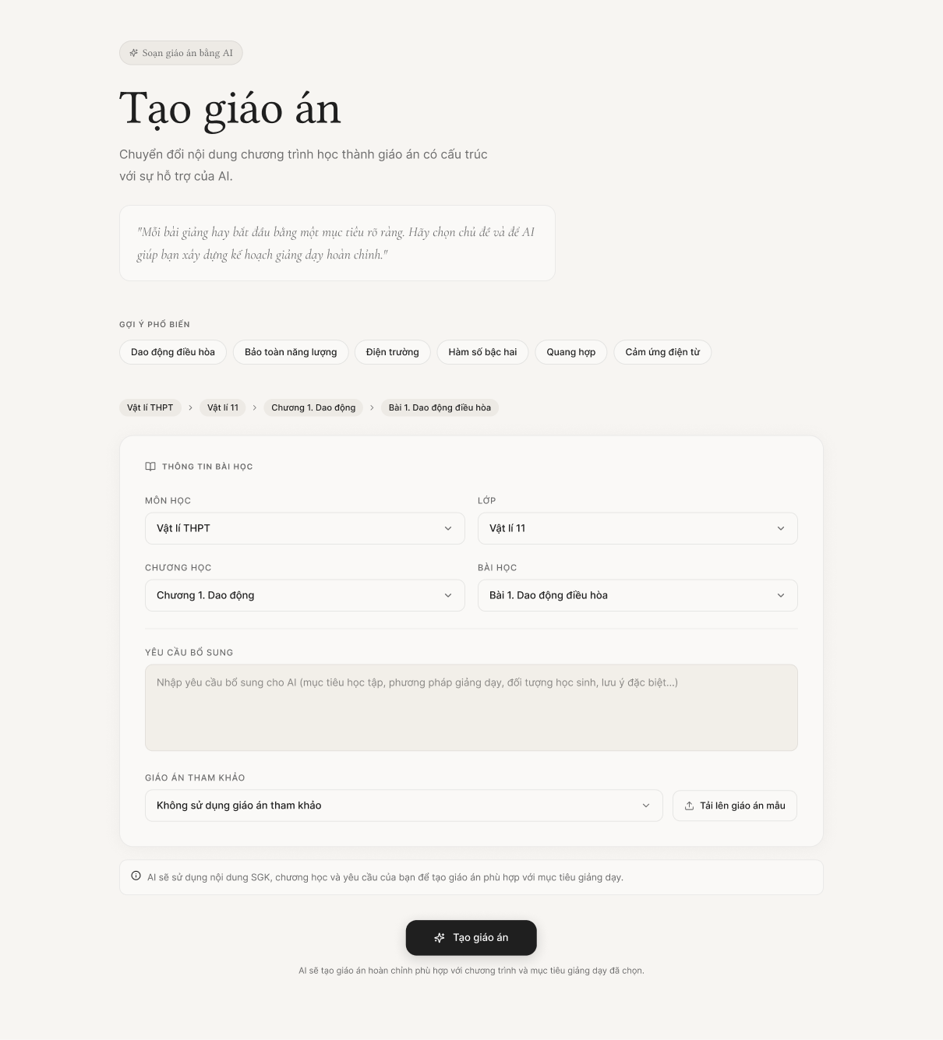
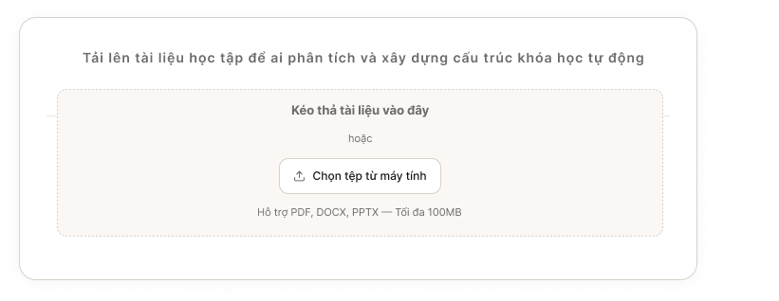
This screen allows the teacher to set up the curriculum context parameters and configuration constraints so the AI system can automatically generate a draft lesson plan aligned with the MOET Circular 5512 standards. Teachers can quickly select from popular topic suggestions or manually define the curriculum hierarchy (Subject $\rightarrow$ Grade $\rightarrow$ Chapter $\rightarrow$ Lesson) based on the official textbook database. Additionally, the system provides a feature to upload reference teaching materials, allowing the AI to analyze specific context data before generating the detailed lesson plan content.
Mapped Use Case(s):
- UC-24: Create Lesson Plan
The Lesson Plan Creation screen allows the Teacher to:
- View and select popular suggested topic tags to quickly populate lesson details.
- Select the exact pedagogical context via cascading dropdowns (Subject, Grade, Chapter, Lesson) derived from the official textbook database.
- Choose the configuration method: Use existing textbook data as the sole input or upload custom reference files.
- Upload supporting teaching materials (e.g., sample lesson plans, reading materials) via a drag-and-drop interface or file selection (supporting .pdf, .docx, .pptx formats).
- Submit the generation request for the AI to process asynchronously, which automatically redirects the user to the Lesson Plan Editor screen upon completion.

Field Description
Field Name | Description
Quick Suggestions | Displays suggested lesson topics to help the teacher start faster. Clicking a suggestion may auto-fill part of the lesson information form.
Suggestion Item | Displays a suggested lesson topic, such as “Bài giảng về Định luật Newton” or other recommended lesson ideas.
Section Title – Lesson Information | Displays the main form section title: “Thông tin bài giảng” / “Lesson Information”.
Subject | Required dropdown field. Allows the teacher to select the subject for the lesson plan, such as Physics, Chemistry, or Mathematics.
Grade | Required dropdown field. Allows the teacher to select the grade level, such as Grade 10, Grade 11, or Grade 12.
Chapter | Required dropdown field. Allows the teacher to select the chapter belonging to the chosen subject and grade. The available chapter list depends on the selected subject and grade.
Lesson / Topic Title | Required text input field. Allows the teacher to enter the lesson name or topic title. Example: “Newton’s First, Second, and Third Laws and Applications”.
Additional Objectives | Optional multi-line text area. Allows the teacher to enter additional requirements, expected outcomes, or custom teaching objectives for the lesson plan.
Reference Document Section | Displays the status of the input reference document.
Upload Document Button | Triggers the system file dialog or expands the drag-and-drop overlay area to allow the teacher to upload a reference file.
Generate Lesson Plan with AI Button | Submits the form and sends the selected information to the AI generation service. If all required fields are valid, the system generates a draft lesson plan and redirects the teacher to the Lesson Plan Editor screen.

3.1.1.2 Lesson Plan Editor

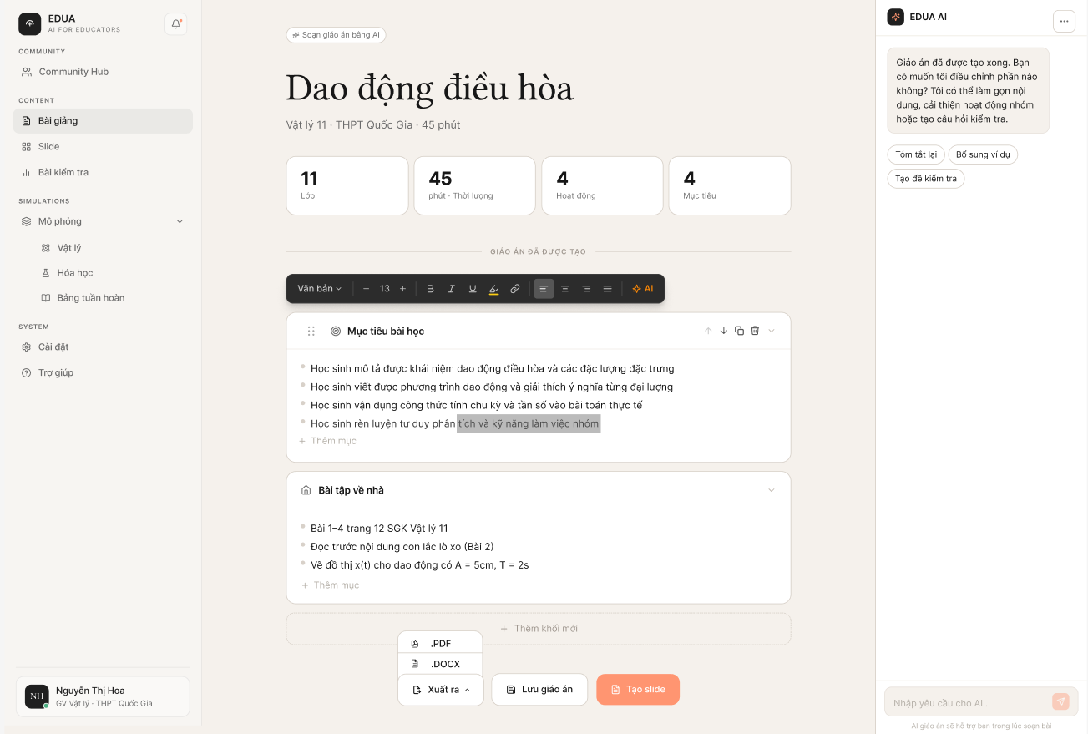

This screen allows the teacher to review and refine the lesson plan generated by the AI service. At the top, a summary highlights key metrics like grade level, duration, and the number of activities. The generated content is displayed as a structured list of lesson sections, shown here in an expanded state to reveal detailed bullet points for objectives, teaching methods, and materials. On the right side, an interactive AI sidebar enables the teacher to easily modify the content. The teacher can use quick-action buttons to simplify text, add group activities, or generate questions, or use the chat input to request specific, direct adjustments to the lesson plan from the AI.
Mapped Use Case(s):
- UC-24: Create Lesson Plan
- UC-28: Edit Lesson Plan
- UC-25: Create Slide Outline
- UC-33: Export Lesson Plan
The Lesson Plan Editor screen allows the Teacher to:
- View the AI-generated lesson plan title and summary information.
- View the lesson structure in a section-based format.
- Edit an existing lesson section.
- Input AI Prompt to configure lesson plan, summary information and lesson section.
- Export lesson as a PDF or DOCX file.

Field Description
Field Name | Description
Lesson Plan Title | Displays the title of the current lesson plan.
Lesson Metadata Summary | Displays summary information such as subject, grade, and lesson duration.
Information Panel | Displays supporting lesson information such as learning objectives, lesson duration, and target students.
Main Editor Area | Displays the generated lesson plan sections in editable blocks.
Section Card | Represents one lesson plan section, such as Learning Objectives, Preparation, Teaching Process, or Homework.
Export button | A drop-down button allow teacher to download lesson as a PDF or DOCX file
Save button | Allow teacher to save lesson plan to personal hub
Create Slide Deck Button | A shortcut button allow teacher to use lesson plan to make slide deck
AI chat sidebar | Allow teacher to use AI to edit lesson plan

3.2 Slide

3.2.1 Create Slide

3.2.1.1 Slide Creation
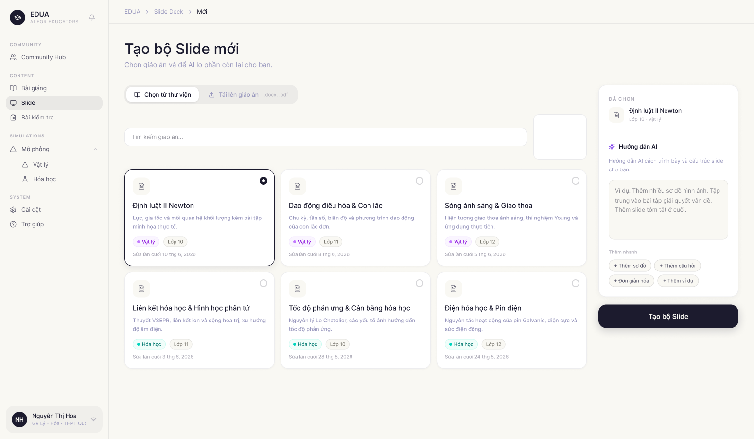
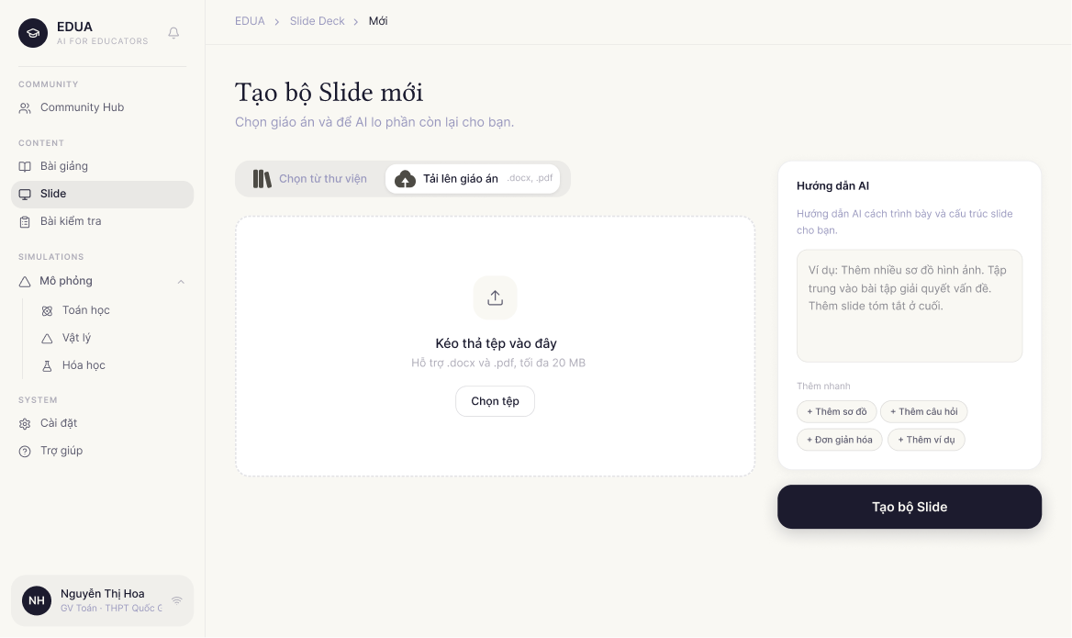
This screen allows the teacher to generate a slide deck with AI based on an existing lesson plan. The teacher selects a lesson plan from the available list, optionally provides additional requirements or style instructions for the AI, and submits the request to generate a slide deck. After the generation process is completed, the system redirects the teacher to the Slide Deck Editor screen.
Mapped Use Case(s):
- UC-25: Create Slide Outline
- UC-26: Create Slide Deck
The Slide Creation screen allows the Teacher to:
- View available lesson plans that can be used as the source content.
- Select one lesson plan as the input for slide generation.
- View basic metadata of each lesson plan, such as subject, grade, and created/updated date.
- Enter additional requirements for AI slide generation.
- Use suggested AI prompts to quickly customize the slide output.
- Generate a slide deck from the selected lesson plan.
Field Description
Field Name | Description
Select Lesson Plan Section | Displays the list of existing lesson plans that the teacher can use as the source input for slide generation.
Lesson Plan Card | Displays one available lesson plan, including title, subject, grade, and created/updated date.
Selected Lesson Plan State | Highlights the lesson plan currently selected by the teacher. Only one lesson plan can be selected at a time.
Lesson Search Box | Text input for user to type and find lesson’name
Lesson Plan Icon | Displays an icon representing a lesson plan resource.
Lesson Plan Title | Displays the name of the lesson plan, such as “Ba Định luật Newton”.
Subject Tag | Displays the subject of the lesson plan, such as Physics, Chemistry, or Mathematics.
Grade Information | Displays the grade level associated with the lesson plan, such as Grade 10.
Created / Updated Date | Displays the date when the lesson plan was created or last updated.
Additional AI Requirements Panel | Allows the teacher to describe extra style, content, or design requirements that should be considered when generating the slide deck.
AI Suggestion Item | Represents one suggested requirement. When clicked, the suggestion can be added to the AI requirement input.
AI Requirement Input | Optional text input field. The teacher can enter custom instructions for the AI, such as preferred slide style, additional activities, target audience, or visual requirements.
Generate Slide Button | Submits the selected lesson plan and additional AI requirements to the AI generation service. If the input is valid, the system starts generating the slide deck and redirects the teacher to the Slide Deck Editor when the result is ready.
Upload Button | Allows the teacher to upload the document and use AI to create slide base on following contents

3.2.1.2 Slide Outline Preview
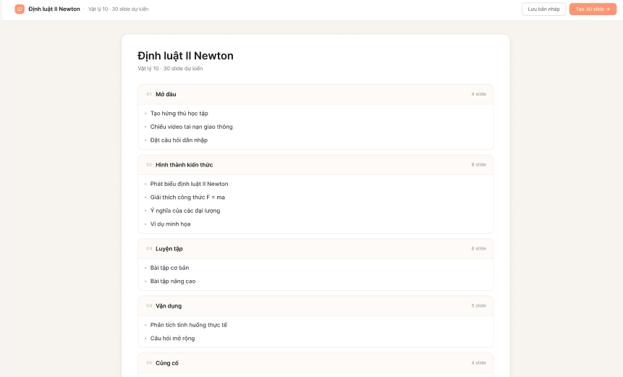

This screen allows the teacher to review and refine the logical structure of the slide deck before the full visual content is generated by the AI. The outline is organized into pedagogical sections (e.g., Introduction, Knowledge Formation, Practice, Application) derived from the approved lesson plan. Teachers can customize the presentation flow by adding or removing sections, adding or deleting individual slides, and reordering content to better fit their classroom needs.
Mapped Use Case(s):
- UC-25: Create Slide Outline
The Slide Outline Preview screen allows the Teacher to:
- View the overall summary of the proposed deck (Total sections and Total slides).
- Review the titles and categories of all slides grouped within specific lesson phases.
- Edit the titles of sections and individual slides.
- Reorder slides or entire sections using a drag-and-drop interface.
- Add new pedagogical sections or additional slides to existing sections.
- Delete unnecessary slides or sections.
- Navigate back to the Lesson Plan Editor if adjustments to the source material are needed.
- Submit the finalized outline to trigger the full AI Slide Deck Generation.

Field Description
Field Name | Description
Outline Title | Displays the name of the lesson plan used for generation
Outline Summary | Displays the current structure statistics.
Section Card | A container representing a major phase of the lesson.
Section Title Editor | An editable text field for the title of the pedagogical phase.
Slide Item Row | Represents a single slide, teacher can click into item to open edit modal
Slide Title Input | An editable text field for the title of an individual slide.
Delete Icon | Removes the specific slide or section from the outline.
Add Slide Button | Adds a new blank slide entry to the bottom of the current section.
Add Section Button | Adds a new pedagogical section card to the bottom of the outline.
Generate Slides Button | Triggers the AI generation process to create the full visual slide deck based on the finalized outline.

3.2.1.3 Slide Outline Editor
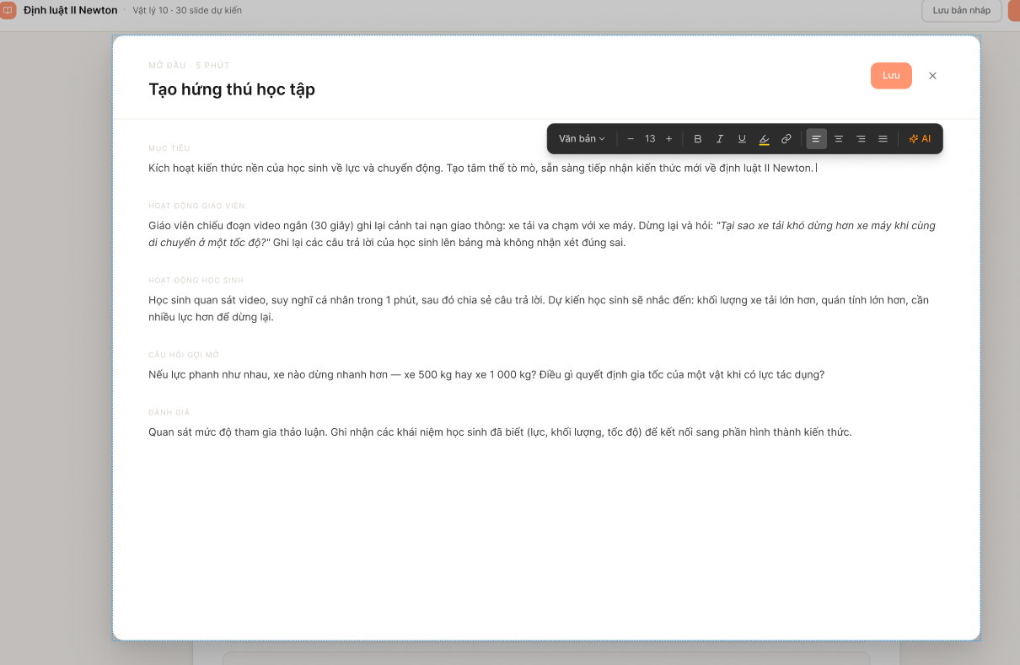
This screen provides an interface for the teacher to refine the text content and structural blocks of each slide in the outline. The teacher can quickly browse the list of slides, select a specific slide to directly modify its title, edit the content of text blocks (headings, paragraphs), or add new content blocks in the central editing canvas.
Mapped Use Case(s):
- UC-29: Edit Slide Outline
The Slide Outline Preview screen allows the Teacher to:
- Modify the title of the selected slide to better match the lesson content.
- Edit the text inside the component blocks of the slide (Heading blocks, Paragraph blocks).

Field Description
Field Name | Description
Slide Title Input | A text input field in the main editing area, displaying and allowing modifications to the main title of the selected slide.
Paragraph Block Input | A multi-line text area allowing the teacher to draft detailed content, explanations, or core knowledge definitions to be displayed on the slide.
Save Button | Allow the teacher to save editing session
X Button | Allows the teacher to cancel the current editing session and return to the previous configuration interface.

3.2.1.4 Slide Deck Editor
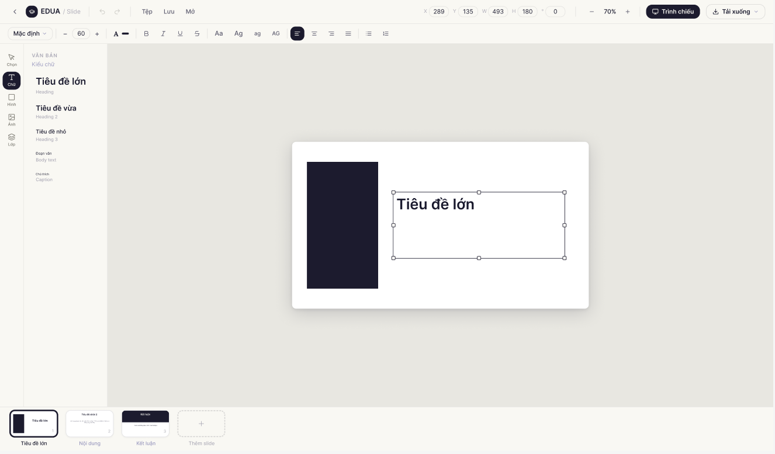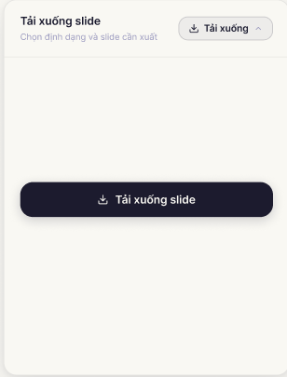
This screen allows the teacher to review, edit, and organize the slide deck generated by the AI service from the selected lesson plan. The teacher can navigate through slides, edit slide content, add visual elements, adjust formatting, apply transitions, duplicate or delete slides, download the slide deck or start presentation mode.
Mapped Use Case(s):
- UC-26: Create Slide Deck
- UC-30: Edit Slide Deck
- UC-32: Present Slide Deck
- UC-34: Export Slide
The Slide Deck Editor screen allows the Teacher to:
- View the AI-generated slide deck.
- Navigate between slides using the slide thumbnail list.
- Edit text content and formatting.
- Add elements such as text, images, shapes, circles, and charts.
- Change visual settings such as color and alignment.
- Duplicate or delete the current slide.
- Apply slide transition effects.
- Change zoom level and grid view.
- Export the slide deck.
- Share the slide deck if permitted.
- Present the slide deck in presentation mode.
Field Description
Field Name | Description
Back Button | Returns the teacher to the previous screen or slide list.
Slide Deck Title | Displays the title of the current slide deck generated from the lesson plan.
Top Toolbar | Provides formatting and editing controls for the selected slide element.
Text Formatting Controls | Allows the teacher to apply text formatting such as bold, italic, underline, and alignment.
Color Control | Allows the teacher to change the color of selected text, shapes, or slide elements.
Zoom Control | Displays and adjusts the current zoom percentage of the slide canvas.
Grid View Button | Shows or hides grid layout support to help align slide elements.
Present Button | Opens the slide deck in presentation mode for classroom presentation.
Export File Button | A drop-down popup allows the teacher to choose export options.
Download FIle Button | A button allow teacher to download slide deck.
Slide Thumbnail Panel | Displays all slides in the deck as thumbnails on the left side. The teacher can select a slide to edit.
Slide Thumbnail | Displays a small preview of a slide, including slide order number. Clicking a thumbnail opens that slide in the main canvas.
Selected Slide State | Highlights the currently selected slide in the thumbnail panel.
Main Slide Canvas | Displays the selected slide in editable form. The teacher can edit text, layout, and visual elements directly on this canvas.
Slide Navigation Indicator | Displays the current slide number and total number of slides, such as “1 / 10”.
Previous / Next Slide Control | Allows the teacher to move to the previous or next slide.
Add Elements Panel | Provides tools for adding new elements to the current slide.
Text Element Button | Adds a text box to the current slide.
Image Element Button | Adds an image to the current slide.
Shape / Box Element Button | Adds a rectangular shape or box to the current slide.
Circle Element Button | Adds a circular shape to the current slide.
Chart Element Button | Adds a chart or diagram element to the current slide.
Current Slide Actions | Provides actions that affect the selected slide.
Duplicate Slide Button | Creates a copy of the current slide.
Delete Slide Button | Deletes the current slide after confirmation.
Transition Effects Panel | Allows the teacher to apply animation or transition effects to the current slide.
Transition Effect Option | Displays available transition effects such as Fade, Slide, Zoom, or Flip.

3.3 Test

3.3.1 Create Test

3.3.1.1 Test Creation
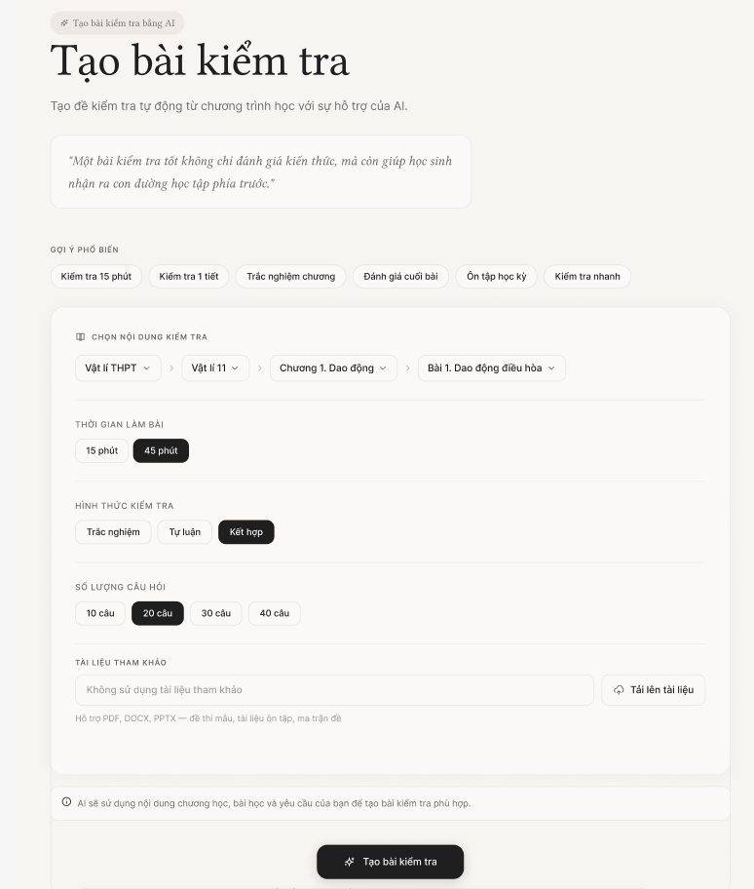

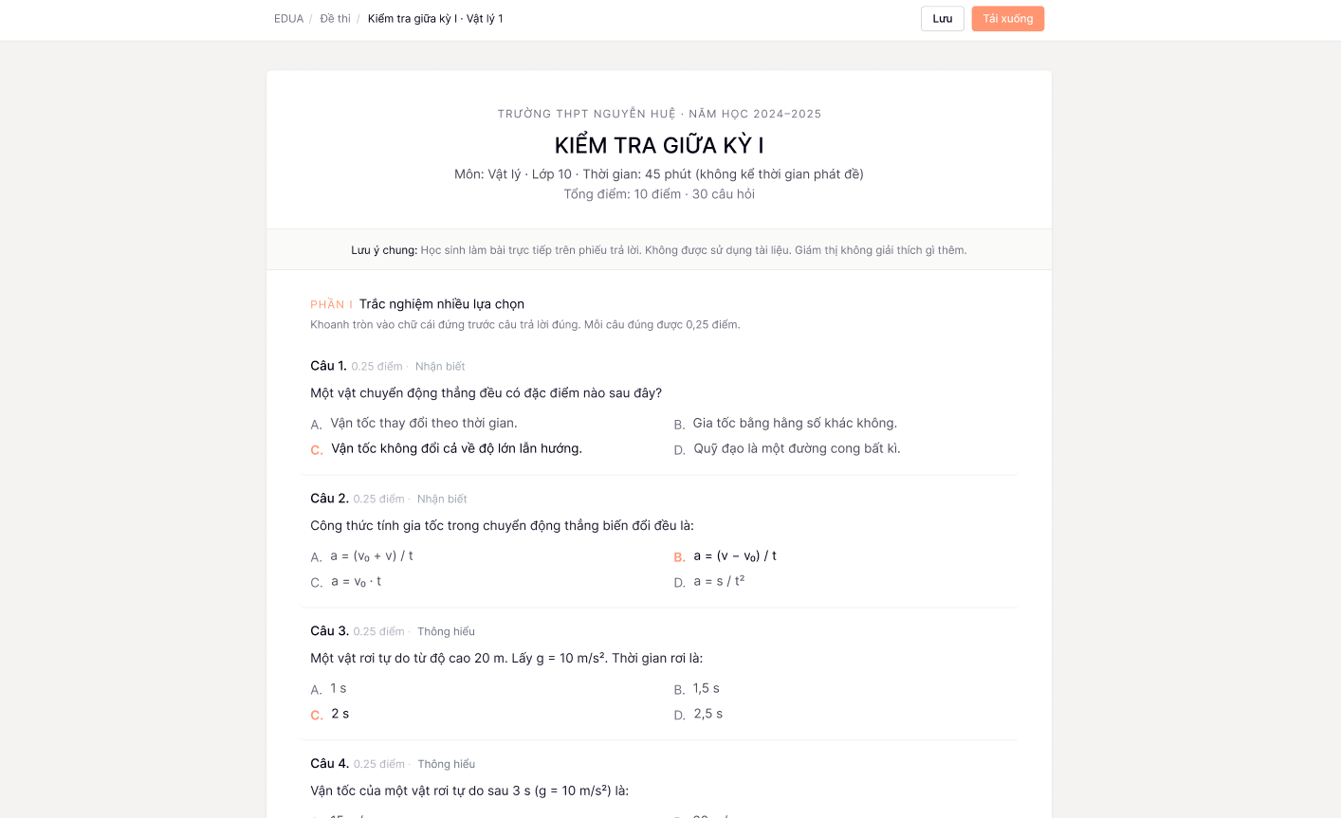
This screen allows the teacher to configure and generate an AI-assisted test or quiz by providing curriculum parameters and specific test constraints. The teacher can choose from popular topic suggestions or manually select the subject, grade, chapter, and lesson. Additionally, the screen provides detailed configurations for the test, including duration, difficulty level, total number of questions, and question types. Users can also upload reference materials or input custom AI instructions before submitting the generation request.
Mapped Use Case(s):
- UC-27: Create Test
The Test Creation screen allows the Teacher to:
- View quick suggestions for common test topics.
- Select the curriculum context (Subject, Grade, Chapter, Lesson).
- Configure the test duration (e.g., 15 minutes, 45 minutes, Mid-term).
- Adjust the difficulty level using a slider.
- Set the total number of questions.
- Select the desired question types (Multiple choice, True/False, Essay/Short answer).
- Enter additional AI instructions for test generation.
- Upload reference files to base the test on.
- Submit the form to generate the test with AI.
- Export the test as a printable document (e.g., PDF/DOCX) for offline use.
Field Description
Field Name | Description
Quick Suggestions | Displays suggested test topics. Clicking a suggestion auto-fills the curriculum context.
Subject / Grade / Chapter / Lesson | Dropdown fields allow the teacher to select the exact curriculum context for the test.
Test Duration | Selection chips to define the length of the test (e.g., 15 phút, 45 phút, Giữa kỳ).
Question Types | Checkboxes allowing the teacher to include specific formats: Multiple choice (Trắc nghiệm nhiều lựa chọn), True/False (Đúng sai), and Essay (Tự luận).
Total Questions | Numeric input field to specify how many questions the generated test should contain.
Upload Reference File | Button to upload files (PDF, DOCX, PPTX) that the AI should use as the source material for the test.
AI Instructions | Optional multi-line text area for custom instructions, such as focusing on specific sub-topics or adjusting the tone.
Generate Test Button | Submits the configurations to the AI service to generate the test and redirects to the Test Editor screen.

3.3.1.2 Test Editor

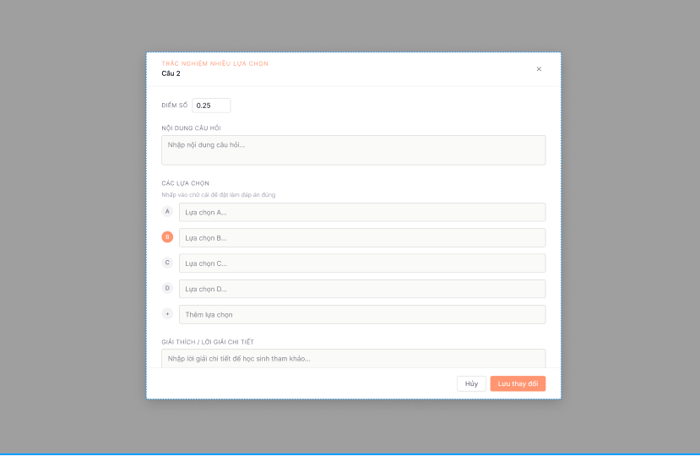

This screen provides an intuitive interface for teachers to review, refine, and organize a generated or uploaded test. The main view displays a structured list of questions categorized logically by format (e.g., Section I: Multiple Choice, Section II: True/False, Section III: Essay).
To streamline the editing process, the screen incorporates an Edit Question Modal. This modal appears as an overlay directly on the main canvas whenever the teacher clicks on a specific question, allowing for detailed manual adjustments without navigating away from the full test view.
Mapped Use Case(s):
- UC-31: Edit Test
- UC-35: Export Test
The Test Editor screen allows the Teacher to:
- View the test title and metadata summary (Grade, Subject, Duration, Total Questions, Max Score).
- Review the list of questions organized by sections.
- Click on any specific question card to open the Edit Question Modal.
- Adjust the point value (score) for individual questions.
- Modify the question content, answer options, and designate the correct answer(s) within the modal.
- Write or edit detailed step-by-step solutions or explanations for each question.
- Save the current state of the test to the Personal Library.
- Export the test as a printable document (e.g., PDF/DOCX) for offline use.
Field Description
Field Name | Description
Export Button | Allows the teacher to download the test and its answer key as a printable document (.docx, .pdf).
Test Title | Displays the title of the current test (e.g., "Bài kiểm tra Dao động cơ học 1"). Allows the teacher to edit the title directly.
Metadata Summary | Displays fixed parameters of the test including: Grade, Subject, Duration (e.g., 45 minutes), Total Questions, and Total Score.
Section Header | Divides the test into major sections based on question types (e.g., Section I: 4-option Multiple Choice).
Question Card Item | Displays a preview of the question text, available options, point value, and correct answer indicator. Clicking this area triggers the Edit Question Modal.
Save Button | Manually saves the current state and edits of the test to the teacher's Personal Library.
Edit Question Modal | An overlay modal that appears when a Question Card is clicked. It includes the following fields:
Score Input | Numeric input field allowing the teacher to adjust the specific point value/weight of the selected question.
Question Text Editor | A rich text editor area to modify the main text of the question, including formatting, math formulas, or symbols.
Correct Answer Selector | Radio buttons (or checkboxes) placed next to each option to allow the teacher to define which answer is correct.
Answer Option Input | Text fields containing the content of each choice (A, B, C, D).
Add Option Button | A button to add a new blank answer option to the question.
Solution Editor | A rich text editor area to provide the step-by-step solution, explanation, or grading rubric for the question.
Cancel Button | Closes the modal and discards any unsaved changes made to the question during the current editing session.
Save Changes Button | Applies the edits to the question, updates the main Test Editor view, and closes the modal.

3.4 Landing Page

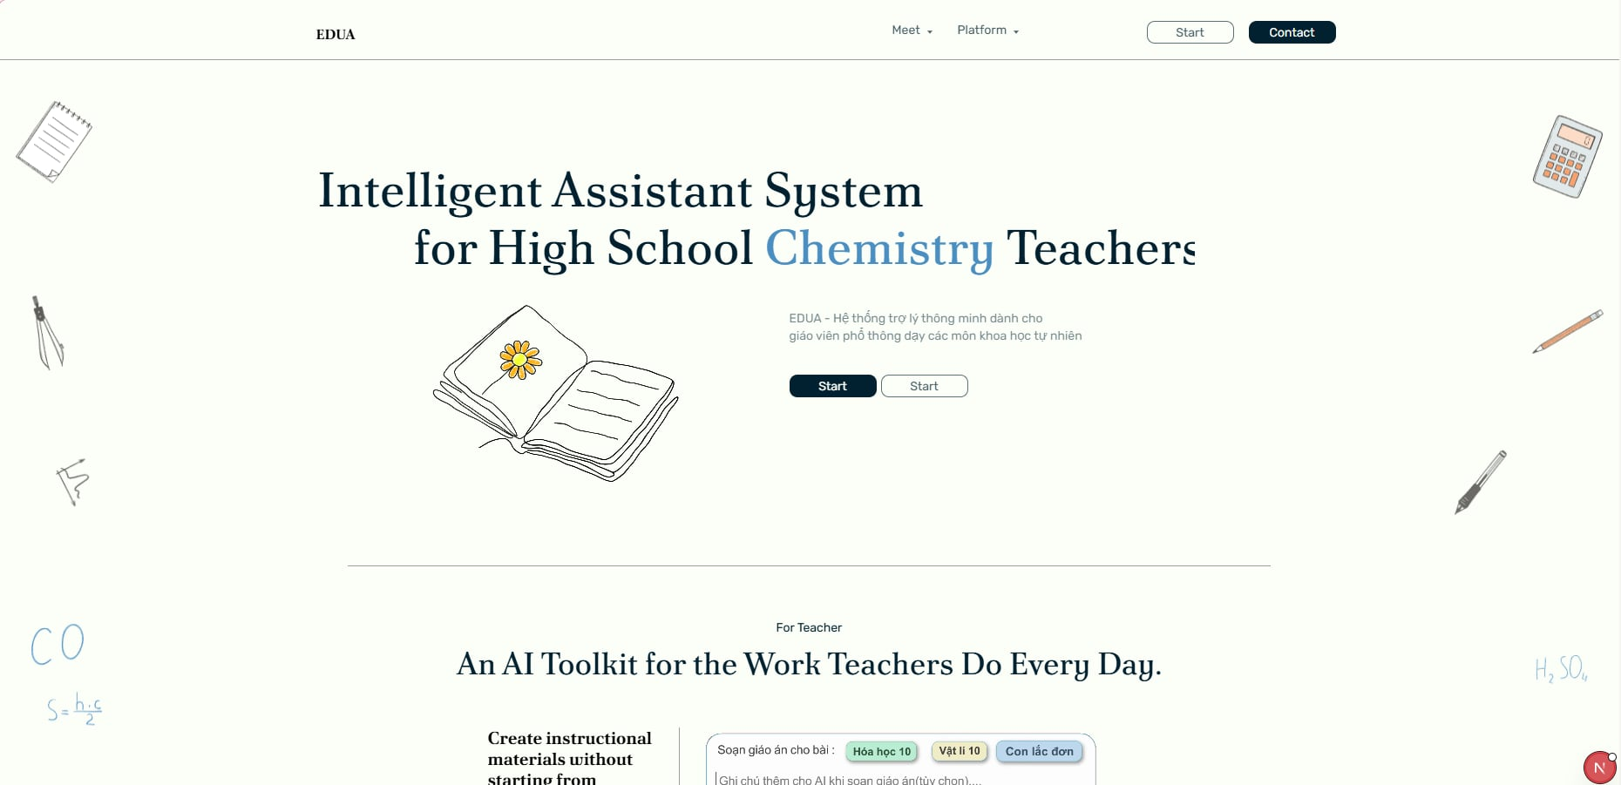
This is the public-facing homepage and primary entry point of the EDUA platform. It introduces the platform's core AI-assisted capabilities tailored for teachers, including automated lesson plan generation, smart slides, interactive 2D/3D simulations, and AI test creation. The screen serves as a marketing and navigation hub, guiding unauthenticated users (guests) to learn about EDUA and proceed to the authentication flow (Login). Guests can only access the Landing Page; all other features require granted access and sign-in. Because EDUA does not support self-registration, access is granted internally by authorized staff.
Mapped Use Case(s):
- UC-01: View Landing Page
- UC-02: Login
The Landing Page allows a Guest to:
- View the platform's value proposition, headline, and system mockup.
- Understand the core features through detailed informational cards.
- Understand that platform access is granted internally and contact the assigned moderator or administrator if access is needed.
- Start sign-in after access has been granted.
Field Description
Field Name | Description
Top Navigation Bar | The persistent header containing the EDUA logo and quick links to different sections of the landing page ("Trang chủ", "Tính năng", "Về chúng tôi").
Login Button | A secondary button in the top navigation bar that redirects the user to the authentication service to sign in.
Access Request Note | A note or guidance text in the top navigation area that explains users must be granted access before signing in.
Hero Section | The main banner area displaying the primary value proposition ("Trợ lý AI toàn diện cho giáo viên STEM") and a visual mockup of the platform.
Sign In Button | A prominent Call-To-Action (CTA) button in the Hero section that starts the Google sign-in flow.
Features Section | A section displaying individual cards that highlight the four core pillars of the platform: Automated Lesson Plans, Smart Slides, Interactive Simulations, and AI Tests.
Access Guidance Section | A dedicated block explaining that EDUA access is limited to granted teacher, moderator, and administrator accounts.

4. Non-Functional Requirements

4.1 External Interfaces
User Interfaces: EDUA is accessed through modern web browsers (Google Chrome 90+, Mozilla Firefox 88+, Microsoft Edge 90+, Safari 14+) on desktop and laptop devices. The interface is optimized for screen resolutions of 1280×720 and above. All user-facing screens follow a consistent layout with a left-side navigation bar, top header bar, and main content area as defined in the Screen Flow (Section 1.4.1).
Hardware Interfaces: No specialized hardware is required. The system runs on standard computing devices (PC, laptop) with a minimum of 4 GB RAM and a stable internet connection (minimum 2 Mbps download speed). For 3D simulation rendering (Chemistry virtual lab, Physics phenomena), a device with WebGL-capable graphics is recommended.
Software Interfaces: EDUA integrates with the following external services:\n– Google OAuth2 Integration: Handles user login via Google sign-in and issues internal JWT tokens for session management and role-based authorization. User accounts are created by administrators and moderators (by granting access to a Gmail address); the system does not support self-registration.\n– OpenAI/DeepSeek: AI/LLM service — receives structured prompts and returns generated content for lesson plans, slide decks, test questions, and simulation descriptions.\n– Cloudflare R2: Object storage — stores and serves uploaded and generated files (lesson plans, slide decks, images, exported PDFs/PPTX) via signed URLs.
Communication Interfaces: All client–server communication uses HTTPS (TLS 1.2+) over REST APIs with JSON payloads. Asynchronous AI generation jobs use a polling mechanism where the client periodically checks the job status endpoint. In-app notifications are delivered via the server notification dispatch service. File uploads and downloads are routed through signed Cloudflare R2 URLs to avoid exposing storage credentials to the client.

4.2 Quality Attributes

4.2.1 Usability
USR-01: A new teacher user shall be able to complete the first login process (sign in with Google, update profile) within 3 minutes without external assistance.
USR-02: A teacher with no prior training shall be able to generate a lesson plan (select subject → grade → lesson → generate) within 5 minutes of first login.
USR-03: All interactive elements (buttons, links, input fields) shall have visible labels or tooltips. Icon-only controls shall display a descriptive tooltip on hover within 0.5 seconds.
USR-04: Form validation errors shall be displayed inline next to the relevant field immediately upon submission, using red text and an error icon, with a clear description of the required correction.
USR-05: The system shall provide consistent navigation across all screens: a persistent left sidebar for feature navigation and a top header bar showing the user's profile, notifications, and logout option.
USR-06: All AI-generated content (lesson plans, slides, tests) shall be presented in an editable format so the teacher can modify any element before saving or exporting.
USR-07: The system shall support Vietnamese and English UI languages. All system messages, labels, and tooltips shall be available in both languages.

4.2.2 Performance
PRF-01: Standard page loads (login, dashboard, library, hub listing) shall complete rendering within 2 seconds under normal network conditions (≥ 2 Mbps).
PRF-02: AI-assisted lesson plan generation shall return the first draft to the editor within 30 seconds for a single lesson selection. The system shall display a progress indicator during generation.
PRF-03: AI-assisted slide deck generation shall complete within 60 seconds for a lesson plan of up to 10 sections.
PRF-04: AI-assisted test generation shall return generated questions within 30 seconds for a single lesson input.
PRF-05: 3D Chemistry simulation (molecule rendering, reaction animation) shall render at a minimum of 24 frames per second on a device with WebGL 2.0 support.
PRF-06: The system shall support at least 200 concurrent authenticated users without degradation of response times specified above.
PRF-07: File upload (lesson plan import, image attachment) shall accept files up to 100 MB and complete the upload within 10 seconds on a 10 Mbps connection.
PRF-08: Search operations on the Community Hub (keyword search, filter by subject/grade) shall return results within 3 seconds for a dataset of up to 10,000 published posts.

4.2.3 Security
SEC-01: All user authentication shall be handled via Google OAuth2. The system shall not store user passwords. Identity verification is delegated to Google; the system validates the returned OAuth token and checks the user's email against the granted-access list server-side.
SEC-02: All client–server communication shall be encrypted using HTTPS with TLS 1.2 or higher. Unencrypted HTTP requests shall be rejected or automatically redirected to HTTPS.
SEC-03: User sessions shall be managed via JWT access tokens with a maximum lifetime of 60 minutes. Refresh tokens shall expire after 24 hours of inactivity. Expired tokens shall be rejected by the API gateway.
SEC-04: Role-based access control (RBAC) shall be enforced on every API request. The system shall verify the user's role (Teacher, Moderator, Administrator) against the Screen Authorization matrix (Section 1.4.2) before granting access to any resource.
SEC-05: All file uploads shall be validated for file type (allowlist: PDF, DOCX, PPTX, PNG, JPG, JPEG) and maximum size (10 MB) before being stored in Cloudflare R2. Executable files and scripts shall be rejected.
SEC-06: User-generated input (lesson plan text, comments, search queries) shall be sanitized against Cross-Site Scripting (XSS) and SQL injection before processing or storage.
SEC-07: API endpoints shall implement rate limiting to prevent abuse — a maximum of 60 requests per minute per authenticated user for standard endpoints and 10 requests per minute for AI generation endpoints.

4.2.4 Reliability
REL-01: The system shall maintain an uptime of at least 99% measured monthly, excluding scheduled maintenance windows communicated at least 24 hours in advance.
REL-02: In the event of an AI service (OpenAI/DeepSeek) outage or timeout, the system shall display a user-friendly error message and allow the teacher to retry the generation request. Previously generated and saved content shall remain accessible.
REL-03: The system shall perform automated daily backups of the application database. Backups shall be retained for a minimum of 30 days and shall support point-in-time recovery.
REL-04: File storage (Cloudflare R2) shall be configured with redundancy such that no single storage failure results in data loss of user-uploaded or AI-generated files.
REL-05: All critical operations (save lesson plan, publish to hub, submit test) shall be wrapped in database transactions to ensure data consistency. A failed operation shall roll back without partial data being committed.

4.2.5 Scalability
SCL-01: The system architecture shall support horizontal scaling of the application server layer to handle increased user load without requiring changes to the application code.
SCL-02: The database schema shall support growth to at least 50,000 registered user accounts and 100,000 stored content items (lesson plans, slide decks, tests, simulations) without significant query performance degradation.
SCL-03: AI generation requests shall be processed through an asynchronous job queue that can be scaled independently of the main application server to manage peak demand periods.

5. Requirement Appendix

5.1 Business Rules
ID | Rule Definition
BR-01 | Teacher accounts are created by the moderator (head of subject department); users do not self-register.
BR-02 | Each account is uniquely identified by a verified email address.
BR-03 | User roles determine screen and feature access. The Principal manages Moderator accounts, while each Moderator manages Teacher accounts within their assigned subject.
BR-04 | The Landing Page is publicly accessible without sign-in. A user must be signed in to access any other platform feature, and access is restricted according to the user's assigned role and permissions.
BR-05 | Login is handled via Google OAuth2; session/token validation is managed by the system's authentication module.
BR-06 | A user signs in with the Google account whose email has been granted platform access. Only accounts with Active status may sign in.
BR-07 | AI generation uses the KNTT textbook knowledge base; the teacher must set a valid content target (Subject / Grade / Lesson) before generating a lesson plan or test.
BR-08 | Generated lesson plans must follow the MOET Circular 5512/BGDĐT structure.
BR-09 | Uploaded files are limited to .docx, .pdf, .pptx, .png, .jpg, and .jpeg formats.
BR-10 | Each uploaded file must not exceed the maximum allowed size (100 MB).
BR-11 | AI-generated content is produced via the AI/LLM service and remains editable by the teacher (manually or by AI prompt) before use.
BR-12 | A test can be generated in one of three frames: 15-minute, 45-minute, or mid-term.
BR-13 | A slide outline is generated from either an owned lesson plan or a supported external document selected by the teacher. A slide deck can be generated only from the latest confirmed slide outline.
BR-14 | Generated assets (images and media) are stored in the File Storage Service (Cloudflare R2).
BR-15 | Newly created teacher-owned content has a default Publish Status of Draft.
BR-16 | Only the owner (the teacher who created the content) can edit or delete that content.
BR-17 | Hub content must be approved by the moderator of its subject before it becomes publicly visible on the Community Hub.
BR-18 | A moderator only reviews and manages content and teacher accounts of their assigned subject.
BR-19 | All created or edited content (lesson plans, slide decks, tests, and simulations) is auto-saved to the owner's Personal Library on first generation and automatically every minute while editing.
BR-20 | Blog posts are published directly without prior approval; each post is tagged with one subject for search and filtering.
BR-21 | A moderator may remove a blog post only if its subject tag matches their assigned subject; removal requires a reason.
BR-22 | The community self-regulates blog discussion through comments.
BR-23 | Editing Draft content saves changes to the same Draft. Editing Rejected content changes its Publish Status to Draft. Pending Publish content is locked until the teacher performs Unpublish Hub Content, which removes it from the Hub review queue and changes its Publish Status to Draft. Editing Published content creates or updates a Draft revision while the Published version remains unchanged until the revision is approved, according to the Publish Status State Diagram.
BR-24 | Profile updates must pass input validation: display name is required and must not exceed the field length limit; school and subject must be selected from allowed values.
BR-25 | Chemistry Lab reference data (the periodic table of 118 elements, element detail cards, and 3D atomic models) is static, system-provided content; it is not created or owned by teachers.
BR-26 | A 3D molecule is specified by entering a supported substance name or chemical formula. The system converts the input into an interactive 3D ball-and-stick model.
BR-27 | A moderator's notifications are delivered only to teachers belonging to the moderator's assigned subject. This notification scope is separate from the moderator's content and account management scope defined in BR-18.
BR-28 | Customizing a public Community Hub content item creates an independent Draft copy in the customizing teacher's Personal Library. The copy is not linked to the original; subsequent edits to either item do not affect the other.
BR-29 | A teacher may edit or delete only Community Hub content comments they authored. The owner of the content item may additionally delete any comment left by others on that item to moderate discussion on their own content.
BR-30 | A user may edit or delete only blog comments they authored. The author of a blog post may additionally delete comments left by other users on that post.
BR-31 | When creating a test, the teacher sets the test frame, number of questions, difficulty level, and question types. The AI uses these criteria to generate the test content.
BR-32 | Deleting a content item from the Personal Library removes it only from the owner's Personal Library. A Published Community Hub version remains visible until the owner performs Delete Own Public Content from the Hub content detail screen.
BR-33 | A Moderator inherits all Teacher-level Blog permissions: creating a blog post, editing or deleting their own blog post, commenting, and editing or deleting their own blog comment. This is in addition to the Moderator's subject-scoped moderation actions (viewing or removing blog posts in their assigned subject, BR-21).
BR-34 | A class's Hub and resources are accessible only to its owning teacher and its enrolled students; only the owning teacher may manage class settings, resources, and membership.
BR-35 | A class resource is not linked to its source after posting. If posted from the Personal Library, the system creates an independent snapshot copy attached to the Class Hub; subsequent edits to the original Personal Library item do not affect the posted copy, and vice versa. If posted via direct file upload, the file is stored independently through the File Storage Service and is not linked to any Personal Library item.
BR-36 | A student may have only one active submission per class resource; submitting again after unsubmitting or editing replaces the previous submission rather than creating a version history.
BR-37 | An Inactive class is read-only for both the owning teacher and enrolled students. Creating, editing, deleting, changing membership, submitting, and unsubmitting are disabled until the class is reactivated.
BR-38 | When importing students via file, the system adds all valid rows and skips invalid rows (invalid format, duplicate in file, or already a class member) rather than rejecting the entire file.
BR-39 | When a class becomes Inactive, its existing resources and submissions remain viewable and downloadable by the owning teacher and enrolled students.
BR-40 | If AI output is partially invalid, the system preserves valid items and regenerates only identifiable invalid or missing items. Full regeneration is required when the response cannot be processed or the failure affects the whole output.
BR-41 | Each subject must have exactly one Active Moderator, and a Moderator may be assigned to only one subject at a time. The platform must also have exactly one Active IT Supporter.
BR-42 | A replacement Moderator or IT Supporter must be an existing Active account, must be different from the current staff account, must be eligible for the target role, and must not hold a conflicting staff assignment.
BR-43 | Replacing a staff account transfers the role and assignment to the replacement account. A former Moderator becomes an Active Teacher; a former IT Supporter becomes Inactive and loses platform access. Existing content, ownership information, and system records remain unchanged.
BR-44 | Banning a Moderator or IT Supporter requires an eligible replacement in the same operation. The role and assignment are transferred to the replacement account. A former Moderator becomes an Inactive Teacher, and a former IT Supporter becomes Inactive; both lose platform access while existing records remain unchanged.
BR-45 | Removing a student from a class preserves the student's existing submission records. Deleting a class resource permanently deletes all submissions associated with that resource. Deleting a class permanently deletes all resources and submissions belonging to that class.
BR-46 | When a student is added to a class, the system sends a notification to that student. When a class resource is posted, the system sends a notification to all currently enrolled students.
BR-47 | A Weekly Task may be edited only until its deadline. After the deadline passes, the task is locked against further editing; a later week is handled by creating a new Weekly Task.

5.2 System Messages
# | Message code | Message Type | Context | Content
1 | MSG01 | Inline | No search/listing result is found | Không tìm thấy kết quả.
2 | MSG02 | Inline, in red under the field | A required input field is empty | Trường này là bắt buộc.
3 | MSG03 | Inline | Email format is invalid | Vui lòng nhập địa chỉ email hợp lệ.
4 | MSG04 | Inline | Sign-in failed because the account has not been granted access, the account is Inactive, or Google authentication fails | Đăng nhập thất bại. Tài khoản Google của bạn có thể chưa được cấp quyền truy cập hoặc đang ở trạng thái không hoạt động. Vui lòng liên hệ với người quản lý bộ môn.
5 | MSG05 | Toast message | Sign-in is successful | Đăng nhập thành công.
6 | MSG06 | Loading / toast message | The AI/LLM service is generating content | Đang tạo nội dung, vui lòng chờ...
7 | MSG07 | Toast message (error) | AI generation fails or times out | Tạo nội dung thất bại. Vui lòng thử lại.
8 | MSG08 | Toast message | A create, edit, save, or assignment operation is completed successfully | Lưu thành công.
9 | MSG09 | Confirmation popup | A user is about to delete content or a comment | Bạn có chắc chắn muốn xóa mục này không? Hành động này không thể hoàn tác.
10 | MSG10 | Toast message | Content or a comment is deleted successfully | Xóa thành công.
11 | MSG11 | Toast message | Content is submitted to the Community Hub | Nội dung của bạn đã được gửi để xét duyệt.
12 | MSG12 | Toast message | A moderator approves or rejects submitted Community Hub content | Trạng thái nội dung đã được cập nhật.
13 | MSG13 | Inline / toast message (error) | An uploaded file type or size is invalid | Định dạng tệp không được hỗ trợ hoặc kích thước tệp vượt quá giới hạn. Định dạng cho phép: .docx, .pdf, .pptx, .png, .jpg, .jpeg (tối đa 100 MB).
14 | MSG14 | Toast message | A lesson plan is generated successfully | Tạo kế hoạch bài dạy thành công.
15 | MSG15 | Toast message | A test is generated successfully | Tạo đề kiểm tra thành công.
16 | MSG16 | Toast message | A slide deck is generated successfully | Tạo bài trình chiếu thành công.
17 | MSG17 | Toast message | A slide outline is generated successfully | Tạo dàn ý bài trình chiếu thành công.
18 | MSG18 | Toast message | A lesson plan, test, or slide deck is exported successfully | Xuất tệp thành công.
19 | MSG19 | Toast message | The user logs out successfully | Đăng xuất thành công.
20 | MSG20 | Toast message (real-time) | A notification arrives while the user is online | Bạn có thông báo mới.
21 | MSG21 | Toast message | A teacher withdraws content from the Community Hub review queue | Đã rút nội dung khỏi hàng đợi duyệt.
22 | MSG22 | Toast message | A moderator removes a blog post | Bài viết đã được gỡ bỏ.
23 | MSG23 | Inline / dialog | A teacher attempts to edit or manage an Inactive class | Lớp học đang ở trạng thái không hoạt động, không thể chỉnh sửa.
24 | MSG24 | Inline / dialog | An uploaded import file is unsupported, too large, empty, exceeds the row limit, or is missing the required email column | Tệp không hợp lệ. Vui lòng tải lên tệp .csv hoặc .xlsx theo đúng mẫu được cung cấp.
25 | MSG25 | Toast message (error) | A non-AI operation fails because of a server or network error | Thao tác thất bại. Vui lòng thử lại.
26 | MSG26 | Popup (warning) | Some generated questions are missing or invalid | Một số câu hỏi không được tạo đúng. Các câu hỏi hợp lệ đã được giữ lại. Bạn có muốn tạo lại các câu hỏi bị ảnh hưởng không?
27 | MSG27 | Inline | No platform account is associated with the entered replacement email | Không tìm thấy tài khoản với địa chỉ email này.
28 | MSG28 | Inline | The replacement account has status Inactive | Không thể chỉ định tài khoản không hoạt động làm người quản lý bộ môn.
29 | MSG29 | Inline | The replacement account is not eligible for the Moderator role | Tài khoản này không đủ điều kiện để trở thành người quản lý bộ môn.
30 | MSG30 | Inline | The entered replacement email belongs to the current Moderator | Vui lòng chọn một tài khoản khác làm người quản lý bộ môn thay thế.
31 | MSG31 | Inline | The replacement account is already assigned as the Moderator of another subject | Tài khoản này đã được chỉ định làm người quản lý của một môn học khác.
32 | MSG32 | Confirmation popup | The Principal is about to replace a Moderator | Người quản lý bộ môn hiện tại sẽ trở về vai trò giáo viên và tài khoản được chọn sẽ trở thành người quản lý của môn học này. Bạn có muốn tiếp tục không?
33 | MSG33 | Toast message | A Moderator is replaced successfully | Thay thế người quản lý bộ môn thành công.
34 | MSG34 | Confirmation popup | The Principal is about to ban a Moderator and assign a replacement | Người quản lý bộ môn hiện tại sẽ trở về vai trò giáo viên, tài khoản sẽ chuyển sang trạng thái không hoạt động và tài khoản được chọn sẽ trở thành người quản lý của môn học này. Bạn có muốn tiếp tục không?
35 | MSG35 | Toast message | A Moderator is banned successfully | Cấm người quản lý bộ môn thành công.
36 | MSG36 | Inline / toast message | The selected Moderator account is already Inactive | Tài khoản này đã ở trạng thái không hoạt động.
37 | MSG37 | Toast message (error) | An operation would leave a subject with no Active Moderator or more than one Active Moderator | Mỗi môn học phải có đúng một người quản lý bộ môn đang hoạt động.

5.3 Research References
The following table lists the reference materials gathered during the requirement analysis phase. These documents were compiled to support the design of specific use cases.
# | Related Use Case | Reference Document | Link
1 | UC-24: Create Lesson Plan | Cách làm slide theo Phụ lục 5512 | Bản sao của Cách làm slide theo Phụ lục 5512
2 | UC-53: View physics Hub | Các hiện tượng vật lý cần mô tả khi giảng dạy (Lớp 10 – 12) | Bản sao của Các hiện tượng vật lý cần mô tả khi giảng dạy (Lớp 10 – 12)
3 | UC-53: View physics Hub | Phần tử vật lý trong chương trình THPT (lớp 10–12) | Bản sao của Phần tử vật lý trong chương trình THPT (lớp 10–12)
4 | UC-53: View physics Hub | Tiêu chuẩn dự án Mô phỏng Vật lý | Bản sao của Tiêu chuẩn dự án Mô phỏng Vật lý
5 | UC-56: Run Chemistry Virtual Lab Experiment | pt-tac-dong-boi-xuc-tac.xlsx | Bản sao của pt-tac-dong-boi-xuc-tac.xlsx
6 | UC-56: Run Chemistry Virtual Lab Experiment | tài nguyên hóa (minh) | Bản sao của danh-sach-thi-nghiem.md
7 | UC-57: View Periodic Table | các danh sách nt,pt,chất và thí nghiệm (minh họa) | Bản sao của nguyen-tu-phan-tu-chat-theo-bai-sgk.xlsx
8 | UC-58: View 3D Atomic Model | các danh sách nt,pt,chất và thí nghiệm (minh họa) | Bản sao của các danh sách nt,pt,chất và thí nghiệm (minh họa)
9 | UC-59: Generate 3D Organic Molecule Model | các danh sách nt,pt,chất và thí nghiệm (minh họa) | Bản sao của các danh sách nt,pt,chất và thí nghiệm (minh họa)

5.4 Data

5.4.1 Data Physical

STT | Tên thí nghiệm | Lớp | Tham số
1 | Ống Newton trong không khí | 10 | - Độ cao thả (m)  - Gia tốc trọng trường (m/s²)  - Khối lượng viên bi (kg)  - Khối lượng lông chim (kg)  - Mức cản không khí (x)
2 | Ống Newton trong chân không | 10 | - Độ cao thả (m)  - Gia tốc trọng trường (m/s²)  - Khối lượng viên bi (kg)  - Khối lượng lông chim (kg)
3 | Chuyển động ném ngang | 10 | - Độ cao ném (m)  - Vận tốc ngang (m/s)  - Gia tốc trọng trường (m/s²)
4 | Chuyển động ném xiên | 10 | - Vận tốc đầu (m/s)  - Góc ném (°)  - Gia tốc trọng trường (m/s²)
5 | Tổng hợp lực | 10 | - Lực F₁, hướng sang trái (N)  - Lực F₂, hướng sang phải (N)  - Khối lượng vật (kg)"
6 | Phân tích lực | 10 | - Góc nghiêng (°)  - Khối lượng vật (kg)  - Gia tốc trọng trường (m/s²)
7 | Máng cong Galilei | 10 | - Độ cao ban đầu (m)  - Độ dốc nhánh phải (°)  - Hao phí quy đổi (N·s/m)  - Gia tốc trọng trường (m/s²)
8 | Định luật II Newton | 10 | - Lực kéo (N)  - Khối lượng (kg)  - Hệ số ma sát (không đơn vị)  - Gia tốc trọng trường (m/s²)
9 | Định luật III Newton | 10 | - Khối lượng vật A (kg)  - Khối lượng vật B (kg)  - Độ cứng lò xo (N/m)  - Độ nén ban đầu (m)
10 | Đo trọng lượng của vật bằng lực kế | 10 | - Khối lượng vật (kg)
11 | Chuyển động trong chất lưu | 10 | - Độ cao thả (m)  - Khối lượng mỗi vật (kg)  - Độ cản của chất lưu (x)  - Diện tích cản (x)  - Gia tốc trọng trường (m/s²)
12 | Quy tắc moment lực với bập bênh | 10 | - Khối lượng vật trái (kg)  - Khoảng cách bên trái (m)  - Khối lượng vật phải (kg)  - Khoảng cách bên phải (m)  - Gia tốc trọng trường (m/s²)
13 | Quy tắc moment lực với vòng đĩa quay | 10 | - Khối lượng vật trái (kg)  - Khoảng cách trái d₁ (m)  - Khối lượng vật phải (kg)  - Khoảng cách phải d₂ (m)
15 | Tàu lượn chuyển hoá động năng/thế năng | 10 | - Độ cao thả (m)  - Khối lượng bi (kg)  - Ma sát ray (không đơn vị)  - Gia tốc trọng trường (m/s²)
16 | Con lắc minh hoạ bảo toàn cơ năng | 10 | - Chiều dài dây (m)  - Góc thả (°)  - Khối lượng vật (kg)  - Gia tốc trọng trường (m/s²)
17 | Va chạm mềm | 10 | - Khối lượng vật 1 (kg)  - Khối lượng vật 2 (kg)  - Vận tốc vật 1 (m/s)
18 | Va chạm đàn hồi | 10 | - Khối lượng vật 1 (kg)  - Khối lượng vật 2 (kg)  - Vận tốc vật 1 (m/s)
19 | Quay vật trên dây | 10 | - Bán kính quỹ đạo (m)  - Tốc độ góc ω (rad/s)  - Khối lượng vật (kg)
20 | Định luật Hooke | 10 | - Độ cứng lò xo (N/m)  - Khối lượng quả cân (kg)  - Gia tốc trọng trường (m/s²)
21 | Áp suất chất lỏng theo độ sâu | 10 | - Độ sâu điểm đo (m)  - Khối lượng riêng (kg/m³)  - Gia tốc trọng trường (m/s²)  - Độ sâu bể (m)
22 | Con lắc lò xo | 11 | - Khối lượng (kg)  - Độ cứng lò xo (N/m)  - Biên độ (m)  - Gia tốc trọng trường (m/s²)
23 | Con lắc đơn | 11 | - Chiều dài dây (m)  - Biên độ góc (°)  - Gia tốc trọng trường (m/s²)
24 | Dao động tắt dần | 11 | - Độ cứng lò xo (N/m)  - Khối lượng (kg)  - Hệ số cản (N·s/m)  - Biên độ đầu (m)
25 | Cộng hưởng nhiều con lắc đơn | 11 | - Chiều dài con lắc 1, con lắc bị kéo lệch (m)  - Chiều dài con lắc 2, con lắc bên cạnh (m)  - Chiều dài con lắc 3, con lắc đối chứng (m)  - Góc lệch ban đầu của con lắc 1 (°)  - Độ cứng lò xo ghép (N/m)  - Gia tốc trọng trường (m/s²)
26 | Sóng mặt nước | 11 | - Biên độ nguồn A (cm)  - Tần số nguồn f (Hz)  - Tốc độ truyền sóng v (cm/s)  - Hệ số tắt dần (s⁻¹)  - Vị trí nguồn theo trục x (cm)  - Vị trí nguồn theo trục y (cm)
27 | Sóng trên dây | 11 | - Biên độ A (cm)  - Bước sóng λ (cm)  - Tần số f (Hz)  - Chiều truyền sóng: sang phải hoặc sang trái
28 | Sóng trên lò xo | 11 | - Kiểu sóng: sóng dọc hoặc sóng ngang  - Biên độ kích thích A (cm)  - Tần số kích thích f (Hz)  - Chiều dài lò xo (cm)  - Tốc độ truyền sóng (cm/s)  - Hệ số cản (s⁻¹)
29 | Đo tần số f bằng dao động kí | 11 | - Dạng tín hiệu: sin, vuông hoặc tam giác  - Biên độ tín hiệu (V)  - Tần số tín hiệu (Hz)  - Độ lệch điện áp DC (V)  - Thang thời gian Time/Div (ms/ô)  - Thang điện áp Volt/Div (V/ô)  - Pha ban đầu (°)
30 | Giao thoa 2 nguồn mặt nước | 11 | - Khoảng cách hai nguồn (cm)  - Bước sóng λ (cm)  - Tần số f (Hz)
31 | Young - giao thoa ánh sáng | 11 | - Bước sóng λ (đv)  - Khoảng cách hai khe a (đv)  - Độ rộng mỗi khe b (đv)  - Khoảng cách từ khe tới màn D (đv)  - Tần số hoặc tốc độ hoạt hoạ (Hz)
32 | Sóng dừng trên dây | 11 | - Chiều dài dây L (cm)  - Số bó sóng k  - Biên độ sóng thành phần A (cm)  - Tần số f (Hz)
33 | Sóng dừng cột không khí | 11 | - Kiểu ống: hở-hở hoặc kín-hở  - Chiều dài cột khí L (cm)  - Tần số âm f (Hz)  - Nhiệt độ không khí (°C)  - Biên độ sóng âm  - Số họa âm hoặc bậc dao động
34 | Cộng hưởng cột khí | 11 | - Tần số âm thoa (Hz)  - Chiều dài cột khí (cm)  - Nhiệt độ không khí (°C)  - Biên độ kích thích  - Hệ số tắt dần  - Kiểu ống: kín-hở hoặc hở-hở
35 | Nhiễm điện hút | 11 | - Khoảng cách hai giá treo (cm)  - Chiều dài dây treo (cm)  - Độ lớn điện tích quả cầu 1 (µC)  - Độ lớn điện tích quả cầu 2 (µC)  - Khối lượng mỗi quả cầu (g)  - Gia tốc trọng trường (m/s²)
36 | Nhiễm điện đẩy | 11 | - Chiều dài dây treo (cm)  - Điện tích quả cầu 1 (µC)  - Điện tích quả cầu 2 (µC)  - Khối lượng mỗi quả cầu (g)  - Gia tốc trọng trường (m/s²)
37 | Điện phổ | 11 | - Điện tích q₁ (nC)  - Điện tích q₂ (nC)  - Vị trí q₁ theo trục x (m)  - Vị trí q₁ theo trục y (m)  - Vị trí q₂ theo trục x (m)  - Vị trí q₂ theo trục y (m)  - Hằng số điện môi tương đối εᵣ  - Số đường sức  - Chế độ hiển thị: đường sức hoặc điện phổ hạt
38 | Điện trường giữa 2 bản song song | 11 | - Khoảng cách hai bản (cm)  - Hiệu điện thế giữa hai bản U (V)  - Điện tích của hạt q (µC)  - Khối lượng hạt (g)  - Vận tốc đầu v₀ cùng chiều điện trường (m/s)
39 | Tác dụng nhiệt của dòng điện | 11 | - Cường độ dòng điện I (A)  - Điện trở dây đốt R (Ω)  - Thời gian đun t (s)  - Khối lượng chất được đun (kg)  - Nhiệt dung riêng (J/kg·K)  - Nhiệt độ ban đầu (°C)  - Hiệu suất truyền nhiệt (%)
40 | Tác dụng từ của dòng điện | 11 | - Cường độ dòng điện I (A)  - Chiều dòng điện  - Số vòng dây N  - Bán kính ống dây (cm)  - Khoảng cách từ kim đến dây dẫn (cm)  - Hệ số cản của kim nam châm  - Thành phần từ trường Trái Đất (µT)
41 | Đặc trưng V-A của vật dẫn | 11 | - Hiệu điện thế U (V)  - Điện trở vật dẫn R (Ω)  - Nhiệt độ vật dẫn (°C)  - Sai số vôn kế (%)  - Sai số ampe kế (%)  - Chế độ quét điện áp tự động
42 | Đặc trưng V-A của đèn dây tóc | 11 | - Hiệu điện thế U (V)  - Điện trở nguội của dây tóc (Ω)  - Hệ số nhiệt điện trở (K⁻¹)  - Nhiệt dung dây tóc (J/K)  - Hệ số tỏa nhiệt ra môi trường (W/K)  - Nhiệt độ môi trường (°C)
43 | Điện trở nhiệt NTC | 11 | - Nhiệt độ NTC (°C)  - Điện trở tại 25°C, R₂₅ (Ω)  - Hệ số Beta B (K)  - Điện áp đặt vào NTC (V)  - Điện trở mắc nối tiếp (Ω)  - Công suất tự nung tối đa (W)
44 | Đo suất điện động E của pin | 11 | - Suất điện động thật E (V)  - Điện trở trong của pin r (Ω)  - Điện trở vôn kế (kΩ hoặc MΩ)  - Điện trở tải ngoài (Ω)  - Sai số vôn kế (%)
45 | Đo điện trở trong r của pin | 11 | - Suất điện động E (V)  - Điện trở trong thật r (Ω)  - Điện trở mạch ngoài R (Ω)  - Điện trở lớn nhất của biến trở (Ω)  - Điện trở ampe kế (Ω)  - Điện trở vôn kế (kΩ)  - Sai số dụng cụ (%)
46 | Chuyển động Brown của hạt phấn hoa | 12 | - Nhiệt độ chất lỏng (K)  - Độ nhớt động lực (Pa·s)  - Đường kính hạt phấn hoa (µm)  - Số lượng hạt quan sát  - Mật độ phân tử môi trường  - Tốc độ mô phỏng
47 | Đun nóng và vẽ đồ thị nhiệt độ-thời gian | 12 | - Công suất bếp hoặc dây đốt P (W)  - Khối lượng chất (kg)  - Nhiệt dung riêng c (J/kg·K)  - Nhiệt độ ban đầu (°C)  - Nhiệt độ môi trường (°C)  - Hệ số thất thoát nhiệt (W/K)  - Thời gian đun (s)
48 | Nút bấc bật: nội năng chuyển thành công | 12 | - Nhiệt độ ban đầu của khí (°C)  - Công suất đun (W)  - Thể tích chai (L)  - Lượng khí trong chai (mol)  - Khối lượng nút bấc (g)  - Diện tích tiết diện nút (cm²)  - Lực giữ hoặc lực ma sát cực đại (N)  - Áp suất môi trường (kPa)
49 | Cân bằng nhiệt | 12 | - Khối lượng vật 1 (kg)  - Nhiệt dung riêng vật 1 (J/kg·K)  - Nhiệt độ ban đầu vật 1 (°C)  - Khối lượng vật 2 (kg)  - Nhiệt dung riêng vật 2 (J/kg·K)  - Nhiệt độ ban đầu vật 2 (°C)  - Nhiệt dung của bình chứa (J/K)  - Tỉ lệ thất thoát nhiệt (%)
50 | Đo nhiệt dung riêng c của nước | 12 | - Khối lượng nước (kg)  - Hiệu điện thế dây đốt (V)  - Cường độ dòng điện (A)  - Thời gian đun (s)  - Nhiệt độ ban đầu (°C)  - Nhiệt dung của nhiệt lượng kế (J/K)  - Hiệu suất truyền nhiệt (%)
51 | Đo nhiệt nóng chảy riêng λ của nước đá | 12 | - Khối lượng nước đá (kg)  - Nhiệt độ ban đầu của nước đá (°C)  - Công suất dây đốt (W)  - Thời gian đun (s)  - Nhiệt dung riêng của nước đá (J/kg·K)  - Nhiệt dung của bình chứa (J/K)  - Hiệu suất truyền nhiệt (%)
52 | Đo nhiệt hoá hơi riêng L của nước | 12 | - Khối lượng nước ban đầu (kg)  - Công suất dây đốt (W)  - Thời gian đun ở trạng thái sôi (s)  - Áp suất khí quyển (kPa)  - Nhiệt độ sôi (°C)  - Nhiệt dung của bình chứa (J/K)  - Hiệu suất truyền nhiệt (%)
53 | Chuyển động Brown với giọt mực | 12 | - Nhiệt độ nước (K)  - Độ nhớt của nước (Pa·s)  - Kích thước phân tử hoặc hạt màu (nm)  - Bán kính giọt mực ban đầu (mm)  - Nồng độ mực ban đầu (%)  - Số hạt mô phỏng  - Hệ số khuếch tán D (m²/s)
54 | Quá trình đẳng nhiệt p-V | 12 | - Số mol khí n (mol)  - Nhiệt độ không đổi T (K)  - Thể tích khí V (L)  - Thể tích nhỏ nhất và lớn nhất của xi lanh (L)  - Áp suất môi trường (kPa)  - Tốc độ dịch chuyển piston
55 | Quá trình đẳng áp V-T | 12 | - Số mol khí n (mol)  - Áp suất không đổi p (kPa)  - Nhiệt độ khí T (K)  - Nhiệt độ ban đầu (K)  - Khối lượng piston hoặc tải đặt lên piston (kg)  - Diện tích piston (cm²)  - Tốc độ cấp nhiệt (K/s)
56 | Tương tác giữa 2 nam châm | 12 | - Độ mạnh của thanh nam châm (đv)  - Ma sát ở trục quay (đv)
57 | Tương tác giữa 2 tấm kim loại mang dòng điện | 12 | - Dòng điện tấm trái (A)  - Dòng điện tấm phải (A)  - Khoảng cách ban đầu (cm)  - Cản dao động (đv)
58 | Từ phổ | 12 | - Độ mạnh nam châm (đv)
59 | Cảm ứng điện từ | 12 | - Số vòng dây (vòng)  - Độ mạnh nam châm (đv)  - Điện trở mạch (Ω)
60 | Biến thiên dòng điện bằng biến trở/khoá K | 12 | - Điện áp nguồn (V)  - Số vòng nam châm điện (vòng)  - Số vòng cuộn dây kín (vòng)  - Điện trở lớn nhất của biến trở (Ω)

5.4.2 Data Chemical

STT | Tên đối tượng hóa học | Lớp | Tham số
1 | Nguyên tử Hydrogen (H) | 10, 11, 12 | - Số hiệu nguyên tử Z  - Số khối A  - Số proton, neutron, electron  - Nguyên tử khối (amu)  - Cấu hình electron  - Electron lớp ngoài cùng  - Loại nguyên tố  - Vị trí trong bảng tuần hoàn  - Cấu tạo mô hình Bohr
2 | Nguyên tử Helium (He) | 10 | - Số hiệu nguyên tử Z  - Số khối A  - Số proton, neutron, electron  - Nguyên tử khối (amu)  - Cấu hình electron  - Electron lớp ngoài cùng  - Loại nguyên tố  - Vị trí trong bảng tuần hoàn  - Cấu tạo mô hình Bohr
3 | Nguyên tử Lithium (Li) | 10, 12 | - Số hiệu nguyên tử Z  - Số khối A  - Số proton, neutron, electron  - Nguyên tử khối (amu)  - Cấu hình electron  - Electron lớp ngoài cùng  - Loại nguyên tố  - Vị trí trong bảng tuần hoàn  - Cấu tạo mô hình Bohr
4 | Nguyên tử Beryllium (Be) | 10, 12 | - Số hiệu nguyên tử Z  - Số khối A  - Số proton, neutron, electron  - Nguyên tử khối (amu)  - Cấu hình electron  - Electron lớp ngoài cùng  - Loại nguyên tố  - Vị trí trong bảng tuần hoàn  - Cấu tạo mô hình Bohr
5 | Nguyên tử Boron (B) | 10 | - Số hiệu nguyên tử Z  - Số khối A  - Số proton, neutron, electron  - Nguyên tử khối (amu)  - Cấu hình electron  - Electron lớp ngoài cùng  - Loại nguyên tố  - Vị trí trong bảng tuần hoàn  - Cấu tạo mô hình Bohr
6 | Nguyên tử Carbon (C) | 10, 11, 12 | - Số hiệu nguyên tử Z  - Số khối A  - Số proton, neutron, electron  - Nguyên tử khối (amu)  - Cấu hình electron  - Electron lớp ngoài cùng  - Loại nguyên tố  - Vị trí trong bảng tuần hoàn  - Cấu tạo mô hình Bohr
7 | Nguyên tử Nitrogen (N) | 10, 11, 12 | - Số hiệu nguyên tử Z  - Số khối A  - Số proton, neutron, electron  - Nguyên tử khối (amu)  - Cấu hình electron  - Electron lớp ngoài cùng  - Loại nguyên tố  - Vị trí trong bảng tuần hoàn  - Cấu tạo mô hình Bohr
8 | Nguyên tử Oxygen (O) | 10, 11, 12 | - Số hiệu nguyên tử Z  - Số khối A  - Số proton, neutron, electron  - Nguyên tử khối (amu)  - Cấu hình electron  - Electron lớp ngoài cùng  - Loại nguyên tố  - Vị trí trong bảng tuần hoàn  - Cấu tạo mô hình Bohr
9 | Nguyên tử Fluorine (F) | 10, 11 | - Số hiệu nguyên tử Z  - Số khối A  - Số proton, neutron, electron  - Nguyên tử khối (amu)  - Cấu hình electron  - Electron lớp ngoài cùng  - Loại nguyên tố  - Vị trí trong bảng tuần hoàn  - Cấu tạo mô hình Bohr
10 | Nguyên tử Neon (Ne) | 10 | - Số hiệu nguyên tử Z  - Số khối A  - Số proton, neutron, electron  - Nguyên tử khối (amu)  - Cấu hình electron  - Electron lớp ngoài cùng  - Loại nguyên tố  - Vị trí trong bảng tuần hoàn  - Cấu tạo mô hình Bohr
11 | Nguyên tử Sodium (Na) | 10, 11, 12 | - Số hiệu nguyên tử Z  - Số khối A  - Số proton, neutron, electron  - Nguyên tử khối (amu)  - Cấu hình electron  - Electron lớp ngoài cùng  - Loại nguyên tố  - Vị trí trong bảng tuần hoàn  - Cấu tạo mô hình Bohr
12 | Nguyên tử Magnesium (Mg) | 10, 11, 12 | - Số hiệu nguyên tử Z  - Số khối A  - Số proton, neutron, electron  - Nguyên tử khối (amu)  - Cấu hình electron  - Electron lớp ngoài cùng  - Loại nguyên tố  - Vị trí trong bảng tuần hoàn  - Cấu tạo mô hình Bohr
13 | Nguyên tử Aluminium (Al) | 10, 11, 12 | - Số hiệu nguyên tử Z  - Số khối A  - Số proton, neutron, electron  - Nguyên tử khối (amu)  - Cấu hình electron  - Electron lớp ngoài cùng  - Loại nguyên tố  - Vị trí trong bảng tuần hoàn  - Cấu tạo mô hình Bohr
14 | Nguyên tử Silicon (Si) | 10, 12 | - Số hiệu nguyên tử Z  - Số khối A  - Số proton, neutron, electron  - Nguyên tử khối (amu)  - Cấu hình electron  - Electron lớp ngoài cùng  - Loại nguyên tố  - Vị trí trong bảng tuần hoàn  - Cấu tạo mô hình Bohr
15 | Nguyên tử Phosphorus (P) | 10 | - Số hiệu nguyên tử Z  - Số khối A  - Số proton, neutron, electron  - Nguyên tử khối (amu)  - Cấu hình electron  - Electron lớp ngoài cùng  - Loại nguyên tố  - Vị trí trong bảng tuần hoàn  - Cấu tạo mô hình Bohr
16 | Nguyên tử Sulfur (S) | 10, 11, 12 | - Số hiệu nguyên tử Z  - Số khối A  - Số proton, neutron, electron  - Nguyên tử khối (amu)  - Cấu hình electron  - Electron lớp ngoài cùng  - Loại nguyên tố  - Vị trí trong bảng tuần hoàn  - Cấu tạo mô hình Bohr
17 | Nguyên tử Chlorine (Cl) | 10, 11, 12 | - Số hiệu nguyên tử Z  - Số khối A  - Số proton, neutron, electron  - Nguyên tử khối (amu)  - Cấu hình electron  - Electron lớp ngoài cùng  - Loại nguyên tố  - Vị trí trong bảng tuần hoàn  - Cấu tạo mô hình Bohr
18 | Nguyên tử Argon (Ar) | 10 | - Số hiệu nguyên tử Z  - Số khối A  - Số proton, neutron, electron  - Nguyên tử khối (amu)  - Cấu hình electron  - Electron lớp ngoài cùng  - Loại nguyên tố  - Vị trí trong bảng tuần hoàn  - Cấu tạo mô hình Bohr
19 | Nguyên tử Potassium (K) | 10, 11, 12 | - Số hiệu nguyên tử Z  - Số khối A  - Số proton, neutron, electron  - Nguyên tử khối (amu)  - Cấu hình electron  - Electron lớp ngoài cùng  - Loại nguyên tố  - Vị trí trong bảng tuần hoàn  - Cấu tạo mô hình Bohr
20 | Nguyên tử Calcium (Ca) | 10, 11, 12 | - Số hiệu nguyên tử Z  - Số khối A  - Số proton, neutron, electron  - Nguyên tử khối (amu)  - Cấu hình electron  - Electron lớp ngoài cùng  - Loại nguyên tố  - Vị trí trong bảng tuần hoàn  - Cấu tạo mô hình Bohr
21 | Nguyên tử Vanadium (V) | 12 | - Số hiệu nguyên tử Z  - Số khối A  - Số proton, neutron, electron  - Nguyên tử khối (amu)  - Cấu hình electron  - Electron lớp ngoài cùng  - Loại nguyên tố  - Vị trí trong bảng tuần hoàn  - Cấu tạo mô hình Bohr
22 | Nguyên tử Chromium (Crom) (Cr) | 12 | - Số hiệu nguyên tử Z  - Số khối A  - Số proton, neutron, electron  - Nguyên tử khối (amu)  - Cấu hình electron  - Electron lớp ngoài cùng  - Loại nguyên tố  - Vị trí trong bảng tuần hoàn  - Cấu tạo mô hình Bohr
23 | Nguyên tử Manganese (Mangan) (Mn) | 10, 12 | - Số hiệu nguyên tử Z  - Số khối A  - Số proton, neutron, electron  - Nguyên tử khối (amu)  - Cấu hình electron  - Electron lớp ngoài cùng  - Loại nguyên tố  - Vị trí trong bảng tuần hoàn  - Cấu tạo mô hình Bohr
24 | Nguyên tử Iron (Sắt) (Fe) | 10, 11, 12 | - Số hiệu nguyên tử Z  - Số khối A  - Số proton, neutron, electron  - Nguyên tử khối (amu)  - Cấu hình electron  - Electron lớp ngoài cùng  - Loại nguyên tố  - Vị trí trong bảng tuần hoàn  - Cấu tạo mô hình Bohr
25 | Nguyên tử Cobalt (Coban) (Co) | 12 | - Số hiệu nguyên tử Z  - Số khối A  - Số proton, neutron, electron  - Nguyên tử khối (amu)  - Cấu hình electron  - Electron lớp ngoài cùng  - Loại nguyên tố  - Vị trí trong bảng tuần hoàn  - Cấu tạo mô hình Bohr
26 | Nguyên tử Nickel (Niken) (Ni) | 12 | - Số hiệu nguyên tử Z  - Số khối A  - Số proton, neutron, electron  - Nguyên tử khối (amu)  - Cấu hình electron  - Electron lớp ngoài cùng  - Loại nguyên tố  - Vị trí trong bảng tuần hoàn  - Cấu tạo mô hình Bohr
27 | Nguyên tử Copper (Đồng) (Cu) | 10, 11, 12 | - Số hiệu nguyên tử Z  - Số khối A  - Số proton, neutron, electron  - Nguyên tử khối (amu)  - Cấu hình electron  - Electron lớp ngoài cùng  - Loại nguyên tố  - Vị trí trong bảng tuần hoàn  - Cấu tạo mô hình Bohr
28 | Nguyên tử Zinc (Kẽm) (Zn) | 10, 12 | - Số hiệu nguyên tử Z  - Số khối A  - Số proton, neutron, electron  - Nguyên tử khối (amu)  - Cấu hình electron  - Electron lớp ngoài cùng  - Loại nguyên tố  - Vị trí trong bảng tuần hoàn  - Cấu tạo mô hình Bohr
29 | Nguyên tử Bromine (Br) | 10, 11, 12 | - Số hiệu nguyên tử Z  - Số khối A  - Số proton, neutron, electron  - Nguyên tử khối (amu)  - Cấu hình electron  - Electron lớp ngoài cùng  - Loại nguyên tố  - Vị trí trong bảng tuần hoàn  - Cấu tạo mô hình Bohr
30 | Nguyên tử Strontium (Stronti) (Sr) | 12 | - Số hiệu nguyên tử Z  - Số khối A  - Số proton, neutron, electron  - Nguyên tử khối (amu)  - Cấu hình electron  - Electron lớp ngoài cùng  - Loại nguyên tố  - Vị trí trong bảng tuần hoàn  - Cấu tạo mô hình Bohr
31 | Nguyên tử Palladium (Paladi) (Pd) | 10–12 | - Số hiệu nguyên tử Z  - Số khối A  - Số proton, neutron, electron  - Nguyên tử khối (amu)  - Cấu hình electron  - Electron lớp ngoài cùng  - Loại nguyên tố  - Vị trí trong bảng tuần hoàn  - Cấu tạo mô hình Bohr
32 | Nguyên tử Silver (Bạc) (Ag) | 10, 11, 12 | - Số hiệu nguyên tử Z  - Số khối A  - Số proton, neutron, electron  - Nguyên tử khối (amu)  - Cấu hình electron  - Electron lớp ngoài cùng  - Loại nguyên tố  - Vị trí trong bảng tuần hoàn  - Cấu tạo mô hình Bohr
33 | Nguyên tử Tin (Thiếc) (Sn) | 12 | - Số hiệu nguyên tử Z  - Số khối A  - Số proton, neutron, electron  - Nguyên tử khối (amu)  - Cấu hình electron  - Electron lớp ngoài cùng  - Loại nguyên tố  - Vị trí trong bảng tuần hoàn  - Cấu tạo mô hình Bohr
34 | Nguyên tử Iodine (I) | 10, 11, 12 | - Số hiệu nguyên tử Z  - Số khối A  - Số proton, neutron, electron  - Nguyên tử khối (amu)  - Cấu hình electron  - Electron lớp ngoài cùng  - Loại nguyên tố  - Vị trí trong bảng tuần hoàn  - Cấu tạo mô hình Bohr
35 | Nguyên tử Caesium (Xesi) (Cs) | 12 | - Số hiệu nguyên tử Z  - Số khối A  - Số proton, neutron, electron  - Nguyên tử khối (amu)  - Cấu hình electron  - Electron lớp ngoài cùng  - Loại nguyên tố  - Vị trí trong bảng tuần hoàn  - Cấu tạo mô hình Bohr
36 | Nguyên tử Barium (Bari) (Ba) | 11, 12 | - Số hiệu nguyên tử Z  - Số khối A  - Số proton, neutron, electron  - Nguyên tử khối (amu)  - Cấu hình electron  - Electron lớp ngoài cùng  - Loại nguyên tố  - Vị trí trong bảng tuần hoàn  - Cấu tạo mô hình Bohr
37 | Nguyên tử Platinum (Bạch kim) (Pt) | 10, 12 | - Số hiệu nguyên tử Z  - Số khối A  - Số proton, neutron, electron  - Nguyên tử khối (amu)  - Cấu hình electron  - Electron lớp ngoài cùng  - Loại nguyên tố  - Vị trí trong bảng tuần hoàn  - Cấu tạo mô hình Bohr
38 | Nguyên tử Gold (Vàng) (Au) | 10, 12 | - Số hiệu nguyên tử Z  - Số khối A  - Số proton, neutron, electron  - Nguyên tử khối (amu)  - Cấu hình electron  - Electron lớp ngoài cùng  - Loại nguyên tố  - Vị trí trong bảng tuần hoàn  - Cấu tạo mô hình Bohr
39 | Nguyên tử Mercury (Thuỷ ngân) (Hg) | 10–12 | - Số hiệu nguyên tử Z  - Số khối A  - Số proton, neutron, electron  - Nguyên tử khối (amu)  - Cấu hình electron  - Electron lớp ngoài cùng  - Loại nguyên tố  - Vị trí trong bảng tuần hoàn  - Cấu tạo mô hình Bohr
40 | Nguyên tử Lead (Chì) (Pb) | 12 | - Số hiệu nguyên tử Z  - Số khối A  - Số proton, neutron, electron  - Nguyên tử khối (amu)  - Cấu hình electron  - Electron lớp ngoài cùng  - Loại nguyên tố  - Vị trí trong bảng tuần hoàn  - Cấu tạo mô hình Bohr
41 | Nguyên tử Uranium (U) | 10 | - Số hiệu nguyên tử Z  - Số khối A  - Số proton, neutron, electron  - Nguyên tử khối (amu)  - Cấu hình electron  - Electron lớp ngoài cùng  - Loại nguyên tố  - Vị trí trong bảng tuần hoàn  - Cấu tạo mô hình Bohr
42 | Phân tử Hydrogen (H₂) | 10, 11, 12 | - Công thức phân tử và công thức cấu tạo  - Loại và số liên kết  - Số nguyên tử và nguyên tử thành phần  - Phân tử khối (amu)  - Hình dạng và cấu tạo hình học  - Cách nối nguyên tử và hydrogen ẩn  - Điện tích hình thức và hóa trị  - Tính bất đối  - Vòng thơm và cấu trúc vòng
43 | Phân tử Oxygen (O₂) | 10, 12 | - Công thức phân tử và công thức cấu tạo  - Loại và số liên kết  - Số nguyên tử và nguyên tử thành phần  - Phân tử khối (amu)  - Hình dạng và cấu tạo hình học  - Cách nối nguyên tử và hydrogen ẩn  - Điện tích hình thức và hóa trị  - Tính bất đối  - Vòng thơm và cấu trúc vòng
44 | Phân tử Nitrogen (N₂) | 10, 11 | - Công thức phân tử và công thức cấu tạo  - Loại và số liên kết  - Số nguyên tử và nguyên tử thành phần  - Phân tử khối (amu)  - Hình dạng và cấu tạo hình học  - Cách nối nguyên tử và hydrogen ẩn  - Điện tích hình thức và hóa trị  - Tính bất đối  - Vòng thơm và cấu trúc vòng
45 | Phân tử Chlorine (Cl₂) | 10, 12 | - Công thức phân tử và công thức cấu tạo  - Loại và số liên kết  - Số nguyên tử và nguyên tử thành phần  - Phân tử khối (amu)  - Hình dạng và cấu tạo hình học  - Cách nối nguyên tử và hydrogen ẩn  - Điện tích hình thức và hóa trị  - Tính bất đối  - Vòng thơm và cấu trúc vòng
46 | Phân tử Ozone (O₃) | 10–12 | - Công thức phân tử và công thức cấu tạo  - Loại và số liên kết  - Số nguyên tử và nguyên tử thành phần  - Phân tử khối (amu)  - Hình dạng và cấu tạo hình học  - Cách nối nguyên tử và hydrogen ẩn  - Điện tích hình thức và hóa trị  - Tính bất đối  - Vòng thơm và cấu trúc vòng
47 | Phân tử Nước (H₂O) | 10, 11, 12 | - Công thức phân tử và công thức cấu tạo  - Loại và số liên kết  - Số nguyên tử và nguyên tử thành phần  - Phân tử khối (amu)  - Hình dạng và cấu tạo hình học  - Cách nối nguyên tử và hydrogen ẩn  - Điện tích hình thức và hóa trị  - Tính bất đối  - Vòng thơm và cấu trúc vòng
48 | Phân tử Carbon dioxide (CO₂) | 10, 11 | - Công thức phân tử và công thức cấu tạo  - Loại và số liên kết  - Số nguyên tử và nguyên tử thành phần  - Phân tử khối (amu)  - Hình dạng và cấu tạo hình học  - Cách nối nguyên tử và hydrogen ẩn  - Điện tích hình thức và hóa trị  - Tính bất đối  - Vòng thơm và cấu trúc vòng
49 | Phân tử Ammonia (NH₃) | 10, 11, 12 | - Công thức phân tử và công thức cấu tạo  - Loại và số liên kết  - Số nguyên tử và nguyên tử thành phần  - Phân tử khối (amu)  - Hình dạng và cấu tạo hình học  - Cách nối nguyên tử và hydrogen ẩn  - Điện tích hình thức và hóa trị  - Tính bất đối  - Vòng thơm và cấu trúc vòng
50 | Phân tử Methane (CH₄) | 10, 11 | - Công thức phân tử và công thức cấu tạo  - Loại và số liên kết  - Số nguyên tử và nguyên tử thành phần  - Phân tử khối (amu)  - Hình dạng và cấu tạo hình học  - Cách nối nguyên tử và hydrogen ẩn  - Điện tích hình thức và hóa trị  - Tính bất đối  - Vòng thơm và cấu trúc vòng
51 | Phân tử Hydrogen chloride (HCl) | 10, 11, 12 | - Công thức phân tử và công thức cấu tạo  - Loại và số liên kết  - Số nguyên tử và nguyên tử thành phần  - Phân tử khối (amu)  - Hình dạng và cấu tạo hình học  - Cách nối nguyên tử và hydrogen ẩn  - Điện tích hình thức và hóa trị  - Tính bất đối  - Vòng thơm và cấu trúc vòng
52 | Phân tử Hydrogen sulfide (H₂S) | 10, 11, 12 | - Công thức phân tử và công thức cấu tạo  - Loại và số liên kết  - Số nguyên tử và nguyên tử thành phần  - Phân tử khối (amu)  - Hình dạng và cấu tạo hình học  - Cách nối nguyên tử và hydrogen ẩn  - Điện tích hình thức và hóa trị  - Tính bất đối  - Vòng thơm và cấu trúc vòng
53 | Phân tử Sulfur dioxide (SO₂) | 11 | - Công thức phân tử và công thức cấu tạo  - Loại và số liên kết  - Số nguyên tử và nguyên tử thành phần  - Phân tử khối (amu)  - Hình dạng và cấu tạo hình học  - Cách nối nguyên tử và hydrogen ẩn  - Điện tích hình thức và hóa trị  - Tính bất đối  - Vòng thơm và cấu trúc vòng
54 | Phân tử Sulfuric acid (H₂SO₄) | 10, 11, 12 | - Công thức phân tử và công thức cấu tạo  - Loại và số liên kết  - Số nguyên tử và nguyên tử thành phần  - Phân tử khối (amu)  - Hình dạng và cấu tạo hình học  - Cách nối nguyên tử và hydrogen ẩn  - Điện tích hình thức và hóa trị  - Tính bất đối  - Vòng thơm và cấu trúc vòng
55 | Phân tử Nitric acid (HNO₃) | 10, 11, 12 | - Công thức phân tử và công thức cấu tạo  - Loại và số liên kết  - Số nguyên tử và nguyên tử thành phần  - Phân tử khối (amu)  - Hình dạng và cấu tạo hình học  - Cách nối nguyên tử và hydrogen ẩn  - Điện tích hình thức và hóa trị  - Tính bất đối  - Vòng thơm và cấu trúc vòng
56 | Phân tử Ethanol (C₂H₅OH) | 10, 11 | - Công thức phân tử và công thức cấu tạo  - Loại và số liên kết  - Số nguyên tử và nguyên tử thành phần  - Phân tử khối (amu)  - Hình dạng và cấu tạo hình học  - Cách nối nguyên tử và hydrogen ẩn  - Điện tích hình thức và hóa trị  - Tính bất đối  - Vòng thơm và cấu trúc vòng
57 | Phân tử Acetic acid (CH₃COOH) | 10, 11 | - Công thức phân tử và công thức cấu tạo  - Loại và số liên kết  - Số nguyên tử và nguyên tử thành phần  - Phân tử khối (amu)  - Hình dạng và cấu tạo hình học  - Cách nối nguyên tử và hydrogen ẩn  - Điện tích hình thức và hóa trị  - Tính bất đối  - Vòng thơm và cấu trúc vòng
58 | Phân tử Glucose (C₆H₁₂O₆) | 11, 12 | - Công thức phân tử và công thức cấu tạo  - Loại và số liên kết  - Số nguyên tử và nguyên tử thành phần  - Phân tử khối (amu)  - Hình dạng và cấu tạo hình học  - Cách nối nguyên tử và hydrogen ẩn  - Điện tích hình thức và hóa trị  - Tính bất đối  - Vòng thơm và cấu trúc vòng
59 | Phân tử Saccharose (đường mía) (C₁₂H₂₂O₁₁) | 12 | - Công thức phân tử và công thức cấu tạo  - Loại và số liên kết  - Số nguyên tử và nguyên tử thành phần  - Phân tử khối (amu)  - Hình dạng và cấu tạo hình học  - Cách nối nguyên tử và hydrogen ẩn  - Điện tích hình thức và hóa trị  - Tính bất đối  - Vòng thơm và cấu trúc vòng
60 | Phân tử Benzene (C₆H₆) | 11 | - Công thức phân tử và công thức cấu tạo  - Loại và số liên kết  - Số nguyên tử và nguyên tử thành phần  - Phân tử khối (amu)  - Hình dạng và cấu tạo hình học  - Cách nối nguyên tử và hydrogen ẩn  - Điện tích hình thức và hóa trị  - Tính bất đối  - Vòng thơm và cấu trúc vòng
61 | Phân tử Polyethylene (PE) ((–CH₂–CH₂–)ₙ) | 11, 12 | - Công thức phân tử và công thức cấu tạo  - Loại và số liên kết  - Số nguyên tử và nguyên tử thành phần  - Phân tử khối (amu)  - Hình dạng và cấu tạo hình học  - Cách nối nguyên tử và hydrogen ẩn  - Điện tích hình thức và hóa trị  - Tính bất đối  - Vòng thơm và cấu trúc vòng
62 | Phân tử PVC ((–CH₂–CHCl–)ₙ) | 12 | - Công thức phân tử và công thức cấu tạo  - Loại và số liên kết  - Số nguyên tử và nguyên tử thành phần  - Phân tử khối (amu)  - Hình dạng và cấu tạo hình học  - Cách nối nguyên tử và hydrogen ẩn  - Điện tích hình thức và hóa trị  - Tính bất đối  - Vòng thơm và cấu trúc vòng
63 | Phân tử Cellulose ((C₆H₁₀O₅)ₙ) | 12 | - Công thức phân tử và công thức cấu tạo  - Loại và số liên kết  - Số nguyên tử và nguyên tử thành phần  - Phân tử khối (amu)  - Hình dạng và cấu tạo hình học  - Cách nối nguyên tử và hydrogen ẩn  - Điện tích hình thức và hóa trị  - Tính bất đối  - Vòng thơm và cấu trúc vòng
64 | Phân tử Tinh bột ((C₆H₁₀O₅)ₙ) | 12 | - Công thức phân tử và công thức cấu tạo  - Loại và số liên kết  - Số nguyên tử và nguyên tử thành phần  - Phân tử khối (amu)  - Hình dạng và cấu tạo hình học  - Cách nối nguyên tử và hydrogen ẩn  - Điện tích hình thức và hóa trị  - Tính bất đối  - Vòng thơm và cấu trúc vòng
65 | Phân tử Cisplatin ([PtCl₂(NH₃)₂]) | 12 | - Công thức phân tử và công thức cấu tạo  - Loại và số liên kết  - Số nguyên tử và nguyên tử thành phần  - Phân tử khối (amu)  - Hình dạng và cấu tạo hình học  - Cách nối nguyên tử và hydrogen ẩn  - Điện tích hình thức và hóa trị  - Tính bất đối  - Vòng thơm và cấu trúc vòng
66 | Phân tử Hemoglobin (heme) (C₃₄H₃₂FeN₄O₄) | 12 | - Công thức phân tử và công thức cấu tạo  - Loại và số liên kết  - Số nguyên tử và nguyên tử thành phần  - Phân tử khối (amu)  - Hình dạng và cấu tạo hình học  - Cách nối nguyên tử và hydrogen ẩn  - Điện tích hình thức và hóa trị  - Tính bất đối  - Vòng thơm và cấu trúc vòng
67 | Phân tử Fluorine (F₂) | 10 | - Công thức phân tử và công thức cấu tạo  - Loại và số liên kết  - Số nguyên tử và nguyên tử thành phần  - Phân tử khối (amu)  - Hình dạng và cấu tạo hình học  - Cách nối nguyên tử và hydrogen ẩn  - Điện tích hình thức và hóa trị  - Tính bất đối  - Vòng thơm và cấu trúc vòng
68 | Phân tử Bromine (Br₂) | 10, 11, 12 | - Công thức phân tử và công thức cấu tạo  - Loại và số liên kết  - Số nguyên tử và nguyên tử thành phần  - Phân tử khối (amu)  - Hình dạng và cấu tạo hình học  - Cách nối nguyên tử và hydrogen ẩn  - Điện tích hình thức và hóa trị  - Tính bất đối  - Vòng thơm và cấu trúc vòng
69 | Phân tử Iodine (I₂) | 10, 12 | - Công thức phân tử và công thức cấu tạo  - Loại và số liên kết  - Số nguyên tử và nguyên tử thành phần  - Phân tử khối (amu)  - Hình dạng và cấu tạo hình học  - Cách nối nguyên tử và hydrogen ẩn  - Điện tích hình thức và hóa trị  - Tính bất đối  - Vòng thơm và cấu trúc vòng
70 | Phân tử Hydrogen fluoride (HF) | 10, 11 | - Công thức phân tử và công thức cấu tạo  - Loại và số liên kết  - Số nguyên tử và nguyên tử thành phần  - Phân tử khối (amu)  - Hình dạng và cấu tạo hình học  - Cách nối nguyên tử và hydrogen ẩn  - Điện tích hình thức và hóa trị  - Tính bất đối  - Vòng thơm và cấu trúc vòng
71 | Phân tử Hydrogen bromide (HBr) | 10, 11 | - Công thức phân tử và công thức cấu tạo  - Loại và số liên kết  - Số nguyên tử và nguyên tử thành phần  - Phân tử khối (amu)  - Hình dạng và cấu tạo hình học  - Cách nối nguyên tử và hydrogen ẩn  - Điện tích hình thức và hóa trị  - Tính bất đối  - Vòng thơm và cấu trúc vòng
72 | Phân tử Hydrogen iodide (HI) | 10, 11 | - Công thức phân tử và công thức cấu tạo  - Loại và số liên kết  - Số nguyên tử và nguyên tử thành phần  - Phân tử khối (amu)  - Hình dạng và cấu tạo hình học  - Cách nối nguyên tử và hydrogen ẩn  - Điện tích hình thức và hóa trị  - Tính bất đối  - Vòng thơm và cấu trúc vòng
73 | Phân tử Nitric oxide (Nitrogen monoxide) (NO) | 10, 11 | - Công thức phân tử và công thức cấu tạo  - Loại và số liên kết  - Số nguyên tử và nguyên tử thành phần  - Phân tử khối (amu)  - Hình dạng và cấu tạo hình học  - Cách nối nguyên tử và hydrogen ẩn  - Điện tích hình thức và hóa trị  - Tính bất đối  - Vòng thơm và cấu trúc vòng
74 | Phân tử Nitrogen dioxide (NO₂) | 11 | - Công thức phân tử và công thức cấu tạo  - Loại và số liên kết  - Số nguyên tử và nguyên tử thành phần  - Phân tử khối (amu)  - Hình dạng và cấu tạo hình học  - Cách nối nguyên tử và hydrogen ẩn  - Điện tích hình thức và hóa trị  - Tính bất đối  - Vòng thơm và cấu trúc vòng
75 | Phân tử Dinitrogen tetroxide (N₂O₄) | 11 | - Công thức phân tử và công thức cấu tạo  - Loại và số liên kết  - Số nguyên tử và nguyên tử thành phần  - Phân tử khối (amu)  - Hình dạng và cấu tạo hình học  - Cách nối nguyên tử và hydrogen ẩn  - Điện tích hình thức và hóa trị  - Tính bất đối  - Vòng thơm và cấu trúc vòng
76 | Phân tử Sulfur trioxide (SO₃) | 10, 11 | - Công thức phân tử và công thức cấu tạo  - Loại và số liên kết  - Số nguyên tử và nguyên tử thành phần  - Phân tử khối (amu)  - Hình dạng và cấu tạo hình học  - Cách nối nguyên tử và hydrogen ẩn  - Điện tích hình thức và hóa trị  - Tính bất đối  - Vòng thơm và cấu trúc vòng
77 | Phân tử Ammonium chloride (NH₄Cl) | 11 | - Công thức phân tử và công thức cấu tạo  - Loại và số liên kết  - Số nguyên tử và nguyên tử thành phần  - Phân tử khối (amu)  - Hình dạng và cấu tạo hình học  - Cách nối nguyên tử và hydrogen ẩn  - Điện tích hình thức và hóa trị  - Tính bất đối  - Vòng thơm và cấu trúc vòng
78 | Phân tử Ammonium nitrate (NH₄NO₃) | 11 | - Công thức phân tử và công thức cấu tạo  - Loại và số liên kết  - Số nguyên tử và nguyên tử thành phần  - Phân tử khối (amu)  - Hình dạng và cấu tạo hình học  - Cách nối nguyên tử và hydrogen ẩn  - Điện tích hình thức và hóa trị  - Tính bất đối  - Vòng thơm và cấu trúc vòng
79 | Phân tử Sodium hydroxide (NaOH) | 10, 11, 12 | - Công thức phân tử và công thức cấu tạo  - Loại và số liên kết  - Số nguyên tử và nguyên tử thành phần  - Phân tử khối (amu)  - Hình dạng và cấu tạo hình học  - Cách nối nguyên tử và hydrogen ẩn  - Điện tích hình thức và hóa trị  - Tính bất đối  - Vòng thơm và cấu trúc vòng
80 | Phân tử Potassium hydroxide (KOH) | 10–12 | - Công thức phân tử và công thức cấu tạo  - Loại và số liên kết  - Số nguyên tử và nguyên tử thành phần  - Phân tử khối (amu)  - Hình dạng và cấu tạo hình học  - Cách nối nguyên tử và hydrogen ẩn  - Điện tích hình thức và hóa trị  - Tính bất đối  - Vòng thơm và cấu trúc vòng
81 | Phân tử Calcium hydroxide (Vôi tôi) (Ca(OH)₂) | 12 | - Công thức phân tử và công thức cấu tạo  - Loại và số liên kết  - Số nguyên tử và nguyên tử thành phần  - Phân tử khối (amu)  - Hình dạng và cấu tạo hình học  - Cách nối nguyên tử và hydrogen ẩn  - Điện tích hình thức và hóa trị  - Tính bất đối  - Vòng thơm và cấu trúc vòng
82 | Phân tử Calcium carbonate (CaCO₃) | 10, 12 | - Công thức phân tử và công thức cấu tạo  - Loại và số liên kết  - Số nguyên tử và nguyên tử thành phần  - Phân tử khối (amu)  - Hình dạng và cấu tạo hình học  - Cách nối nguyên tử và hydrogen ẩn  - Điện tích hình thức và hóa trị  - Tính bất đối  - Vòng thơm và cấu trúc vòng
83 | Phân tử Sodium hydrogen carbonate (Baking soda) (NaHCO₃) | 10, 11, 12 | - Công thức phân tử và công thức cấu tạo  - Loại và số liên kết  - Số nguyên tử và nguyên tử thành phần  - Phân tử khối (amu)  - Hình dạng và cấu tạo hình học  - Cách nối nguyên tử và hydrogen ẩn  - Điện tích hình thức và hóa trị  - Tính bất đối  - Vòng thơm và cấu trúc vòng
84 | Phân tử Sodium carbonate (Soda) (Na₂CO₃) | 10, 11, 12 | - Công thức phân tử và công thức cấu tạo  - Loại và số liên kết  - Số nguyên tử và nguyên tử thành phần  - Phân tử khối (amu)  - Hình dạng và cấu tạo hình học  - Cách nối nguyên tử và hydrogen ẩn  - Điện tích hình thức và hóa trị  - Tính bất đối  - Vòng thơm và cấu trúc vòng
85 | Phân tử Sodium chloride (NaCl) | 10, 11, 12 | - Công thức phân tử và công thức cấu tạo  - Loại và số liên kết  - Số nguyên tử và nguyên tử thành phần  - Phân tử khối (amu)  - Hình dạng và cấu tạo hình học  - Cách nối nguyên tử và hydrogen ẩn  - Điện tích hình thức và hóa trị  - Tính bất đối  - Vòng thơm và cấu trúc vòng
86 | Phân tử Calcium chloride (CaCl₂) | 10 | - Công thức phân tử và công thức cấu tạo  - Loại và số liên kết  - Số nguyên tử và nguyên tử thành phần  - Phân tử khối (amu)  - Hình dạng và cấu tạo hình học  - Cách nối nguyên tử và hydrogen ẩn  - Điện tích hình thức và hóa trị  - Tính bất đối  - Vòng thơm và cấu trúc vòng
87 | Phân tử Silver chloride (AgCl) | 10 | - Công thức phân tử và công thức cấu tạo  - Loại và số liên kết  - Số nguyên tử và nguyên tử thành phần  - Phân tử khối (amu)  - Hình dạng và cấu tạo hình học  - Cách nối nguyên tử và hydrogen ẩn  - Điện tích hình thức và hóa trị  - Tính bất đối  - Vòng thơm và cấu trúc vòng
88 | Phân tử Potassium permanganate (KMnO₄) | 10, 11, 12 | - Công thức phân tử và công thức cấu tạo  - Loại và số liên kết  - Số nguyên tử và nguyên tử thành phần  - Phân tử khối (amu)  - Hình dạng và cấu tạo hình học  - Cách nối nguyên tử và hydrogen ẩn  - Điện tích hình thức và hóa trị  - Tính bất đối  - Vòng thơm và cấu trúc vòng
89 | Phân tử Ethane (C₂H₆) | 10, 11 | - Công thức phân tử và công thức cấu tạo  - Loại và số liên kết  - Số nguyên tử và nguyên tử thành phần  - Phân tử khối (amu)  - Hình dạng và cấu tạo hình học  - Cách nối nguyên tử và hydrogen ẩn  - Điện tích hình thức và hóa trị  - Tính bất đối  - Vòng thơm và cấu trúc vòng
90 | Phân tử Propane (C₃H₈) | 10, 11, 12 | - Công thức phân tử và công thức cấu tạo  - Loại và số liên kết  - Số nguyên tử và nguyên tử thành phần  - Phân tử khối (amu)  - Hình dạng và cấu tạo hình học  - Cách nối nguyên tử và hydrogen ẩn  - Điện tích hình thức và hóa trị  - Tính bất đối  - Vòng thơm và cấu trúc vòng
91 | Phân tử Butane (C₄H₁₀) | 10, 11 | - Công thức phân tử và công thức cấu tạo  - Loại và số liên kết  - Số nguyên tử và nguyên tử thành phần  - Phân tử khối (amu)  - Hình dạng và cấu tạo hình học  - Cách nối nguyên tử và hydrogen ẩn  - Điện tích hình thức và hóa trị  - Tính bất đối  - Vòng thơm và cấu trúc vòng
92 | Phân tử Ethylene (Ethene) (C₂H₄) | 10, 11 | - Công thức phân tử và công thức cấu tạo  - Loại và số liên kết  - Số nguyên tử và nguyên tử thành phần  - Phân tử khối (amu)  - Hình dạng và cấu tạo hình học  - Cách nối nguyên tử và hydrogen ẩn  - Điện tích hình thức và hóa trị  - Tính bất đối  - Vòng thơm và cấu trúc vòng
93 | Phân tử Propylene (Propene) (C₃H₆) | 11, 12 | - Công thức phân tử và công thức cấu tạo  - Loại và số liên kết  - Số nguyên tử và nguyên tử thành phần  - Phân tử khối (amu)  - Hình dạng và cấu tạo hình học  - Cách nối nguyên tử và hydrogen ẩn  - Điện tích hình thức và hóa trị  - Tính bất đối  - Vòng thơm và cấu trúc vòng
94 | Phân tử Acetylene (Ethyne) (C₂H₂) | 10, 11 | - Công thức phân tử và công thức cấu tạo  - Loại và số liên kết  - Số nguyên tử và nguyên tử thành phần  - Phân tử khối (amu)  - Hình dạng và cấu tạo hình học  - Cách nối nguyên tử và hydrogen ẩn  - Điện tích hình thức và hóa trị  - Tính bất đối  - Vòng thơm và cấu trúc vòng
95 | Phân tử Toluene (Methylbenzene) (C₆H₅CH₃) | 11 | - Công thức phân tử và công thức cấu tạo  - Loại và số liên kết  - Số nguyên tử và nguyên tử thành phần  - Phân tử khối (amu)  - Hình dạng và cấu tạo hình học  - Cách nối nguyên tử và hydrogen ẩn  - Điện tích hình thức và hóa trị  - Tính bất đối  - Vòng thơm và cấu trúc vòng
96 | Phân tử Methanol (CH₃OH) | 10, 11 | - Công thức phân tử và công thức cấu tạo  - Loại và số liên kết  - Số nguyên tử và nguyên tử thành phần  - Phân tử khối (amu)  - Hình dạng và cấu tạo hình học  - Cách nối nguyên tử và hydrogen ẩn  - Điện tích hình thức và hóa trị  - Tính bất đối  - Vòng thơm và cấu trúc vòng
97 | Phân tử Glycerol (Glycerin) (C₃H₈O₃) | 11, 12 | - Công thức phân tử và công thức cấu tạo  - Loại và số liên kết  - Số nguyên tử và nguyên tử thành phần  - Phân tử khối (amu)  - Hình dạng và cấu tạo hình học  - Cách nối nguyên tử và hydrogen ẩn  - Điện tích hình thức và hóa trị  - Tính bất đối  - Vòng thơm và cấu trúc vòng
98 | Phân tử Ethylene glycol (C₂H₆O₂) | 11 | - Công thức phân tử và công thức cấu tạo  - Loại và số liên kết  - Số nguyên tử và nguyên tử thành phần  - Phân tử khối (amu)  - Hình dạng và cấu tạo hình học  - Cách nối nguyên tử và hydrogen ẩn  - Điện tích hình thức và hóa trị  - Tính bất đối  - Vòng thơm và cấu trúc vòng
99 | Phân tử Phenol (C₆H₅OH) | 10, 11 | - Công thức phân tử và công thức cấu tạo  - Loại và số liên kết  - Số nguyên tử và nguyên tử thành phần  - Phân tử khối (amu)  - Hình dạng và cấu tạo hình học  - Cách nối nguyên tử và hydrogen ẩn  - Điện tích hình thức và hóa trị  - Tính bất đối  - Vòng thơm và cấu trúc vòng
100 | Phân tử Formaldehyde (Methanal) (HCHO) | 11 | - Công thức phân tử và công thức cấu tạo  - Loại và số liên kết  - Số nguyên tử và nguyên tử thành phần  - Phân tử khối (amu)  - Hình dạng và cấu tạo hình học  - Cách nối nguyên tử và hydrogen ẩn  - Điện tích hình thức và hóa trị  - Tính bất đối  - Vòng thơm và cấu trúc vòng
101 | Phân tử Acetaldehyde (Ethanal) (CH₃CHO) | 11 | - Công thức phân tử và công thức cấu tạo  - Loại và số liên kết  - Số nguyên tử và nguyên tử thành phần  - Phân tử khối (amu)  - Hình dạng và cấu tạo hình học  - Cách nối nguyên tử và hydrogen ẩn  - Điện tích hình thức và hóa trị  - Tính bất đối  - Vòng thơm và cấu trúc vòng
102 | Phân tử Acetone (Propanone) ((CH₃)₂CO) | 11 | - Công thức phân tử và công thức cấu tạo  - Loại và số liên kết  - Số nguyên tử và nguyên tử thành phần  - Phân tử khối (amu)  - Hình dạng và cấu tạo hình học  - Cách nối nguyên tử và hydrogen ẩn  - Điện tích hình thức và hóa trị  - Tính bất đối  - Vòng thơm và cấu trúc vòng
103 | Phân tử Formic acid (Methanoic acid) (HCOOH) | 11 | - Công thức phân tử và công thức cấu tạo  - Loại và số liên kết  - Số nguyên tử và nguyên tử thành phần  - Phân tử khối (amu)  - Hình dạng và cấu tạo hình học  - Cách nối nguyên tử và hydrogen ẩn  - Điện tích hình thức và hóa trị  - Tính bất đối  - Vòng thơm và cấu trúc vòng
104 | Phân tử Benzoic acid (C₆H₅COOH) | 11 | - Công thức phân tử và công thức cấu tạo  - Loại và số liên kết  - Số nguyên tử và nguyên tử thành phần  - Phân tử khối (amu)  - Hình dạng và cấu tạo hình học  - Cách nối nguyên tử và hydrogen ẩn  - Điện tích hình thức và hóa trị  - Tính bất đối  - Vòng thơm và cấu trúc vòng
105 | Phân tử Ethyl acetate (CH₃COOC₂H₅) | 11, 12 | - Công thức phân tử và công thức cấu tạo  - Loại và số liên kết  - Số nguyên tử và nguyên tử thành phần  - Phân tử khối (amu)  - Hình dạng và cấu tạo hình học  - Cách nối nguyên tử và hydrogen ẩn  - Điện tích hình thức và hóa trị  - Tính bất đối  - Vòng thơm và cấu trúc vòng
106 | Phân tử Methyl salicylate (Dầu xanh) (C₈H₈O₃) | 12 | - Công thức phân tử và công thức cấu tạo  - Loại và số liên kết  - Số nguyên tử và nguyên tử thành phần  - Phân tử khối (amu)  - Hình dạng và cấu tạo hình học  - Cách nối nguyên tử và hydrogen ẩn  - Điện tích hình thức và hóa trị  - Tính bất đối  - Vòng thơm và cấu trúc vòng
107 | Phân tử Triolein (chất béo dầu thực vật) (C₅₇H₁₀₄O₆) | 12 | - Công thức phân tử và công thức cấu tạo  - Loại và số liên kết  - Số nguyên tử và nguyên tử thành phần  - Phân tử khối (amu)  - Hình dạng và cấu tạo hình học  - Cách nối nguyên tử và hydrogen ẩn  - Điện tích hình thức và hóa trị  - Tính bất đối  - Vòng thơm và cấu trúc vòng
108 | Phân tử Methylamine (CH₃NH₂) | 11, 12 | - Công thức phân tử và công thức cấu tạo  - Loại và số liên kết  - Số nguyên tử và nguyên tử thành phần  - Phân tử khối (amu)  - Hình dạng và cấu tạo hình học  - Cách nối nguyên tử và hydrogen ẩn  - Điện tích hình thức và hóa trị  - Tính bất đối  - Vòng thơm và cấu trúc vòng
109 | Phân tử Aniline (Phenylamine) (C₆H₅NH₂) | 12 | - Công thức phân tử và công thức cấu tạo  - Loại và số liên kết  - Số nguyên tử và nguyên tử thành phần  - Phân tử khối (amu)  - Hình dạng và cấu tạo hình học  - Cách nối nguyên tử và hydrogen ẩn  - Điện tích hình thức và hóa trị  - Tính bất đối  - Vòng thơm và cấu trúc vòng
110 | Phân tử Glycine (amino acid đơn giản nhất) (NH₂CH₂COOH) | 12 | - Công thức phân tử và công thức cấu tạo  - Loại và số liên kết  - Số nguyên tử và nguyên tử thành phần  - Phân tử khối (amu)  - Hình dạng và cấu tạo hình học  - Cách nối nguyên tử và hydrogen ẩn  - Điện tích hình thức và hóa trị  - Tính bất đối  - Vòng thơm và cấu trúc vòng
111 | Phân tử Alanine (CH₃CH(NH₂)COOH) | 12 | - Công thức phân tử và công thức cấu tạo  - Loại và số liên kết  - Số nguyên tử và nguyên tử thành phần  - Phân tử khối (amu)  - Hình dạng và cấu tạo hình học  - Cách nối nguyên tử và hydrogen ẩn  - Điện tích hình thức và hóa trị  - Tính bất đối  - Vòng thơm và cấu trúc vòng
112 | Phân tử Polypropylene (PP) ((–CH₂–CH(CH₃)–)ₙ) | 12 | - Công thức phân tử và công thức cấu tạo  - Loại và số liên kết  - Số nguyên tử và nguyên tử thành phần  - Phân tử khối (amu)  - Hình dạng và cấu tạo hình học  - Cách nối nguyên tử và hydrogen ẩn  - Điện tích hình thức và hóa trị  - Tính bất đối  - Vòng thơm và cấu trúc vòng
113 | Phân tử Polystyrene (PS) ((–CH₂–CH(C₆H₅)–)ₙ) | 12 | - Công thức phân tử và công thức cấu tạo  - Loại và số liên kết  - Số nguyên tử và nguyên tử thành phần  - Phân tử khối (amu)  - Hình dạng và cấu tạo hình học  - Cách nối nguyên tử và hydrogen ẩn  - Điện tích hình thức và hóa trị  - Tính bất đối  - Vòng thơm và cấu trúc vòng
114 | Phân tử Nylon-6,6 ((–OC–(CH₂)₄–CO–NH–(CH₂)₆–NH–)ₙ) | 12 | - Công thức phân tử và công thức cấu tạo  - Loại và số liên kết  - Số nguyên tử và nguyên tử thành phần  - Phân tử khối (amu)  - Hình dạng và cấu tạo hình học  - Cách nối nguyên tử và hydrogen ẩn  - Điện tích hình thức và hóa trị  - Tính bất đối  - Vòng thơm và cấu trúc vòng
115 | Phân tử Tetraamminecopper(II) complex ([Cu(NH₃)₄]²⁺) | 11, 12 | - Công thức phân tử và công thức cấu tạo  - Loại và số liên kết  - Số nguyên tử và nguyên tử thành phần  - Phân tử khối (amu)  - Hình dạng và cấu tạo hình học  - Cách nối nguyên tử và hydrogen ẩn  - Điện tích hình thức và hóa trị  - Tính bất đối  - Vòng thơm và cấu trúc vòng
116 | Phân tử Diamminesilver(I) complex (Tollens) ([Ag(NH₃)₂]⁺) | 11, 12 | - Công thức phân tử và công thức cấu tạo  - Loại và số liên kết  - Số nguyên tử và nguyên tử thành phần  - Phân tử khối (amu)  - Hình dạng và cấu tạo hình học  - Cách nối nguyên tử và hydrogen ẩn  - Điện tích hình thức và hóa trị  - Tính bất đối  - Vòng thơm và cấu trúc vòng
117 | Phân tử Hexaaquairon(III) complex ([Fe(H₂O)₆]³⁺) | 11, 12 | - Công thức phân tử và công thức cấu tạo  - Loại và số liên kết  - Số nguyên tử và nguyên tử thành phần  - Phân tử khối (amu)  - Hình dạng và cấu tạo hình học  - Cách nối nguyên tử và hydrogen ẩn  - Điện tích hình thức và hóa trị  - Tính bất đối  - Vòng thơm và cấu trúc vòng
118 | Phân tử Iron(II) sulfide (FeS) | 10, 11, 12 | - Công thức phân tử và công thức cấu tạo  - Loại và số liên kết  - Số nguyên tử và nguyên tử thành phần  - Phân tử khối (amu)  - Hình dạng và cấu tạo hình học  - Cách nối nguyên tử và hydrogen ẩn  - Điện tích hình thức và hóa trị  - Tính bất đối  - Vòng thơm và cấu trúc vòng
119 | Phân tử Pyrite (Iron disulfide) (FeS₂) | 10, 11, 12 | - Công thức phân tử và công thức cấu tạo  - Loại và số liên kết  - Số nguyên tử và nguyên tử thành phần  - Phân tử khối (amu)  - Hình dạng và cấu tạo hình học  - Cách nối nguyên tử và hydrogen ẩn  - Điện tích hình thức và hóa trị  - Tính bất đối  - Vòng thơm và cấu trúc vòng
120 | Khí helium (He) | 10, 12 | - Công thức hóa học  - Khối lượng mol (g/mol)  - Khối lượng riêng và đơn vị  - Cấu trúc hạt  - Loại chất  - Dạng tồn tại  - Tính chất  - Cấu tạo hình học
121 | Khí neon (Ne) | 10–12 | - Công thức hóa học  - Khối lượng mol (g/mol)  - Khối lượng riêng và đơn vị  - Cấu trúc hạt  - Loại chất  - Dạng tồn tại  - Tính chất  - Cấu tạo hình học
122 | Khí argon (Ar) | 10–12 | - Công thức hóa học  - Khối lượng mol (g/mol)  - Khối lượng riêng và đơn vị  - Cấu trúc hạt  - Loại chất  - Dạng tồn tại  - Tính chất  - Cấu tạo hình học
123 | Khí oxy (O₂) | 10 | - Công thức hóa học  - Khối lượng mol (g/mol)  - Khối lượng riêng và đơn vị  - Cấu trúc hạt  - Loại chất  - Dạng tồn tại  - Tính chất  - Cấu tạo hình học
124 | Khí nitơ (N₂) | 10, 11 | - Công thức hóa học  - Khối lượng mol (g/mol)  - Khối lượng riêng và đơn vị  - Cấu trúc hạt  - Loại chất  - Dạng tồn tại  - Tính chất  - Cấu tạo hình học
125 | Nước (H₂O) | 10, 11, 12 | - Công thức hóa học  - Khối lượng mol (g/mol)  - Khối lượng riêng và đơn vị  - Cấu trúc hạt  - Loại chất  - Dạng tồn tại  - Tính chất  - Cấu tạo hình học
126 | Khí carbonic (CO₂) | 10, 11 | - Công thức hóa học  - Khối lượng mol (g/mol)  - Khối lượng riêng và đơn vị  - Cấu trúc hạt  - Loại chất  - Dạng tồn tại  - Tính chất  - Cấu tạo hình học
127 | Muối ăn (NaCl) (NaCl) | 10, 11, 12 | - Công thức hóa học  - Khối lượng mol (g/mol)  - Khối lượng riêng và đơn vị  - Cấu trúc hạt  - Loại chất  - Dạng tồn tại  - Tính chất  - Cấu tạo hình học
128 | Đá vôi (CaCO₃) (CaCO₃) | 10, 12 | - Công thức hóa học  - Khối lượng mol (g/mol)  - Khối lượng riêng và đơn vị  - Cấu trúc hạt  - Loại chất  - Dạng tồn tại  - Tính chất  - Cấu tạo hình học
129 | Vôi sống (CaO) (CaO) | 10, 11, 12 | - Công thức hóa học  - Khối lượng mol (g/mol)  - Khối lượng riêng và đơn vị  - Cấu trúc hạt  - Loại chất  - Dạng tồn tại  - Tính chất  - Cấu tạo hình học
130 | Sắt (Fe) (Fe) | 10, 12 | - Công thức hóa học  - Khối lượng mol (g/mol)  - Khối lượng riêng và đơn vị  - Cấu trúc hạt  - Loại chất  - Dạng tồn tại  - Tính chất  - Cấu tạo hình học
131 | Đồng (Cu) (Cu) | 10, 12 | - Công thức hóa học  - Khối lượng mol (g/mol)  - Khối lượng riêng và đơn vị  - Cấu trúc hạt  - Loại chất  - Dạng tồn tại  - Tính chất  - Cấu tạo hình học
132 | Nhôm (Al) (Al) | 12 | - Công thức hóa học  - Khối lượng mol (g/mol)  - Khối lượng riêng và đơn vị  - Cấu trúc hạt  - Loại chất  - Dạng tồn tại  - Tính chất  - Cấu tạo hình học
133 | Kim cương (C (mạng)) | 12 | - Công thức hóa học  - Khối lượng mol (g/mol)  - Khối lượng riêng và đơn vị  - Cấu trúc hạt  - Loại chất  - Dạng tồn tại  - Tính chất  - Cấu tạo hình học
134 | Than chì (graphite) (C (mạng lớp)) | 10–12 | - Công thức hóa học  - Khối lượng mol (g/mol)  - Khối lượng riêng và đơn vị  - Cấu trúc hạt  - Loại chất  - Dạng tồn tại  - Tính chất  - Cấu tạo hình học
135 | Cát (SiO₂) (SiO₂) | 10 | - Công thức hóa học  - Khối lượng mol (g/mol)  - Khối lượng riêng và đơn vị  - Cấu trúc hạt  - Loại chất  - Dạng tồn tại  - Tính chất  - Cấu tạo hình học
136 | Nhựa PE ((–CH₂–CH₂–)ₙ) | 12 | - Công thức hóa học  - Khối lượng mol (g/mol)  - Khối lượng riêng và đơn vị  - Cấu trúc hạt  - Loại chất  - Dạng tồn tại  - Tính chất  - Cấu tạo hình học
137 | Cao su tự nhiên ((C₅H₈)ₙ) | 10, 12 | - Công thức hóa học  - Khối lượng mol (g/mol)  - Khối lượng riêng và đơn vị  - Cấu trúc hạt  - Loại chất  - Dạng tồn tại  - Tính chất  - Cấu tạo hình học
138 | Tinh bột ((C₆H₁₀O₅)ₙ) | 12 | - Công thức hóa học  - Khối lượng mol (g/mol)  - Khối lượng riêng và đơn vị  - Cấu trúc hạt  - Loại chất  - Dạng tồn tại  - Tính chất  - Cấu tạo hình học
139 | Không khí (Hỗn hợp khí) | 12 | - Công thức hóa học  - Khối lượng mol (g/mol)  - Khối lượng riêng và đơn vị  - Cấu trúc hạt  - Loại chất  - Dạng tồn tại  - Tính chất  - Cấu tạo hình học
140 | Nước muối (NaCl(aq)) | 10 | - Công thức hóa học  - Khối lượng mol (g/mol)  - Khối lượng riêng và đơn vị  - Cấu trúc hạt  - Loại chất  - Dạng tồn tại  - Tính chất  - Cấu tạo hình học
141 | Nước đường (C₁₂H₂₂O₁₁(aq)) | 10, 11 | - Công thức hóa học  - Khối lượng mol (g/mol)  - Khối lượng riêng và đơn vị  - Cấu trúc hạt  - Loại chất  - Dạng tồn tại  - Tính chất  - Cấu tạo hình học
142 | Đồng sulfate ngậm nước (CuSO₄·5H₂O) | 10, 12 | - Công thức hóa học  - Khối lượng mol (g/mol)  - Khối lượng riêng và đơn vị  - Cấu trúc hạt  - Loại chất  - Dạng tồn tại  - Tính chất  - Cấu tạo hình học
143 | Thạch cao (CaSO₄·2H₂O) (CaSO₄·2H₂O) | 10, 11, 12 | - Công thức hóa học  - Khối lượng mol (g/mol)  - Khối lượng riêng và đơn vị  - Cấu trúc hạt  - Loại chất  - Dạng tồn tại  - Tính chất  - Cấu tạo hình học
144 | Khí fluorine (F₂) | 10 | - Công thức hóa học  - Khối lượng mol (g/mol)  - Khối lượng riêng và đơn vị  - Cấu trúc hạt  - Loại chất  - Dạng tồn tại  - Tính chất  - Cấu tạo hình học
145 | Khí chlorine (Cl₂) | 10, 12 | - Công thức hóa học  - Khối lượng mol (g/mol)  - Khối lượng riêng và đơn vị  - Cấu trúc hạt  - Loại chất  - Dạng tồn tại  - Tính chất  - Cấu tạo hình học
146 | Bromine lỏng (Br₂) | 10, 11, 12 | - Công thức hóa học  - Khối lượng mol (g/mol)  - Khối lượng riêng và đơn vị  - Cấu trúc hạt  - Loại chất  - Dạng tồn tại  - Tính chất  - Cấu tạo hình học
147 | Iodine rắn (I₂) | 10 | - Công thức hóa học  - Khối lượng mol (g/mol)  - Khối lượng riêng và đơn vị  - Cấu trúc hạt  - Loại chất  - Dạng tồn tại  - Tính chất  - Cấu tạo hình học
148 | Acid hydrochloric đặc (HCl(aq)) | 10–12 | - Công thức hóa học  - Khối lượng mol (g/mol)  - Khối lượng riêng và đơn vị  - Cấu trúc hạt  - Loại chất  - Dạng tồn tại  - Tính chất  - Cấu tạo hình học
149 | Acid sulfuric đặc (H₂SO₄ đặc) | 10, 11 | - Công thức hóa học  - Khối lượng mol (g/mol)  - Khối lượng riêng và đơn vị  - Cấu trúc hạt  - Loại chất  - Dạng tồn tại  - Tính chất  - Cấu tạo hình học
150 | Acid nitric đặc (HNO₃ đặc) | 11 | - Công thức hóa học  - Khối lượng mol (g/mol)  - Khối lượng riêng và đơn vị  - Cấu trúc hạt  - Loại chất  - Dạng tồn tại  - Tính chất  - Cấu tạo hình học
151 | Dung dịch NaOH (Xút) (NaOH(aq)) | 10, 11, 12 | - Công thức hóa học  - Khối lượng mol (g/mol)  - Khối lượng riêng và đơn vị  - Cấu trúc hạt  - Loại chất  - Dạng tồn tại  - Tính chất  - Cấu tạo hình học
152 | Dung dịch ammonia (NH₃(aq)) | 11 | - Công thức hóa học  - Khối lượng mol (g/mol)  - Khối lượng riêng và đơn vị  - Cấu trúc hạt  - Loại chất  - Dạng tồn tại  - Tính chất  - Cấu tạo hình học
153 | Nước Javel (NaClO + NaCl) | 10, 12 | - Công thức hóa học  - Khối lượng mol (g/mol)  - Khối lượng riêng và đơn vị  - Cấu trúc hạt  - Loại chất  - Dạng tồn tại  - Tính chất  - Cấu tạo hình học
154 | Tinh thể KMnO₄ (thuốc tím) (KMnO₄) | 10, 11, 12 | - Công thức hóa học  - Khối lượng mol (g/mol)  - Khối lượng riêng và đơn vị  - Cấu trúc hạt  - Loại chất  - Dạng tồn tại  - Tính chất  - Cấu tạo hình học
155 | Baking soda (NaHCO₃) | 12 | - Công thức hóa học  - Khối lượng mol (g/mol)  - Khối lượng riêng và đơn vị  - Cấu trúc hạt  - Loại chất  - Dạng tồn tại  - Tính chất  - Cấu tạo hình học
156 | Soda (sodium carbonate) (Na₂CO₃) | 10, 11, 12 | - Công thức hóa học  - Khối lượng mol (g/mol)  - Khối lượng riêng và đơn vị  - Cấu trúc hạt  - Loại chất  - Dạng tồn tại  - Tính chất  - Cấu tạo hình học
157 | Thạch cao (CaSO₄·2H₂O) | 10, 11, 12 | - Công thức hóa học  - Khối lượng mol (g/mol)  - Khối lượng riêng và đơn vị  - Cấu trúc hạt  - Loại chất  - Dạng tồn tại  - Tính chất  - Cấu tạo hình học
158 | Quặng bauxite (Al₂O₃·nH₂O (+ tạp)) | 12 | - Công thức hóa học  - Khối lượng mol (g/mol)  - Khối lượng riêng và đơn vị  - Cấu trúc hạt  - Loại chất  - Dạng tồn tại  - Tính chất  - Cấu tạo hình học
159 | Quặng hematite (Fe₂O₃) | 12 | - Công thức hóa học  - Khối lượng mol (g/mol)  - Khối lượng riêng và đơn vị  - Cấu trúc hạt  - Loại chất  - Dạng tồn tại  - Tính chất  - Cấu tạo hình học
160 | Quặng pyrite (FeS₂) | 10, 11, 12 | - Công thức hóa học  - Khối lượng mol (g/mol)  - Khối lượng riêng và đơn vị  - Cấu trúc hạt  - Loại chất  - Dạng tồn tại  - Tính chất  - Cấu tạo hình học
161 | Gang (cast iron) (Fe + 2-4% C + tạp) | 12 | - Công thức hóa học  - Khối lượng mol (g/mol)  - Khối lượng riêng và đơn vị  - Cấu trúc hạt  - Loại chất  - Dạng tồn tại  - Tính chất  - Cấu tạo hình học
162 | Thép (steel) (Fe + <2% C) | 12 | - Công thức hóa học  - Khối lượng mol (g/mol)  - Khối lượng riêng và đơn vị  - Cấu trúc hạt  - Loại chất  - Dạng tồn tại  - Tính chất  - Cấu tạo hình học
163 | Duralumin (Al + Cu + Mn + Mg + Si) | 12 | - Công thức hóa học  - Khối lượng mol (g/mol)  - Khối lượng riêng và đơn vị  - Cấu trúc hạt  - Loại chất  - Dạng tồn tại  - Tính chất  - Cấu tạo hình học
164 | Kẽm kim loại (Zn) | 12 | - Công thức hóa học  - Khối lượng mol (g/mol)  - Khối lượng riêng và đơn vị  - Cấu trúc hạt  - Loại chất  - Dạng tồn tại  - Tính chất  - Cấu tạo hình học
165 | Magnesium kim loại (Mg) | 10, 12 | - Công thức hóa học  - Khối lượng mol (g/mol)  - Khối lượng riêng và đơn vị  - Cấu trúc hạt  - Loại chất  - Dạng tồn tại  - Tính chất  - Cấu tạo hình học
166 | Kali kim loại (K) | 12 | - Công thức hóa học  - Khối lượng mol (g/mol)  - Khối lượng riêng và đơn vị  - Cấu trúc hạt  - Loại chất  - Dạng tồn tại  - Tính chất  - Cấu tạo hình học
167 | Lithium kim loại (Li) | 10, 12 | - Công thức hóa học  - Khối lượng mol (g/mol)  - Khối lượng riêng và đơn vị  - Cấu trúc hạt  - Loại chất  - Dạng tồn tại  - Tính chất  - Cấu tạo hình học
168 | Canxi kim loại (Ca) | 12 | - Công thức hóa học  - Khối lượng mol (g/mol)  - Khối lượng riêng và đơn vị  - Cấu trúc hạt  - Loại chất  - Dạng tồn tại  - Tính chất  - Cấu tạo hình học
169 | Đồng sulfate (CuSO₄) (CuSO₄) | 10, 11, 12 | - Công thức hóa học  - Khối lượng mol (g/mol)  - Khối lượng riêng và đơn vị  - Cấu trúc hạt  - Loại chất  - Dạng tồn tại  - Tính chất  - Cấu tạo hình học
170 | Phân đạm urea ((NH₂)₂CO) | 11 | - Công thức hóa học  - Khối lượng mol (g/mol)  - Khối lượng riêng và đơn vị  - Cấu trúc hạt  - Loại chất  - Dạng tồn tại  - Tính chất  - Cấu tạo hình học
171 | Methanol (rượu metylic) (CH₃OH) | 10, 11 | - Công thức hóa học  - Khối lượng mol (g/mol)  - Khối lượng riêng và đơn vị  - Cấu trúc hạt  - Loại chất  - Dạng tồn tại  - Tính chất  - Cấu tạo hình học
172 | Ethanol y tế (C₂H₅OH (≥70%)) | 10, 11 | - Công thức hóa học  - Khối lượng mol (g/mol)  - Khối lượng riêng và đơn vị  - Cấu trúc hạt  - Loại chất  - Dạng tồn tại  - Tính chất  - Cấu tạo hình học
173 | Glycerol (Glycerin) (C₃H₈O₃) | 11, 12 | - Công thức hóa học  - Khối lượng mol (g/mol)  - Khối lượng riêng và đơn vị  - Cấu trúc hạt  - Loại chất  - Dạng tồn tại  - Tính chất  - Cấu tạo hình học
174 | Phenol (C₆H₅OH) | 10, 11 | - Công thức hóa học  - Khối lượng mol (g/mol)  - Khối lượng riêng và đơn vị  - Cấu trúc hạt  - Loại chất  - Dạng tồn tại  - Tính chất  - Cấu tạo hình học
175 | Formol (Formalin) (HCHO 37% trong H₂O) | 11 | - Công thức hóa học  - Khối lượng mol (g/mol)  - Khối lượng riêng và đơn vị  - Cấu trúc hạt  - Loại chất  - Dạng tồn tại  - Tính chất  - Cấu tạo hình học
176 | Acetone ((CH₃)₂CO) | 11 | - Công thức hóa học  - Khối lượng mol (g/mol)  - Khối lượng riêng và đơn vị  - Cấu trúc hạt  - Loại chất  - Dạng tồn tại  - Tính chất  - Cấu tạo hình học
177 | Dầu thực vật (triolein) (C₅₇H₁₀₄O₆) | 12 | - Công thức hóa học  - Khối lượng mol (g/mol)  - Khối lượng riêng và đơn vị  - Cấu trúc hạt  - Loại chất  - Dạng tồn tại  - Tính chất  - Cấu tạo hình học
178 | Xà phòng (sodium stearate) (C₁₇H₃₅COONa) | 12 | - Công thức hóa học  - Khối lượng mol (g/mol)  - Khối lượng riêng và đơn vị  - Cấu trúc hạt  - Loại chất  - Dạng tồn tại  - Tính chất  - Cấu tạo hình học
179 | Glucose y tế (C₆H₁₂O₆) | 11, 12 | - Công thức hóa học  - Khối lượng mol (g/mol)  - Khối lượng riêng và đơn vị  - Cấu trúc hạt  - Loại chất  - Dạng tồn tại  - Tính chất  - Cấu tạo hình học
180 | Cao su buna ((–CH₂–CH=CH–CH₂–)ₙ) | 10, 12 | - Công thức hóa học  - Khối lượng mol (g/mol)  - Khối lượng riêng và đơn vị  - Cấu trúc hạt  - Loại chất  - Dạng tồn tại  - Tính chất  - Cấu tạo hình học
181 | Polypropylene (nhựa PP) ((–CH₂–CH(CH₃)–)ₙ) | 12 | - Công thức hóa học  - Khối lượng mol (g/mol)  - Khối lượng riêng và đơn vị  - Cấu trúc hạt  - Loại chất  - Dạng tồn tại  - Tính chất  - Cấu tạo hình học
182 | Polystyrene (nhựa PS/xốp) ((–CH₂–CH(C₆H₅)–)ₙ) | 12 | - Công thức hóa học  - Khối lượng mol (g/mol)  - Khối lượng riêng và đơn vị  - Cấu trúc hạt  - Loại chất  - Dạng tồn tại  - Tính chất  - Cấu tạo hình học
183 | Nylon-6,6 ((–OC(CH₂)₄CONH(CH₂)₆NH–)ₙ) | 12 | - Công thức hóa học  - Khối lượng mol (g/mol)  - Khối lượng riêng và đơn vị  - Cấu trúc hạt  - Loại chất  - Dạng tồn tại  - Tính chất  - Cấu tạo hình học
184 | Tơ tằm (silk fibroin) ((NH–CHR–CO)ₙ (protein)) | 12 | - Công thức hóa học  - Khối lượng mol (g/mol)  - Khối lượng riêng và đơn vị  - Cấu trúc hạt  - Loại chất  - Dạng tồn tại  - Tính chất  - Cấu tạo hình học
185 | Tơ visco (rayon) ((C₆H₁₀O₅)ₙ (cellulose tái sinh)) | 11, 12 | - Công thức hóa học  - Khối lượng mol (g/mol)  - Khối lượng riêng và đơn vị  - Cấu trúc hạt  - Loại chất  - Dạng tồn tại  - Tính chất  - Cấu tạo hình học
186 | Composite sợi thuỷ tinh (Polymer + sợi SiO₂) | 11, 12 | - Công thức hóa học  - Khối lượng mol (g/mol)  - Khối lượng riêng và đơn vị  - Cấu trúc hạt  - Loại chất  - Dạng tồn tại  - Tính chất  - Cấu tạo hình học
187 | Acquy chì-acid (Pb + PbO₂ + H₂SO₄(aq)) | 12 | - Công thức hóa học  - Khối lượng mol (g/mol)  - Khối lượng riêng và đơn vị  - Cấu trúc hạt  - Loại chất  - Dạng tồn tại  - Tính chất  - Cấu tạo hình học
188 | Pin Li-ion (LiCoO₂ + C₆ + Li⁺(electrolyte)) | 12 | - Công thức hóa học  - Khối lượng mol (g/mol)  - Khối lượng riêng và đơn vị  - Cấu trúc hạt  - Loại chất  - Dạng tồn tại  - Tính chất  - Cấu tạo hình học
189 | Hợp chất Cu²⁺ ammine (phức) ([Cu(NH₃)₄](OH)₂) | 10–12 | - Công thức hóa học  - Khối lượng mol (g/mol)  - Khối lượng riêng và đơn vị  - Cấu trúc hạt  - Loại chất  - Dạng tồn tại  - Tính chất  - Cấu tạo hình học
190 | Quặng dolomite (CaCO₃·MgCO₃) | 12 | - Công thức hóa học  - Khối lượng mol (g/mol)  - Khối lượng riêng và đơn vị  - Cấu trúc hạt  - Loại chất  - Dạng tồn tại  - Tính chất  - Cấu tạo hình học
191 | Quặng apatite (Ca₅(PO₄)₃(F,Cl,OH)) | 12 | - Công thức hóa học  - Khối lượng mol (g/mol)  - Khối lượng riêng và đơn vị  - Cấu trúc hạt  - Loại chất  - Dạng tồn tại  - Tính chất  - Cấu tạo hình học
192 | Nước cứng (Dd có Ca²⁺/Mg²⁺ + HCO₃⁻/SO₄⁻/Cl⁻) | 10, 12 | - Công thức hóa học  - Khối lượng mol (g/mol)  - Khối lượng riêng và đơn vị  - Cấu trúc hạt  - Loại chất  - Dạng tồn tại  - Tính chất  - Cấu tạo hình học
193 | Chlorophyll (diệp lục) (C₅₅H₇₂MgN₄O₅) | 12 | - Công thức hóa học  - Khối lượng mol (g/mol)  - Khối lượng riêng và đơn vị  - Cấu trúc hạt  - Loại chất  - Dạng tồn tại  - Tính chất  - Cấu tạo hình học

